6 Practices to enhance the performance of a Text Classification Model

Introduction

Text classification problems and algorithms have been around for a while now. They are widely used for Email Spam Filtering by the likes of Google and Yahoo, for conducting sentiment analysis of twitter data and automatic news categorization in google alerts.

However, while dealing with enormous amount of text data, model’s performance and accuracy becomes a challenge. The performance of a text classification model is heavily dependent upon the type of words used in the corpus and type of features created for classification. I used several practices to improve the results of my model.

In this article, I’ve illustrated the six best practices to enhance the performance and accuracy of a text classification model which I had used:

1. Domain Specific Features in the Corpus

For a classification problem, it is important to choose the test and training corpus very carefully. For a variety of features to act in the classification algorithm, domain knowledge plays an integral part.

For example, if the problem is “Sentiment Classification on social media data”, the training corpus should consist of the data from social sources like twitter and facebook.

On the other hand if the problem is “Sentiment Classification for news data”, the corpus should consist of data from news sources. This is because the vocabulary of a corpus varies with domains. Social Media contains a lot of slangs and improper keywords like “awsum, lol, gooood” etc which are absent in any of the formal corpus such as news, blogs etc.

Let’s take an example of a naive bayes classification problem where the task is to classify the statements into two Classes: “Class A and Class B”. We’ve training data corpus and a test data corpus.  As mentioned here, the training corpus should contain the features from relevant corpus. Therefore, training corpus should consist of data points such as:

training_data = [('The apple iphone was gooooooood, ##$! http://www.apple.com', 'Class A'), ('I do not enjoy my job, holy shiiit', 'Class B'),("I ain't feeling lol today crappp.", 'Class B'), ("I feel amazing!", 'Class A')]

test_data = [

    ('I luv this phones.', 'Class A'),

    ('This is an amaaaazingg company!', 'Class A'),

    ('I am feeling very gooood about these features lol.', 'Class A'),

    ('This is my bestest phones.', 'Class A'),

    ("What an awesomee player", 'Class A'),

    ('I do not like this phone #apple  ', 'Class B'),

    ('I am tired of this stuff.', 'Class B'),

    ('They are my worst fears! . check them out here: http://goo.gl/qdjk3rf ', 'Class B'),

  ('My boss lives in India, He is horrible.', 'Class B')

]

2. Use An Exhaustive Stopword List

Stopwords are defined as the most commonly used words in a corpus. Most commonly used stopwords are “a, the, of, on, … etc”. These words are used to define the structure of a sentence. But, are of no use in defining the context. Treating these type of words as feature words would result in poor performance in text classification. These words can be directly ignored from the corpus in order to obtain a better performance. Apart from language stopwords, There are some other supporting words as well which are of lesser importance than any other terms. These includes:

[](https://www.analyticsvidhya.com/wp-content/uploads/2015/10/a3.jpg)

**Language Stopwords** – a, of, on, the … etc

**Location Stopwords** – Country names, Cities names etc

**Time Stopwords** – Name of the months and days (january, february, monday, tuesday, today, tomorrow …) etc

**Numerals Stopwords** – Words describing numerical terms ( hundred, thousand, … etc)

After removal of these entities from the test data, test data would be reformed to following:

test_data = [

    (' luv  phones.', 'Class A'),

    ('   amaaaazingg company!', 'Class A'),

    ('  feeling very gooood about  features lol.', 'Class A'),

    ('   bestest phones.', 'Class A'),

    ("  awesomee player", 'Class A'),

    ('  not like  phone #apple  ', 'Class B'),

    ('  tired   stuff.', 'Class B'),

    ('   worst fears! . check  out here: http://goo.gl/qdjk3rf ', 'Class B'),

    (' boss lives,   horrible.', 'Class B')

x]

3. Noise Free Corpus

In most of the data science problems, it is recommended to undertake a classification algorithm on a cleaned corpus rather than a noisy corpus. Noisy corpus refers to unimportant entities of the text such as punctuations marks, numerical values, links and urls etc. Removal of these entities from the text would increase the accuracy, because size of sample space of possible features set decreases.

Yet, it becomes essential to note that, these entities should only be removed if the classification problem does not use these entities. For example – emoticons such as  :), :P,   are important for sentiment classification but may not be important for other text classifications.

After eliminating the noisy entities like hashtags, url text, the training corpus would look like:

test_data = [

    ('luv phones', 'Class A'),

    ('amaaaazingg company', 'Class A'),

    ('feeling very gooood about features lol', 'Class A'),

    ('bestest phones', 'Class A'),

    ("awesomee player", 'Class A'),

    ('not like phone apple  ', 'Class B'),

    ('tired stuff', 'Class B'),

    ('worst fears check out here', 'Class B'),

    ('boss lives horrible', 'Class B')

]

4. Eliminating features with extremely low frequency

Keywords which occur in lesser frequency in the corpus usually does not play a role in text classification. One can get rid of these low occurring features, resulting in better performance of the model. For example – if the frequency counts of words of a corpus looks like the following:It is clear that terms “fig” and “dale” have occurred in low frequency as compared to other terms. Hence, if we choose a threshold of 10,  all keywords with less frequency can be ignored, resulting in good accuracy.

[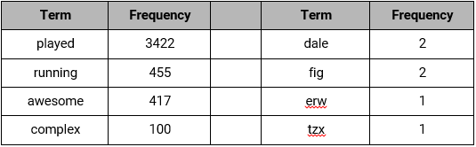](https://www.analyticsvidhya.com/wp-content/uploads/2015/10/1111.png)

5. Normalized Corpus

Words are the integral part of any classification technique. However, these words are often used with different variations in the text depending on their grammar (verb, adjective, noun, etc.). It is always a good practice to normalize the terms to their root forms. This technique is known as Lemmatization. For example, the words:

* Playing
* Player
* Plays
* Play
* Players
* Played

All can be normalized down to the word “**Play**” as far as the classifier is concerned. Performance will be good when there is single feature for ten variations rather than ten features for each variations.

test_data = [

    ('luv phone', 'Class A'),

    ('amazing company', 'Class A'),

    ('feeling very good about feature lol', 'Class A'),

    ('best phone', 'Class A'),

    ("awesome player", 'Class A'),

    ('not like phone apple', 'Class B'),

    ('tired stuff', 'Class B'),

    ('worst fear check out here', 'Class B'),

    ('boss live horrible', 'Class B')

]

6. Use Complex Features: n-grams and part of speech tags

In some cases, features as the combination of words provides better significance rather than considering single words as features. Combination of N words together are called N-grams. It is known that Bigrams are the most informative N-Gram combinations. Adding bigrams to feature set will improve the accuracy of text classification model.

Similarly considering Part of Speech tags combined with with words/n-grams will give an extra set of feature space. also increase the classifications. For example –

it’s better to train the model, such that word “book” when used as NOUN means “book of pages”, when used as VERB means to “book a ticket or something else”.

[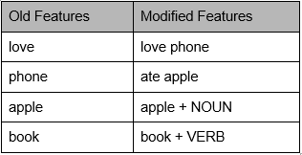](https://www.analyticsvidhya.com/wp-content/uploads/2015/10/123.png)

End Notes

In this article, we discussed few practices to improve the accuracy of a text classifier model. These gave me an improvement of ~10% – 20% in accuracy depending on the use case.

This is obviously not a complete list, but it provides a nice introduction for optimization of text classification algorithms. If you feel there are any other techniques which I have missed, feel free to share in comments section below.

**CL Algorithm Details**

**Non-hierarchical clustering methods**

**Single-pass methods**

* **Similarity:**Computed between input and all representatives of existing clusters
* **Example --- cover coefficient algorithm of Can et al.:**Select set of documents as cluster seeds; assign each document to cluster that maximally covers it
* **Time:**O(N log N)
* **Space:**O(M)
* **Advantages:**Simple, requiring only one pass through data; may be useful as starting point for reallocation methods
* **Disadvantages:**Produces large clusters early in process; clusters formed are dependent on order of input data

**Algorithm**

1. Assign the first document D1 as the representative of cluster C1
2. Calculate the similarity Sj between document Di and each cluster, keeping track of the largest, Smax
3. If Smax is greater than Sthreshold, add the document to the appropriate cluster, else create a new cluster with centroid Di
4. If documents remain, repeat from step 2

**Reallocation methods**

* **Similarity:**Allows various definitions of similarity / cluster cohesion
* **Type of clusters:**Refinements of initial input clustering
* **Time:**O(MN)
* **Space:**O(M + N)
* **Advantages:**Allows processing of larger data sets than other methods
* **Disadvantages:**Can take a long time to converge to a solution, depending on the appropriateness of the reallocation criteria to the structure of the data

**Algorithm**

1. Select M cluster representatives or centroids
2. Assign each document to the most similar centroid
3. Recalculate the centroid for each cluster
4. Repeat steps 2 and 3 until there is little change in cluster membership from pass to pass

**Hierarchical clustering methods**

**single link method**

* **Similarity:**Join the most similar pair of objects that are not yet in the same cluster. Distance between 2 clusters is the distance between the closest pair of points, each of which is in one of the two clusters.
* **Type of clusters:**Long straggly clusters, chains, ellipsoidal
* **Time:**Usually O(N**2) though can range from O(N log N) to O(N**5)
* **Space:**O(N)
* **Advantages:**Theoretical properties, efficient implementations, widely used. No cluster centroid or representative required, so no need arises to recalculate the similarity matrix.
* **Disadvantages:**Unsuitable for isolating spherical or poorly separated clusters

**SLINK Algorithm**

* Arrays record cluster pointer and distance information
* Process input documents one by one. For each:
* Compute and store a row of the distance matrix
* Find nearest other point, using the matrix
* Relabel clusters, as needed

**MST Algorithms** (see Prim, Kruskal algorithm animations)

* MST has all info needed to generate single link hierarchy in O(N**2) operations, or the single link hierarchy can be built at the same time as MST.
* Prim-Dijkstra algorithm operates as follows:
* Place an arbitrary document in the MST and connect its NN to it, to create an initial MST fragment.
* Find the document not in the MST that is closest to any point in the MST, and add it to the current MST fragment.
* If a document remains that is not in the MST fragment, repeat the previous step.

**complete link method**

* **Similarity:**Join least similar pair between each of two clusters
* **Type of clusters:**All entries in a cluster are linked to one another within some minimum similarity, so have small, tightly bound clusters.
* **Time:**Voorhees alg. worst case is O(N**3) but sparse matrices require much less
* **Space:**Voorhees alg. worst case is O(N**2) but sparse matrices require much less
* **Advantages:**Good results from (Voorhees) comparative studies.
* **Disadvantages:**Difficult to apply to large data sets since most efficient algorithm is general HACM using stored data or stored matrix approach.

**Voorhees Algorithm**

* Variation on the sorted matrix HACM approach
* Based on fact: if sims between all pairs of docs are processed in descending order, two clusters of size mi and mj can be merged as soon as the mi x mj th similarity of documents in those clusters is reached.
* Requires sorted list of doc-doc similarities
* Requires way to count no. of sims seen between any 2 active clusters

**group average link method**

* **Similarity:**Use the average value of the pairwise links within a cluster, based upon all objects in the cluster. Save space and time if use inner product of 2 (appropriately weighted) vectors --- see Voorhees alg. below.
* **Type of clusters:**Intermediate in tightness between single link and complete link
* **Time:**O(N**2)
* **Space:**O(N)
* **Advantages:**Ranked well in evaluation studies
* **Disadvantages:**Expensive for large collections

**Algorithm**

* Sim between cluster centroid and any doc = mean sim between the doc and all docs in the cluster.
* Hence, can use centroids only to compute cluster-cluster sim, in O(N) space

**Ward's method (minimum variance method)**

* **Similarity:**Join the cluster pair whose merger minimizes the increase in the total within-group error sum of squares, based on Euclidean distance between centroids
* **Type of clusters:**Homogeneous clusters in a symmetric hierarchy; cluster centroid nicely characterized by its center of gravity
* **Time:**O(N**2)
* **Space:**O(N) --- carries out agglomerations in restricted spatial regions
* **Advantages:**Good at recovering cluster structure, yields unique and exact hierarchy
* **Disdvantages:**Sensitive to outliers, poor at recovering elongated clusters

*RNN:*  
We can apply a reciprocal nearest neighbor (RNN) algorithm, since for any point or cluster there exists a chain of nearest neighbors (NNs) that ends with a pair that are each others' NN.  
**Algorithm - Single Cluster:**

1. Select an arbitrary doc
2. Follow the NN chain from it till an RNN pair is found.
3. Merge the 2 points in that pair, replacing them with a single new point.
4. If there is only one point, stop. Otherwise, if there is a point in the NN chain preceding the merged points, return to step 2 else to step 1.

**centroid and median methods**

* **Similarity:**At each stage join the pair of clusters with the most similar centroids.
* **Type of clusters:**Cluster is represented by the coordinates of the group centroid or median.
* **Disadvantages:**Newly formed clusters may differ overly much from constituent points, meaning that updates may cause large changes throughout the cluster hierarchy.

**General algorithm for HACM**

All hierarchical agglomerative clustering methods (HACMs) can be described by the following general algorithm.   
**Algorithm**

1. Identify the 2 closest points and combine them into a cluster
2. Identify and combine the next 2 closest points (treating existing clusters as points too)
3. If more than one cluster remains, return to step 1.

**How to apply general algorithm:**  
Lance and Williams proposed the Lance-Williams dissimilarity update formula, to calculate dissimilarities between a new cluster and existing points, based on the dissimilarities prior to forming the new cluster. This formula has 3 parameters, and each HACM can be characterized by its own set of Lance-Williams parameters (see Table 16.1 in text). Then, the algorithm above can be applied, using the appropriate Lance-Williams dissimilarities.

**Implementations of the general algorithm:**

* **Stored matrix** approach: Use matrix, and then apply Lance-Williams to recalculate dissimilarities between cluster centers. Storage is therefore O(N**2) and time is at least O(N**2), but will be O(N**3) if matrix is scanned linearly.
* **Stored data** approach: O(N) space for data but recompute pairwise dissimilarities so need O(N**3) time
* **Sorted matrix** approach: O(N**2) to calculate dissimilarity matrix, O(N**2 log N**2) to sort it, O(N**2) to construct hierarchy, but one need not store the data set, and the matrix can be processed linearly, which reduces disk accesses.

Bag of words [Bag of Words](https://en.wikipedia.org/wiki/Bag-of-words_model) (BoW) is an algorithm that counts how many times a word appears in a document. Those word counts allow us to compare documents and gauge their similarities for applications like search, document classification and topic modeling. BoW is a method for preparing text for input in a deep-learning net.

BoW lists words with their word counts per document. In the table where the words and documents effectively become vectors are stored, each row is a word, each column is a document and each cell is a word count. Each of the documents in the corpus is represented by columns of equal length. Those are wordcount vectors, an output stripped of context.

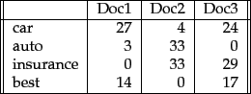

Before they’re fed to the neural net, each vector of wordcounts is normalized such that all elements of the vector add up to one. Thus, the frequencies of each word is effectively converted to represent the probabilities of those words’ occurrence in the document. Probabilities that surpass certain levels will activate nodes in the net and influence the document’s classification.

[Term Frequency-Inverse Document Frequency (TF-IDF)](https://deeplearning4j.org/bagofwords-tf-idf.html#term-frequency-inverse-document-frequency-tf-idf)

[Term-frequency-inverse document frequency](https://en.wikipedia.org/wiki/Tf%E2%80%93idf) (TF-IDF) is another way to judge the topic of an article by the words it contains. With TF-IDF, words are given weight – TF-IDF measures relevance, not frequency. That is, wordcounts are replaced with TF-IDF scores across the whole dataset.

First, TF-IDF measures the number of times that words appear in a given document (that’s term frequency). But because words such as “and” or “the” appear frequently in all documents, those are systematically discounted. That’s the inverse-document frequency part. The more documents a word appears in, the less valuable that word is as a signal. That’s intended to leave only the frequent AND distinctive words as markers. Each word’s TF-IDF relevance is a normalized data format that also adds up to one.

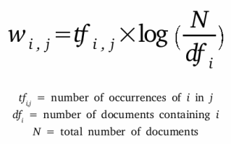

Those marker words are then fed to the neural net as features in order to determine the topic covered by the document that contains them.

Setting up a BoW looks something like this:

public class BagOfWordsVectorizer extends BaseTextVectorizer {

public BagOfWordsVectorizer(){}

protected BagOfWordsVectorizer(VocabCache cache,

TokenizerFactory tokenizerFactory,

List<String> stopWords,

int minWordFrequency,

DocumentIterator docIter,

SentenceIterator sentenceIterator,

List<String> labels,

InvertedIndex index,

int batchSize,

double sample,

boolean stem,

boolean cleanup) {

super(cache, tokenizerFactory, stopWords, minWordFrequency, docIter, sentenceIterator,

labels,index,batchSize,sample,stem,cleanup);

}

While simple, TF-IDF is incredibly powerful, and contributes to such ubiquitous and useful tools as Google search.

BoW is different from [Word2vec](https://deeplearning4j.org/word2vec.html), which we’ll cover next. The main difference is that Word2vec produces one vector per word, whereas BoW produces one number (a wordcount). Word2vec is great for digging into documents and identifying content and subsets of content. Its vectors represent each word’s context, the ngrams of which it is a part. BoW is good for classifying documents as a whole.

# A Gentle Introduction to the Bag-of-Words Model

The bag-of-words model is a way of representing text data when modeling text with machine learning algorithms.

The bag-of-words model is simple to understand and implement and has seen great success in problems such as language modeling and document classification.

In this tutorial, you will discover the bag-of-words model for feature extraction in natural language processing.

After completing this tutorial, you will know:

* What the bag-of-words model is and why it is needed to represent text.
* How to develop a bag-of-words model for a collection of documents.
* How to use different techniques to prepare a vocabulary and score words.

Let’s get started.

## Tutorial Overview

This tutorial is divided into 6 parts; they are:

1. The Problem with Text
2. What is a Bag-of-Words?
3. Example of the Bag-of-Words Model
4. Managing Vocabulary
5. Scoring Words
6. Limitations of Bag-of-Words

## The Problem with Text

A problem with modeling text is that it is messy, and techniques like machine learning algorithms prefer well defined fixed-length inputs and outputs.

Machine learning algorithms cannot work with raw text directly; the text must be converted into numbers. Specifically, vectors of numbers.

*In language processing, the vectors x are derived from textual data, in order to reflect various linguistic properties of the text.*

This is called feature extraction or feature encoding.

A popular and simple method of feature extraction with text data is called the bag-of-words model of text.

## What is a Bag-of-Words?

A bag-of-words model, or BoW for short, is a way of extracting features from text for use in modeling, such as with machine learning algorithms.

The approach is very simple and flexible, and can be used in a myriad of ways for extracting features from documents.

A bag-of-words is a representation of text that describes the occurrence of words within a document. It involves two things:

1. A vocabulary of known words.
2. A measure of the presence of known words.

It is called a “bag” of words, because any information about the order or structure of words in the document is discarded. The model is only concerned with whether known words occur in the document, not where in the document.

*A very common feature extraction procedures for sentences and documents is the bag-of-words approach (BOW). In this approach, we look at the histogram of the words within the text, i.e. considering each word count as a feature.*

The intuition is that documents are similar if they have similar content. Further, that from the content alone we can learn something about the meaning of the document.

The bag-of-words can be as simple or complex as you like. The complexity comes both in deciding how to design the vocabulary of known words (or tokens) and how to score the presence of known words.

We will take a closer look at both of these concerns.

## Example of the Bag-of-Words Model

Let’s make the bag-of-words model concrete with a worked example.

### Step 1: Collect Data

Below is a snippet of the first few lines of text from the book “[A Tale of Two Cities](https://www.gutenberg.org/ebooks/98)” by Charles Dickens, taken from Project Gutenberg.

*It was the best of times,  
it was the worst of times,  
it was the age of wisdom,  
it was the age of foolishness,*

For this small example, let’s treat each line as a separate “document” and the 4 lines as our entire corpus of documents.

### Step 2: Design the Vocabulary

Now we can make a list of all of the words in our model vocabulary.

The unique words here (ignoring case and punctuation) are:

* “it” “was” “the” “best” “of” “times” “worst” “age” “wisdom” “foolishness”

That is a vocabulary of 10 words from a corpus containing 24 words.

### Step 3: Create Document Vectors

The next step is to score the words in each document.

The objective is to turn each document of free text into a vector that we can use as input or output for a machine learning model.

Because we know the vocabulary has 10 words, we can use a fixed-length document representation of 10, with one position in the vector to score each word.

The simplest scoring method is to mark the presence of words as a boolean value, 0 for absent, 1 for present.

Using the arbitrary ordering of words listed above in our vocabulary, we can step through the first document (“It was the best of times“) and convert it into a binary vector.

The scoring of the document would look as follows:

* “it” = 1
* “was” = 1
* “the” = 1
* “best” = 1
* “of” = 1
* “times” = 1
* “worst” = 0
* “age” = 0
* “wisdom” = 0
* “foolishness” = 0

As a binary vector, this would look as follows:



|  |  |
| --- | --- |
| 1 | [1, 1, 1, 1, 1, 1, 0, 0, 0, 0] |

The other three documents would look as follows:



|  |  |
| --- | --- |
| 1  2  3 | "it was the worst of times" = [1, 1, 1, 0, 1, 1, 1, 0, 0, 0]  "it was the age of wisdom" = [1, 1, 1, 0, 1, 0, 0, 1, 1, 0]  "it was the age of foolishness" = [1, 1, 1, 0, 1, 0, 0, 1, 0, 1] |

All ordering of the words is nominally discarded and we have a consistent way of extracting features from any document in our corpus, ready for use in modeling.

New documents that overlap with the vocabulary of known words, but may contain words outside of the vocabulary, can still be encoded, where only the occurrence of known words are scored and unknown words are ignored.

You can see how this might naturally scale to large vocabularies and larger documents.

## Managing Vocabulary

As the vocabulary size increases, so does the vector representation of documents.

In the previous example, the length of the document vector is equal to the number of known words.

You can imagine that for a very large corpus, such as thousands of books, that the length of the vector might be thousands or millions of positions. Further, each document may contain very few of the known words in the vocabulary.

This results in a vector with lots of zero scores, called a sparse vector or sparse representation.

Sparse vectors require more memory and computational resources when modeling and the vast number of positions or dimensions can make the modeling process very challenging for traditional algorithms.

As such, there is pressure to decrease the size of the vocabulary when using a bag-of-words model.

There are simple text cleaning techniques that can be used as a first step, such as:

* Ignoring case
* Ignoring punctuation
* Ignoring frequent words that don’t contain much information, called stop words, like “a,” “of,” etc.
* Fixing misspelled words.
* Reducing words to their stem (e.g. “play” from “playing”) using stemming algorithms.

A more sophisticated approach is to create a vocabulary of grouped words. This both changes the scope of the vocabulary and allows the bag-of-words to capture a little bit more meaning from the document.

In this approach, each word or token is called a “gram”. Creating a vocabulary of two-word pairs is, in turn, called a bigram model. Again, only the bigrams that appear in the corpus are modeled, not all possible bigrams.

*An N-gram is an N-token sequence of words: a 2-gram (more commonly called a bigram) is a two-word sequence of words like “please turn”, “turn your”, or “your homework”, and a 3-gram (more commonly called a trigram) is a three-word sequence of words like “please turn your”, or “turn your homework”.*

— Page 85, [Speech and Language Processing](http://amzn.to/2vaEb7T), 2009.

For example, the bigrams in the first line of text in the previous section: “It was the best of times” are as follows:

* “it was”
* “was the”
* “the best”
* “best of”
* “of times”

A vocabulary then tracks triplets of words is called a trigram model and the general approach is called the n-gram model, where n refers to the number of grouped words.

Often a simple bigram approach is better than a 1-gram bag-of-words model for tasks like documentation classification.

*a bag-of-bigrams representation is much more powerful than bag-of-words, and in many cases proves very hard to beat.*

— Page 75, [Neural Network Methods in Natural Language Processing](http://amzn.to/2wycQKA), 2017.

## Scoring Words

Once a vocabulary has been chosen, the occurrence of words in example documents needs to be scored.

In the worked example, we have already seen one very simple approach to scoring: a binary scoring of the presence or absence of words.

Some additional simple scoring methods include:

* **Counts**. Count the number of times each word appears in a document.
* **Frequencies**. Calculate the frequency that each word appears in a document out of all the words in the document.

### Word Hashing

You may remember from computer science that a [hash function](https://en.wikipedia.org/wiki/Hash_function) is a bit of math that maps data to a fixed size set of numbers.

For example, we use them in hash tables when programming where perhaps names are converted to numbers for fast lookup.

We can use a hash representation of known words in our vocabulary. This addresses the problem of having a very large vocabulary for a large text corpus because we can choose the size of the hash space, which is in turn the size of the vector representation of the document.

Words are hashed deterministically to the same integer index in the target hash space. A binary score or count can then be used to score the word.

This is called the “hash trick” or “feature hashing“.

The challenge is to choose a hash space to accommodate the chosen vocabulary size to minimize the probability of collisions and trade-off sparsity.

### TF-IDF

A problem with scoring word frequency is that highly frequent words start to dominate in the document (e.g. larger score), but may not contain as much “informational content” to the model as rarer but perhaps domain specific words.

One approach is to rescale the frequency of words by how often they appear in all documents, so that the scores for frequent words like “the” that are also frequent across all documents are penalized.

This approach to scoring is called Term Frequency – Inverse Document Frequency, or TF-IDF for short, where:

* **Term Frequency**: is a scoring of the frequency of the word in the current document.
* **Inverse Document Frequency**: is a scoring of how rare the word is across documents.

The scores are a weighting where not all words are equally as important or interesting.

The scores have the effect of highlighting words that are distinct (contain useful information) in a given document.

*Thus the idf of a rare term is high, whereas the idf of a frequent term is likely to be low.*

— Page 118, [An Introduction to Information Retrieval](http://amzn.to/2hAR7PH), 2008.

## Limitations of Bag-of-Words

The bag-of-words model is very simple to understand and implement and offers a lot of flexibility for customization on your specific text data.

It has been used with great success on prediction problems like language modeling and documentation classification.

Nevertheless, it suffers from some shortcomings, such as:

* **Vocabulary**: The vocabulary requires careful design, most specifically in order to manage the size, which impacts the sparsity of the document representations.
* **Sparsity**: Sparse representations are harder to model both for computational reasons (space and time complexity) and also for information reasons, where the challenge is for the models to harness so little information in such a large representational space.
* **Meaning**: Discarding word order ignores the context, and in turn meaning of words in the document (semantics). Context and meaning can offer a lot to the model, that if modeled could tell the difference between the same words differently arranged (“this is interesting” vs “is this interesting”), synonyms (“old bike” vs “used bike”), and much more.

**A Beginner's Guide To Understanding Convolutional Neural Networks**

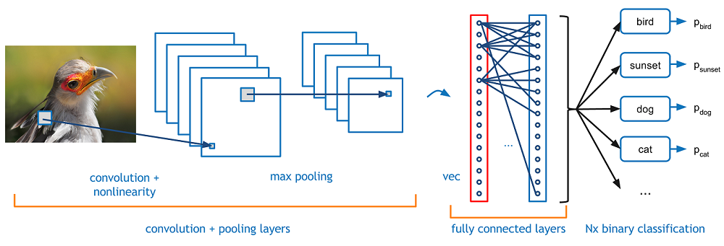

**Introduction**

                Convolutional neural networks. Sounds like a weird combination of biology and math with a little CS sprinkled in, but these networks have been some of the most influential innovations in the field of computer vision. 2012 was the first year that neural nets grew to prominence as Alex Krizhevsky used them to win that year’s ImageNet competition (basically, the annual Olympics of computer vision), dropping the classification error record from 26% to 15%, an astounding improvement at the time.Ever since then, a host of companies have been using deep learning at the core of their services. Facebook uses neural nets for their automatic tagging algorithms, Google for their photo search, Amazon for their product recommendations, Pinterest for their home feed personalization, and Instagram for their search infrastructure.



However, the classic, and arguably most popular, use case of these networks is for image processing. Within image processing, let’s take a look at how to use these CNNs for image classification.

**The Problem Space**

                Image classification is the task of taking an input image and outputting a class (a cat, dog, etc) or a probability of classes that best describes the image. For humans, this task of recognition is one of the first skills we learn from the moment we are born and is one that comes naturally and effortlessly as adults. Without even thinking twice, we’re able to quickly and seamlessly identify the environment we are in as well as the objects that surround us. When we see an image or just when we look at the world around us, most of the time we are able to immediately characterize the scene and give each object a label, all without even consciously noticing. These skills of being able to quickly recognize patterns, generalize from prior knowledge, and adapt to different image environments are ones that we do not share with our fellow machines.

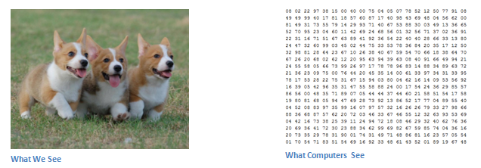

**Inputs and Outputs**

                When a computer sees an image (takes an image as input), it will see an array of pixel values. Depending on the resolution and size of the image, it will see a 32 x 32 x 3 array of numbers (The 3 refers to RGB values). Just to drive home the point, let's say we have a color image in JPG form and its size is 480 x 480. The representative array will be 480 x 480 x 3. Each of these numbers is given a value from 0 to 255 which describes the pixel intensity at that point. These numbers, while meaningless to us when we perform image classification, are the only inputs available to the computer.  The idea is that you give the computer this array of numbers and it will output numbers that describe the probability of the image being a certain class (.80 for cat, .15 for dog, .05 for bird, etc).

**What We Want the Computer to Do**

                Now that we know the problem as well as the inputs and outputs, let’s think about how to approach this. What we want the computer to do is to be able to differentiate between all the images it’s given and figure out the unique features that make a dog a dog or that make a cat a cat. This is the process that goes on in our minds subconsciously as well. When we look at a picture of a dog, we can classify it as such if the picture has identifiable features such as paws or 4 legs. In a similar way, the computer is able perform image classification by looking for low level features such as edges and curves, and then building up to more abstract concepts through a series of convolutional layers. This is a general overview of what a CNN does. Let’s get into the specifics.

**Biological Connection**

                But first, a little background. When you first heard of the term convolutional neural networks, you may have thought of something related to neuroscience or biology, and you would be right. Sort of. CNNs do take a biological inspiration from the visual cortex. The visual cortex has small regions of cells that are sensitive to specific regions of the visual field. This idea was expanded upon by a fascinating experiment by Hubel and Wiesel in 1962 ([Video](https://www.youtube.com/watch?v=Cw5PKV9Rj3o)) where they showed that some individual neuronal cells in the brain responded (or fired) only in the presence of edges of a certain orientation. For example, some neurons fired when exposed to vertical edges and some when shown horizontal or diagonal edges. Hubel and Wiesel found out that all of these neurons were organized in a columnar architecture and that together, they were able to produce visual perception. This idea of specialized components inside of a system having specific tasks (the neuronal cells in the visual cortex looking for specific characteristics) is one that machines use as well, and is the basis behind CNNs.

**Structure**

                Back to the specifics. A more detailed overview of what CNNs do would be that you take the image, pass it through a series of convolutional, nonlinear, pooling (downsampling), and fully connected layers, and get an output. As we said earlier, the output can be a single class or a probability of classes that best describes the image. Now, the hard part is understanding what each of these layers do. So let’s get into the most important one.

**First Layer – Math Part**

                The first layer in a CNN is always a **Convolutional Layer**. First thing to make sure you remember is what the input to this conv (I’ll be using that abbreviation a lot) layer is. Like we mentioned before, the input is a 32 x 32 x 3 array of pixel values. Now, the best way to explain a conv layer is to imagine a flashlight that is shining over the top left of the image. Let’s say that the light this flashlight shines covers a 5 x 5 area. And now, let’s imagine this flashlight sliding across all the areas of the input image. In machine learning terms, this flashlight is called a **filter**(or sometimes referred to as a **neuron**or a **kernel**) and the region that it is shining over is called the **receptive field**. Now this filter is also an array of numbers (the numbers are called **weights** or **parameters**). A very important note is that the depth of this filter has to be the same as the depth of the input (this makes sure that the math works out), so the dimensions of this filter is 5 x 5 x 3. Now, let’s take the first position the filter is in for example.  It would be the top left corner. As the filter is sliding, or **convolving**, around the input image, it is multiplying the values in the filter with the original pixel values of the image (aka computing **element wise multiplications**). These multiplications are all summed up (mathematically speaking, this would be 75 multiplications in total). So now you have a single number. Remember, this number is just representative of when the filter is at the top left of the image. Now, we repeat this process for every location on the input volume. (Next step would be moving the filter to the right by 1 unit, then right again by 1, and so on). Every unique location on the input volume produces a number. After sliding the filter over all the locations, you will find out that what you’re left with is a 28 x 28 x 1 array of numbers, which we call an **activation map** or **feature map**. The reason you get a 28 x 28 array is that there are 784 different locations that a 5 x 5 filter can fit on a 32 x 32 input image. These 784 numbers are mapped to a 28 x 28 array.

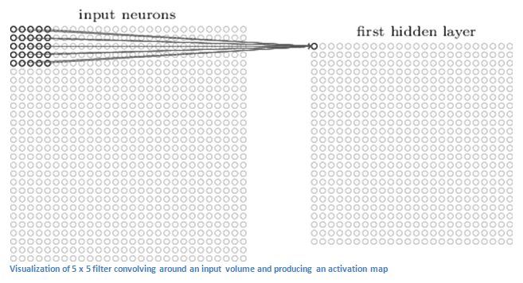

(Quick Note: Some of the images, including the one above, I used came from this terrific book, ["Neural Networks and Deep Learning"](http://neuralnetworksanddeeplearning.com/) by Michael Nielsen. Strongly recommend.)

Let’s say now we use two 5 x 5 x 3 filters instead of one. Then our output volume would be 28 x 28 x 2. By using more filters, we are able to preserve the spatial dimensions better. Mathematically, this is what’s going on in a convolutional layer.

**First Layer – High Level Perspective**

                However, let’s talk about what this convolution is actually doing from a high level. Each of these filters can be thought of as **feature identifiers**. When I say features, I’m talking about things like straight edges, simple colors, and curves. Think about the simplest characteristics that all images have in common with each other. Let’s say our first filter is 7 x 7 x 3 and is going to be a curve detector. (In this section, let’s ignore the fact that the filter is 3 units deep and only consider the top depth slice of the filter and the image, for simplicity.)As a curve detector, the filter will have a pixel structure in which there will be higher numerical values along the area that is a shape of a curve (Remember, these filters that we’re talking about as just numbers!).

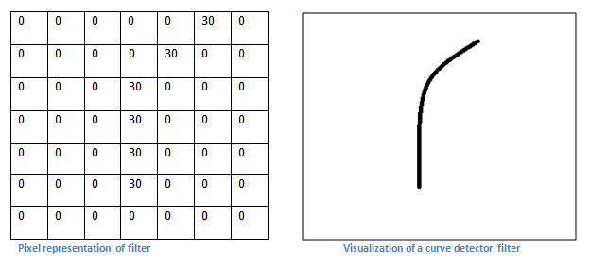

Now, let’s go back to visualizing this mathematically. When we have this filter at the top left corner of the input volume, it is computing multiplications between the filter and pixel values at that region. Now let’s take an example of an image that we want to classify, and let’s put our filter at the top left corner.

Remember, what we have to do is multiply the values in the filter with the original pixel values of the image.

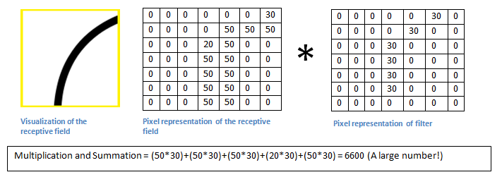

Basically, in the input image, if there is a shape that generally resembles the curve that this filter is representing, then all of the multiplications summed together will result in a large value! Now let’s see what happens when we move our filter.

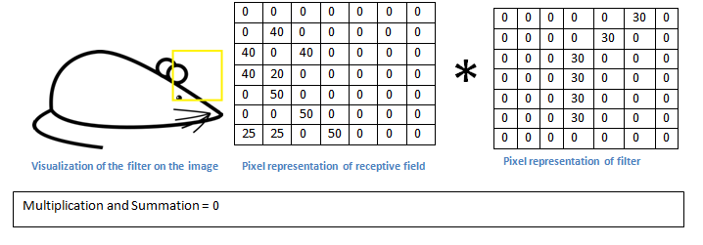

The value is much lower! This is because there wasn’t anything in the image section that responded to the curve detector filter. Remember, the output of this conv layer is an activation map. So, in the simple case of a one filter convolution (and if that filter is a curve detector), the activation map will show the areas in which there at mostly likely to be curves in the picture. In this example, the top left value of our 26 x 26 x 1 activation map (26 because of the 7x7 filter instead of 5x5) will be 6600. This high value means that it is likely that there is some sort of curve in the input volume that caused the filter to activate. The top right value in our activation map will be 0 because there wasn’t anything in the input volume that caused the filter to activate (or more simply said, there wasn’t a curve in that region of the original image). Remember, this is just for one filter. This is just a filter that is going to detect lines that curve outward and to the right. We can have other filters for lines that curve to the left or for straight edges. The more filters, the greater the depth of the activation map, and the more information we have about the input volume.

**Disclaimer:** The filter I described in this section was simplistic for the main purpose of describing the math that goes on during a convolution. In the picture below, you’ll see some examples of actual visualizations of the filters of the first conv layer of a trained network. Nonetheless, the main argument remains the same. The filters on the first layer convolve around the input image and “activate” (or compute high values) when the specific feature it is looking for is in the input volume.

(Quick Note: The above image came from Stanford's [CS 231N course](http://cs231n.stanford.edu/) taught by Andrej Karpathy and Justin Johnson. Recommend for anyone looking for a deeper understanding of CNNs.)

**Going Deeper Through the Network**

                Now in a traditional convolutional neural network architecture, there are other layers that are interspersed between these conv layers. I’d strongly encourage those interested to read up on them and understand their function and effects, but in a general sense, they provide nonlinearities and preservation of dimension that help to improve the robustness of the network and control overfitting. A classic CNN architecture would look like this.



The last layer, however, is an important one and one that we will go into later on. Let’s just take a step back and review what we’ve learned so far. We talked about what the filters in the first conv layer are designed to detect. They detect low level features such as edges and curves. As one would imagine, in order to predict whether an image is a type of object, we need the network to be able to recognize higher level features such as hands or paws or ears. So let’s think about what the output of the network is after the first conv layer. It would be a 28 x 28 x 3 volume (assuming we use three 5 x 5 x 3 filters).  When we go through another conv layer, the output of the first conv layer becomes the input of the 2nd conv layer.  Now, this is a little bit harder to visualize. When we were talking about the first layer, the input was just the original image. However, when we’re talking about the 2nd conv layer, the input is the activation map(s) that result from the first layer. So each layer of the input is basically describing the locations in the original image for where certain low level features appear. Now when you apply a set of filters on top of that (pass it through the 2nd conv layer), the output will be activations that represent higher level features. Types of these features could be semicircles (combination of a curve and straight edge) or squares (combination of several straight edges). As you go through the network and go through more conv layers, you get activation maps that represent more and more complex features. By the end of the network, you may have some filters that activate when there is handwriting in the image, filters that activate when they see pink objects, etc. If you want more information about visualizing filters in ConvNets, Matt Zeiler and Rob Fergus had an excellent [research paper](http://www.matthewzeiler.com/pubs/arxive2013/arxive2013.pdf) discussing the topic. Jason Yosinski also has a [video](https://www.youtube.com/watch?v=AgkfIQ4IGaM) on YouTube that provides a great visual representation. Another interesting thing to note is that as you go deeper into the network, the filters begin to have a larger and larger receptive field, which means that they are able to consider information from a larger area of the original input volume (another way of putting it is that they are more responsive to a larger region of pixel space).

**Fully Connected Layer**

                Now that we can detect these high level features, the icing on the cake is attaching a **fully connected layer** to the end of the network. This layer basically takes an input volume (whatever the output is of the conv or ReLU or pool layer preceding it) and outputs an N dimensional vector where N is the number of classes that the program has to choose from. For example, if you wanted a digit classification program, N would be 10 since there are 10 digits. Each number in this N dimensional vector represents the probability of a certain class. For example, if the resulting vector for a digit classification program is [0 .1 .1 .75 0 0 0 0 0 .05], then this represents a 10% probability that the image is a 1, a 10% probability that the image is a 2, a 75% probability that the image is a 3, and a 5% probability that the image is a 9 (Side note: There are other ways that you can represent the output, but I am just showing the softmax approach). The way this fully connected layer works is that it looks at the output of the previous layer (which as we remember should represent the activation maps of high level features) and determines which features most correlate to a particular class. For example, if the program is predicting that some image is a dog, it will have high values in the activation maps that represent high level features like a paw or 4 legs, etc. Similarly, if the program is predicting that some image is a bird, it will have high values in the activation maps that represent high level features like wings or a beak, etc. Basically, a FC layer looks at what high level features most strongly correlate to a particular class and has particular weights so that when you compute the products between the weights and the previous layer, you get the correct probabilities for the different classes.

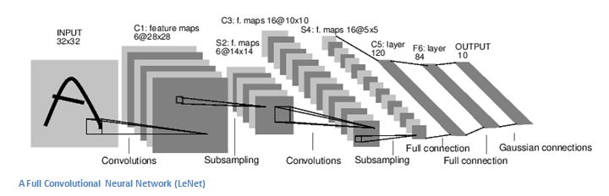

**Training (AKA:What Makes this Stuff Work)**

                Now, this is the one aspect of neural networks that I purposely haven’t mentioned yet and it is probably the most important part. There may be a lot of questions you had while reading. How do the filters in the first conv layer know to look for edges and curves? How does the fully connected layer know what activation maps to look at? How do the filters in each layer know what values to have? The way the computer is able to adjust its filter values (or weights) is through a training process called **backpropagation**.

Before we get into backpropagation, we must first take a step back and talk about what a neural network needs in order to work. At the moment we all were born, our minds were fresh. We didn’t know what a cat or dog or bird was. In a similar sort of way, before the CNN starts, the weights or filter values are randomized. The filters don’t know to look for edges and curves. The filters in the higher layers don’t know to look for paws and beaks. As we grew older however, our parents and teachers showed us different pictures and images and gave us a corresponding label. This idea of being given an image and a label is the training process that CNNs go through. Before getting too into it, let’s just say that we have a training set that has thousands of images of dogs, cats, and birds and each of the images has a label of what animal that picture is. Back to backprop.

So backpropagation can be separated into 4 distinct sections, the forward pass, the loss function, the backward pass, and the weight update. During the **forward pass**, you take a training image which as we remember is a 32 x 32 x 3 array of numbers and pass it through the whole network. On our first training example, since all of the weights or filter values were randomly initialized, the output will probably be something like [.1 .1 .1 .1 .1 .1 .1 .1 .1 .1], basically an output that doesn’t give preference to any number in particular. The network, with its current weights, isn’t able to look for those low level features or thus isn’t able to make any reasonable conclusion about what the classification might be. This goes to the **loss function** part of backpropagation. Remember that what we are using right now is training data. This data has both an image and a label. Let’s say for example that the first training image inputted was a 3. The label for the image would be [0 0 0 1 0 0 0 0 0 0]. A loss function can be defined in many different ways but a common one is MSE (mean squared error), which is ½ times (actual - predicted) squared.

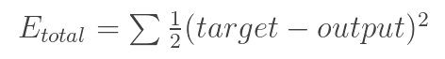

Let’s say the variable L is equal to that value. As you can imagine, the loss will be extremely high for the first couple of training images. Now, let’s just think about this intuitively. We want to get to a point where the predicted label (output of the ConvNet) is the same as the training label (This means that our network got its prediction right).In order to get there, we want to minimize the amount of loss we have. Visualizing this as just an optimization problem in calculus, we want to find out which inputs (weights in our case) most directly contributed to the loss (or error) of the network.

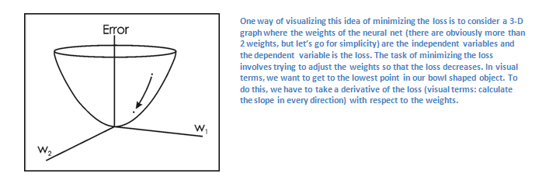

This is the mathematical equivalent of a **dL/dW** where W are the weights at a particular layer. Now, what we want to do is perform a **backward pass** through the network, which is determining which weights contributed most to the loss and finding ways to adjust them so that the loss decreases. Once we compute this derivative, we then go to the last step which is the **weight update**. This is where we take all the weights of the filters and update them so that they change in the opposite direction of the gradient.

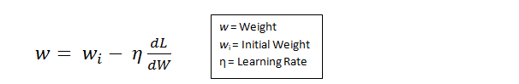

The **learning rate** is a parameter that is chosen by the programmer. A high learning rate means that bigger steps are taken in the weight updates and thus, it may take less time for the model to converge on an optimal set of weights. However, a learning rate that is too high could result in jumps that are too large and not precise enough to reach the optimal point.

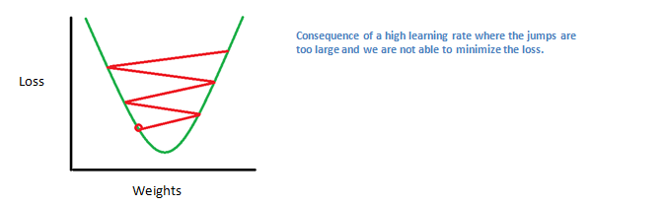

                The process of forward pass, loss function, backward pass, and parameter update is one training iteration. The program will repeat this process for a fixed number of iterations for each set of training images (commonly called a batch). Once you finish the parameter update on the last training example, hopefully the network should be trained well enough so that the weights of the layers are tuned correctly.

**Testing**

                Finally, to see whether or not our CNN works, we have a different set of images and labels (can’t double dip between training and test!) and pass the images through the CNN. We compare the outputs to the ground truth and see if our network works!

**How Companies Use CNNs**

                Data, data, data. The companies that have lots of this magic 4 letter word are the ones that have an inherent advantage over the rest of the competition. The more training data that you can give to a network, the more training iterations you can make, the more weight updates you can make, and the better tuned to the network is when it goes to production. Facebook (and Instagram) can use all the photos of the billion users it currently has, Pinterest can use information of the 50 billion pins that are on its site, Google can use search data, and Amazon can use data from the millions of products that are bought every day. And now you know the magic behind how they use it.

**A Beginner's Guide To Understanding Convolutional Neural Networks Part 2**

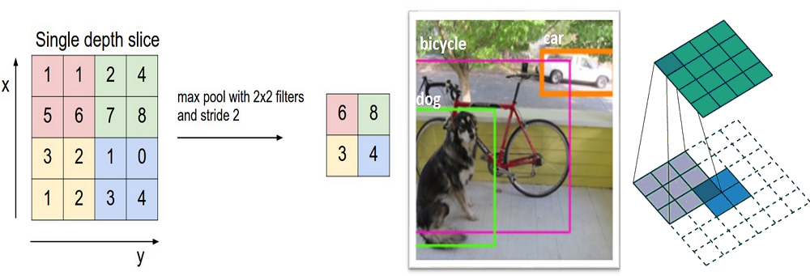

**Introduction**

               In this post, we’ll go into a lot more of the specifics of ConvNets. **Disclaimer:**Now, I do realize that some of these topics are quite complex and could be made in whole posts by themselves. In an effort to remain concise yet retain comprehensiveness, I will provide links to research papers where the topic is explained in more detail.

**Stride and Padding**

                Alright, let’s look back at our good old conv layers. Remember the filters, the receptive fields, the convolving? Good. Now, there are 2 main parameters that we can change to modify the behavior of each layer. After we choose the filter size, we also have to choose the **stride** and the **padding**.

Stride controls how the filter convolves around the input volume. In the example we had in part 1, the filter convolves around the input volume by shifting one unit at a time. The amount by which the filter shifts is the stride. In that case, the stride was implicitly set at 1. Stride is normally set in a way so that the output volume is an integer and not a fraction. Let’s look at an example. Let’s imagine a 7 x 7 input volume, a 3 x 3 filter (Disregard the 3rd dimension for simplicity), and a stride of 1. This is the case that we’re accustomed to.

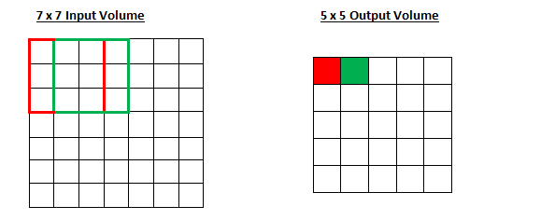

Same old, same old, right? See if you can try to guess what will happen to the output volume as the stride increases to 2.

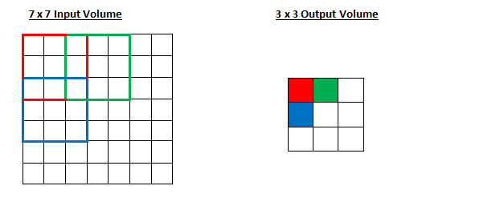

So, as you can see, the receptive field is shifting by 2 units now and the output volume shrinks as well. Notice that if we tried to set our stride to 3, then we’d have issues with spacing and making sure the receptive fields fit on the input volume. Normally, programmers will increase the stride if they want receptive fields to overlap less and if they want smaller spatial dimensions.

Now, let’s take a look at padding. Before getting into that, let’s think about a scenario. What happens when you apply three 5 x 5 x 3 filters to a 32 x 32 x 3 input volume? The output volume would be 28 x 28 x 3. Notice that the spatial dimensions decrease. As we keep applying conv layers, the size of the volume will decrease faster than we would like. In the early layers of our network, we want to preserve as much information about the original input volume so that we can extract those low level features. Let’s say we want to apply the same conv layer but we want the output volume to remain 32 x 32 x 3. To do this, we can apply a zero padding of size 2 to that layer. Zero padding pads the input volume with zeros around the border. If we think about a zero padding of two, then this would result in a 36 x 36 x 3 input volume.

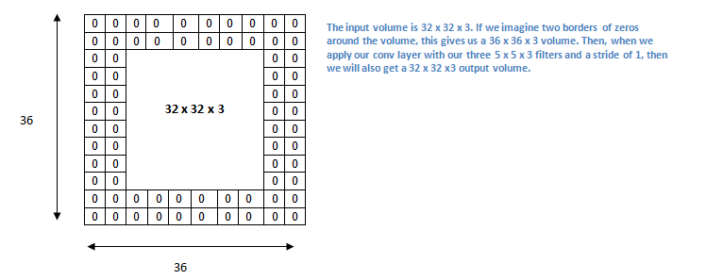

If you have a stride of 1 and if you set the size of zero padding to



where K is the filter size, then the input and output volume will always have the same spatial dimensions.

The formula for calculating the output size for any given conv layer is

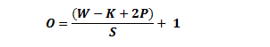

where O is the output height/length, W is the input height/length, K is the filter size, P is the padding, and S is the stride.

**Choosing Hyperparameters**

                How do we know how many layers to use, how many conv layers, what are the filter sizes, or the values for stride and padding? These are not trivial questions and there isn’t a set standard that is used by all researchers. This is because the network will largely depend on the type of data that you have. Data can vary by size, complexity of the image, type of image processing task, and more. When looking at your dataset, one way to think about how to choose the hyperparameters is to find the right combination that creates abstractions of the image at a proper scale.

**ReLU (Rectified Linear Units) Layers**

                After each conv layer, it is convention to apply a nonlinear layer (or **activation layer**) immediately afterward.The purpose of this layer is to introduce nonlinearity to a system that basically has just been computing linear operations during the conv layers (just element wise multiplications and summations).In the past, nonlinear functions like tanh and sigmoid were used, but researchers found out that **ReLU layers** work far better because the network is able to train a lot faster (because of the computational efficiency) without making a significant difference to the accuracy. It also helps to alleviate the vanishing gradient problem, which is the issue where the lower layers of the network train very slowly because the gradient decreases exponentially through the layers (Explaining this might be out of the scope of this post, but see [here](https://en.wikipedia.org/wiki/Vanishing_gradient_problem) and [here](https://www.quora.com/What-is-the-vanishing-gradient-problem) for good descriptions). The ReLU layer applies the function f(x) = max(0, x) to all of the values in the input volume. In basic terms, this layer just changes all the negative activations to 0.This layer increases the nonlinear properties of the model and the overall network without affecting the receptive fields of the conv layer.

[Paper](http://www.cs.toronto.edu/~fritz/absps/reluICML.pdf) by the great Geoffrey Hinton (aka the father of deep learning).

**Pooling Layers**

                After some ReLU layers, programmers may choose to apply a **pooling layer**. It is also referred to as a downsampling layer. In this category, there are also several layer options, with maxpooling being the most popular. This basically takes a filter (normally of size 2x2) and a stride of the same length. It then applies it to the input volume and outputs the maximum number in every subregion that the filter convolves around.

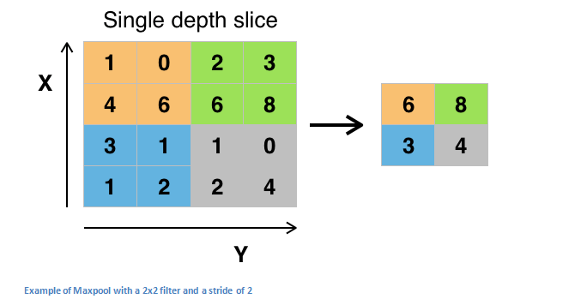

Other options for pooling layers are average pooling and L2-norm pooling. The intuitive reasoning behind this layer is that once we know that a specific feature is in the original input volume (there will be a high activation value), its exact location is not as important as its relative location to the other features. As you can imagine, this layer drastically reduces the spatial dimension (the length and the width change but not the depth) of the input volume. This serves two main purposes. The first is that the amount of parameters or weights is reduced by 75%, thus lessening the computation cost. The second is that it will control **overfitting**. This term refers to when a model is so tuned to the training examples that it is not able to generalize well for the validation and test sets. A symptom of overfitting is having a model that gets 100% or 99% on the training set, but only 50% on the test data.

**Dropout Layers**

               Now, **dropout layers**have a very specific function in neural networks. In the last section, we discussed the problem of overfitting, where after training, the weights of the network are so tuned to the training examples they are given that the network doesn’t perform well when given new examples. The idea of dropout is simplistic in nature. This layer “drops out” a random set of activations in that layer by setting them to zero. Simple as that. Now, what are the benefits of such a simple and seemingly unnecessary and counterintuitive process? Well, in a way, it forces the network to be redundant. By that I mean the network should be able to provide the right classification or output for a specific example even if some of the activations are dropped out. It makes sure that the network isn’t getting too “fitted” to the training data and thus helps alleviate the overfitting problem. An important note is that this layer is only used during training, and not during test time.

[Paper](https://www.cs.toronto.edu/~hinton/absps/JMLRdropout.pdf) by Geoffrey Hinton.

**Network in Network Layers**

                A **network in network** layer refers to a conv layer where a 1 x 1 size filter is used. Now, at first look, you might wonder why this type of layer would even be helpful since receptive fields are normally larger than the space they map to. However, we must remember that these 1x1 convolutions span a certain depth, so we can think of it as a 1 x 1 x N convolution where N is the number of filters applied in the layer. Effectively, this layer is performing a N-D element-wise multiplication where N is the depth of the input volume into the layer.

[Paper](https://arxiv.org/pdf/1312.4400v3.pdf) by Min Lin.

**Classification, Localization, Detection, Segmentation**

                In the example we used in Part 1 of this series, we looked at the task of **image classification**. This is the process of taking an input image and outputting a class number out of a set of categories. However, when we take a task like **object localization**, our job is not only to produce a class label but also a bounding box that describes where the object is in the picture.

We also have the task of **object detection**, where localization needs to be done on all of the objects in the image. Therefore, you will have multiple bounding boxes and multiple class labels.

Finally, we also have **object segmentation** where the task is to output a class label as well as an outline of every object in the input image.

**Transfer Learning**

Now, a common misconception in the DL community is that without a Google-esque amount of data, you can’t possibly hope to create effective deep learning models. While data is a critical part of creating the network, the idea of transfer learning has helped to lessen the data demands. **Transfer learning** is the process of taking a pre-trained model (the weights and parameters of a network that has been trained on a large dataset by somebody else) and “fine-tuning” the model with your own dataset. The idea is that this pre-trained model will act as a feature extractor. You will remove the last layer of the network and replace it with your own classifier (depending on what your problem space is). You then freeze the weights of all the other layers and train the network normally (Freezing the layers means not changing the weights during gradient descent/optimization).

Let’s investigate why this works. Let’s say the pre-trained model that we’re talking about was trained on ImageNet (For those that aren’t familiar, ImageNet is a dataset that contains 14 million images with over 1,000 classes). When we think about the lower layers of the network, we know that they will detect features like edges and curves. Now, unless you have a very unique problem space and dataset, your network is going to need to detect curves and edges as well. Rather than training the whole network through a random initialization of weights, we can use the weights of the pre-trained model (and freeze them) and focus on the more important layers (ones that are higher up) for training. If your dataset is quite different than something like ImageNet, then you’d want to train more of your layers and freeze only a couple of the low layers.

[Paper](https://arxiv.org/pdf/1411.1792v1.pdf) by Yoshua Bengio (another deep learning pioneer).  
[Paper](http://arxiv.org/pdf/1403.6382.pdf) by Ali Sharif Razavian.  
[Paper](https://arxiv.org/pdf/1310.1531.pdf) by Jeff Donahue.  
[Paper](https://arxiv.org/pdf/1705.07706.pdf) and [subsequent paper](https://arxiv.org/pdf/1707.09872.pdf) by Dario Garcia-Gasulla.

**Data Augmentation Techniques**

By now, we’re all probably numb to the importance of data in ConvNets, so let’s talk about ways that you can make your existing dataset even larger, just with a couple easy transformations. Like we’ve mentioned before, when a computer takes an image as an input, it will take in an array of pixel values. Let’s say that the whole image is shifted left by 1 pixel. To you and me, this change is imperceptible. However, to a computer, this shift can be fairly significant as the classification or label of the image doesn’t change, while the array does. Approaches that alter the training data in ways that change the array representation while keeping the label the same are known as **data augmentation**techniques. They are a way to artificially expand your dataset. Some popular augmentations people use are grayscales, horizontal flips, vertical flips, random crops, color jitters, translations, rotations, and much more. By applying just a couple of these transformations to your training data, you can easily double or triple the number of training examples.

### Exercise: Convolutional Neural Network

### Overview

In this exercise you will implement a convolutional neural network for digit classification. The architecture of the network will be a convolution and subsampling layer followed by a densely connected output layer which will feed into the softmax regression and cross entropy objective. You will use mean pooling for the subsampling layer. You will use the back-propagation algorithm to calculate the gradient with respect to the parameters of the model. Finally you will train the parameters of the network with stochastic gradient descent and momentum.

We have provided some MATLAB [starter code](https://github.com/amaas/stanford_dl_ex/tree/master/cnn). You should write your code at the places indicated in the files ”YOUR CODE HERE”. You have to complete the following files: cnnCost.m, minFuncSGD.m. The starter code in cnnTrain.m shows how these functions are used.

### Dependencies

[Convolutional Network starter code](https://github.com/amaas/stanford_dl_ex/tree/master/cnn)

[MNIST helper functions](https://github.com/amaas/stanford_dl_ex/tree/master/common)

We strongly suggest that you complete the [convolution and pooling](http://ufldl.stanford.edu/tutorial/supervised/ExerciseConvolutionAndPooling), [multilayer supervised neural network](http://ufldl.stanford.edu/tutorial/supervised/ExerciseSupervisedNeuralNetwork) and [softmax regression](http://ufldl.stanford.edu/tutorial/supervised/SoftmaxRegression) exercises prior to starting this one.

### Step 0: Initialize Parameters and Load Data

In this step we initialize the parameters of the convolutional neural network. You will be using 10 filters of dimension 9x9, and a non-overlapping, contiguous 2x2 pooling region.

We also load the MNIST training data here as well.

### Step 1: Implement CNN Objective

Implement the CNN cost and gradient computation in this step. Your network will have two layers. The first layer is a convolutional layer followed by mean pooling and the second layer is a densely connected layer into softmax regression. The cost of the network will be the standard cross entropy between the predicted probability distribution over 10 digit classes for each image and the ground truth distribution.

#### Step 1a: Forward Propagation

Convolve every image with every filter, then mean pool the responses. This should be similar to the implementation from the [convolution and pooling](http://ufldl.stanford.edu/tutorial/supervised/ExerciseConvolutionAndPooling) exercise using MATLAB’s conv2 function. You will need to store the activations after the convolution but before the pooling for efficient back propagation later.

Following the convolutional layer, we unroll the subsampled filter responses into a 2D matrix with each column representing an image. Using the activationsPooled matrix, implement a standard softmax layer following the style of the [softmax regression](http://ufldl.stanford.edu/tutorial/supervised/SoftmaxRegression) exercise.

#### Step 1b: Calculate Cost

Generate the ground truth distribution using MATLAB’s sparse function from the labels given for each image. Using the ground truth distribution, calculate the cross entropy cost between that and the predicted distribution.

Note at the end of this section we have also provided code to return early after computing predictions from the probability vectors computed above. This will be useful at test time when we wish make predictions on each image without doing a full back propagation of the network which can be rather costly.

#### Step 1c: Back Propagation

First compute the error, δdδd, from the cross entropy cost function w.r.t. the parameters in the densely connected layer. You will then need to propagate this error through the subsampling and convolutional layer. Use MATLAB’s kron function to upsample the error and propagate through the pooling layer.

**Implementation tip:** Using kron You can upsample the error from an incoming layer to propagate through a mean-pooling layer quickly using MATLAB's kron function. This function takes the Kroneckor Tensor Product of two matrices. For example, suppose the pooling region was 2x2 on a 4x4 image. This means that the incoming error to the pooling layer will be of dimension 2x2 (assuming non-overlapping and contiguous pooling regions). The error must be upsampled from 2x2 to be 4x4. Since mean pooling is used, each error value contributes equally to the values in the region from which it came in the original 4x4 image. Let the incoming error to the pooling layer be given by

delta=(1324)delta=(1234)

If you use kron(delta, ones(2,2)), MATLAB will take the element by element product of each element in ones(2,2) with delta, as below:

⎛⎝⎜⎜⎜1133113322442244⎞⎠⎟⎟⎟→kron((1324),(1111))(1122112233443344)→kron((1234),(1111))

After the error has been upsampled, all that's left to be done to propagate through the pooling layer is to divide by the size of the pooling region. A basic implementation is shown below,

% Upsample the incoming error using kron

delta_pool = (1/poolDim^2) * kron(delta,ones(poolDim));

To propagate error through the convolutional layer, you simply need to multiply the incoming error by the derivative of the activation function as in the usual back propagation algorithm. Using these errors to compute the gradient w.r.t to each weight is a bit trickier since we have tied weights and thus many errors contribute to the gradient w.r.t. a single weight. We will discuss this in the next section.

#### Step 1d: Gradient Calculation

Compute the gradient for the densely connected weights and bias, W_d and b_d following the equations presented in [multilayer neural networks](http://ufldl.stanford.edu/tutorial/supervised/MultiLayerNeuralNetworks).

In order to compute the gradient with respect to each of the filters for a single training example (i.e. image) in the convolutional layer, you must first convolve the error term for that image-filter pair as computed in the previous step with the original training image. Again, use MATLAB’s conv2 function with the ‘valid’ option to handle borders correctly. Make sure to flip the error matrix for that image-filter pair prior to the convolution as discussed in the simple [convolution exercise](http://ufldl.stanford.edu/tutorial/supervised/ExerciseConvolutionAndPooling). The final gradient for a given filter is the sum over the convolution of all images with the error for that image-filter pair.

The gradient w.r.t to the bias term for each filter in the convolutional layer is simply the sum of all error terms corresponding to the given filter.

Make sure to scale your gradients by the inverse size of the training set if you included this scale in the cost calculation otherwise your code will not pass the numerical gradient check.

### Step 2: Gradient Check

Use the computeNumericalGradient function to check the cost and gradient of your convolutional network. We’ve provided a small sample set and toy network to run the numerical gradient check on.

Once your code passes the gradient check you’re ready to move onto training a real network on the full dataset. Make sure to switch the DEBUG boolean to false in order not to run the gradient check again.

### Step 3: Learn Parameters

Using a batch method such as L-BFGS to train a convolutional network of this size even on MNIST, a relatively small dataset, can be computationally slow. A single iteration of calculating the cost and gradient for the full training set can take several minutes or more. Thus you will use stochastic gradient descent (SGD) to learn the parameters of the network.

You will use SGD with momentum as described in [Stochastic Gradient Descent](http://ufldl.stanford.edu/tutorial/supervised/OptimizationStochasticGradientDescent). Implement the velocity vector and parameter vector update in minFuncSGD.m.

In this implementation of SGD we use a relatively heuristic method of annealing the learning rate for better convergence as learning slows down. We simply halve the learning rate after each epoch. As mentioned in [Stochastic Gradient Descent](http://ufldl.stanford.edu/tutorial/supervised/OptimizationStochasticGradientDescent), we also randomly shuffle the data before each epoch, which tends to provide better convergence.

### Step 4: Test

With the convolutional network and SGD optimizer in hand, you are now ready to test the performance of the model. We’ve provided code at the end of cnnTrain.m to test the accuracy of your networks predictions on the MNIST test set.

Run the full function cnnTrain.m which will learn the parameters of you convolutional neural network over 3 epochs of the data. This shouldn’t take more than 20 minutes. After 3 epochs, your networks accuracy on the MNIST test set should be above 96%.

Congratulations, you’ve successfully implemented a Convolutional Neural Network!

**Decision Trees**

**Decision Trees (DTs)** are a non-parametric supervised learning method used for [classification](http://scikit-learn.org/stable/modules/tree.html#tree-classification) and [regression](http://scikit-learn.org/stable/modules/tree.html#tree-regression). The goal is to create a model that predicts the value of a target variable by learning simple decision rules inferred from the data features.

Some advantages of decision trees are:

* Simple to understand and to interpret. Trees can be visualised.
* Requires little data preparation. Other techniques often require data normalisation, dummy variables need to be created and blank values to be removed. Note however that this module does not support missing values.
* The cost of using the tree (i.e., predicting data) is logarithmic in the number of data points used to train the tree.
* Able to handle both numerical and categorical data. Other techniques are usually specialised in analysing datasets that have only one type of variable. See [algorithms](http://scikit-learn.org/stable/modules/tree.html#tree-algorithms) for more information.
* Able to handle multi-output problems.
* Uses a white box model. If a given situation is observable in a model, the explanation for the condition is easily explained by boolean logic. By contrast, in a black box model (e.g., in an artificial neural network), results may be more difficult to interpret.
* Possible to validate a model using statistical tests. That makes it possible to account for the reliability of the model.
* Performs well even if its assumptions are somewhat violated by the true model from which the data were generated.

The disadvantages of decision trees include:

* Decision-tree learners can create over-complex trees that do not generalise the data well. This is called overfitting. Mechanisms such as pruning (not currently supported), setting the minimum number of samples required at a leaf node or setting the maximum depth of the tree are necessary to avoid this problem.
* Decision trees can be unstable because small variations in the data might result in a completely different tree being generated. This problem is mitigated by using decision trees within an ensemble.
* The problem of learning an optimal decision tree is known to be NP-complete under several aspects of optimality and even for simple concepts. Consequently, practical decision-tree learning algorithms are based on heuristic algorithms such as the greedy algorithm where locally optimal decisions are made at each node. Such algorithms cannot guarantee to return the globally optimal decision tree. This can be mitigated by training multiple trees in an ensemble learner, where the features and samples are randomly sampled with replacement.
* There are concepts that are hard to learn because decision trees do not express them easily, such as XOR, parity or multiplexer problems.
* Decision tree learners create biased trees if some classes dominate.

# Decision Tree Classifier — Theory

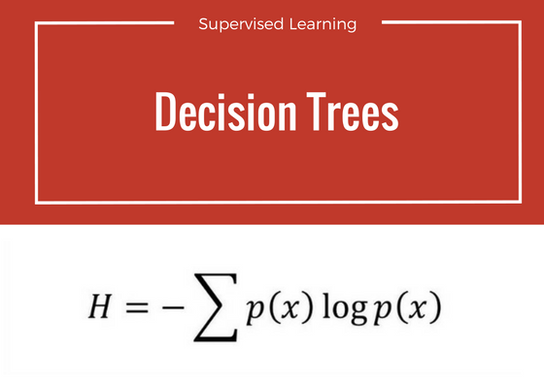

H = Entropy

**W**elcome to third basic classification algorithm of supervised learning. **Decision Trees**. Like previous chapters ([Chapter 1: Naive Bayes](https://medium.com/machine-learning-101/chapter-1-supervised-learning-and-naive-bayes-classification-part-1-theory-8b9e361897d5) and [Chapter 2: SVM Classifier](https://medium.com/machine-learning-101/chapter-2-svm-support-vector-machine-theory-f0812effc72)), this chapter is also divided into two parts: **theory**and[**coding exercise**.](https://medium.com/machine-learning-101/chapter-3-decision-tree-classifier-coding-ae7df4284e99)

In this part we shall discuss the theory and working behind decision trees. We shall see some mathematical aspects of the algorithm i.e. entropy and information gain. In second part we modify spam classification code for decision tree classifier in sklearn library. We shall compare the accuracy compared to Naive Bayes and SVM.

0. Motivation

Suppose we have following plot for two classes represented by black circle and blue squares. Is it possible to draw a single separation line ? Perhaps **no.**

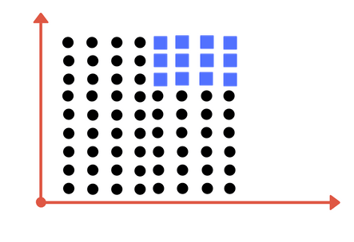

Can you draw single division line for these classes?

We will need more than one line, to divide into classes. Something similar to following image:

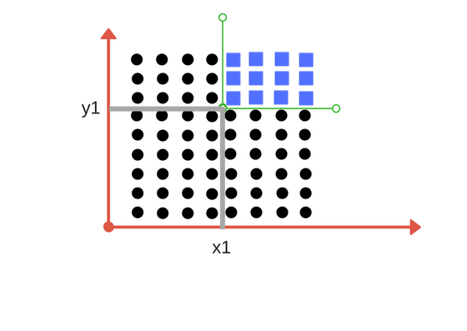

We need two lines one for threshold of x and threshold for y.

We need two lines here one separating according to threshold value of **x**and other for threshold value of **y.**

As you have guessed now what decision tree tries to do.

*Decision Tree Classifier, repetitively divides the working area(plot) into sub part by identifying lines.*(repetitively because there may be two distant regions of same class divided by other as shown in image below).

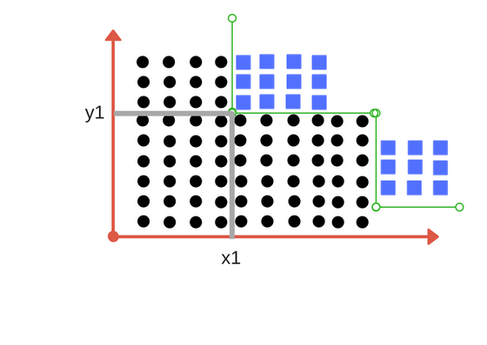

So when does it terminate?

1. Either it has divided into classes that are pure (only containing members of single class )
2. Some criteria of classifier attributes are met.

**We shall see these two points shortly.**

*In following sections we define few terms related to decision tree and then perform those calculation with sample example.*

### 1. Impurity

In above division, we had clear separation of classes. But what if we had following case?

Impurity is when we have a traces of one class division into other. This can arise due to following reason

1. We run out of available features to divide the class upon.
2. We tolerate some percentage of impurity (we stop further division) for faster performance. (There is always trade off between accuracy and performance).

For example in second case we may stop our division when we have x number of fewer number of elements left. This is also known as **gini impurity.**

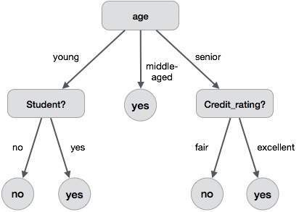

Division based on some features.

### 2. Entropy

Entropy is degree of randomness of elements or in other words it is **measure of impurity.**Mathematically, it can be calculated with the help of probability of the items as:

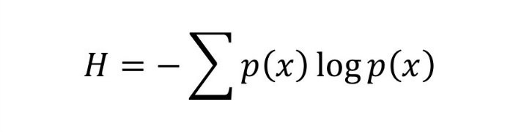

p(x) is probability of item x.

It is negative summation of probability times the log of probability of item x.

**For example,**   
if we have items as number of dice face occurrence in a throw event as **1123,  
the entropy is** p(1) = 0.5  
 p(2) = 0.25  
 p(3) = 0.25  
entropy = - (0.5 * log(0.5)) - (0.25 * log(0.25)) -(0.25 * log(0.25)  
 = 0.45

### 3. Information Gain

Suppose we have multiple features to divide the current working set. What feature should we select for division? Perhaps one that gives us less impurity.

Suppose we divide the classes into multiple branches as follows, the information gain at any node is defined as

Information Gain (n) =  
 Entropy(x) — ([weighted average] * entropy(children for feature))

This need a bit explanation!

Suppose we have following class to work with intially

112234445

Suppose we divide them based on property: divisible by 2

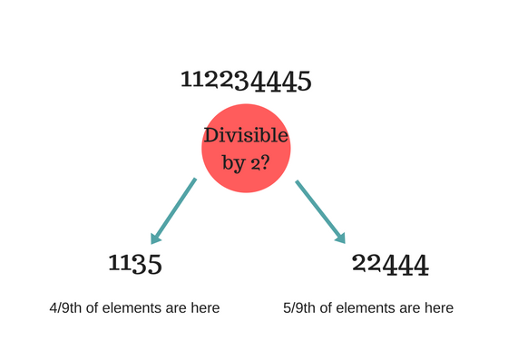

Entropy at root level : 0.66  
Entropy of left child : 0.45 , weighted value = (4/9) * 0.45 = 0.2  
Entropy of right child: 0.29 , weighted value = (5/9) * 0.29 = 0.16

**Information Gain** = 0.66 - [0.2 + 0.16] = **0.3**

*Check what information gain we get if we take decision as***prime number instead of divide by 2.**Which one is better for this case?

Decision tree at every stage selects the one that gives best information gain. **When information gain is 0 means the feature does not divide the working set at all.**

*If you are enjoying this, do hit heart(❤ ) icon and spread the word.*

### Lets solve an example

Now that you know basic stuff about decision tree, lets solve example and look how it works.

Suppose we have a following data for playing a golf on various conditions.

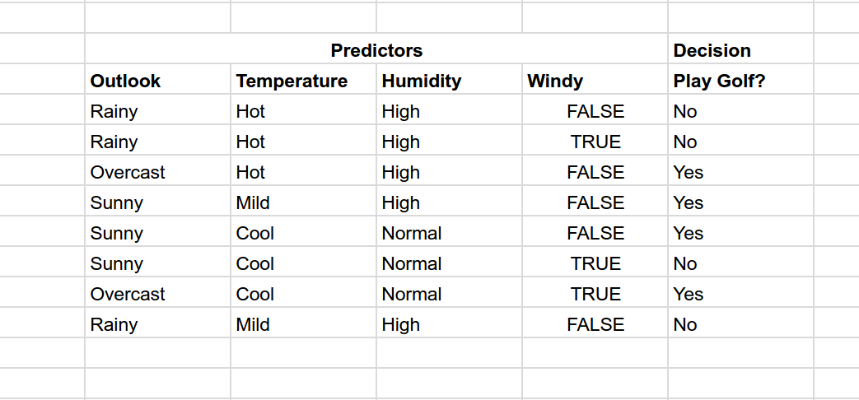

Now if the weather condition is given as :

**Outlook** : Rainy, **Temperature**: Cool, **Humidity**: High, **Windy**: False

#### **Should we play golf?**

We have outcomes at beginning as NNYYYNYN (Y = Yes and N = No) taken in given order. Entropy at this root node is 0.3

Now try to divide on various predictors outlook, temperature, humidity and Windy.  
Calculate the information gain in each case. Which one has highest information gain?

For example, if we divide based on Outlook, we have divisions as  
 Rainy : NNN (entropy = 0)  
 Sunny : YYN (entropy = 0.041)  
 Overcast : YY (entropy = 0)

So information gain = 0.3 - [0 + (3/8)*0.041 + 0]  
 = 0.28

Try out for other cases.

The information gain is max when divided based on Outlook.  
Now the impurity for Rainy and Overcast is 0. We stop for them here.

Next we need to separate Sunny,  
If we divide by Windy, we get max information gain.  
Sunny  
 YYN  
 Windy? Yes : N  
 No : YY

So decision tree look like something as shown in image below.

No the prediction data is   
**Outlook** : Rainy, **Temperature**: Cool, **Humidity**: High, **Windy**: False

Flowing down from tree according to result, we first check Rainy?  
So answer is No, we don't play golf.

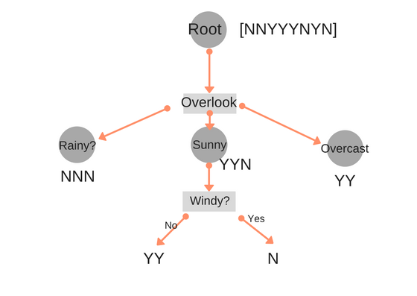

### Final Thoughts

Dividing efficiently based on maximum information gain is key to decision tree classifier. However, in real world with millions of data dividing into pure class in practically not feasible (it may take longer training time) and so we stop at points in nodes of tree when fulfilled with certain parameters (for example impurity percentage).

**Document clustering**

Here are two very short texts to compare:

1. Julie loves me more than Linda loves me
2. Jane likes me more than Julie loves me

We want to know how similar these texts are, purely in terms of word counts (and ignoring word order). We begin by making a list of the words from both texts:

me Julie loves Linda than more likes Jane

Now we count the number of times each of these words appears in each text:

me 2 2

Jane 0 1

Julie 1 1

Linda 1 0

likes 0 1

loves 2 1

more 1 1

than 1 1

We are not interested in the words themselves though. We are interested only in those two vertical vectors of counts. For instance, there are two instances of 'me' in each text. We are going to decide how close these two texts are to each other by calculating one function of those two vectors, namely the cosine of the angle between them.

The two vectors are, again:

a: [2, 1, 0, 2, 0, 1, 1, 1]

b: [2, 1, 1, 1, 1, 0, 1, 1]

The cosine of the angle between them is about 0.822.

Clustering in search engines[[edit](https://en.wikipedia.org/w/index.php?title=Document_clustering&action=edit&section=2)]

A [web search engine](https://en.wikipedia.org/wiki/Web_search_engine) often returns thousands of pages in response to a broad query, making it difficult for users to browse or to identify relevant information. Clustering methods can be used to automatically group the retrieved documents into a list of meaningful categories, as is achieved by e.g. open source software such as [Carrot2](https://en.wikipedia.org/wiki/Carrot2).

Procedures[[edit](https://en.wikipedia.org/w/index.php?title=Document_clustering&action=edit&section=3)]

In practice, document clustering often takes the following steps:

1. [Tokenization](https://en.wikipedia.org/wiki/Tokenization_(lexical_analysis))

Tokenization is the process of parsing text data into smaller units (tokens) such as words and phrases. Commonly used tokenization methods include [Bag-of-words model](https://en.wikipedia.org/wiki/Bag-of-words_model) and [N-gram model](https://en.wikipedia.org/wiki/N-gram_model).

2. [Stemming](https://en.wikipedia.org/wiki/Stemming) and [lemmatization](https://en.wikipedia.org/wiki/Lemmatization)

Different tokens might carry out similar information (e.g. tokenization and tokenizing). And we can avoid calculating similar information repeatedly by reducing all tokens to its base form using various stemming and lemmatization dictionaries.

3. Removing [stop words](https://en.wikipedia.org/wiki/Stop_words) and [punctuation](https://en.wikipedia.org/wiki/Punctuation)

Some tokens are less important than others. For instance, common words such as "the" might not be very helpful for revealing the essential characteristics of a text. So usually it is a good idea to eliminate stop words and punctuation marks before doing further analysis.

4. Computing term frequencies or [tf-idf](https://en.wikipedia.org/wiki/Tf-idf)

After pre-processing the text data, we can then proceed to generate features. For document clustering, one of the most common ways to generate features for a document is to calculate the term frequencies of all its tokens. Although not perfect, these frequencies can usually provide some clues about the topic of the document. And sometimes it is also useful to weight the term frequencies by the inverse document frequencies. See [tf-idf](https://en.wikipedia.org/wiki/Tf-idf) for detailed discussions.

5. Clustering

We can then cluster different documents based on the features we have generated. See the algorithm section in [cluster analysis](https://en.wikipedia.org/wiki/Cluster_analysis) for different types of clustering methods.

6. Evaluation and visualization

Finally, the clustering models can be assessed by various metrics. And it is sometimes helpful to visualize the results by plotting the clusters into low (two) dimensional space. See [multidimensional scaling](https://en.wikipedia.org/wiki/Multidimensional_scaling) as a possible approach.

Clustering v. Classifying[[edit](https://en.wikipedia.org/w/index.php?title=Document_clustering&action=edit&section=4)]

Clustering algorithms in computational text analysis groups documents into grouping a set of text what are called subsets or *clusters* where the algorithm's goal is to create internally coherent clusters that are distinct from one another.[[3]](https://en.wikipedia.org/wiki/Document_clustering#cite_note-3) Classification on the other hand, is a form of [supervised learning](https://en.wikipedia.org/wiki/Supervised_learning) where the features of the documents are used to predict the "type" of documents.

Key Steps

1. **Read data**: read titles, genres, synopses, rankings into four arrays
2. **Tokenize and stem**: break paragraphs into sentences, then to words, stem the words (without removing stopwords) - each synopsis essentially becomes a bag of stemmed words.
3. **Generate tf-idf matrix**: each row is a term (unigram, bigram, trigram...generated from the bag of words in 2.), each column is a synopsis.
4. **Generate clusters**: based on the tf-idf matrix, 5 (or any number) clusters are generated using k-means. The top key terms are selected for each cluster.
5. **Calculate similarity**: generate the cosine similarity matrix using the tf-idf matrix (100x100), then generate the distance matrix (1 - similarity matrix), so each pair of synopsis has a distance number between 0 and 1.
6. **Plot clusters**: use multidimensional scaling (MDS) to convert distance matrix to a 2-dimensional array, each synopsis has (x, y) that represents their relative location based on the distance matrix. Plot the 100 points with their (x, y) using matplotlib (I added an example on using plotly.js).

# NLP and Text Analytics Simplified: Document Clustering

### Introduction

This is our second blog on harnessing Machine Learning (ML) in the form of Natural Language Processing (NLP) for the Automatic Classification of documents. By classifying text, we aim to assign a document or piece of text to one or more classes or categories making it easier to manage or sort. A Document Classifier often returns or assigns a category “label” or “code” to a document or piece of text. Depending on the Classification Algorithm or strategy used, a classifier might also provide a confidence measure to indicate how confident it is that the result is correct.

In our [first blog](https://www.linkedin.com/pulse/20141209180635-83626359-nlp-and-text-analytics-similified-document-classification), we looked at a supervised method of Document Classification. In supervised methods, Document Categories are predefined by using a training dataset with manually tagged documents. A classifier is then trained on the manually tagged dataset so that it will be able to predict any given Document’s Category from then on.

In this blog, we will focus on Unsupervised Document Classification. Unsupervised ML techniques differ from supervised in that they do not require a training dataset and in the case of documents, the categories are not known in advance. For example, let’s say we have a large number of emails that we want to analyze as part of an eDiscovery Process. We may have no idea what the emails are about or what topics they deal with and we want to automatically find out what are the most common topics present in the dataset. Unsupervised techniques such as Clustering can be used to automatically discover groups of similar documents within a collection of documents.

### An Overview of Document Clustering

Document Clustering is a method for finding structure within a collection of documents, so that similar documents can be grouped into categories. The first step in the Clustering process is to create word vectors for the documents we wish to cluster. A vector is simply a numerical representation of the document, where each component of the vector refers to a word, and the value of that component indicates the presence or importance of that word in the document. The distance matrix between these vectors is then fed to algorithms, which group similar vectors together into clusters. A simple example will help to illustrate how documents might be transformed into vectors.

### A simple example of transforming documents into vectors

Using the words within a document as the “features” that describe a document, we need to find a way to represent these features numerically as a vector. As we did in our first blog in the series we will consider three very short documents to illustrate the process.

We start by taking all of the words across the three documents in our training set and create a table or vector from these words.

<some,tigers,live,in,the,zoo,green,is,a,color,he,has,gone,to,New,York>

Then for each of the documents, we create a vector by assigning a 1 if the word exists in the document and a 0 if it doesn’t. In the table below each row is a vector describing a single document.

### Preprocessing the data

As we described in our [blog on Supervised Methods of Classification](https://www.linkedin.com/pulse/20141209180635-83626359-nlp-and-text-analytics-similified-document-classification) it is likely that some preprocessing of the data would be needed prior to creating the vectors. In our simple example, we have given equal importance (a value of 1) to each and every word when creating Document Vectors and no word appears more than once. To improve the accuracy, we could give different weighting to words based on their importance to the document in question and their frequency within the document set as a whole. A common methodology used to do this is TF-IDF ([term frequency - inverse document frequency](http://en.wikipedia.org/wiki/Tf%E2%80%93idf)). The TF-IDF weighting for a word increases with the number of times the word appears in the document but decreases based on how frequently the word appears across the entire document set. This has the effect of giving a lower overall weighting to words which occur more frequently in the document set such as “a”, “it”, etc

### Clustering Algorithms

In the graph below each “dot” is a vector which represents a document. The graph shows the output from a [Clustering Algorithm](http://blog.mpacula.com/2011/04/27/k-means-clustering-example-python/) with an X marking the center of each cluster (known as a ‘centroid’). In this case the vector’s only have two features (or dimensions) and can easily be plotted on a two-dimensional graph as shown below.

### K-Means Clustering Algorithm output example:

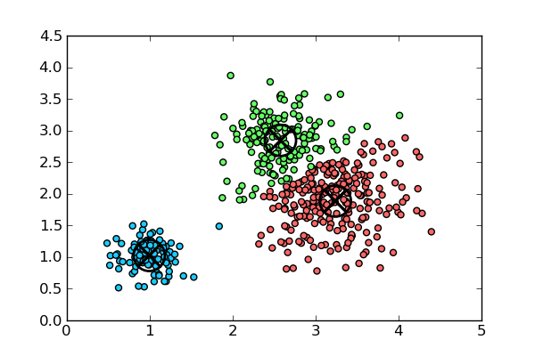

### Two extreme cases to illustrate the concept of discovering the clusters

If we want to group the vectors together into clusters, we first need to look at the two extreme cases to illustrate how it can be done. Firstly, we assume that there is only one cluster and that all of the document vectors belong in this cluster. This is a very simple approach which is not very useful when it comes to managing or sorting the documents effectively.

The second extreme case is to decide that each document is a cluster by itself, so that if we had n documents we would have N clusters. Again, this is a very simple solution with not much practical use.

### ****Finding the K clusters from the N Document Vectors****

Ideally from N documents we want to find K distinct clusters that separate the document into useful and meaningful categories. There are many Clustering Algorithms available to help us achieve this. For this blog, we will look at the [k-means algorithm](http://en.wikipedia.org/wiki/K-means_clustering) in more detail to illustrate the concept.

#### **How many clusters (K)?**

One simple rule of thumb for deciding the optimum number of clusters (K) to have is:

K = sqrt(N/2).

There are many more methods of finding K which can read about [here](http://en.wikipedia.org/wiki/Determining_the_number_of_clusters_in_a_data_set).

#### **Finding the Clusters**

Again, there are many ways we can find clusters. To illustrate the concept we’ll look at the steps used in one popular method, the [K-means](http://en.wikipedia.org/wiki/K-means_clustering) algorithm which follows the following steps:

1. Find the value of K using our simple rule of thumb above.
2. Randomly assign each of the K cluster centroids throughout the dataset.
3. Assign each data point to the cluster whose centroid is closest to it.
4. Recompute the centroid location for each cluster as an average of the vector points within the cluster (this will find the new “center” of the cluster).
5. Reassign each vector data point to the centroid closest to it i.e. some will now switch from one cluster to another as the centroids positions have changed.
6. Repeat steps 4 and 5 until none of the data points switch centroids i.e the clusters have “converged”.

That’s pretty much it, you now have your n documents assigned to K clusters! If you have difficulty visualising the steps above, watch this excellent [video tutorial](https://www.youtube.com/watch?v=_aWzGGNrcic) by Viktor Lavrenko of the University of Edinburgh, which explains it in more depth.

Keep an eye out for more in our “Text Analysis 101” series. The next blog will look at how Topic Modeling is performed.

**Word Cloud using R**

**Text mining** methods allow us to highlight the most frequently used keywords in a paragraph of texts. One can create a **word cloud**, also referred as *text cloud* or *tag cloud*, which is a visual representation of text data.

The procedure of creating word clouds is very simple in R if you know the different steps to execute. The text mining package (*tm*) and the word cloud generator package (*wordcloud*) are available in R for helping us to analyze texts and to quickly visualize the keywords as a word cloud.

In this article, we’ll describe, step by step, how to generate **word clouds** using the R software.

**3 reasons you should use word clouds to present your text data**

1. **Word clouds** add simplicity and clarity. The most used keywords stand out better in a word cloud
2. **Word clouds** are a potent communication tool. They are easy to understand, to be shared and are impactful
3. **Word clouds** are visually engaging than a table data

**Who is using word clouds ?**

* Researchers : for reporting qualitative data
* Marketers : for highlighting the needs and pain points of customers
* Educators : to support essential issues
* Politicians and journalists
* social media sites : to collect, analyze and share user sentiments

**The 5 main steps to create word clouds in R**

**Step 1: Create a text file**

In the following examples, I’ll process the “**I have a dream speech**” from “**Martin Luther King**” but you can use any text you want :

* Copy and paste the text in a plain text file (e.g : ml.txt)
* Save the file

Note that, the text should be saved in a plain text (.txt) file format using your favorite text editor.

**Step 2 : Install and load the required packages**

Type the R code below, to install and load the required packages:

# Install

install.packages("tm") # for text mining

install.packages("SnowballC") # for text stemming

install.packages("wordcloud") # word-cloud generator

install.packages("RColorBrewer") # color palettes

# Load

**library**("tm")

**library**("SnowballC")

**library**("wordcloud")

**library**("RColorBrewer")

**Step 3 : Text mining**

**load the text**

The text is loaded using **Corpus()** function from **text mining** (tm) package. Corpus is a list of a document (in our case, we only have one document).

1. **We start by importing the text file created in Step 1**

To import the file saved locally in your computer, type the following R code. You will be asked to choose the text file interactively.

text <- readLines(file.choose())

In the example below, I’ll load a .txt file hosted on STHDA website:

# Read the text file from internet

filePath <- "http://www.sthda.com/sthda/RDoc/example-files/martin-luther-king-i-have-a-dream-speech.txt"

text <- readLines(filePath)

1. **Load the data as a corpus**

# Load the data as a corpus

docs <- Corpus(VectorSource(text))

VectorSource() function creates a corpus of character vectors

1. **Inspect the content of the document**

inspect(docs)

**Text transformation**

Transformation is performed using **tm_map()** function to replace, for example, special characters from the text.

Replacing “/”, “@” and “|” with space:

toSpace <- content_transformer(**function** (x , pattern ) gsub(pattern, " ", x))

docs <- tm_map(docs, toSpace, "/")

docs <- tm_map(docs, toSpace, "@")

docs <- tm_map(docs, toSpace, "\\|")

**Cleaning the text**

the **tm_map()** function is used to remove unnecessary white space, to convert the text to lower case, to remove common stopwords like ‘the’, “we”.

The information value of ‘stopwords’ is near zero due to the fact that they are so common in a language. Removing this kind of words is useful before further analyses. For ‘stopwords’, supported languages are danish, dutch, english, finnish, french, german, hungarian, italian, norwegian, portuguese, russian, spanish and swedish. Language names are case sensitive.

I’ll also show you how to make your own list of stopwords to remove from the text.

You could also remove numbers and punctuation with **removeNumbers** and **removePunctuation** arguments.

Another important preprocessing step is to make a **text stemming** which reduces words to their root form. In other words, this process removes suffixes from words to make it simple and to get the common origin. For example, a stemming process reduces the words “moving”, “moved” and “movement” to the root word, “move”.

Note that, text stemming require the package ‘SnowballC’.

The R code below can be used to clean your text :

# Convert the text to lower case

docs <- tm_map(docs, content_transformer(tolower))

# Remove numbers

docs <- tm_map(docs, removeNumbers)

# Remove english common stopwords

docs <- tm_map(docs, removeWords, stopwords("english"))

# Remove your own stop word

# specify your stopwords as a character vector

docs <- tm_map(docs, removeWords, c("blabla1", "blabla2"))

# Remove punctuations

docs <- tm_map(docs, removePunctuation)

# Eliminate extra white spaces

docs <- tm_map(docs, stripWhitespace)

# Text stemming

# docs <- tm_map(docs, stemDocument)

**Step 4 : Build a term-document matrix**

Document matrix is a table containing the frequency of the words. Column names are words and row names are documents. The function *TermDocumentMatrix()* from **text mining** package can be used as follow :

dtm <- TermDocumentMatrix(docs)

m <- as.matrix(dtm)

v <- sort(rowSums(m),decreasing=TRUE)

d <- data.frame(word = names(v),freq=v)

**head**(d, 10)

word freq

will will 17

freedom freedom 13

ring ring 12

day day 11

dream dream 11

let let 11

every every 9

able able 8

one one 8

together together 7

**Step 5 : Generate the Word cloud**

The importance of words can be illustrated as a **word cloud** as follow :

set.seed(1234)

wordcloud(words = d$word, freq = d$freq, min.freq = 1,

max.words=200, random.order=FALSE, rot.per=0.35,

colors=brewer.pal(8, "Dark2"))

The above **word cloud** clearly shows that “Will”, “freedom”, “dream”, “day” and “together” are the five most important words in the “**I have a dream speech**” from **Martin Luther King**.

Arguments of the **word cloud generator** function :

* words : the words to be plotted
* freq : their frequencies
* min.freq : words with frequency below min.freq will not be plotted
* max.words : maximum number of words to be plotted
* random.order : plot words in random order. If false, they will be plotted in decreasing frequency
* rot.per : proportion words with 90 degree rotation (vertical text)
* colors : color words from least to most frequent. Use, for example, colors =“black” for single color.

**Go further**

**Explore frequent terms and their associations**

You can have a look at the frequent terms in the term-document matrix as follow. In the example below we want to find words that occur at least four times :

findFreqTerms(dtm, lowfreq = 4)

[1] "able" "day" "dream" "every" "faith" "free" "freedom" "let" "mountain" "nation"

[11] "one" "ring" "shall" "together" "will"

You can analyze the association between frequent terms (i.e., terms which correlate) using findAssocs() function. The R code below identifies which words are associated with “freedom” in **I have a dream speech** :

findAssocs(dtm, terms = "freedom", corlimit = 0.3)

$freedom

let ring mississippi mountainside stone every mountain state

0.89 0.86 0.34 0.34 0.34 0.32 0.32 0.32

**The frequency table of words**

**head**(d, 10)

word freq

will will 17

freedom freedom 13

ring ring 12

day day 11

dream dream 11

let let 11

every every 9

able able 8

one one 8

together together 7

**Plot word frequencies**

The frequency of the first 10 frequent words are plotted :

barplot(d[1:10,]$freq, las = 2, names.arg = d[1:10,]$word,

col ="lightblue", main ="Most frequent words",

ylab = "Word frequencies")

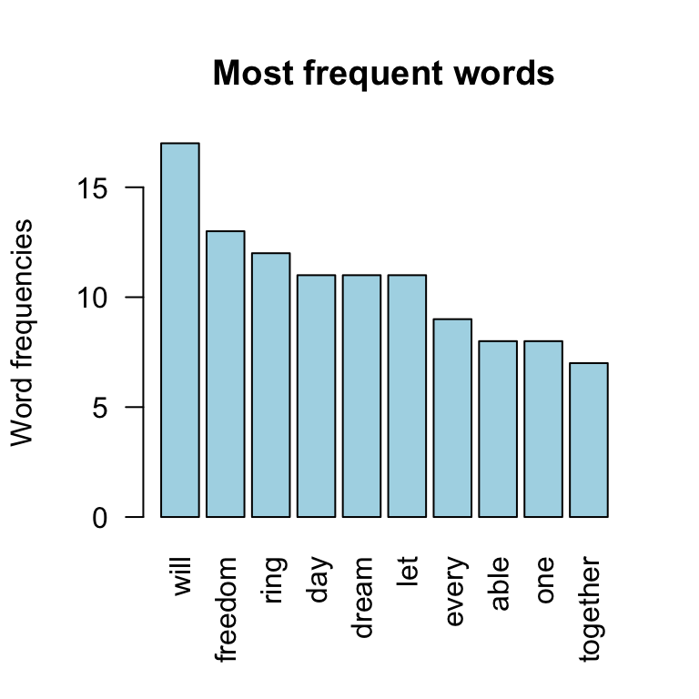

Hierarchical clustering:

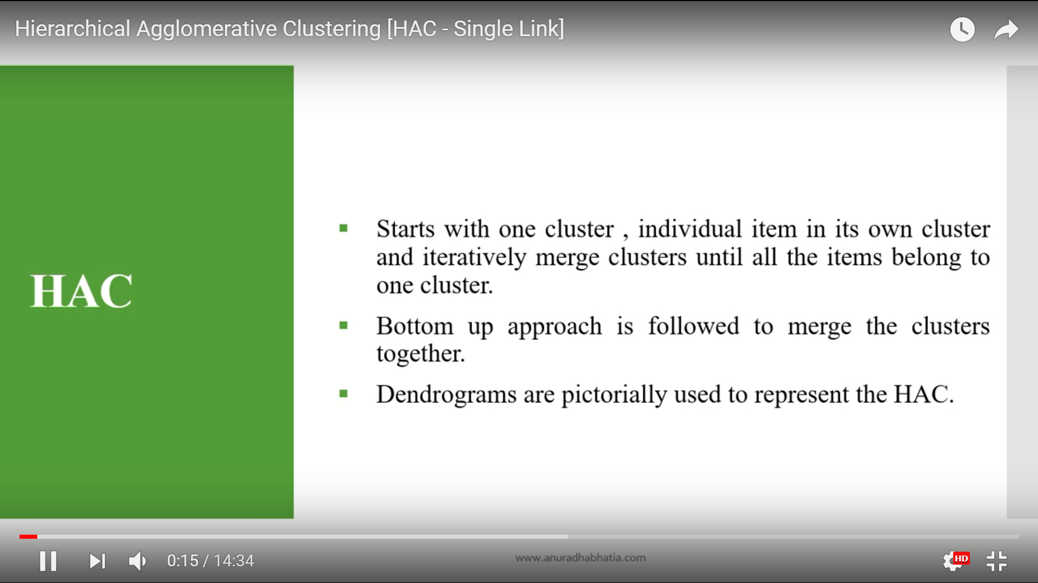

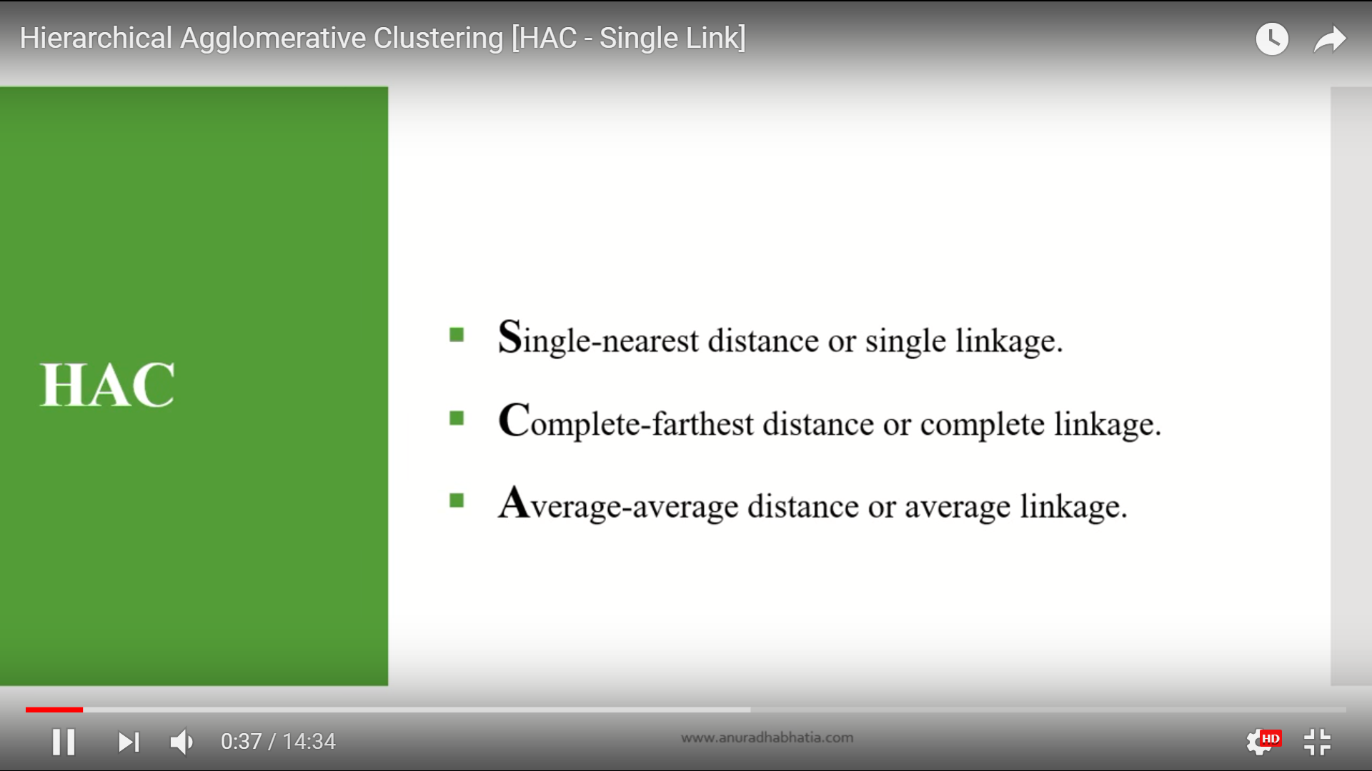

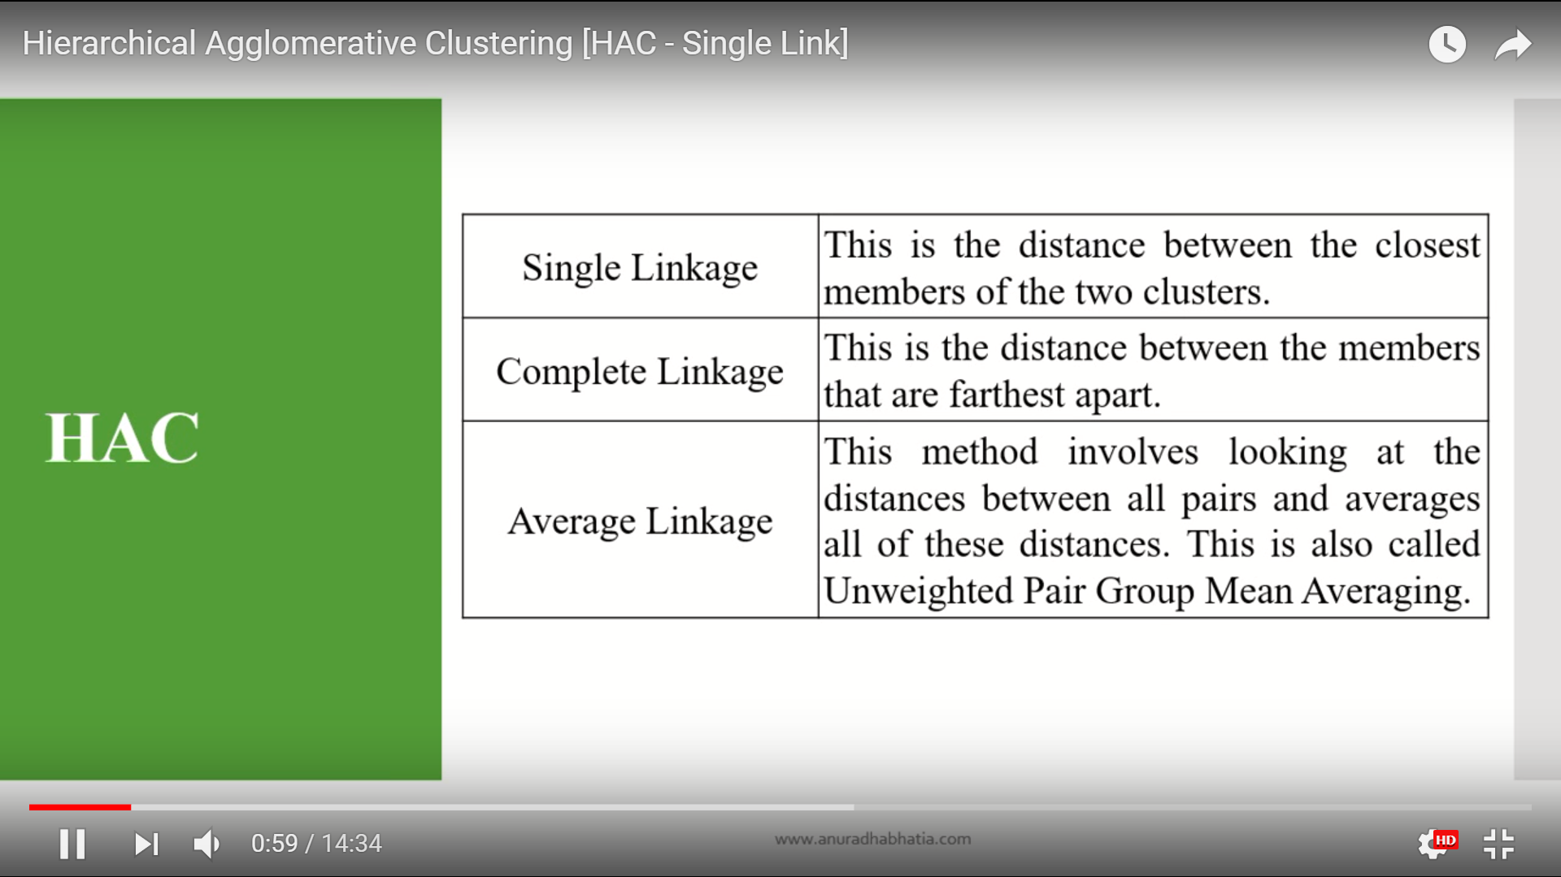

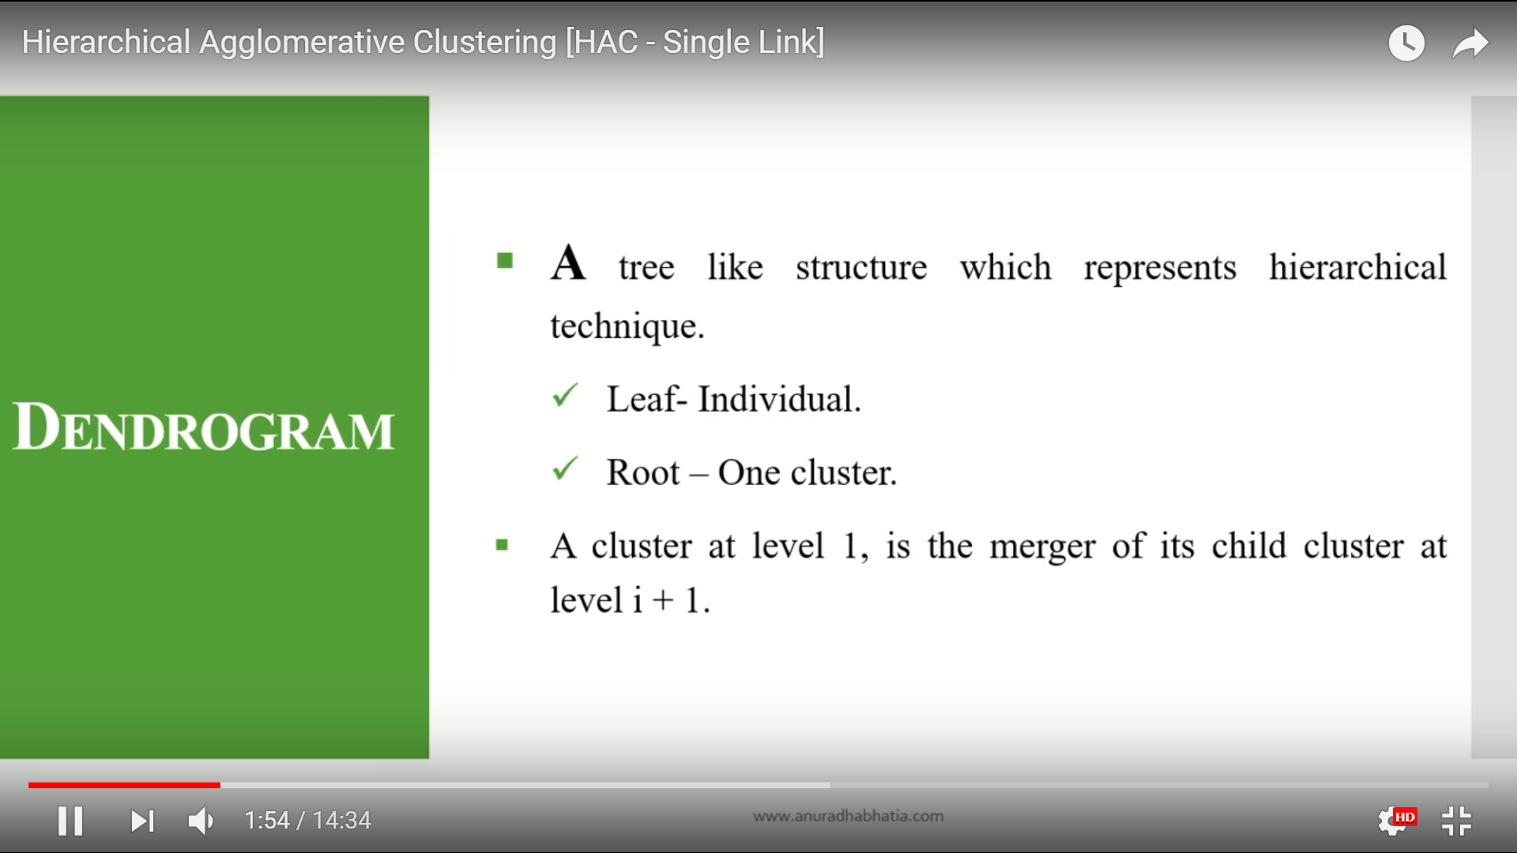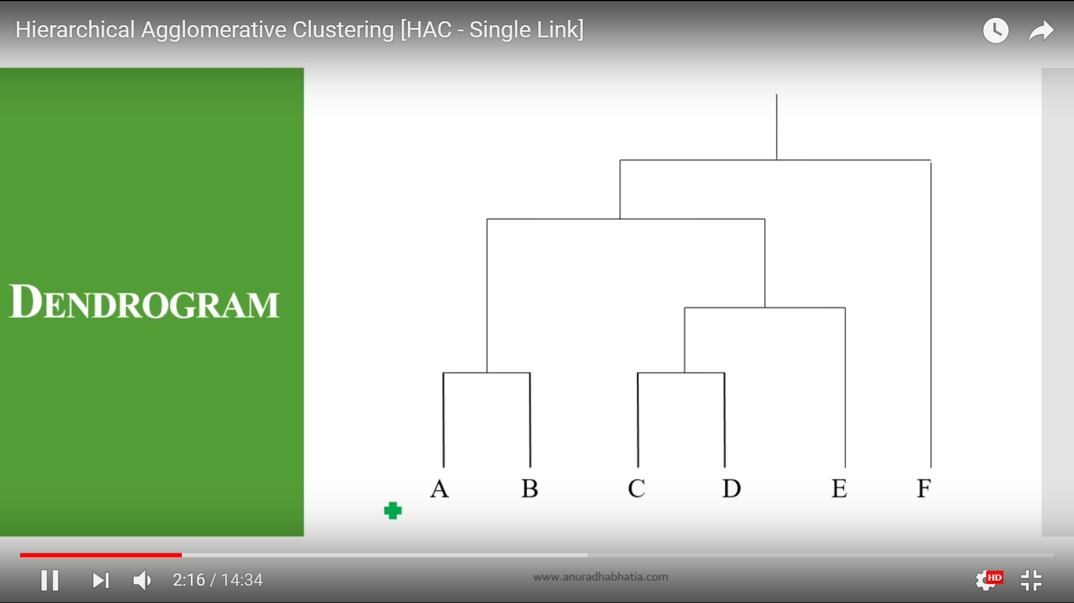

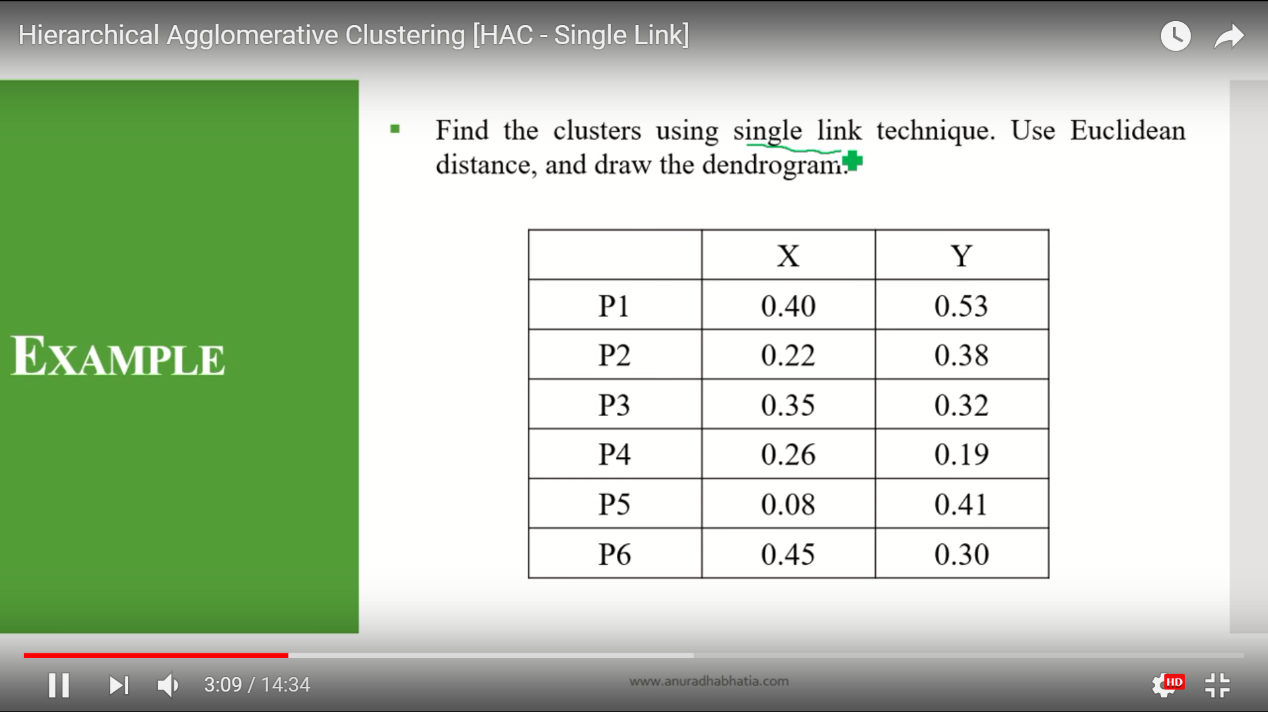

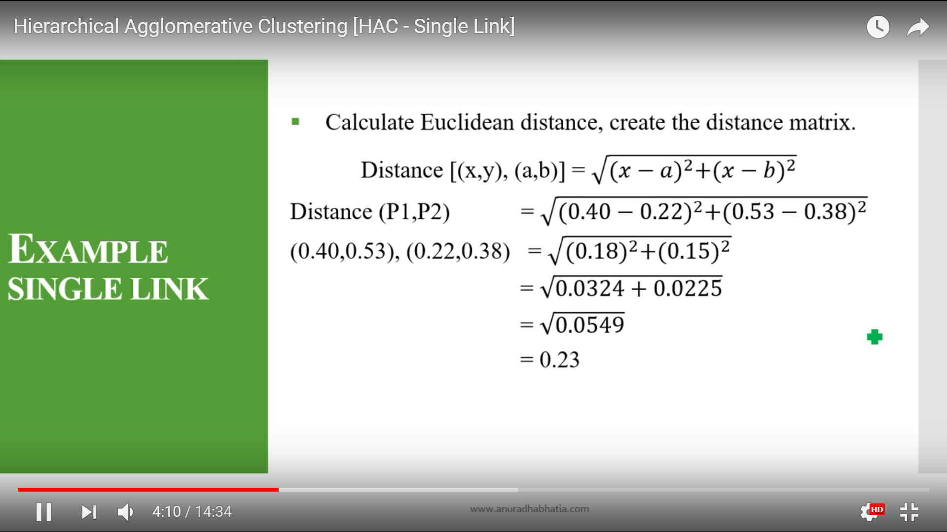

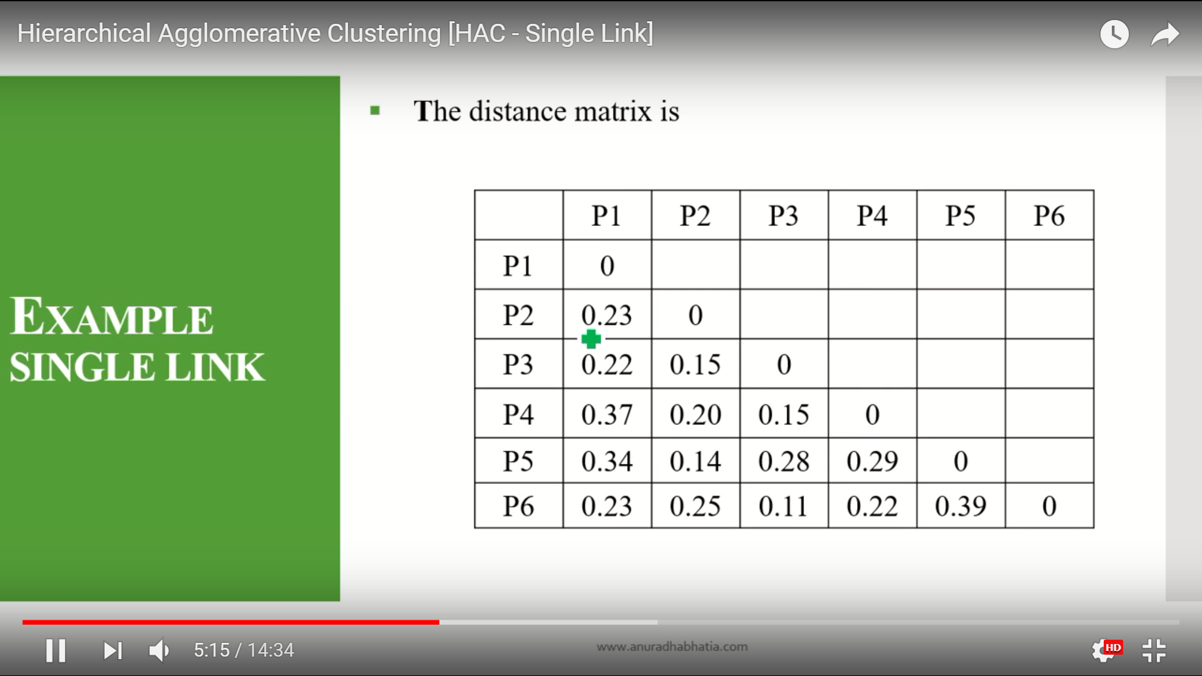

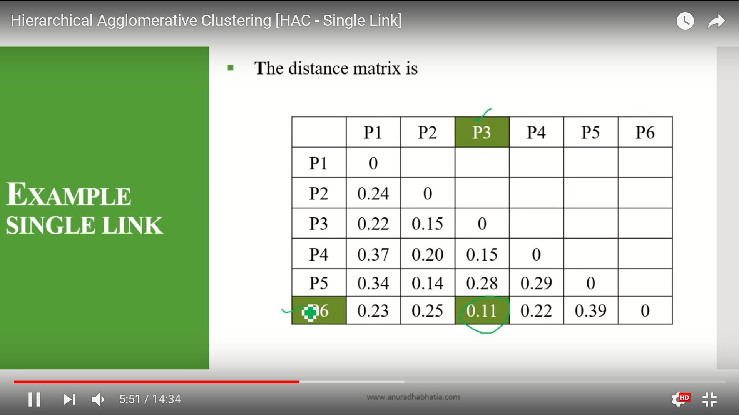

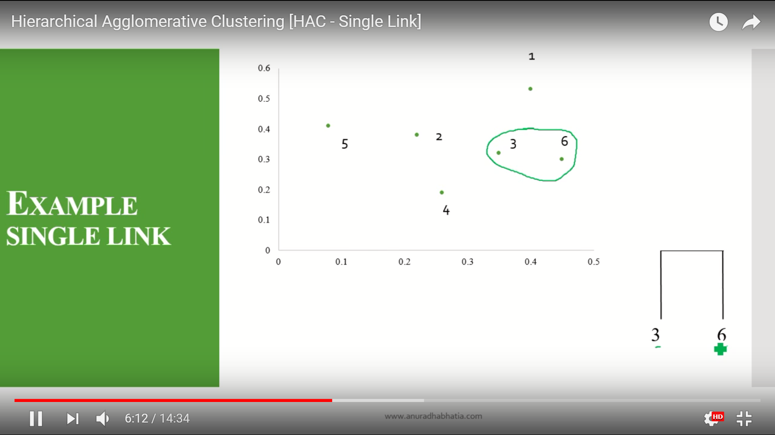

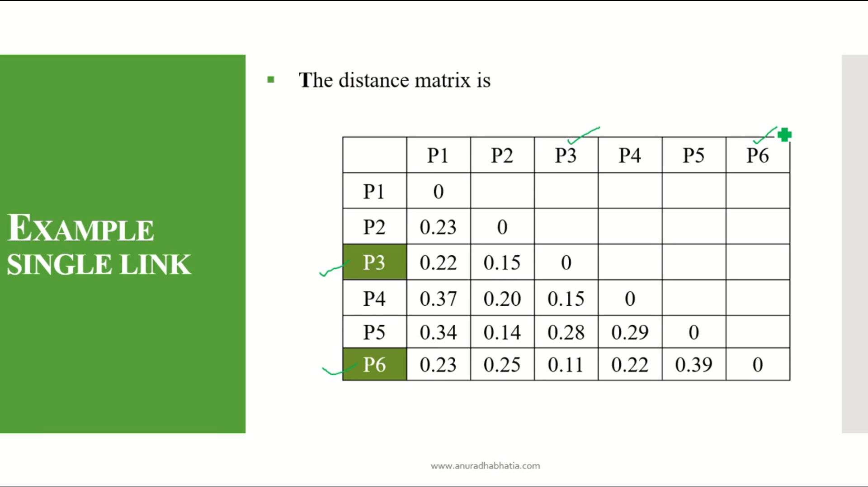

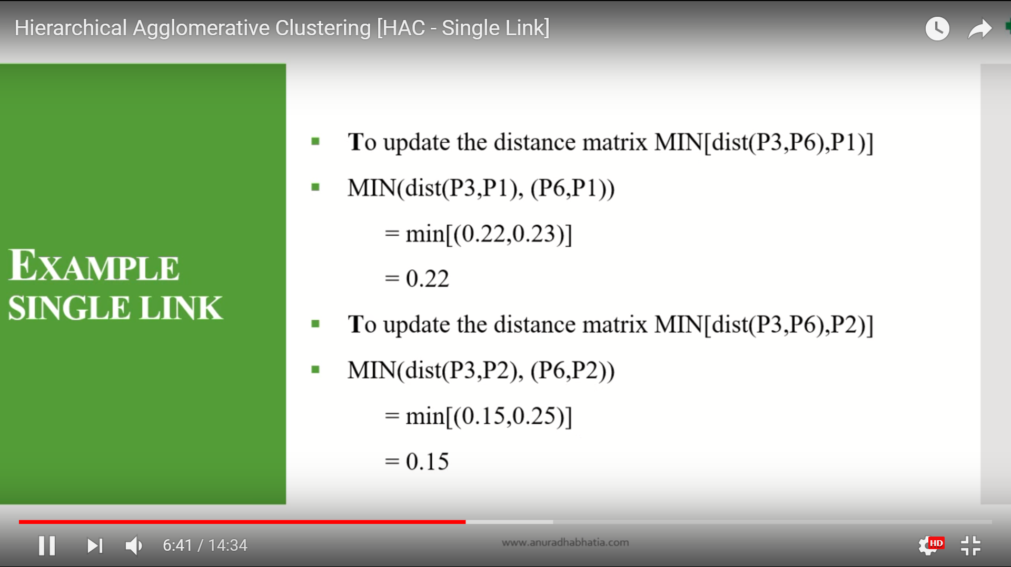

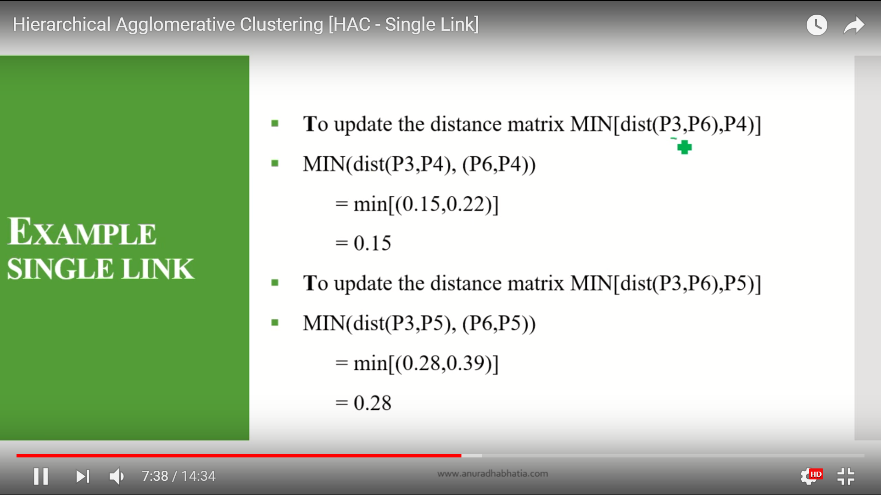

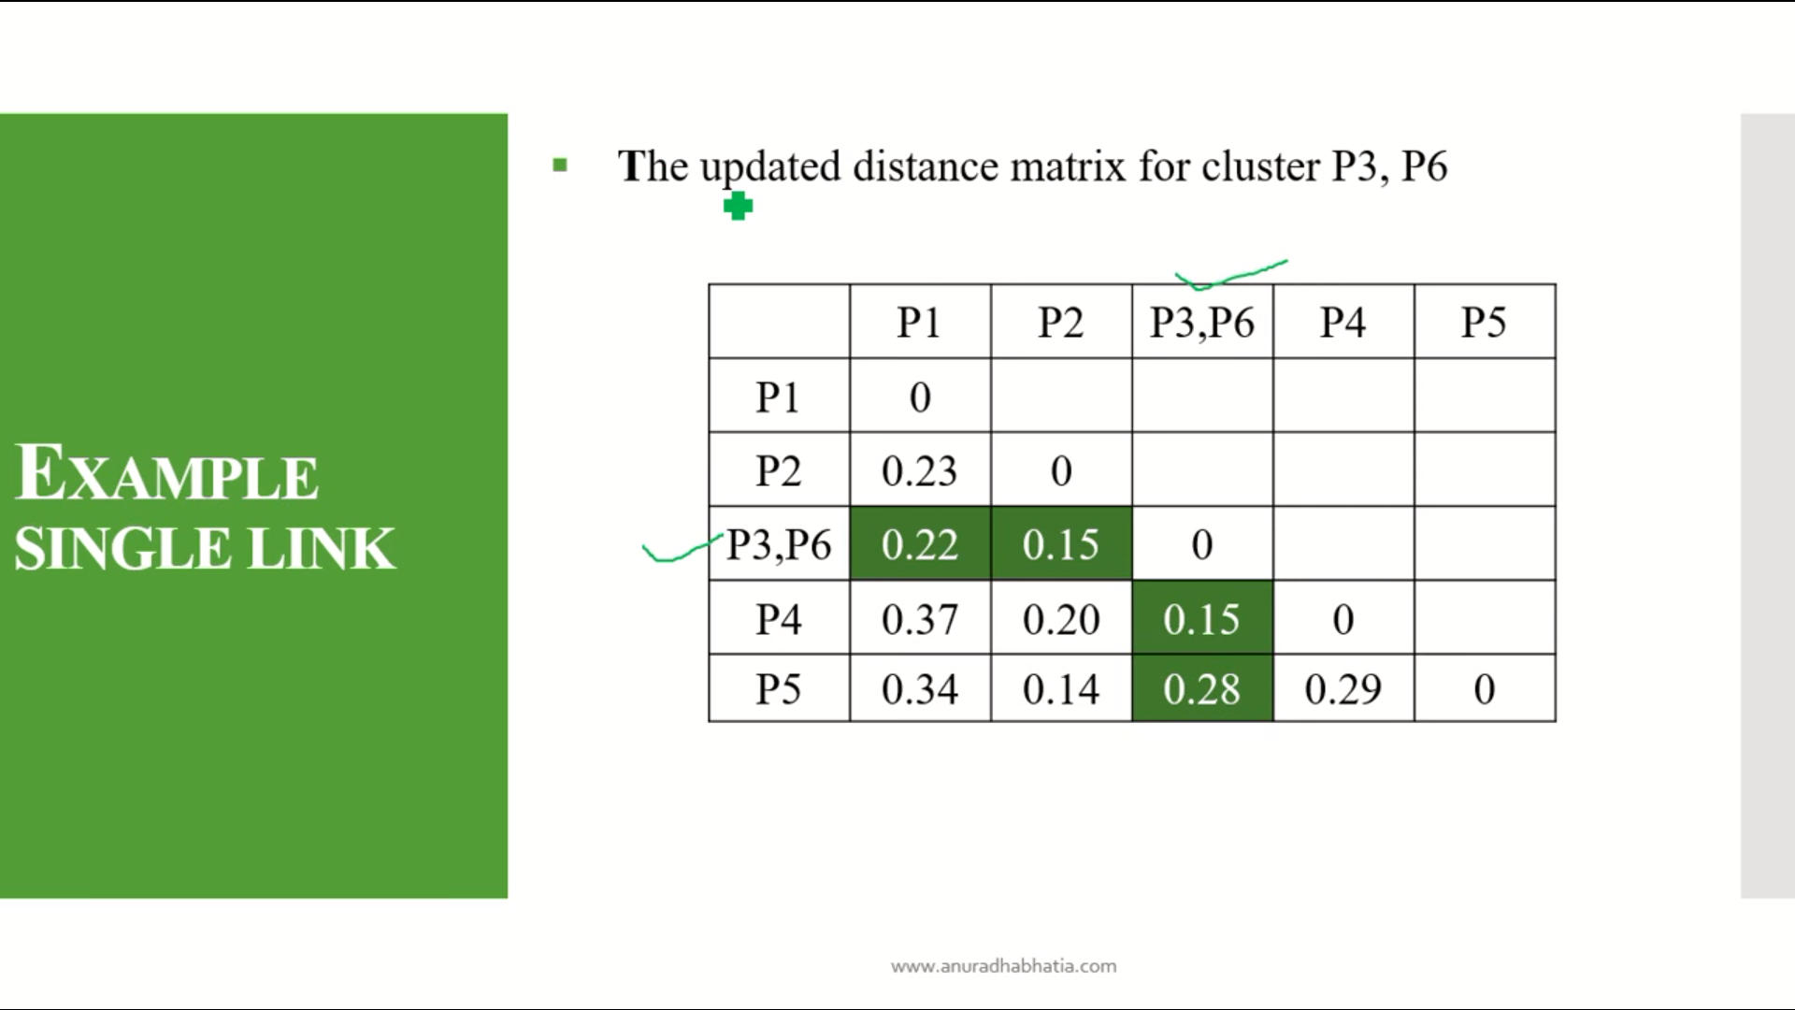

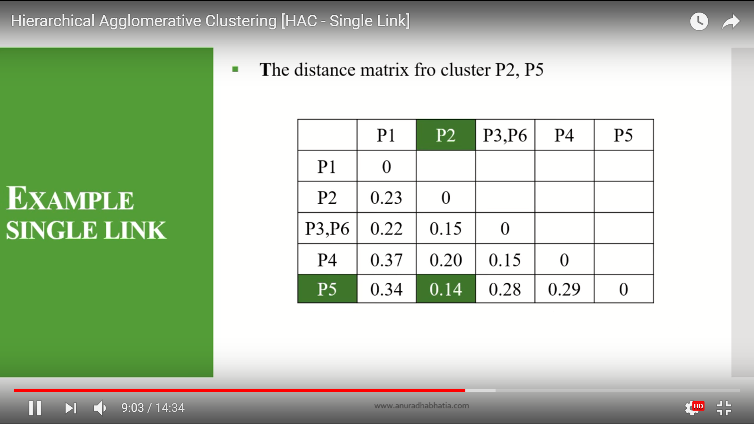

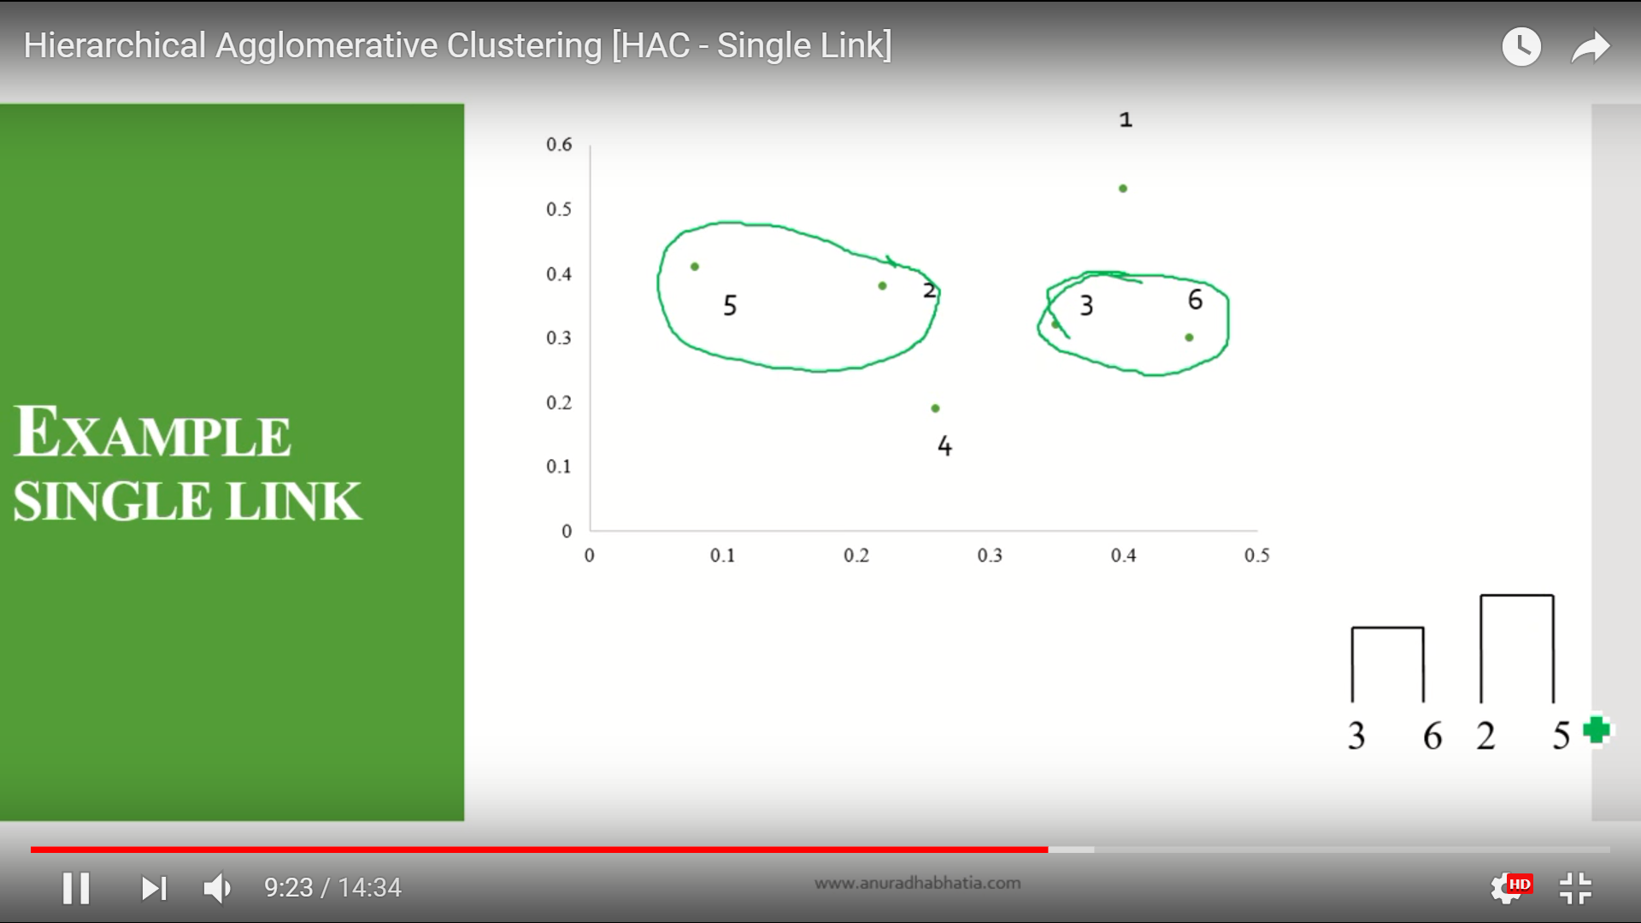

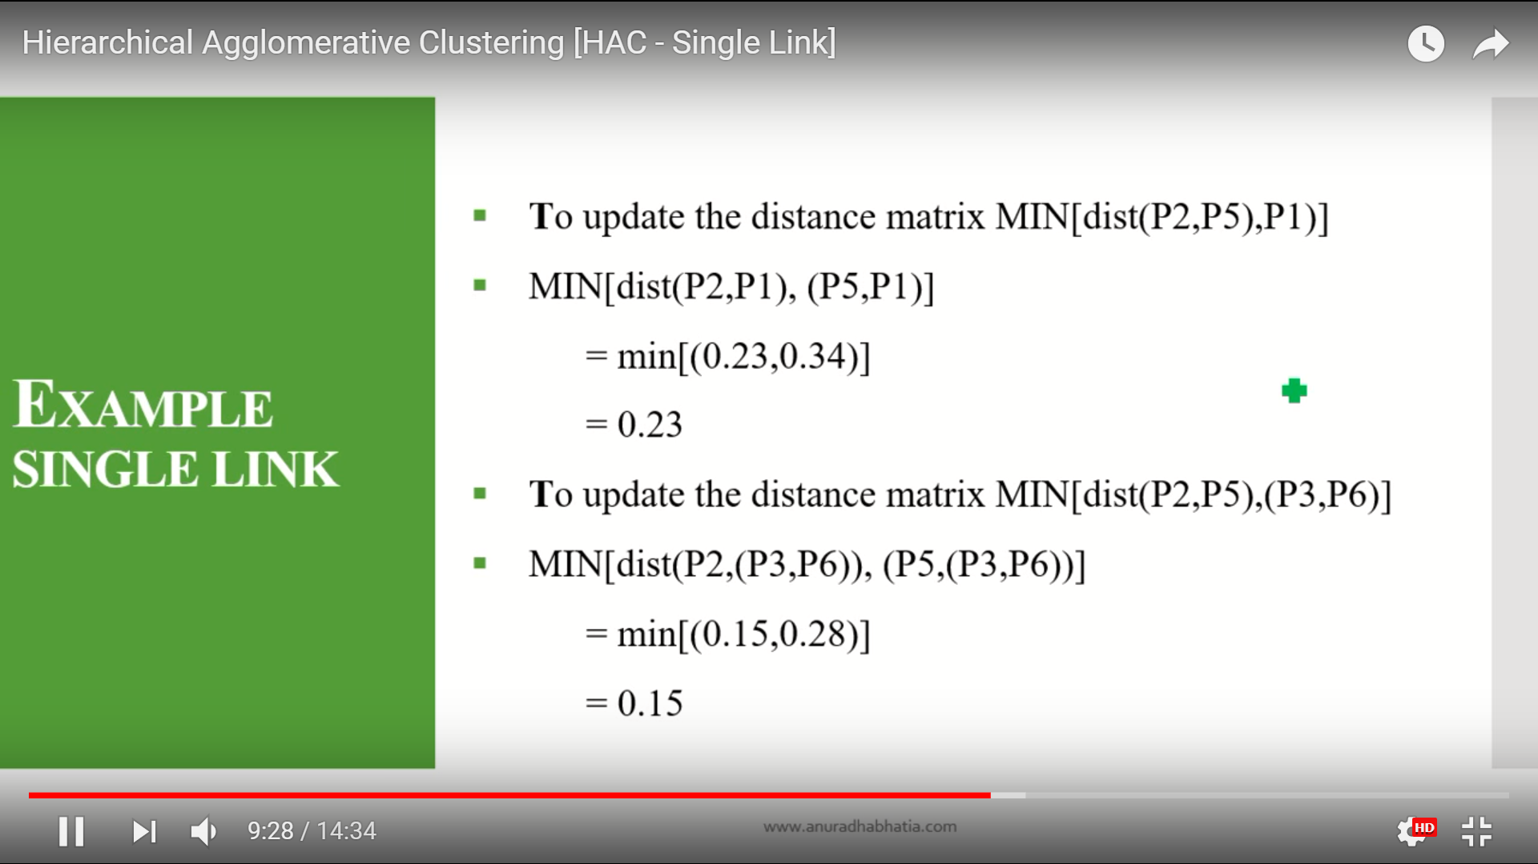

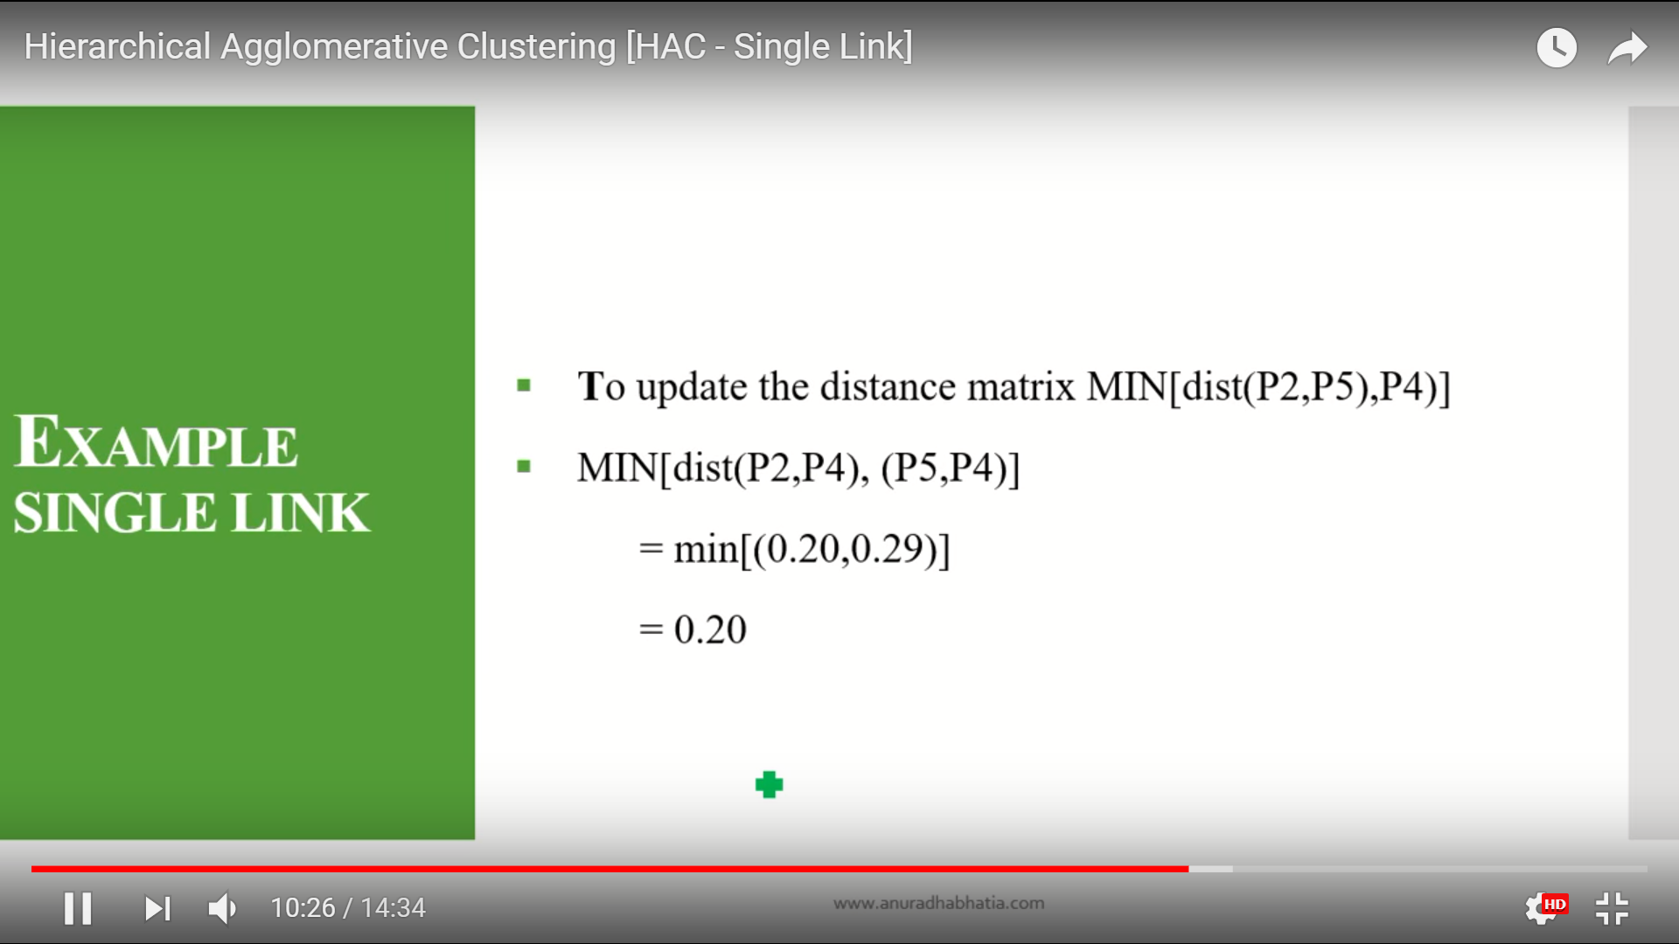

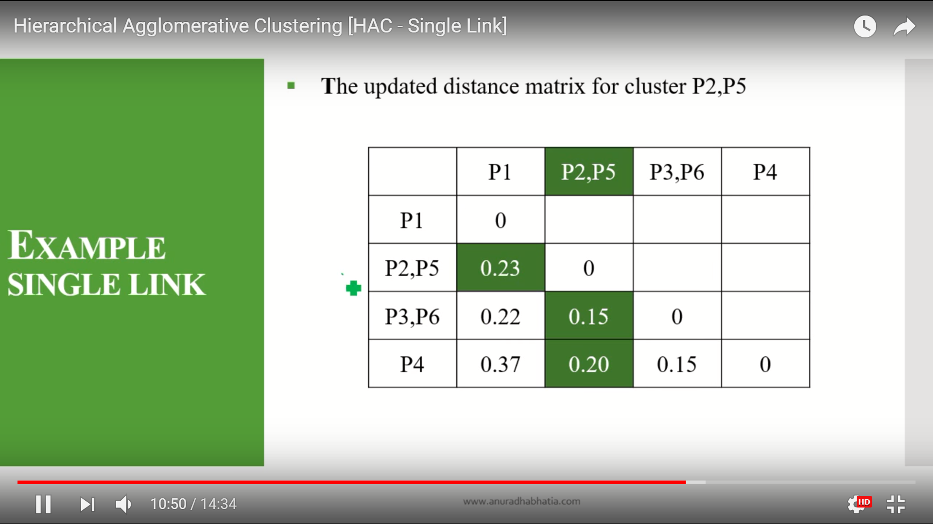

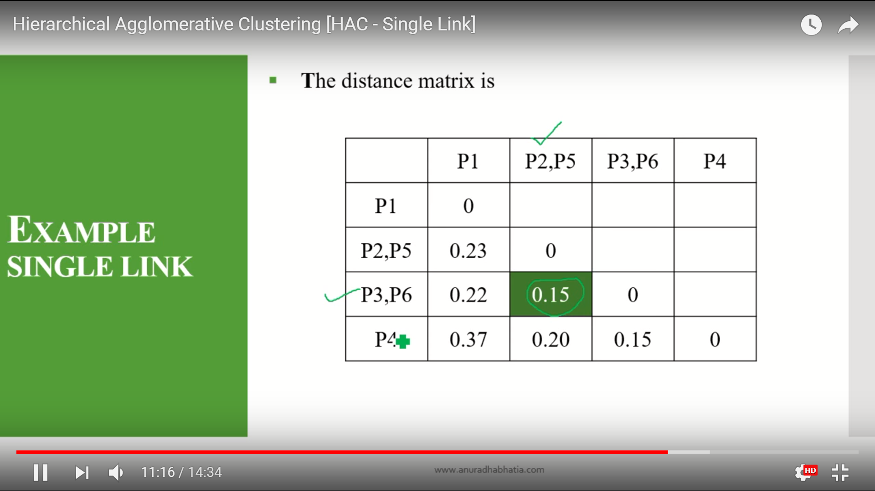

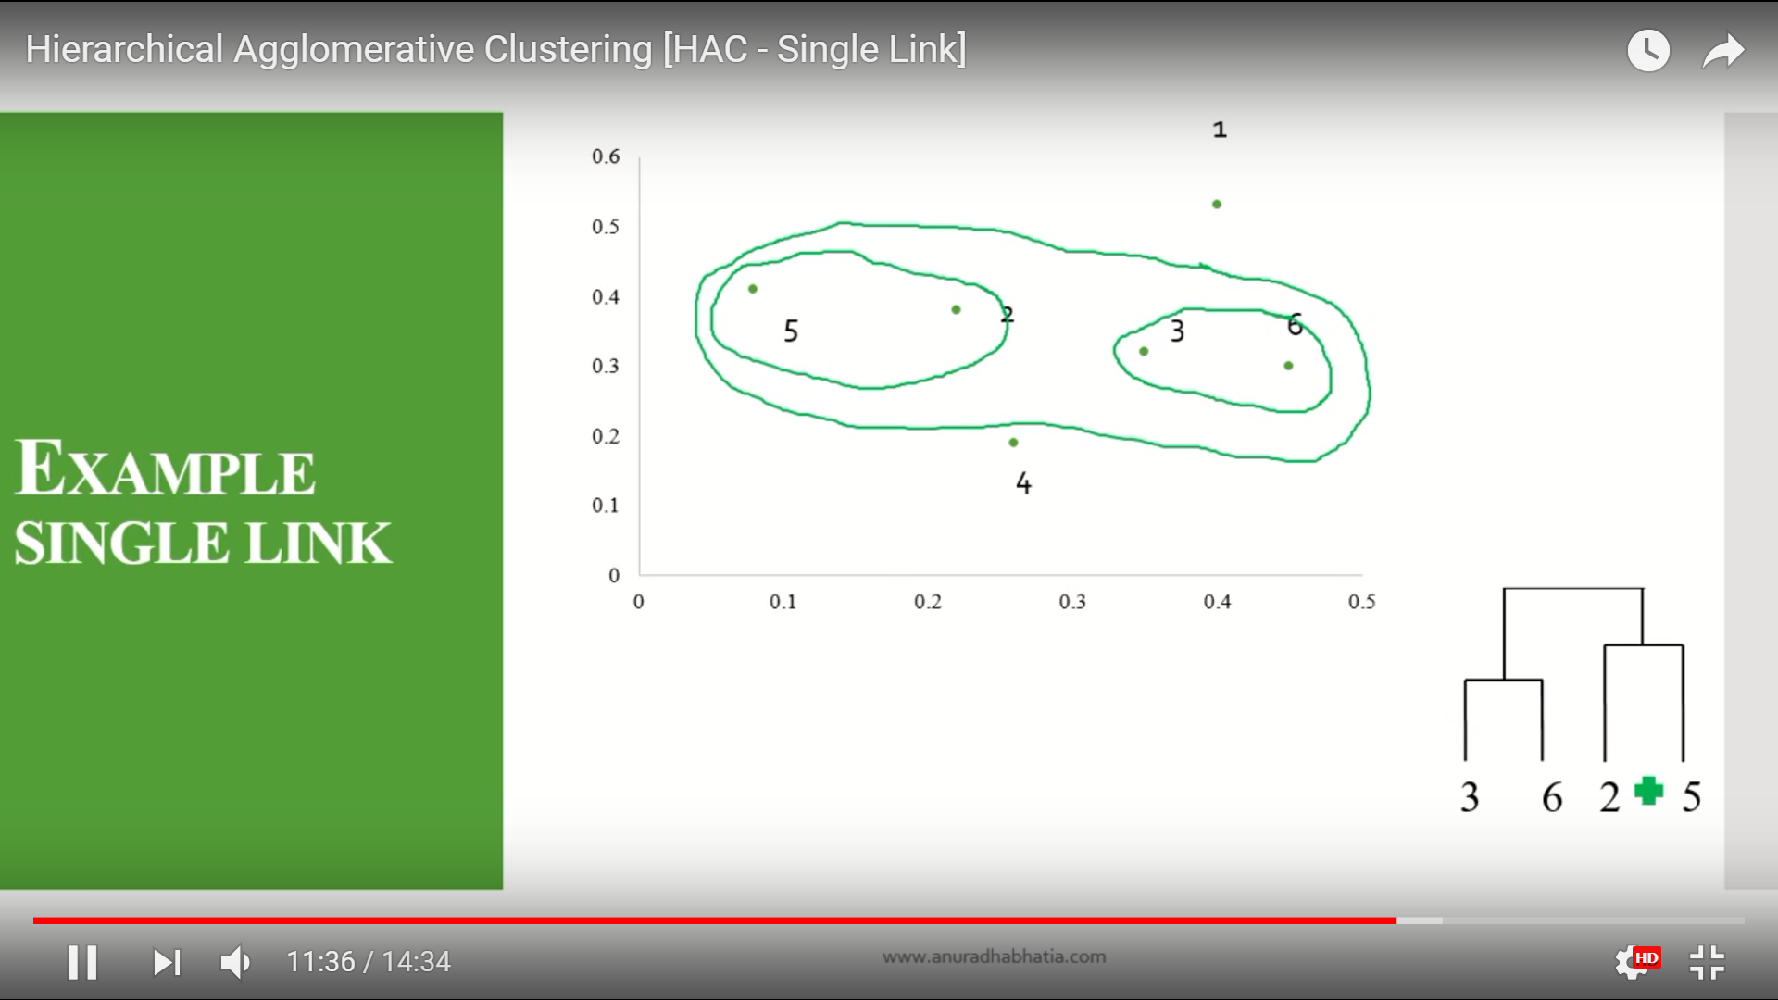

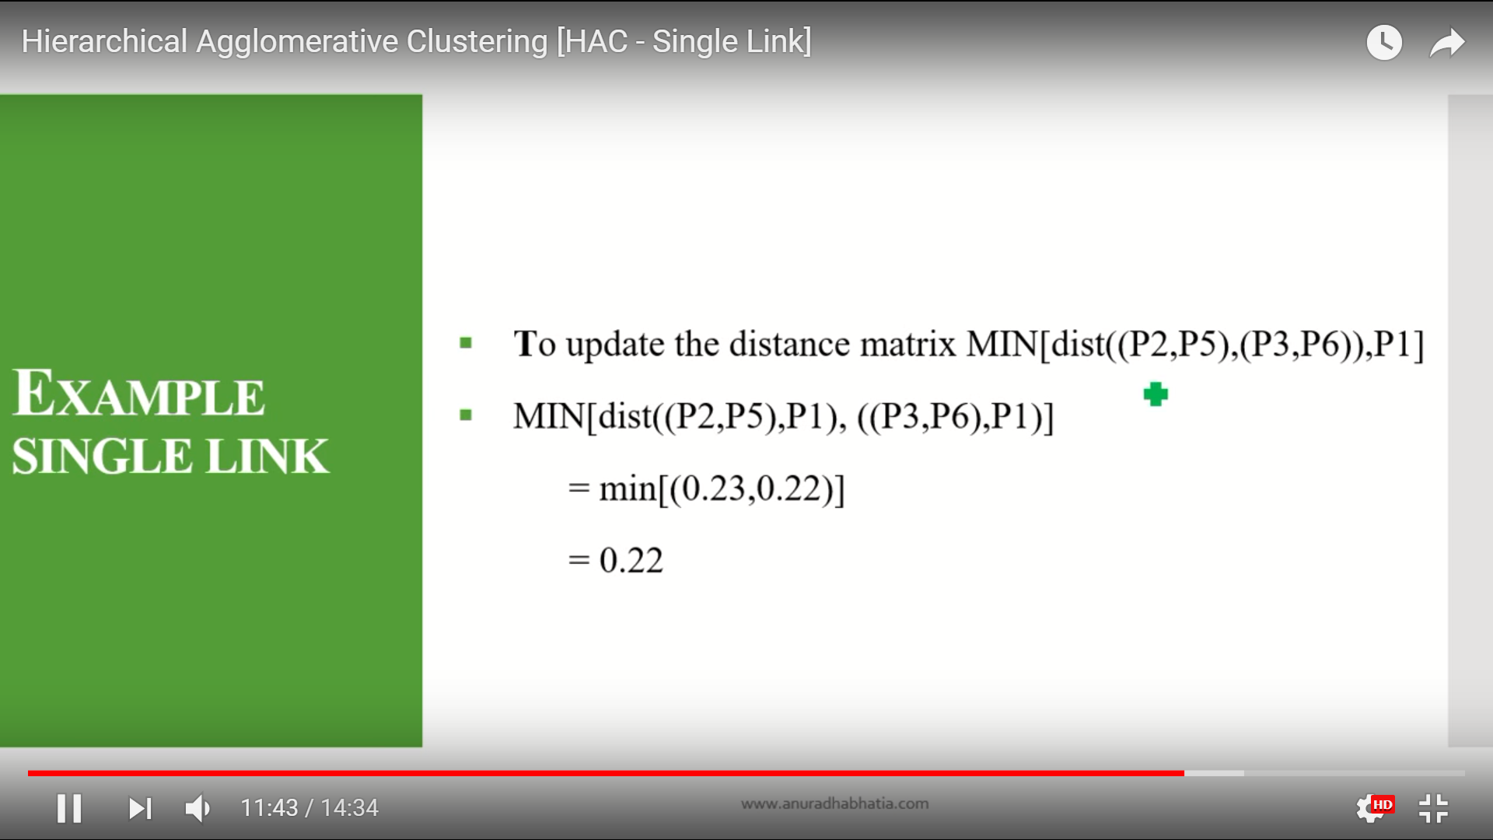

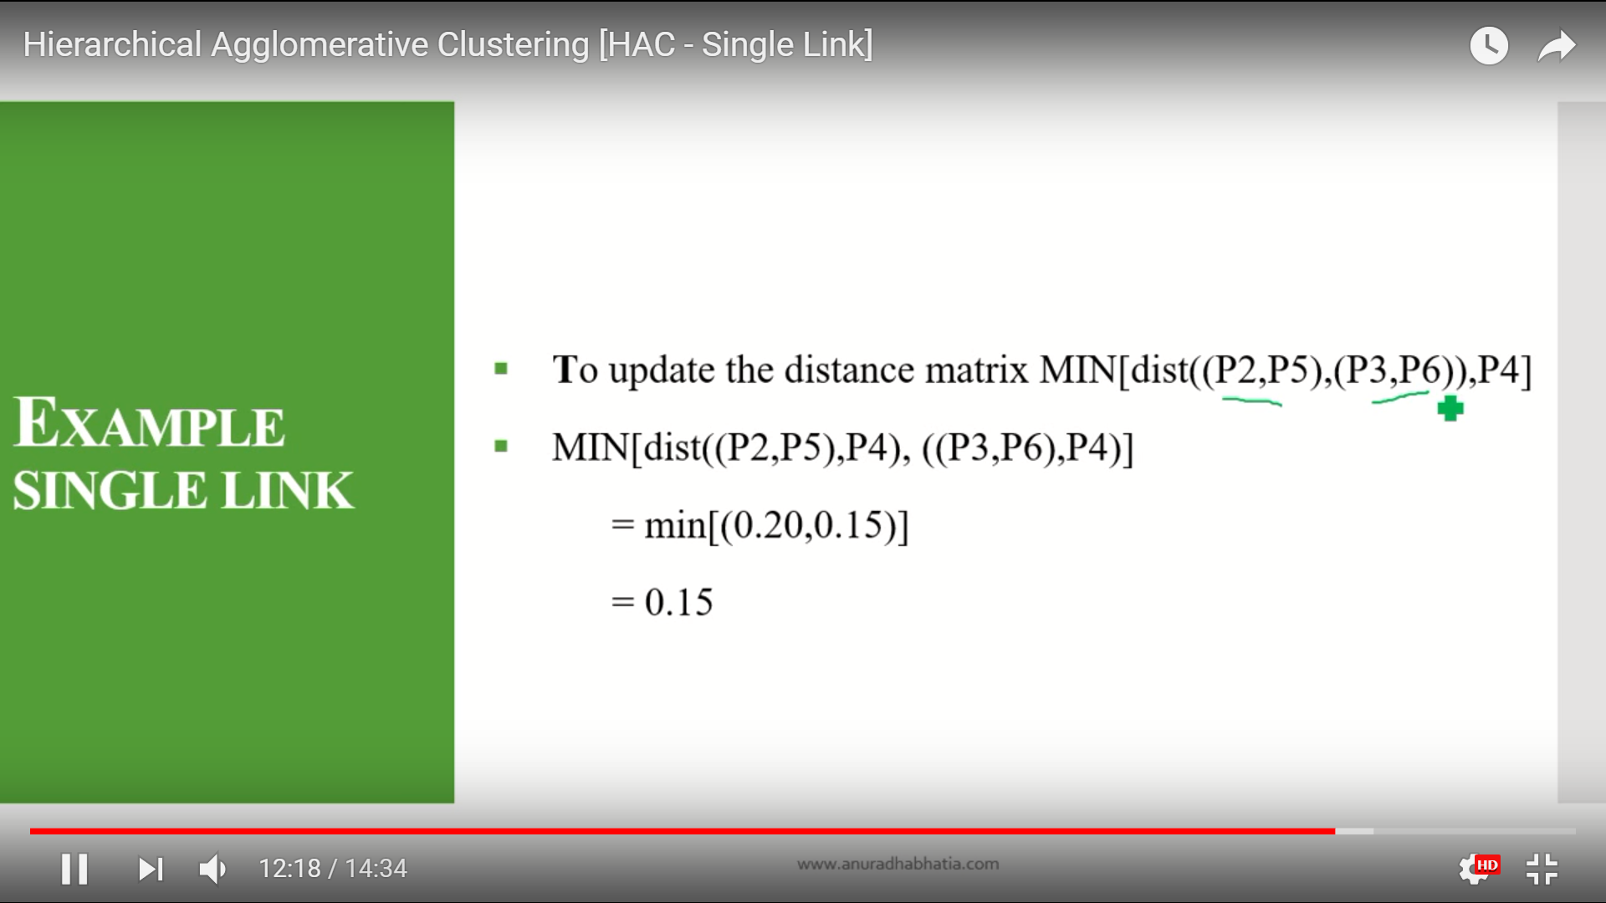

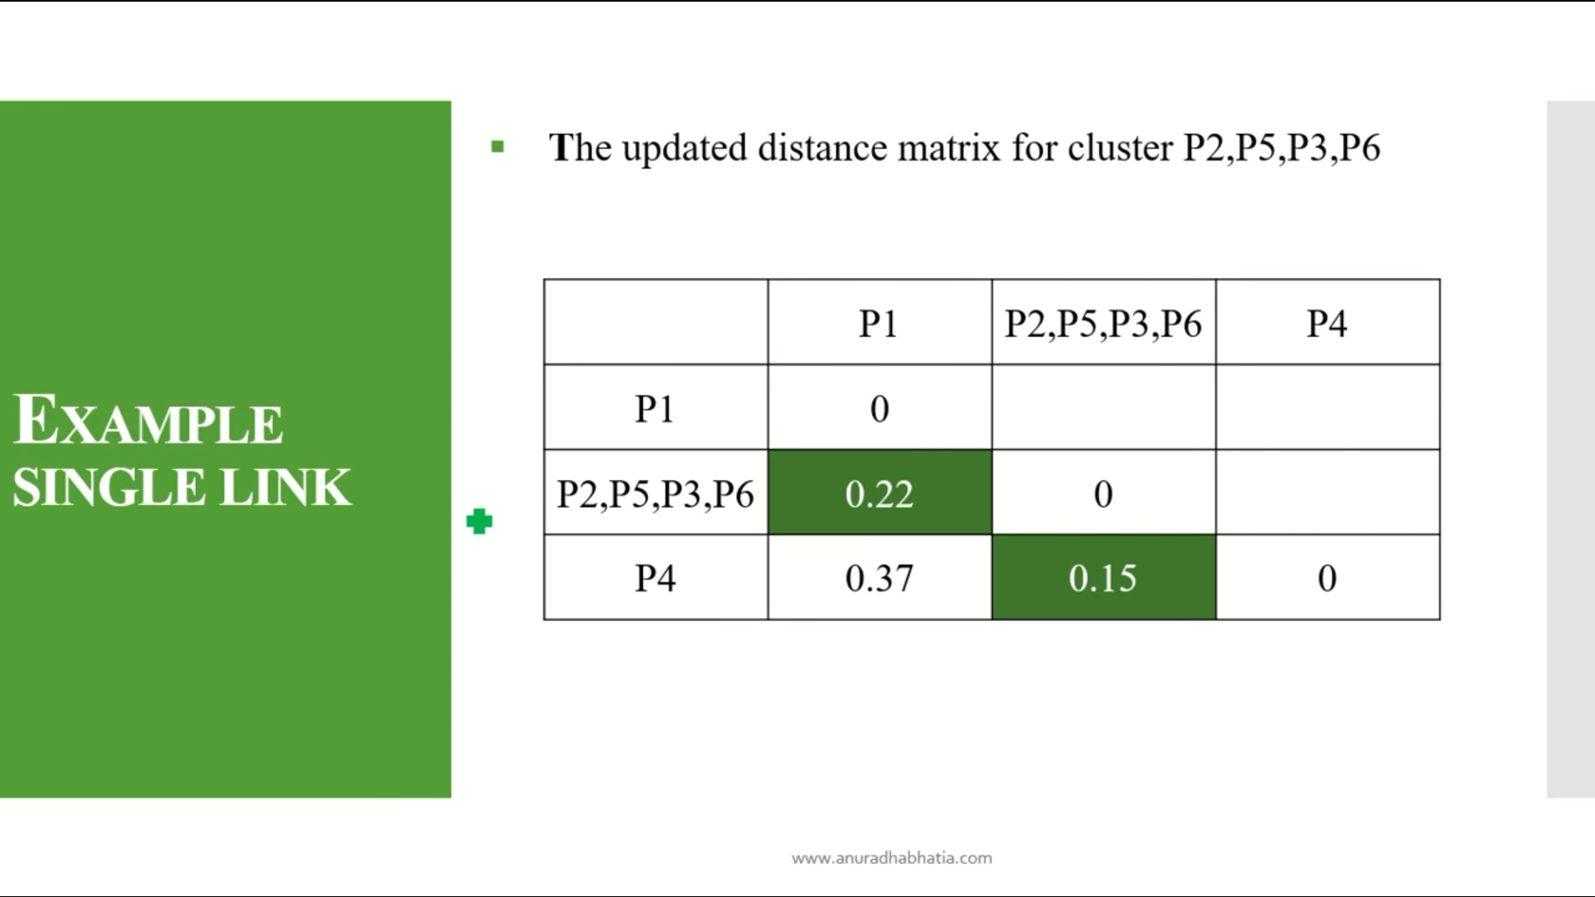

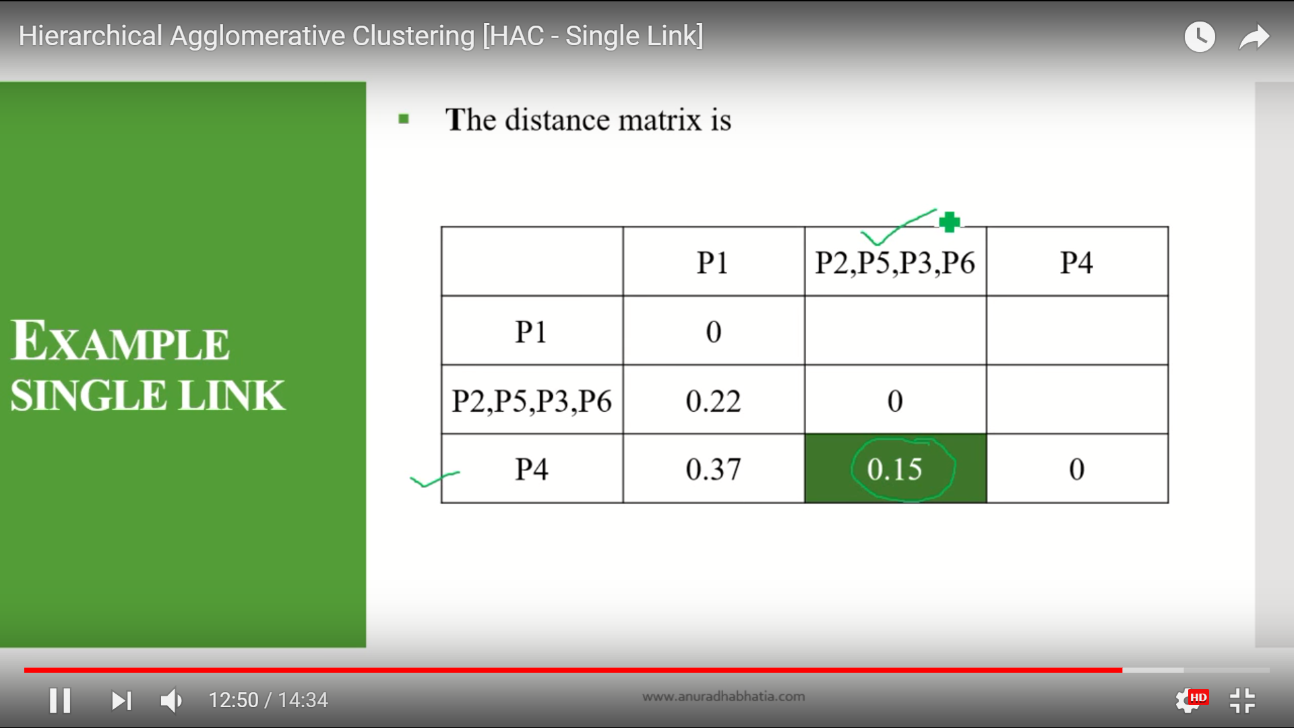

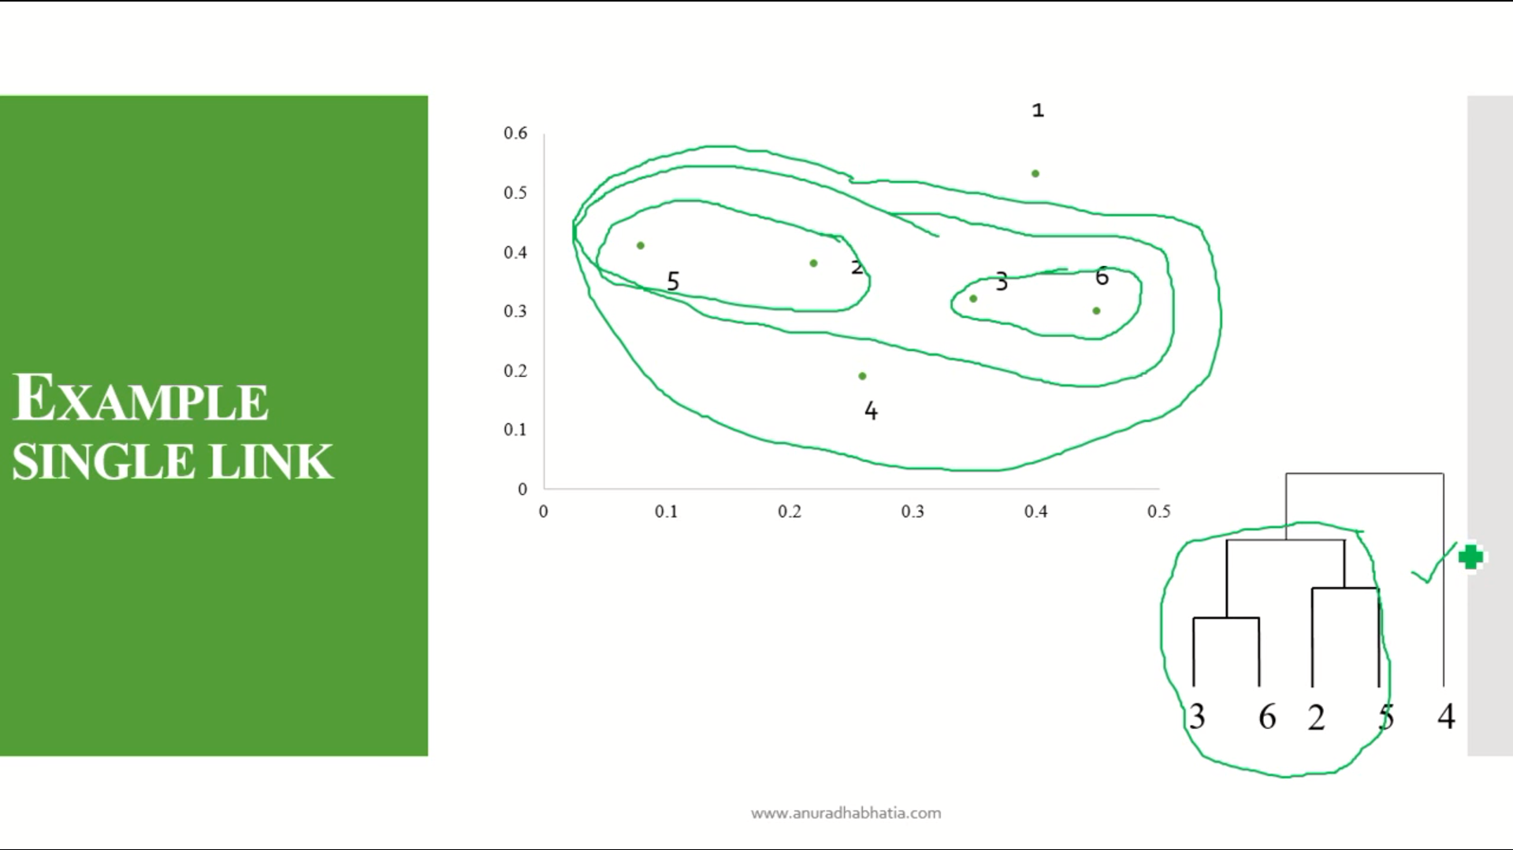

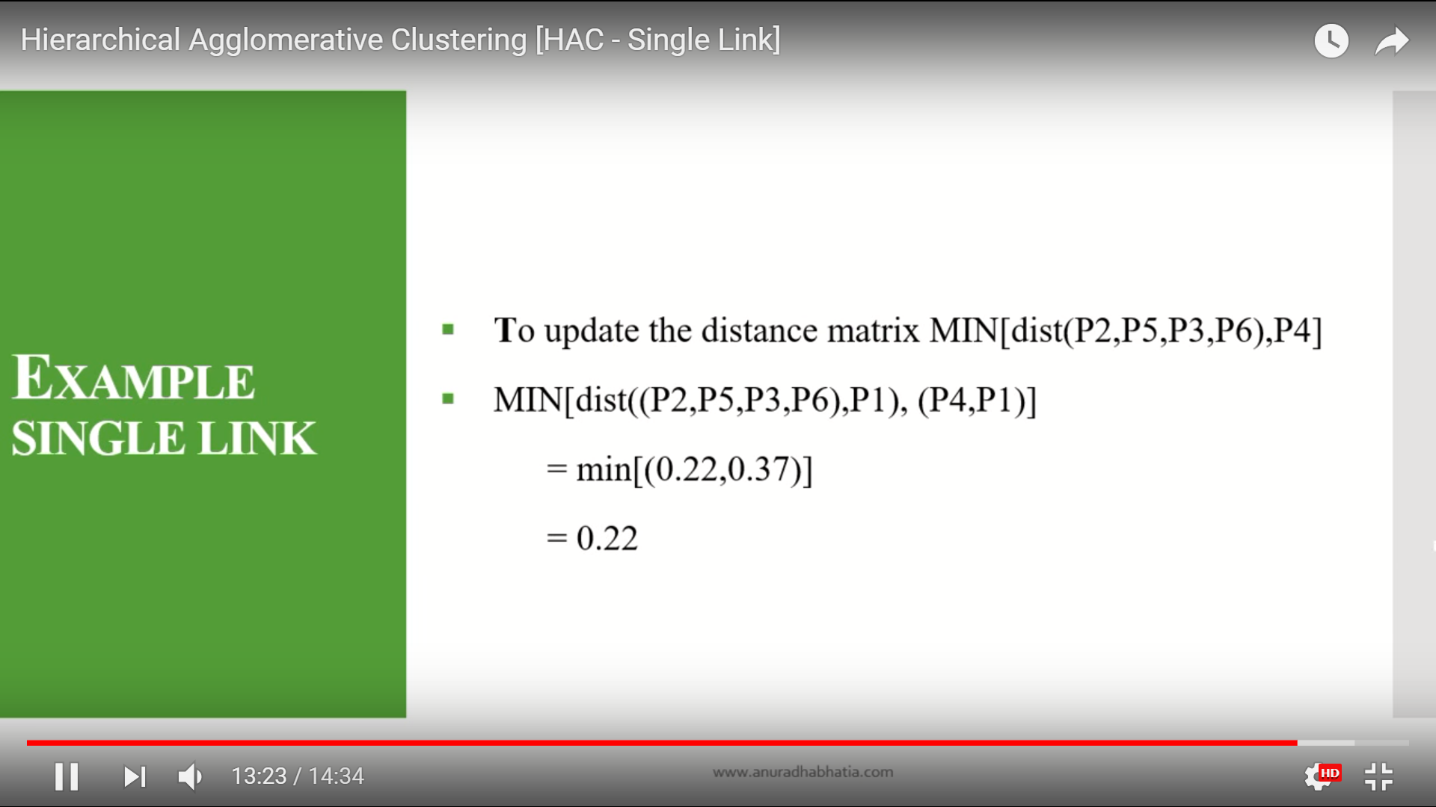

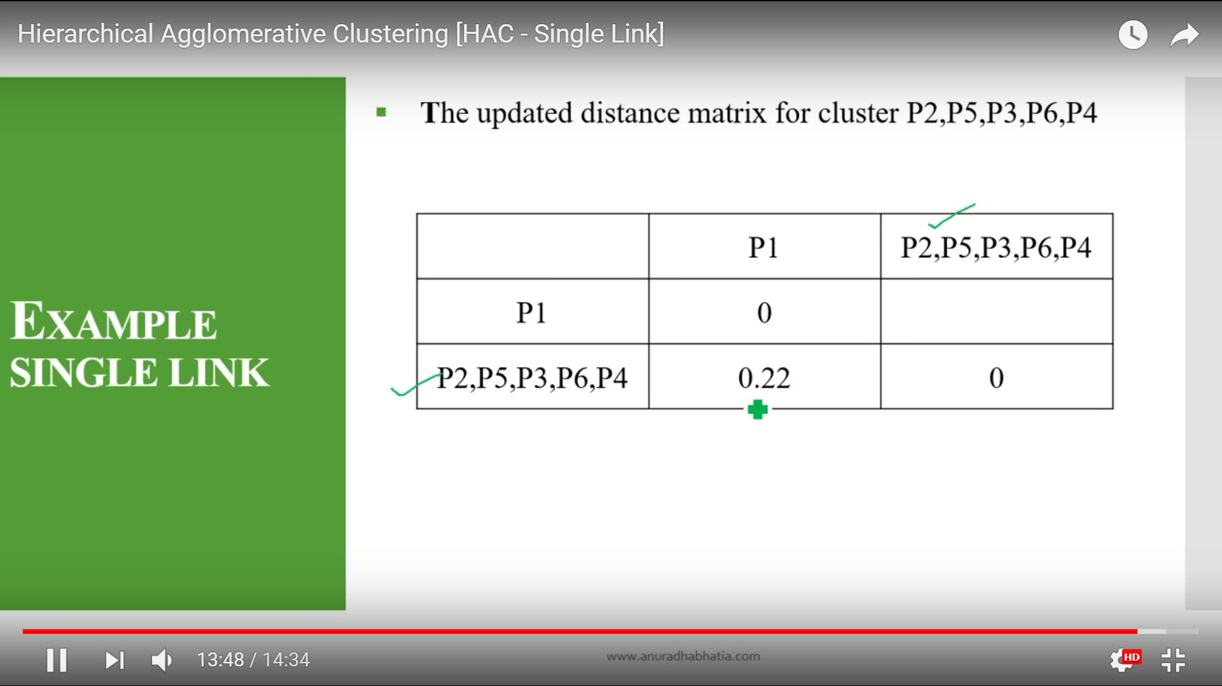

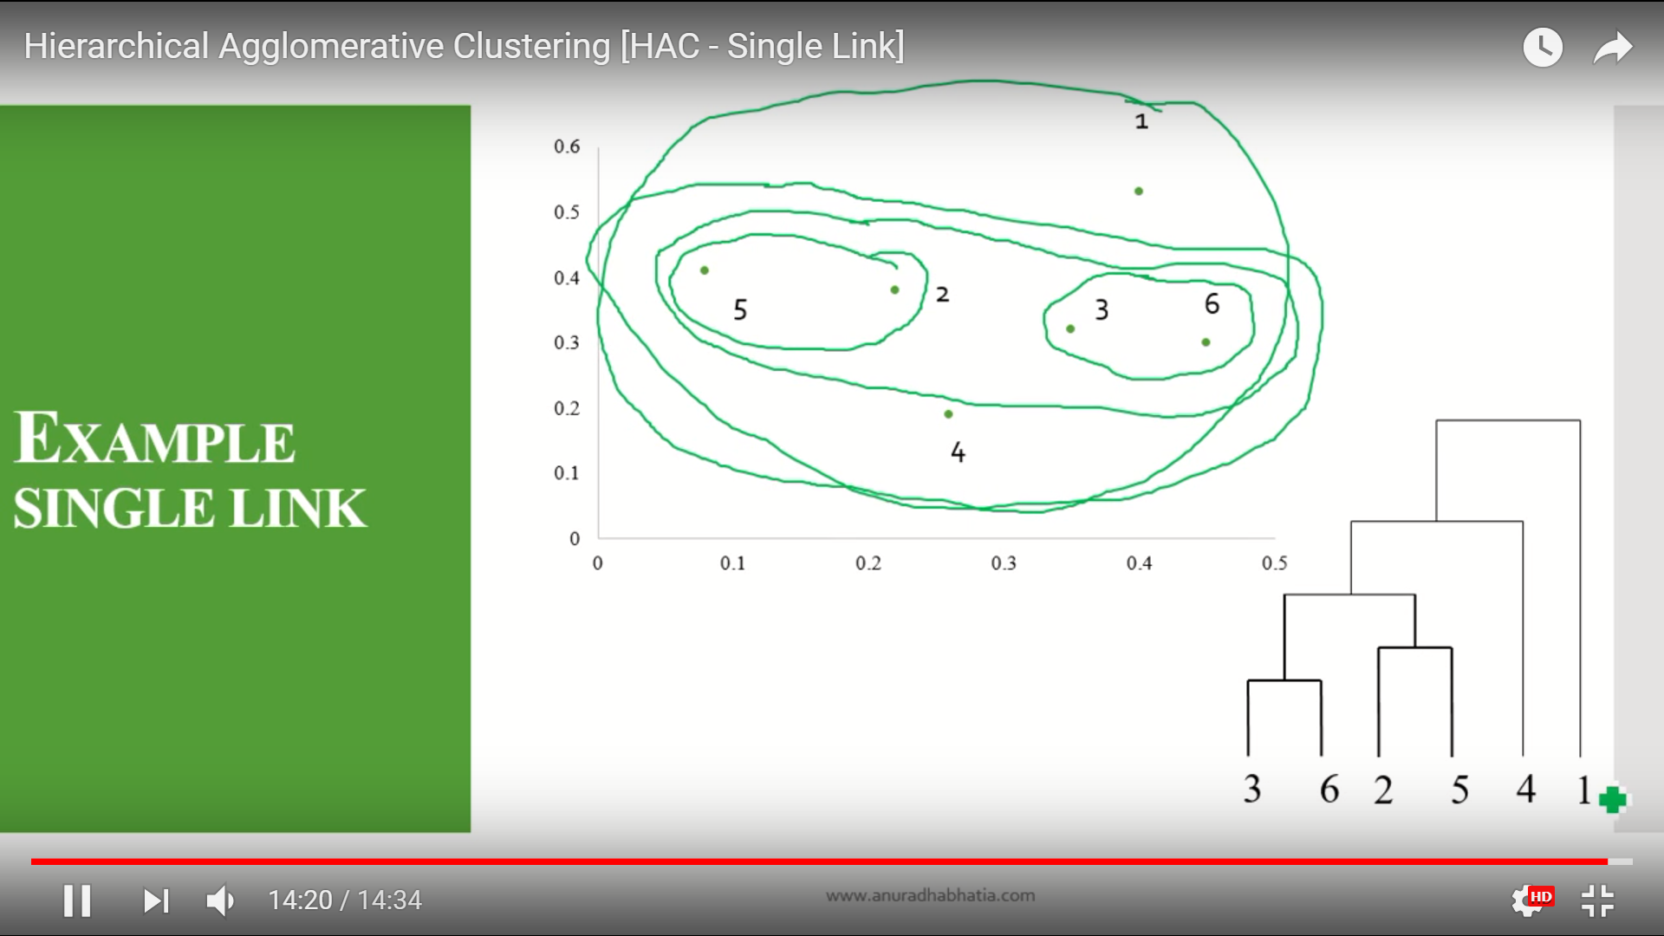

K-mean clustering

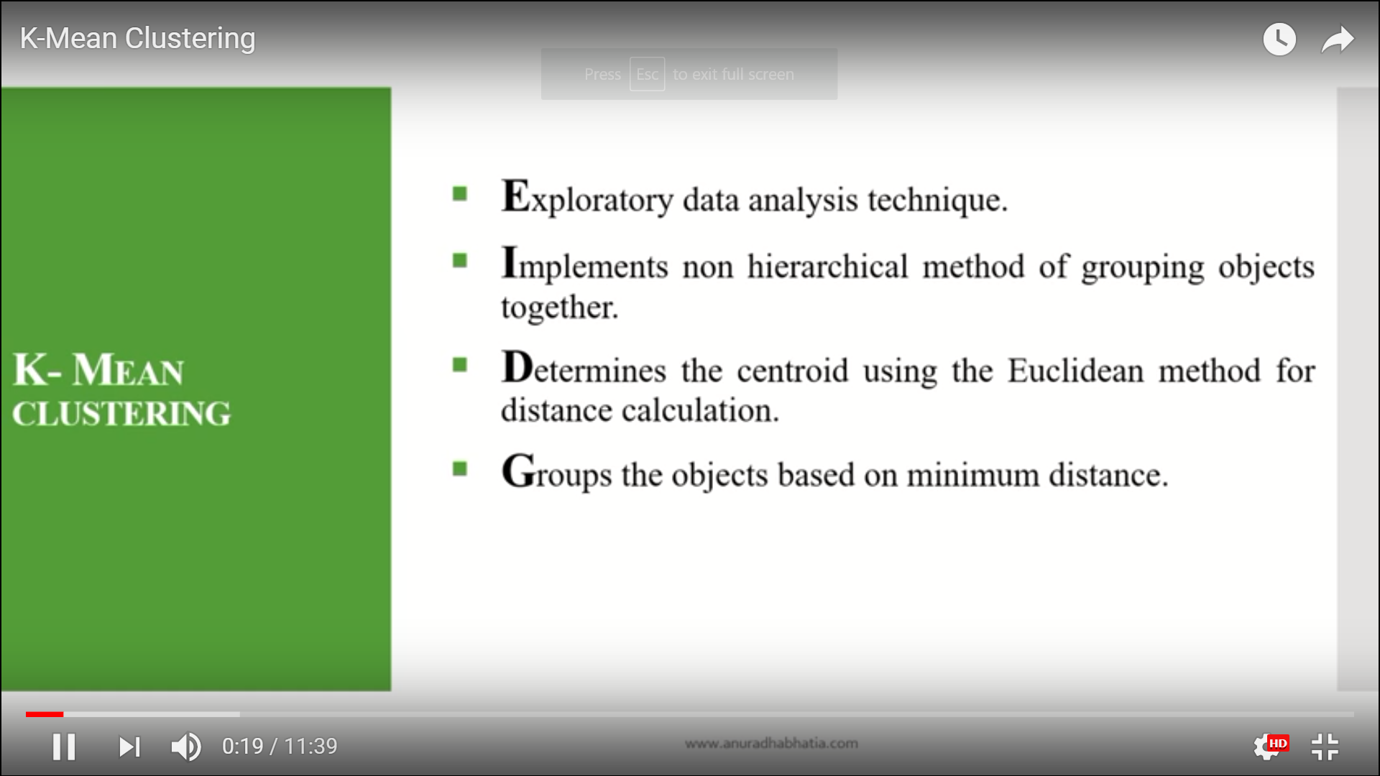

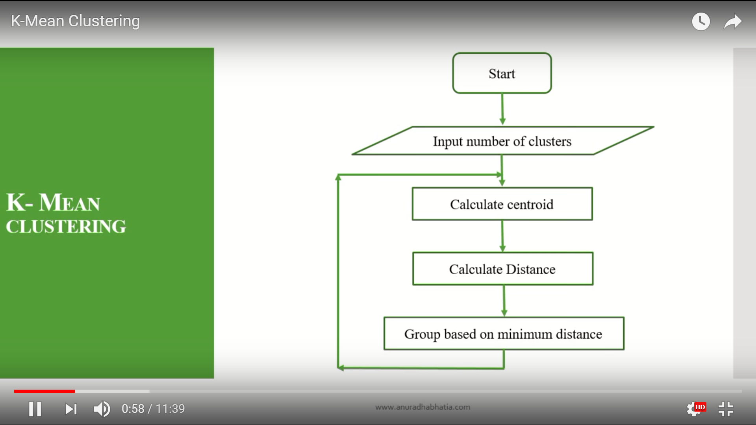

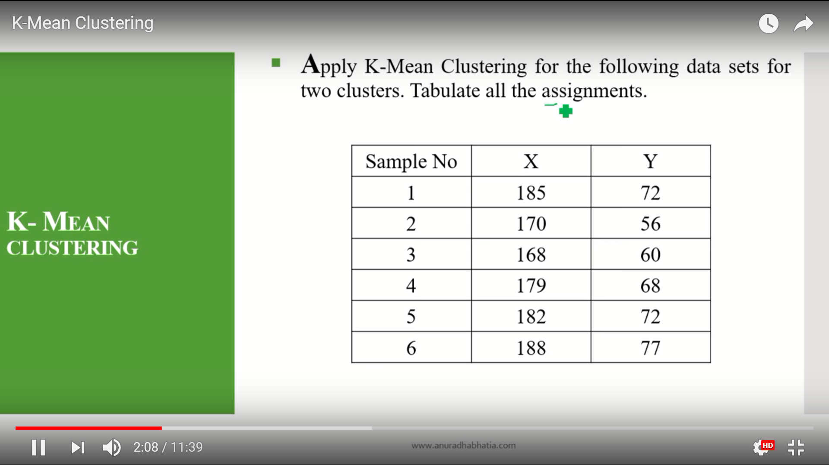

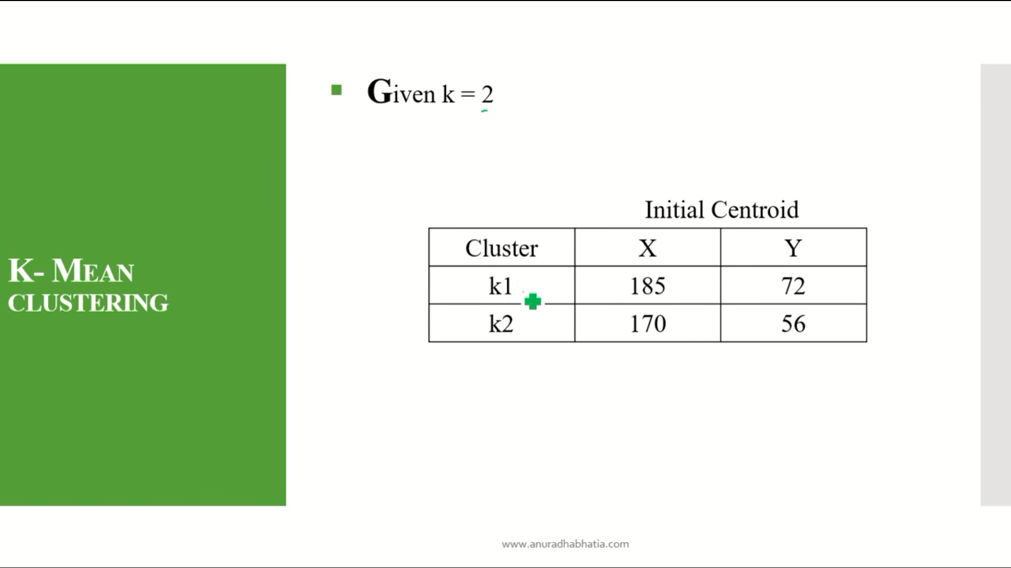

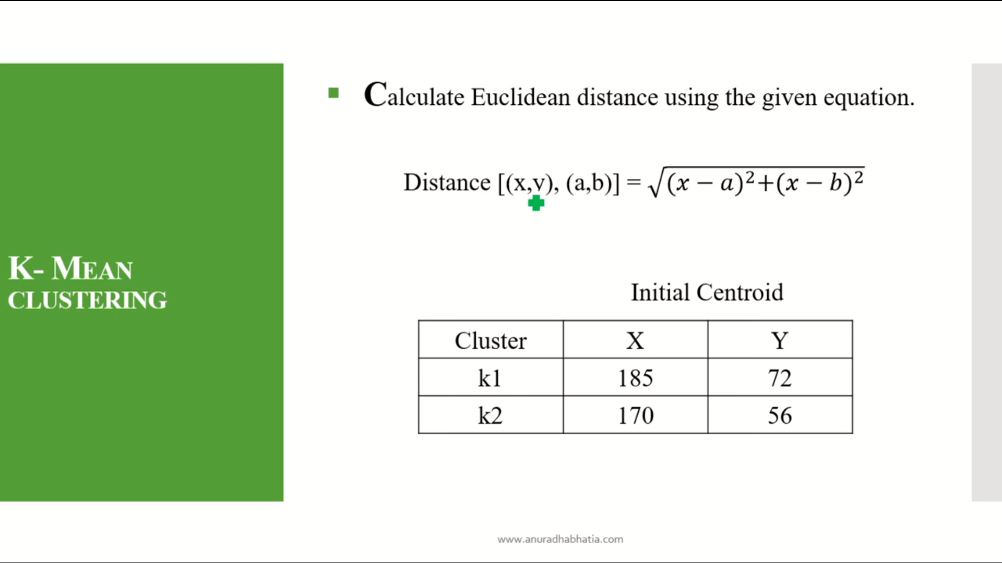

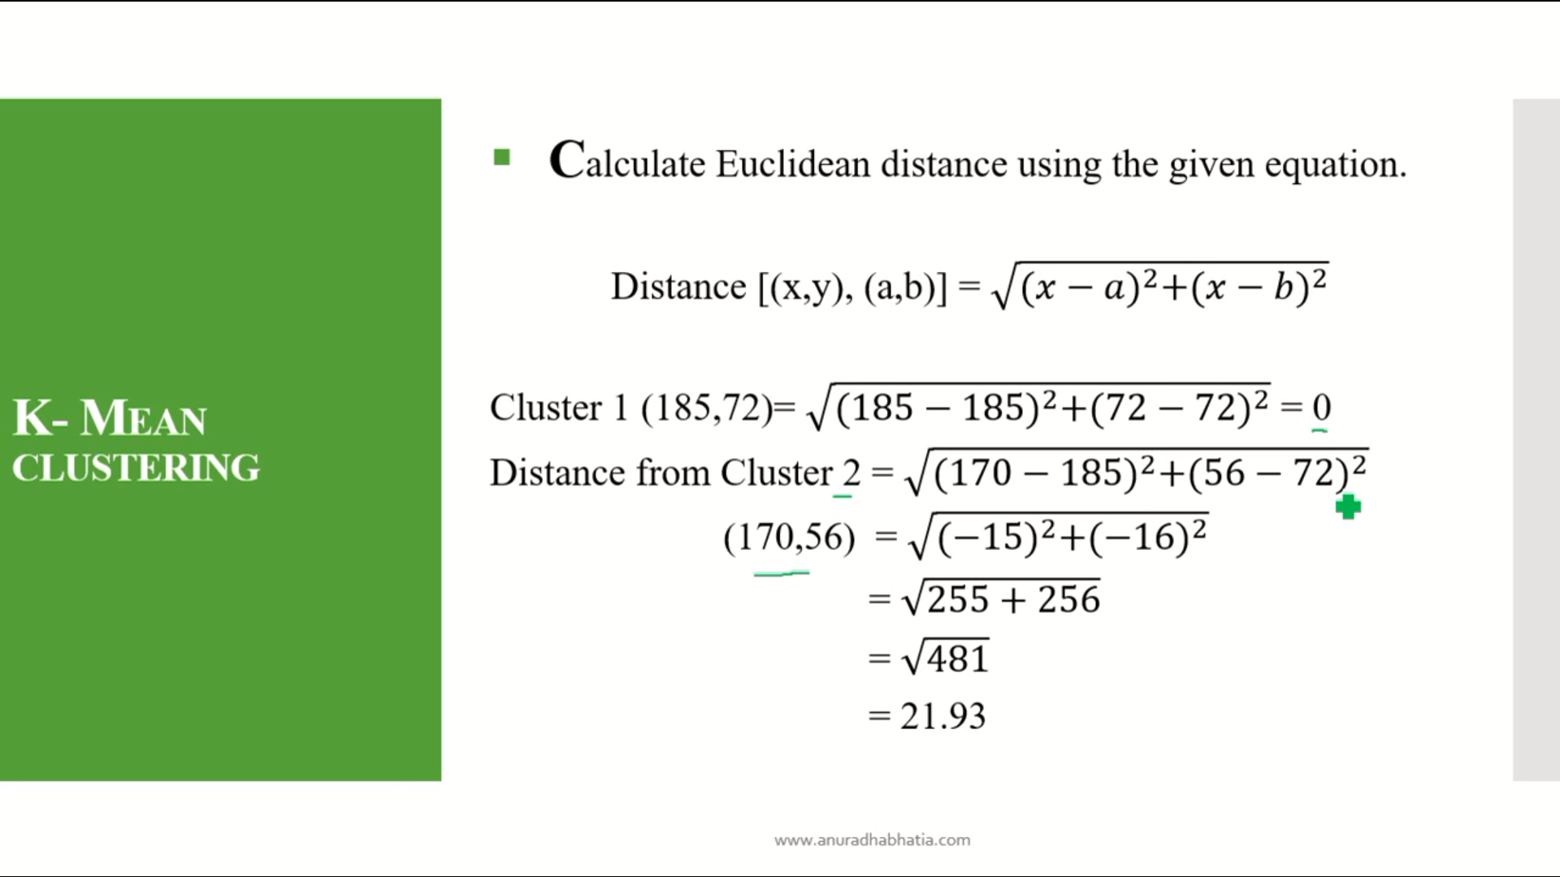

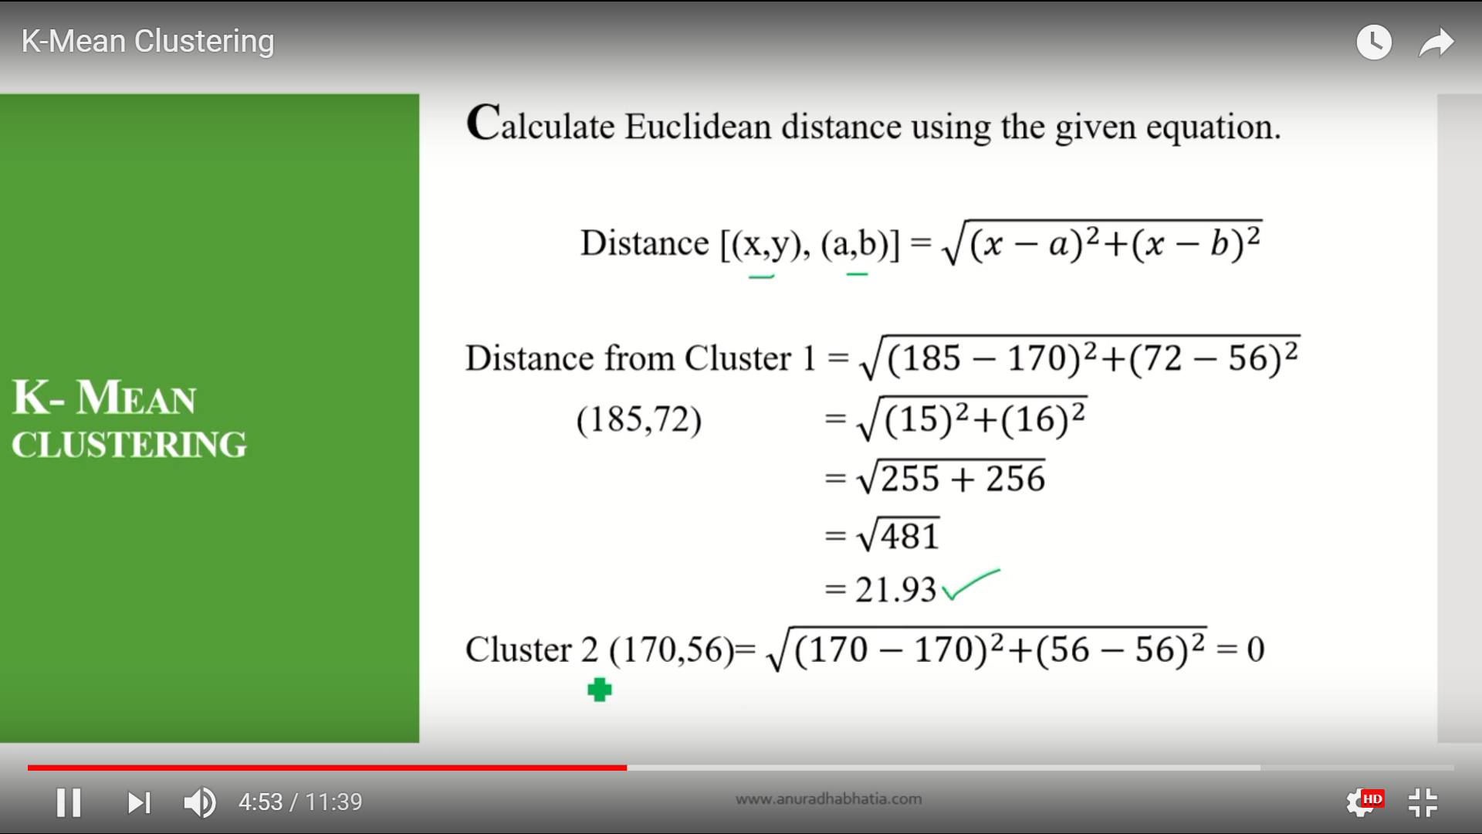

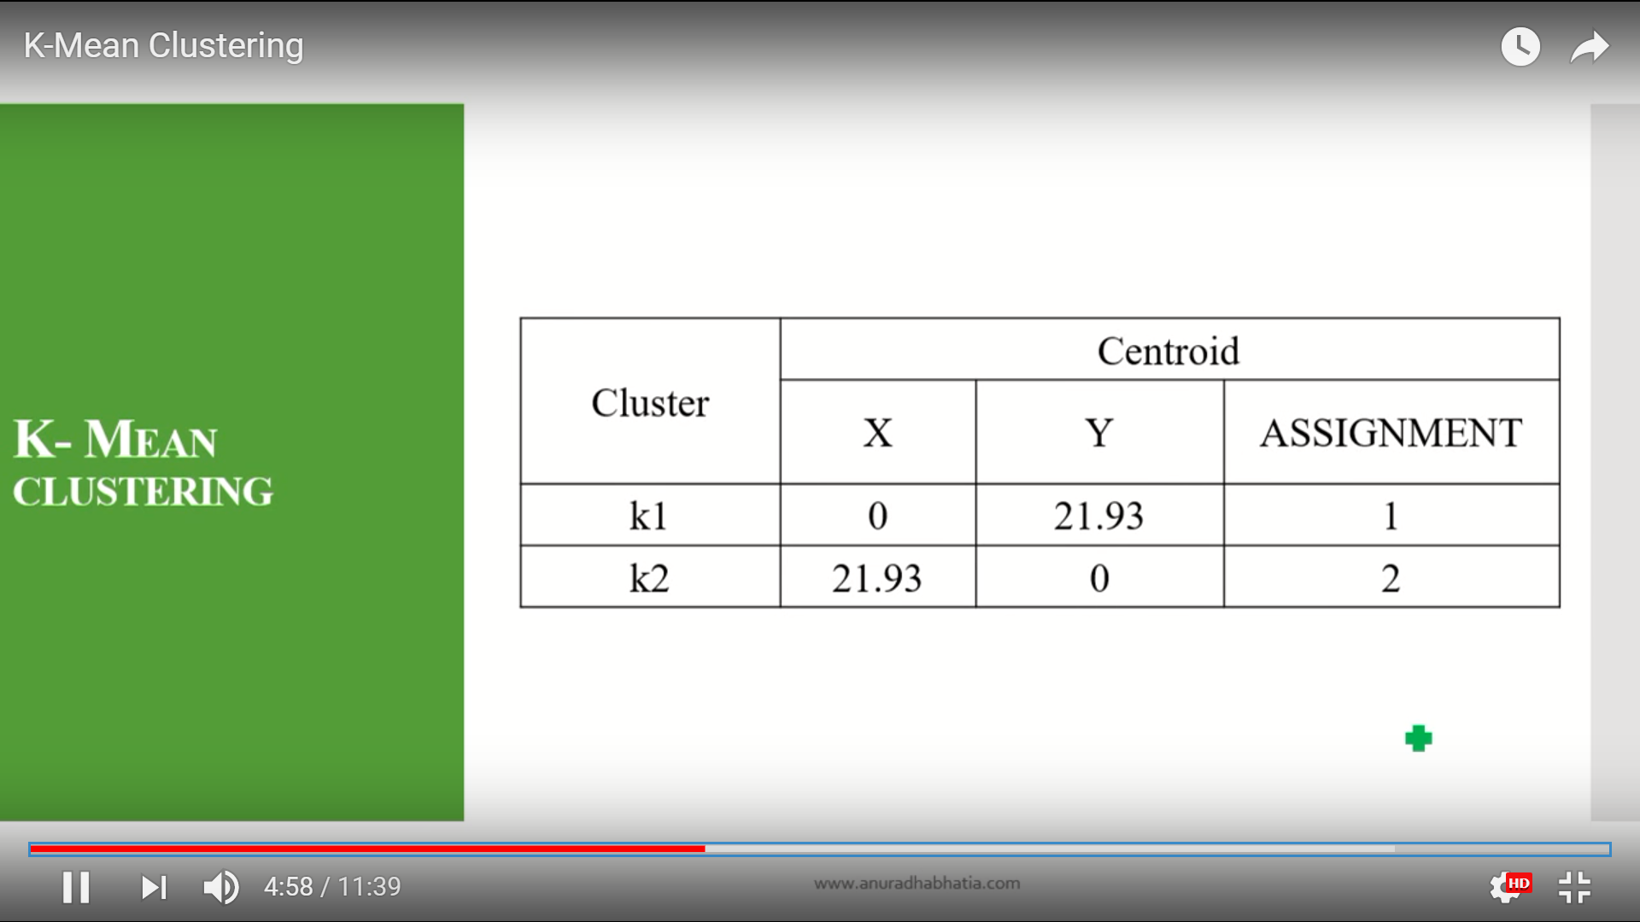

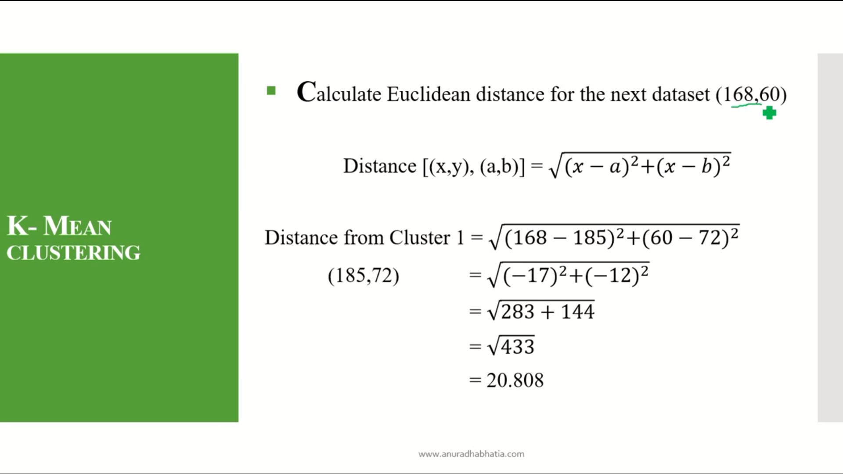

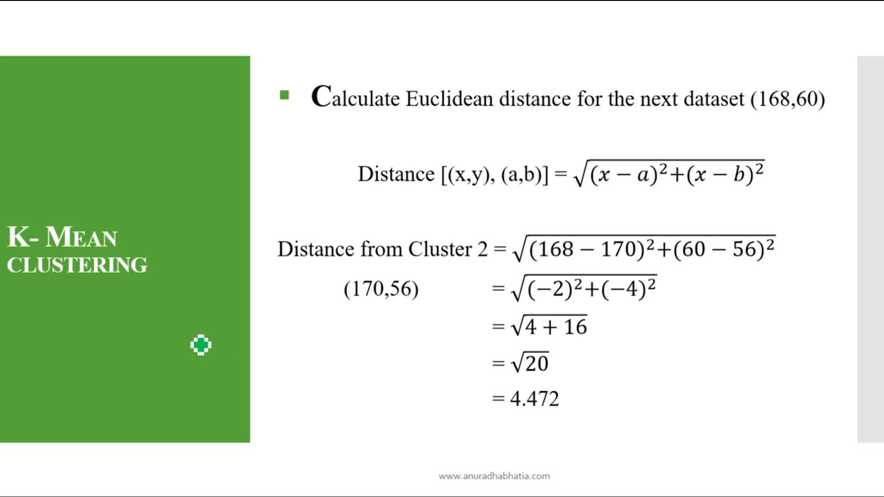

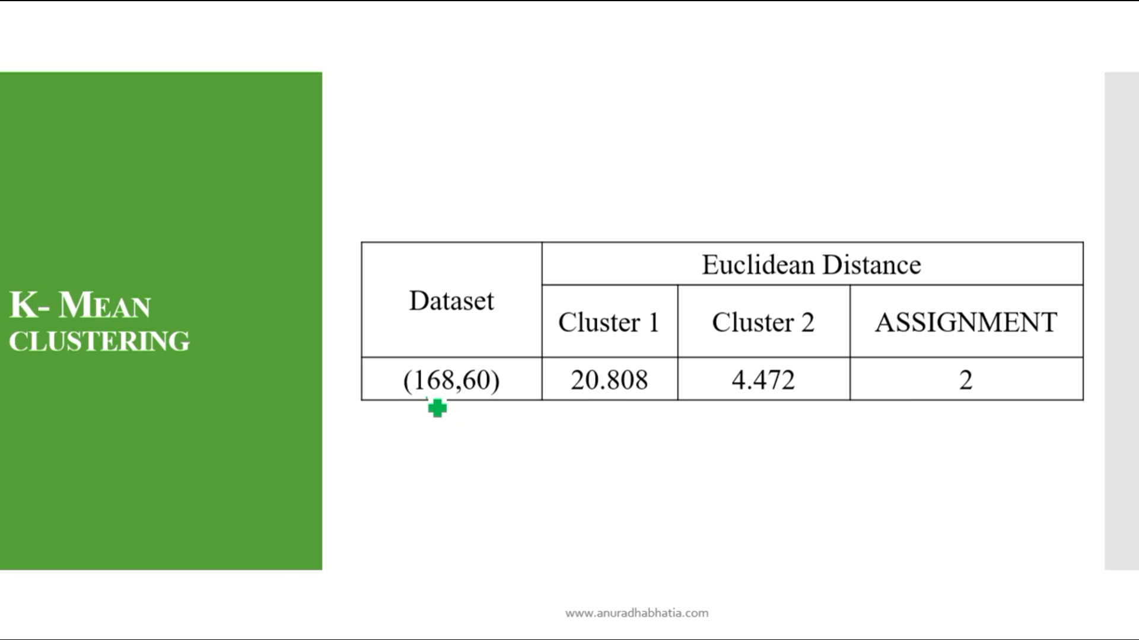

Here the minimum distance for cluster1 and cluster 2 is 4.472 so the assignment is 2.beacuse the min value is in cluster 2.

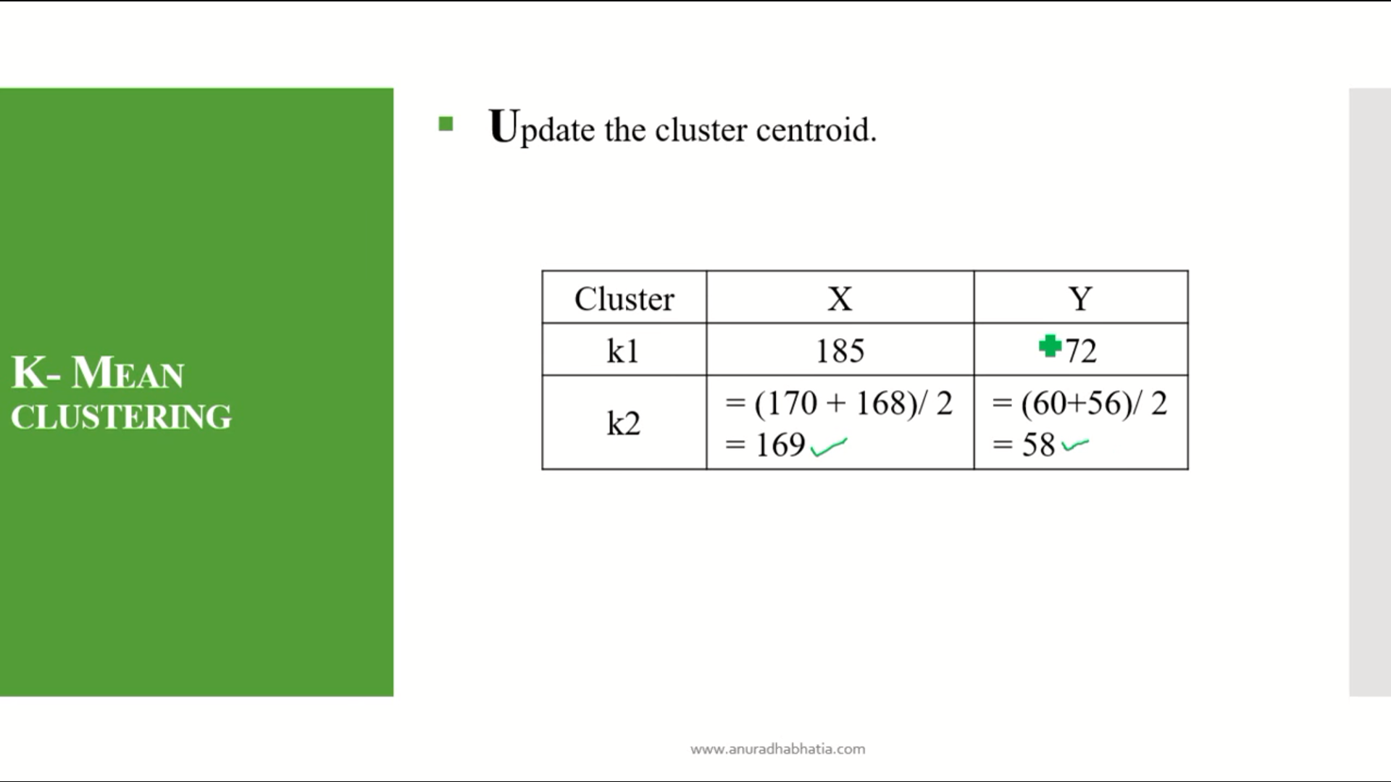

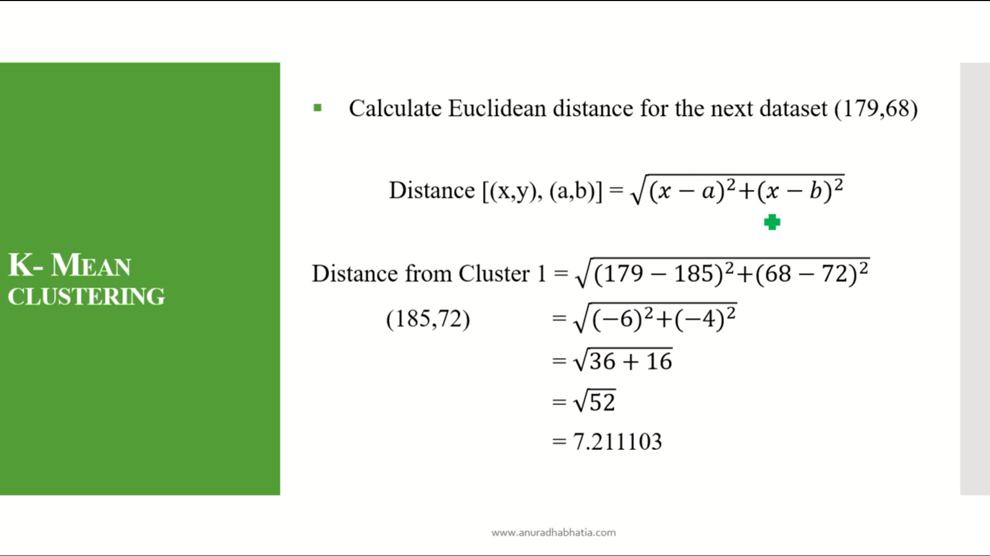

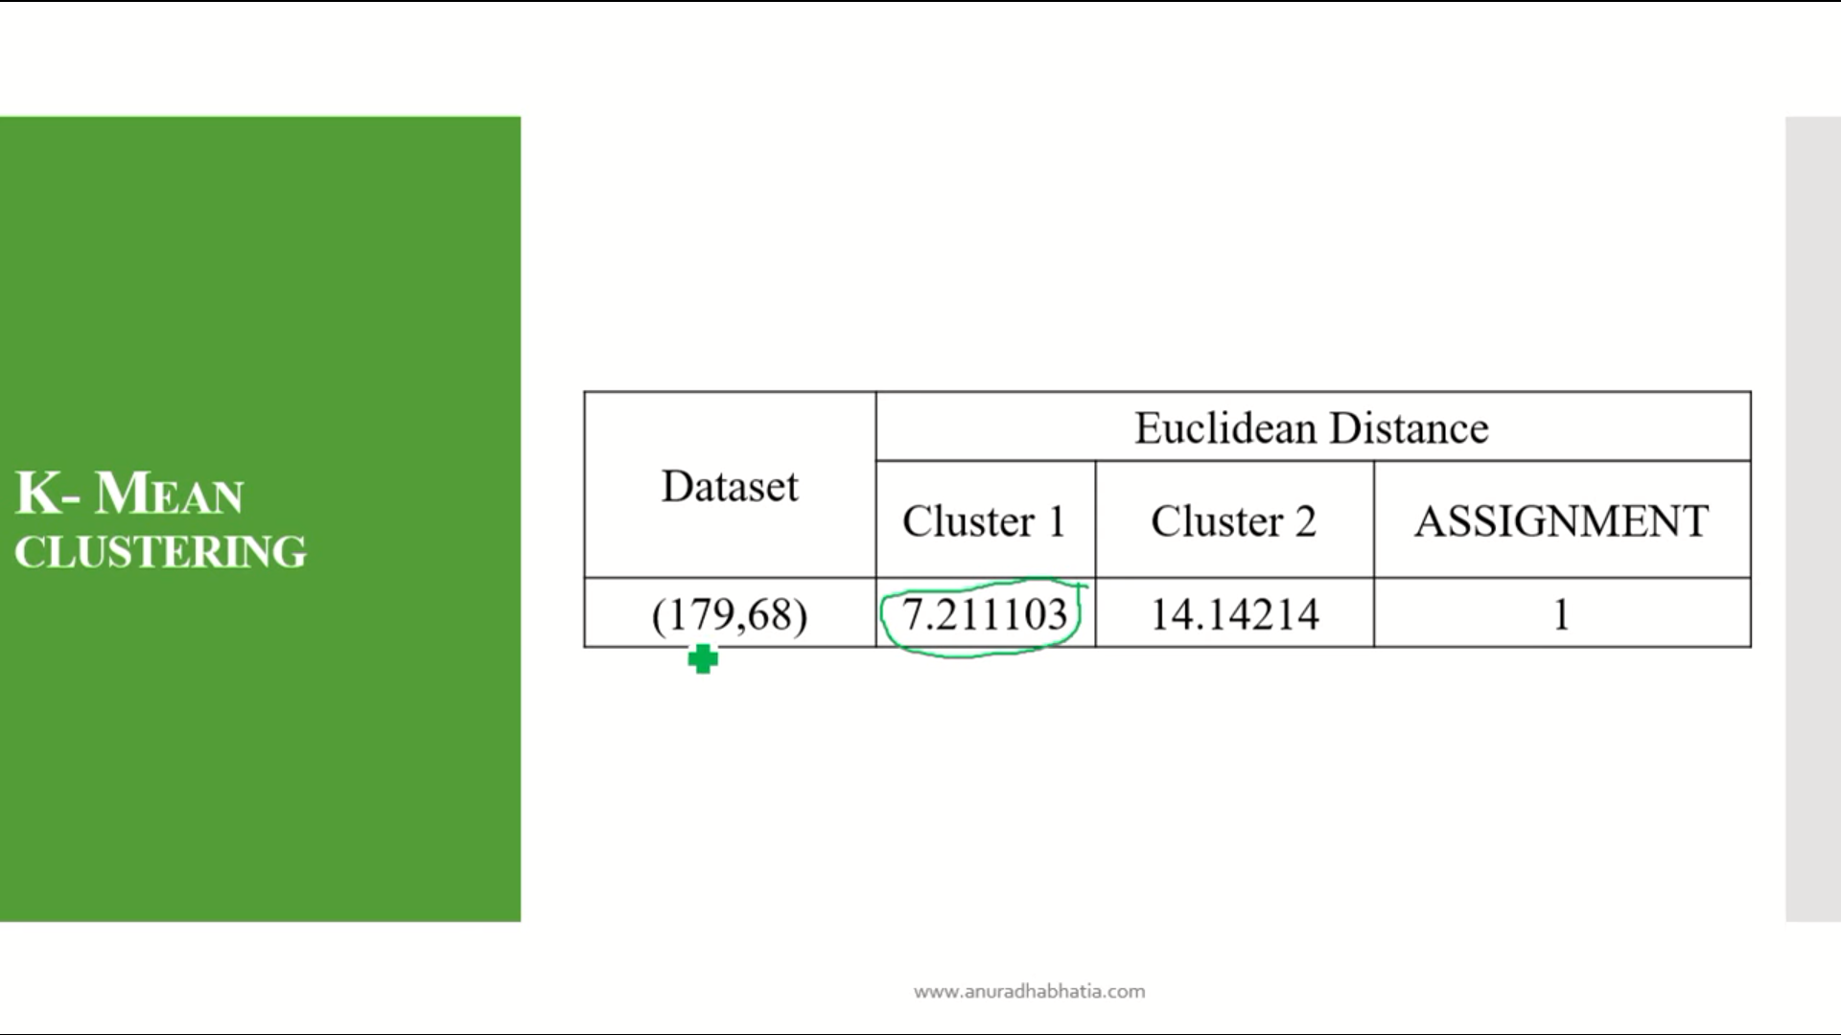

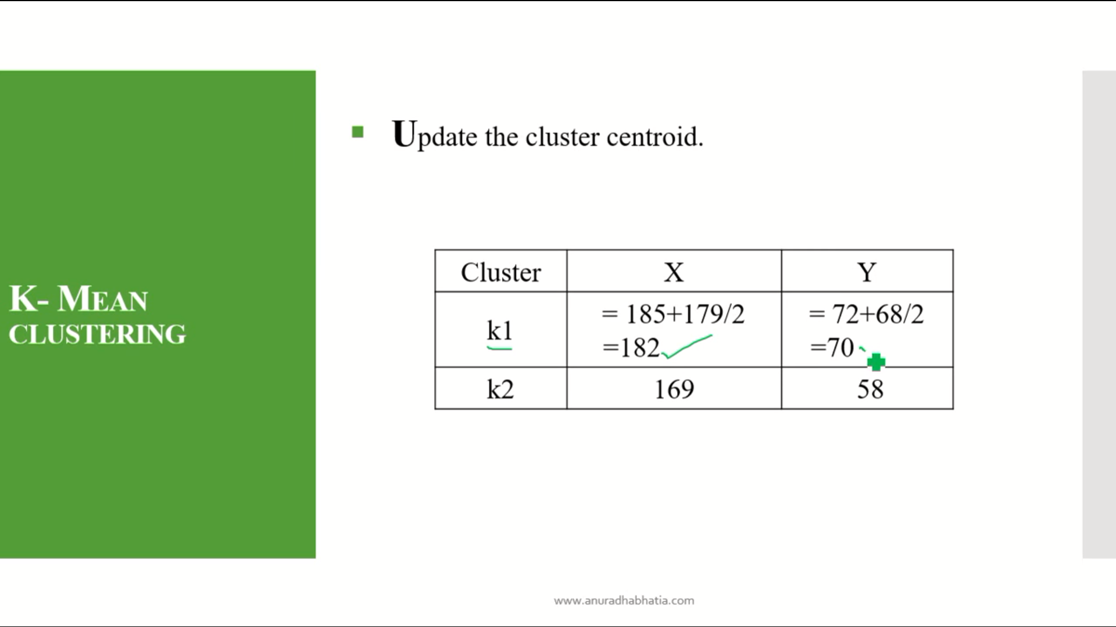

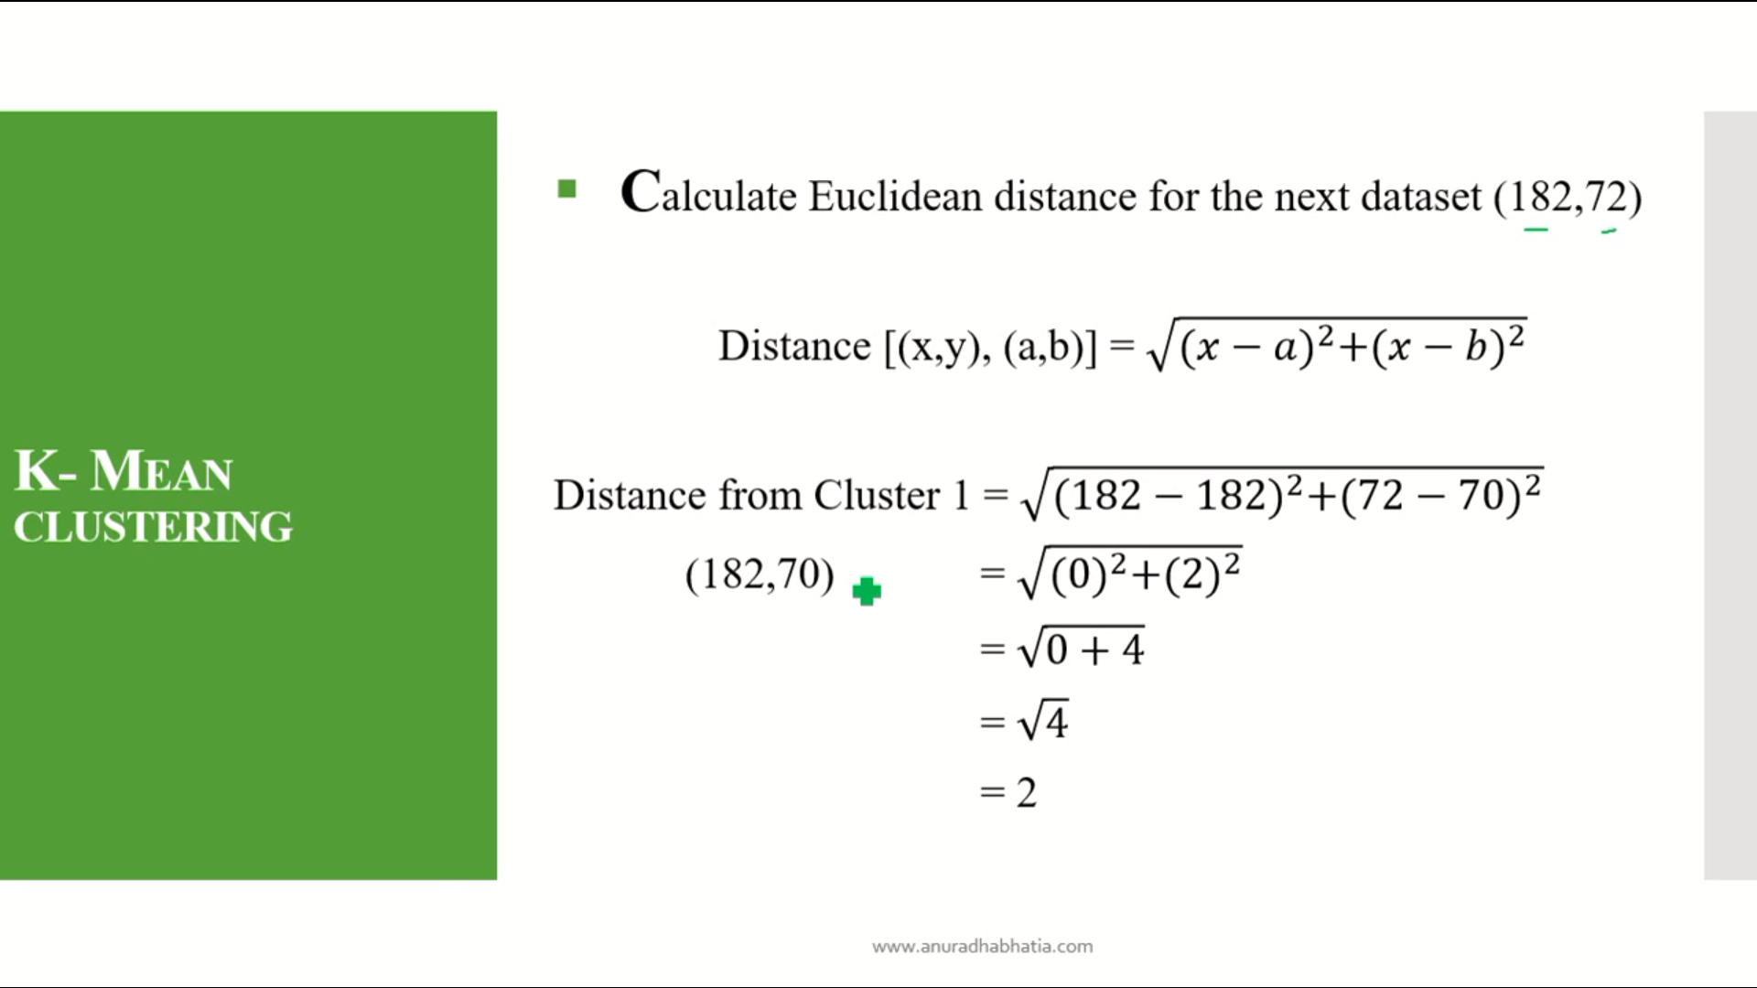

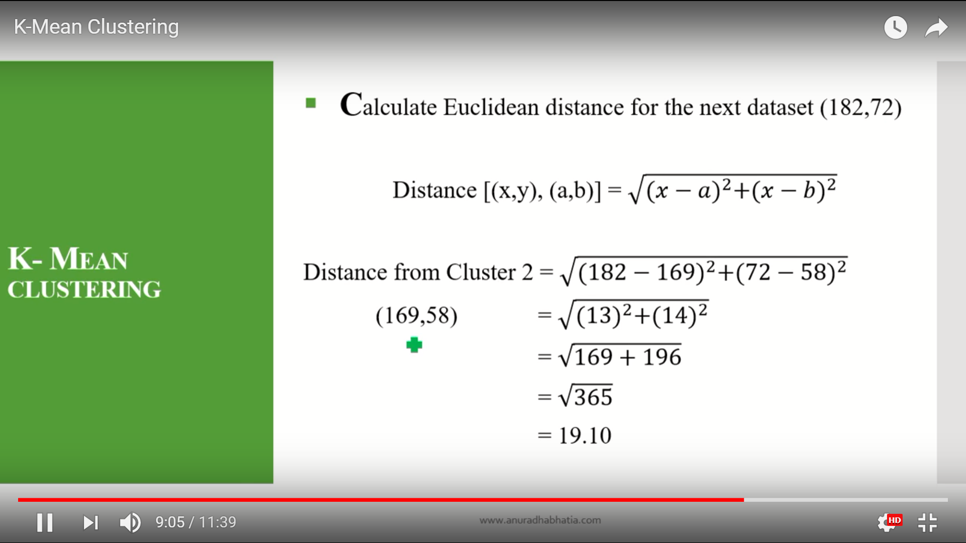

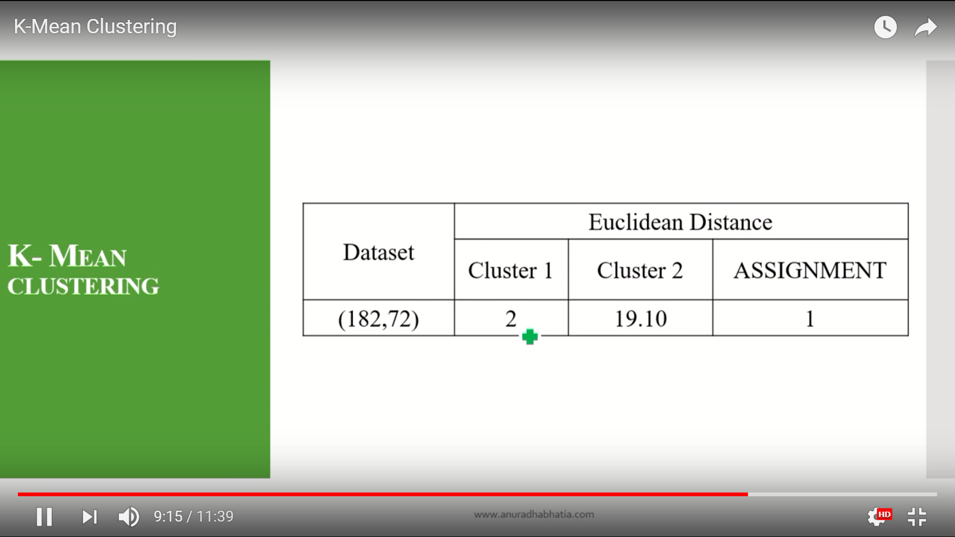

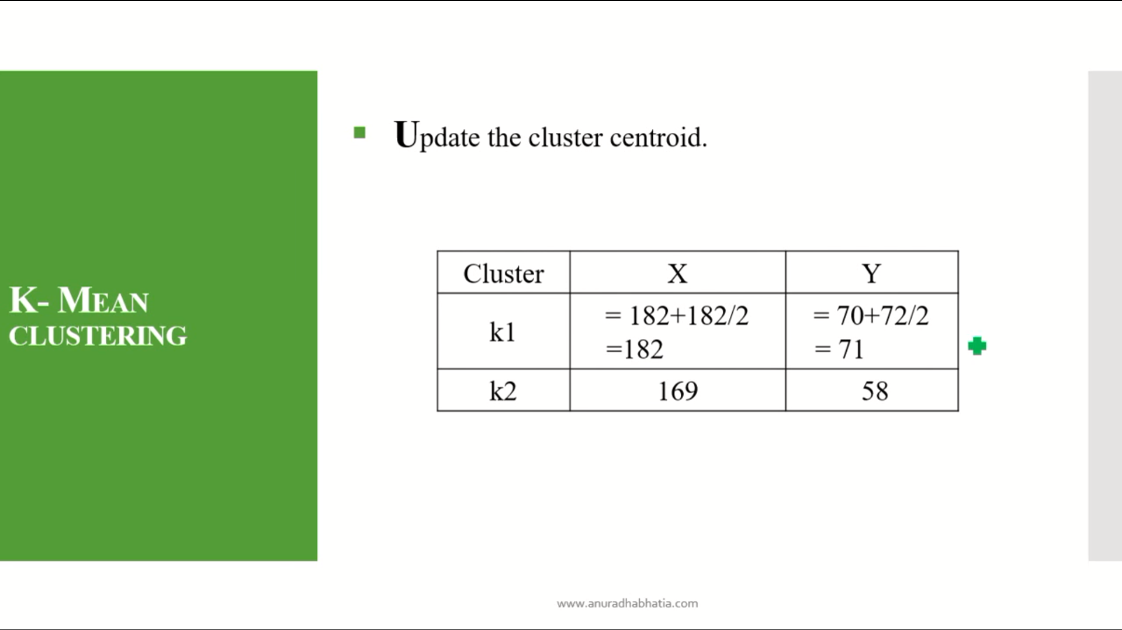

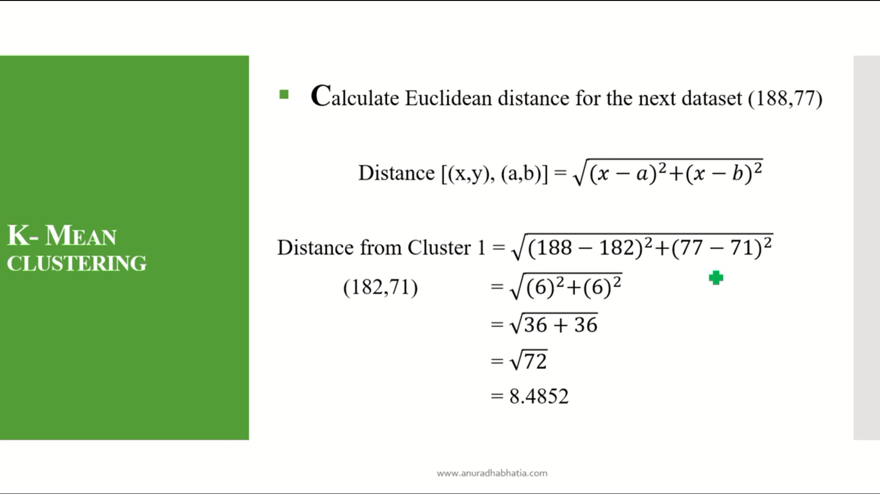

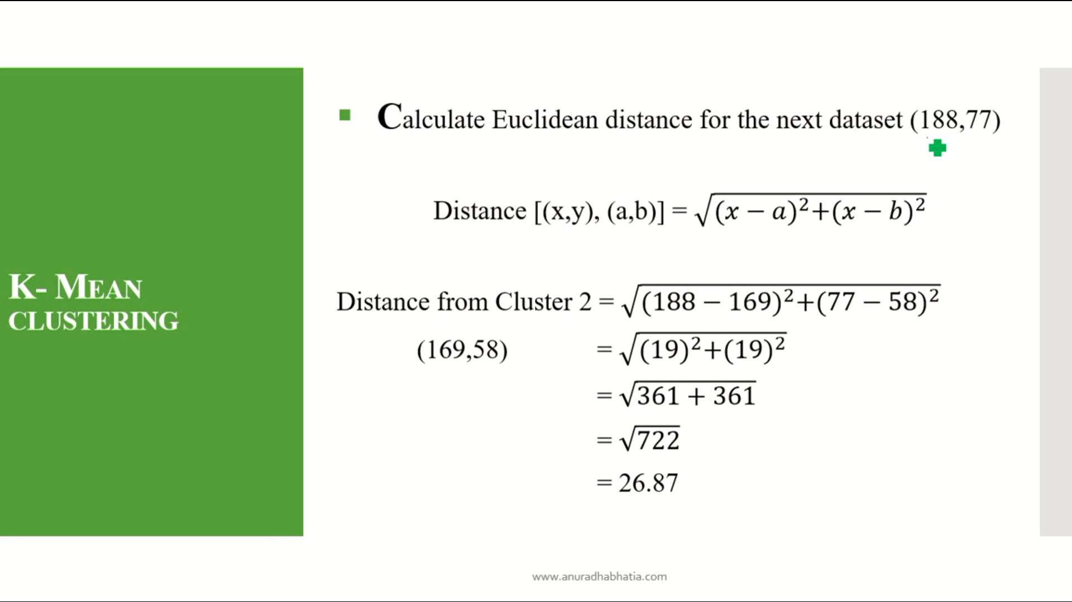

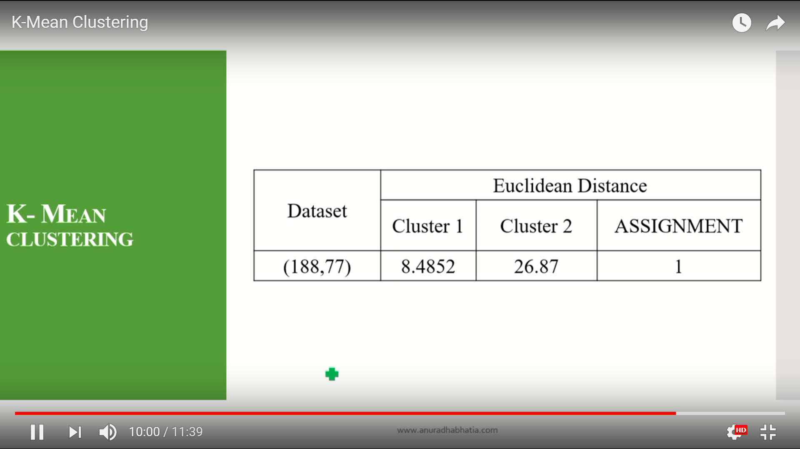

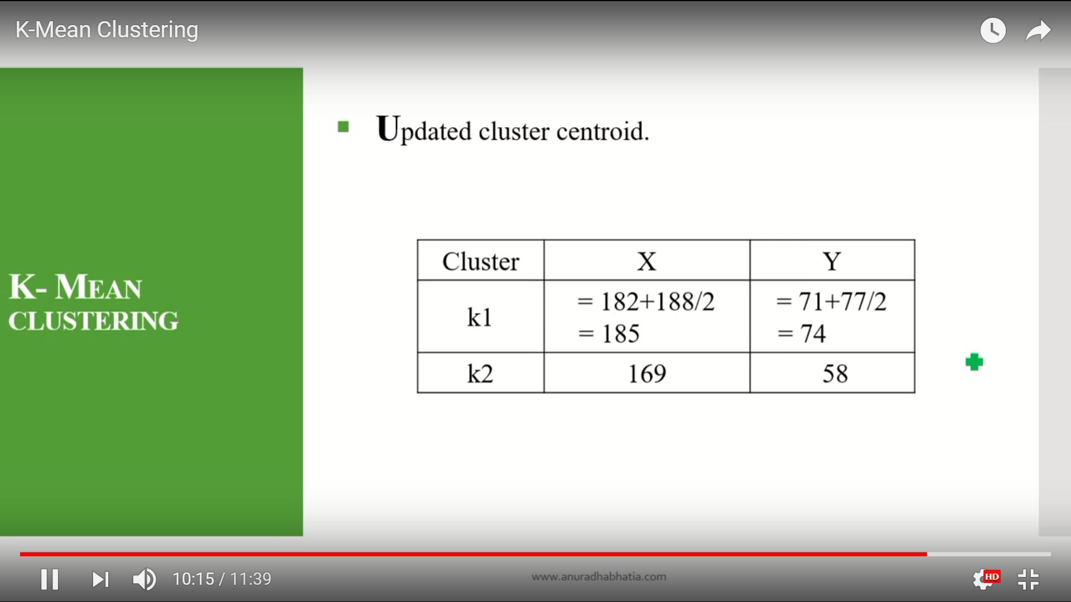

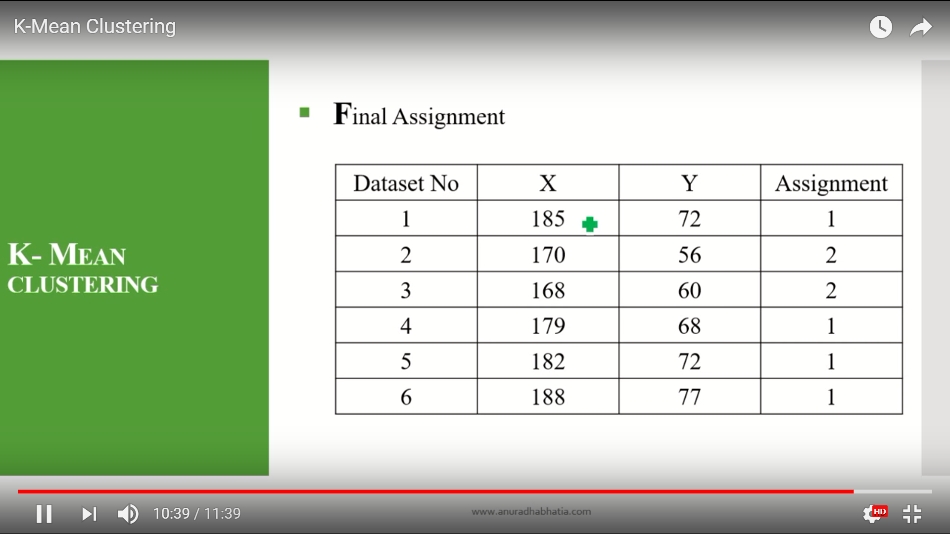

k-mean for single data set.

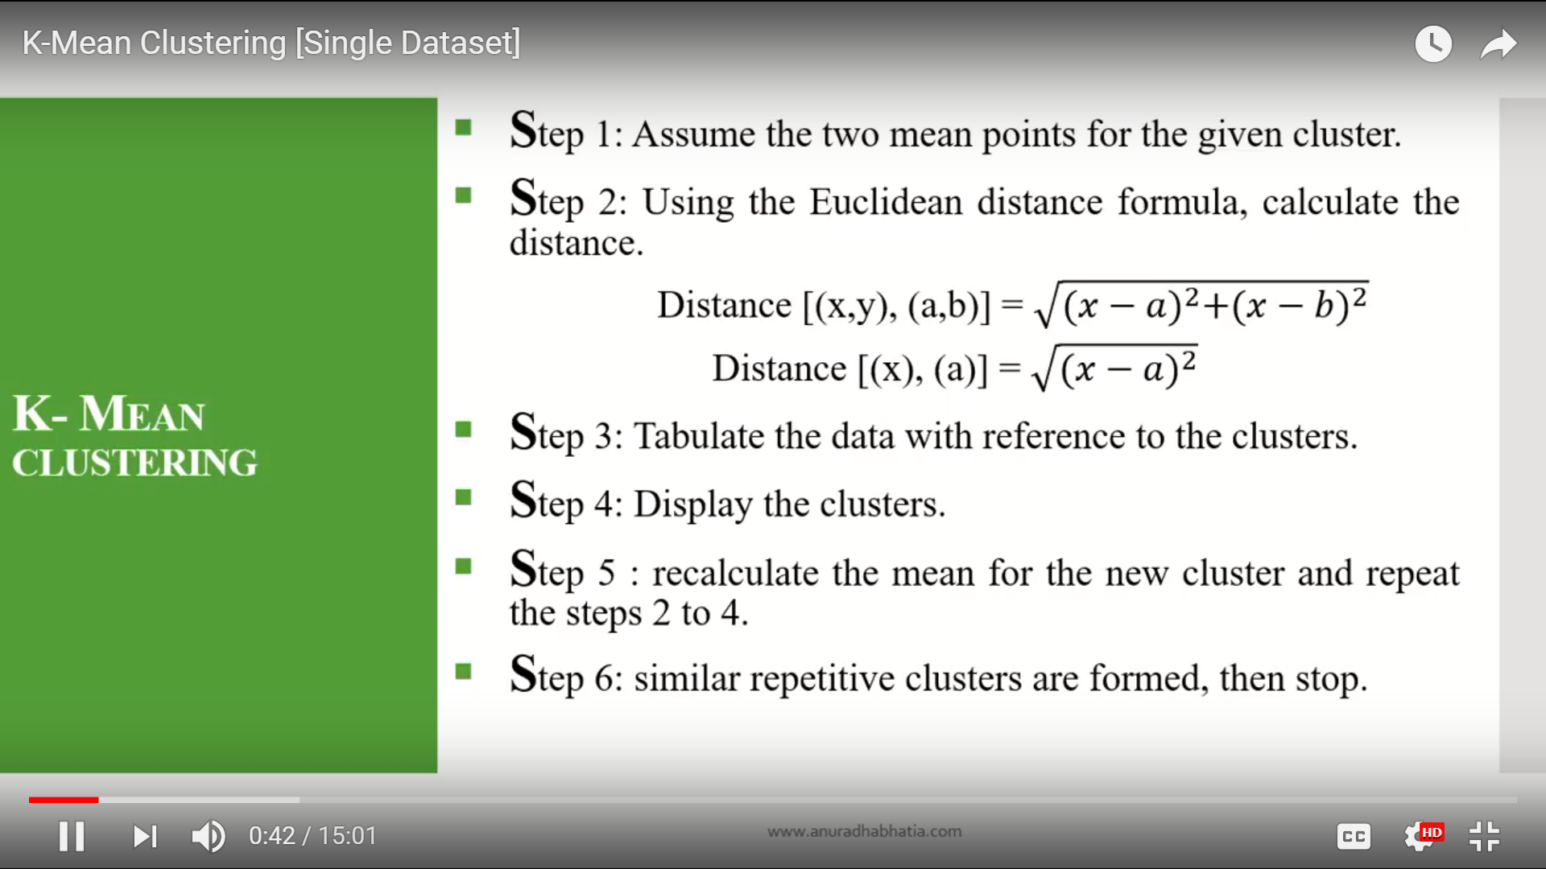

Here in the first step if they gave 3 cluster so assume that three mean points for the given cluster.

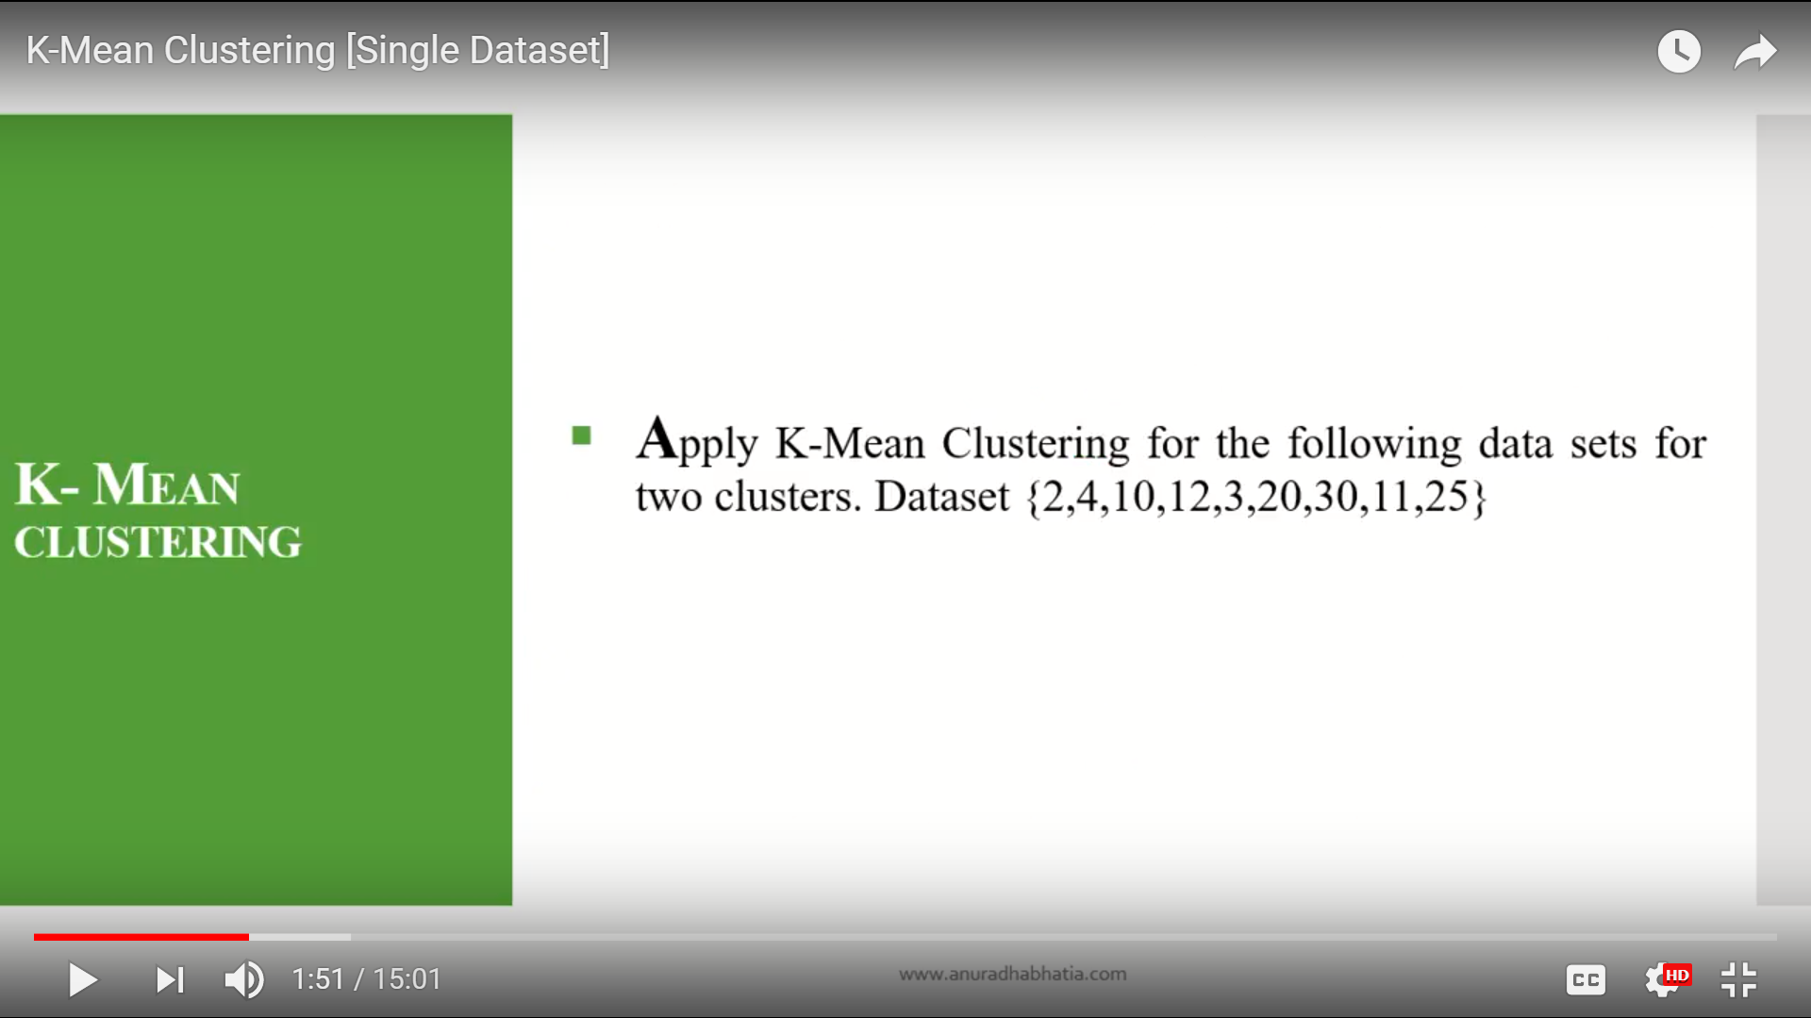

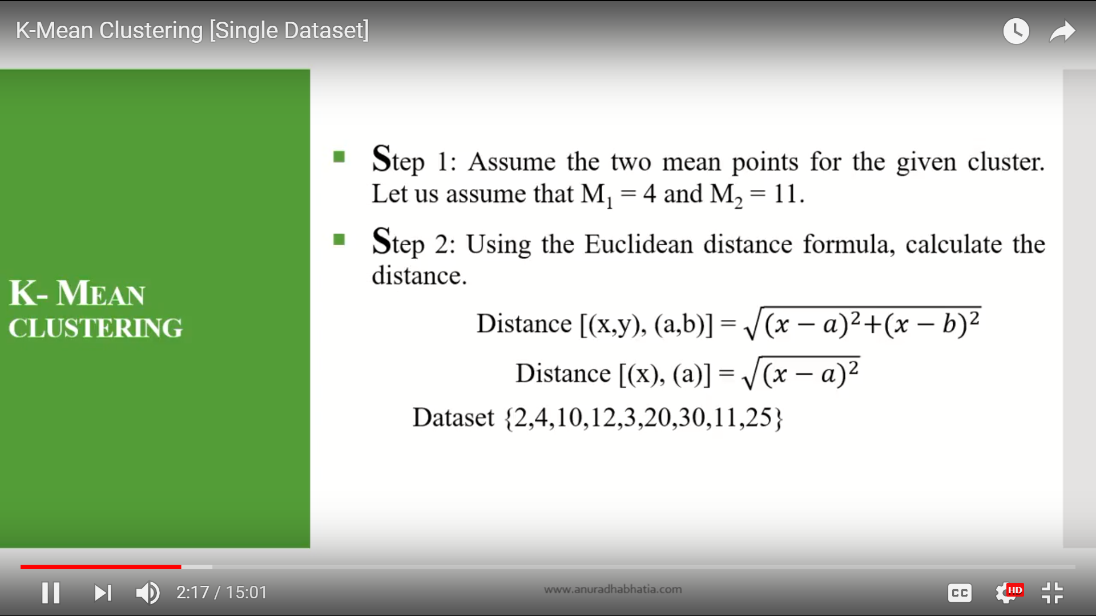

Here in the step one we have to assume the two mean values in the data. any values you can take from the set.if they

tell three mean points in the first step you have to take 3 mean values from the given data set.

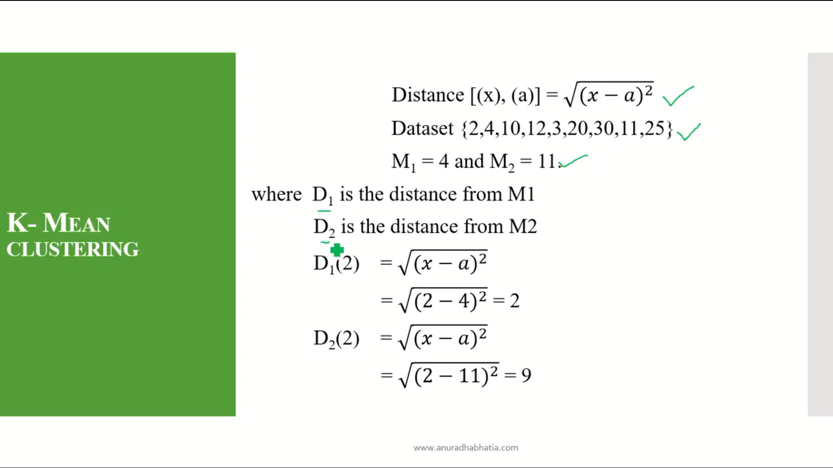

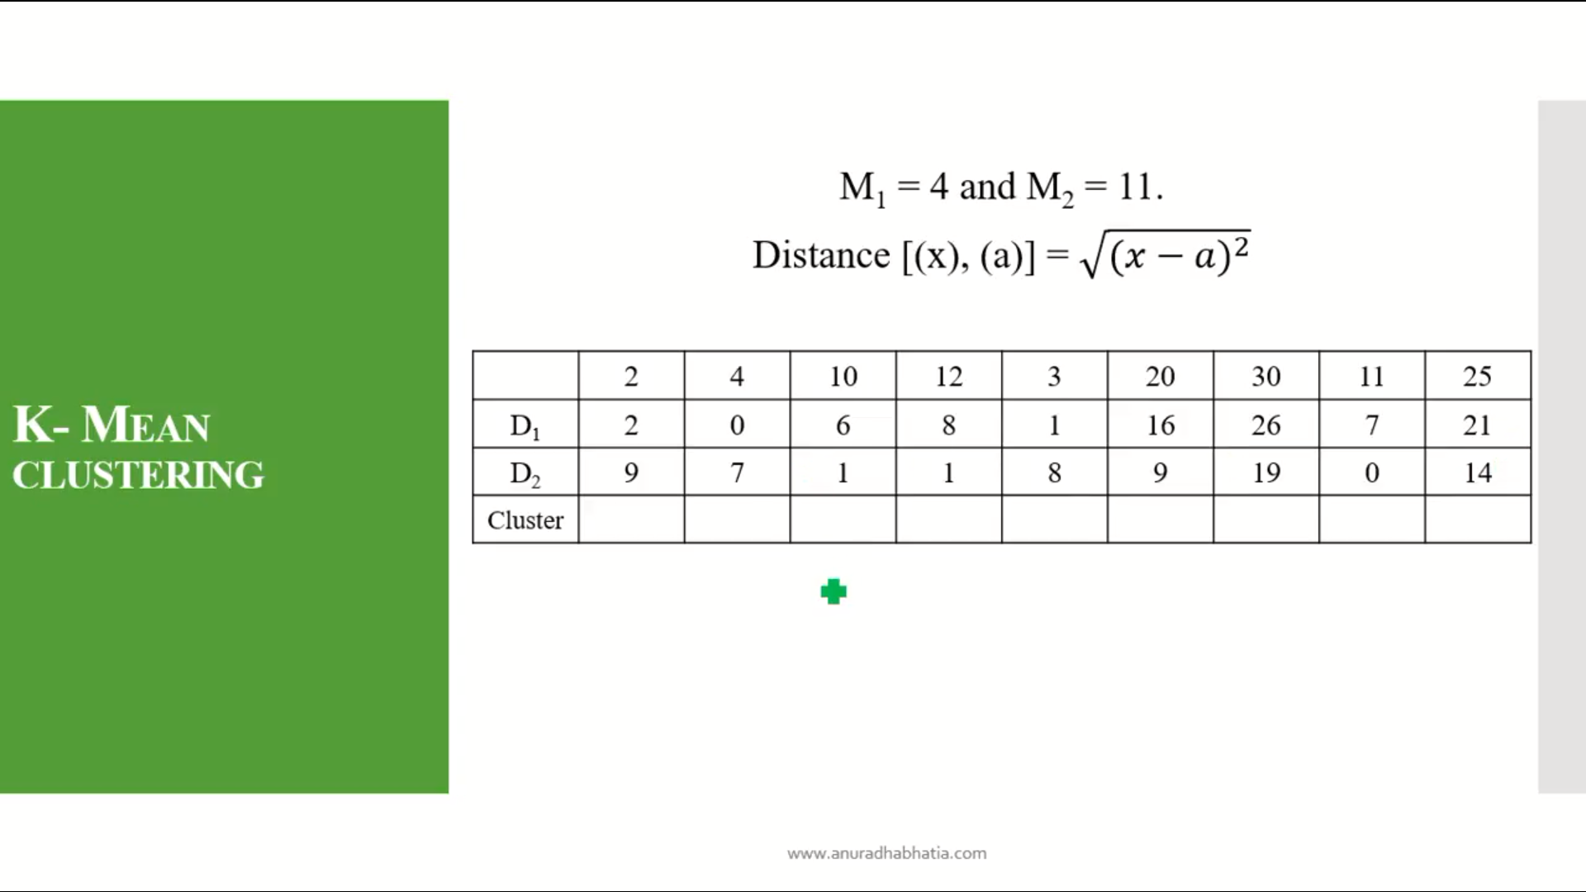

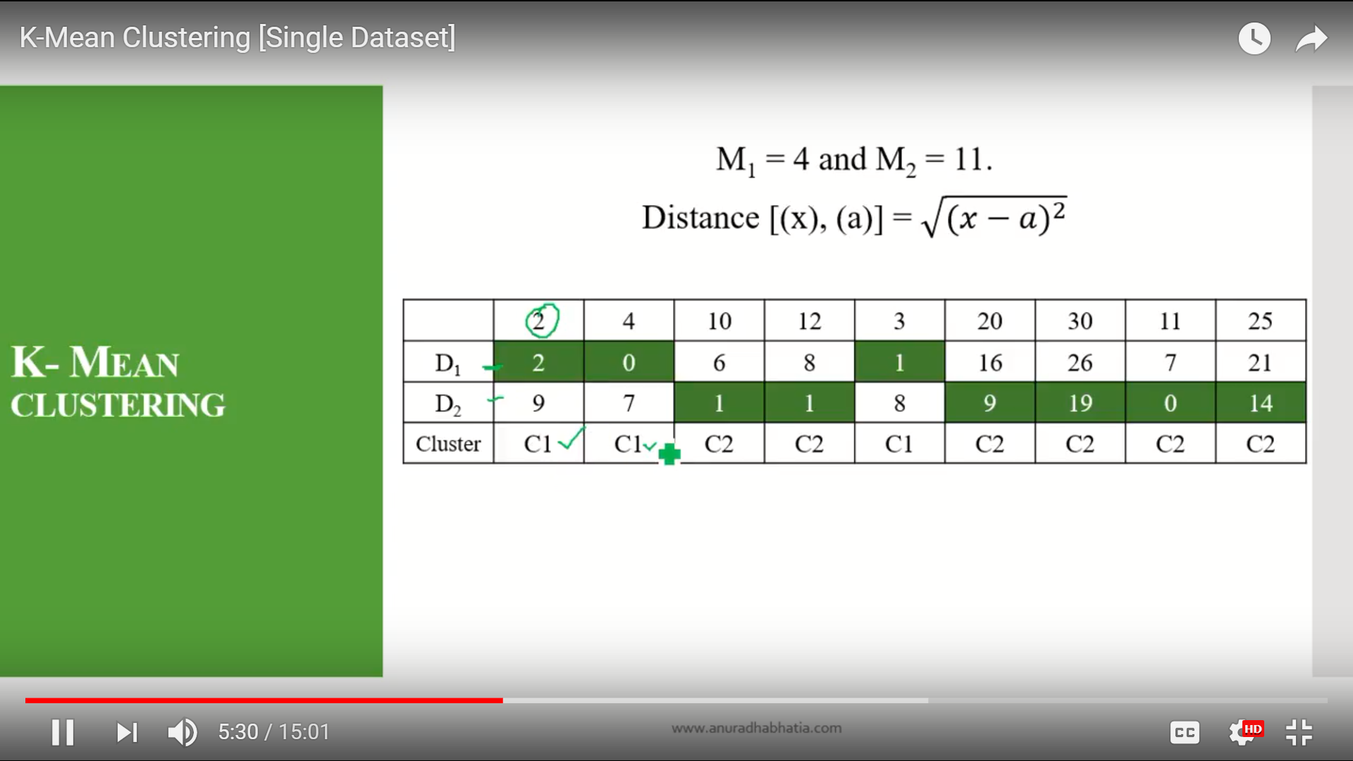

Here minimum values are heighleted for D1 and D2.

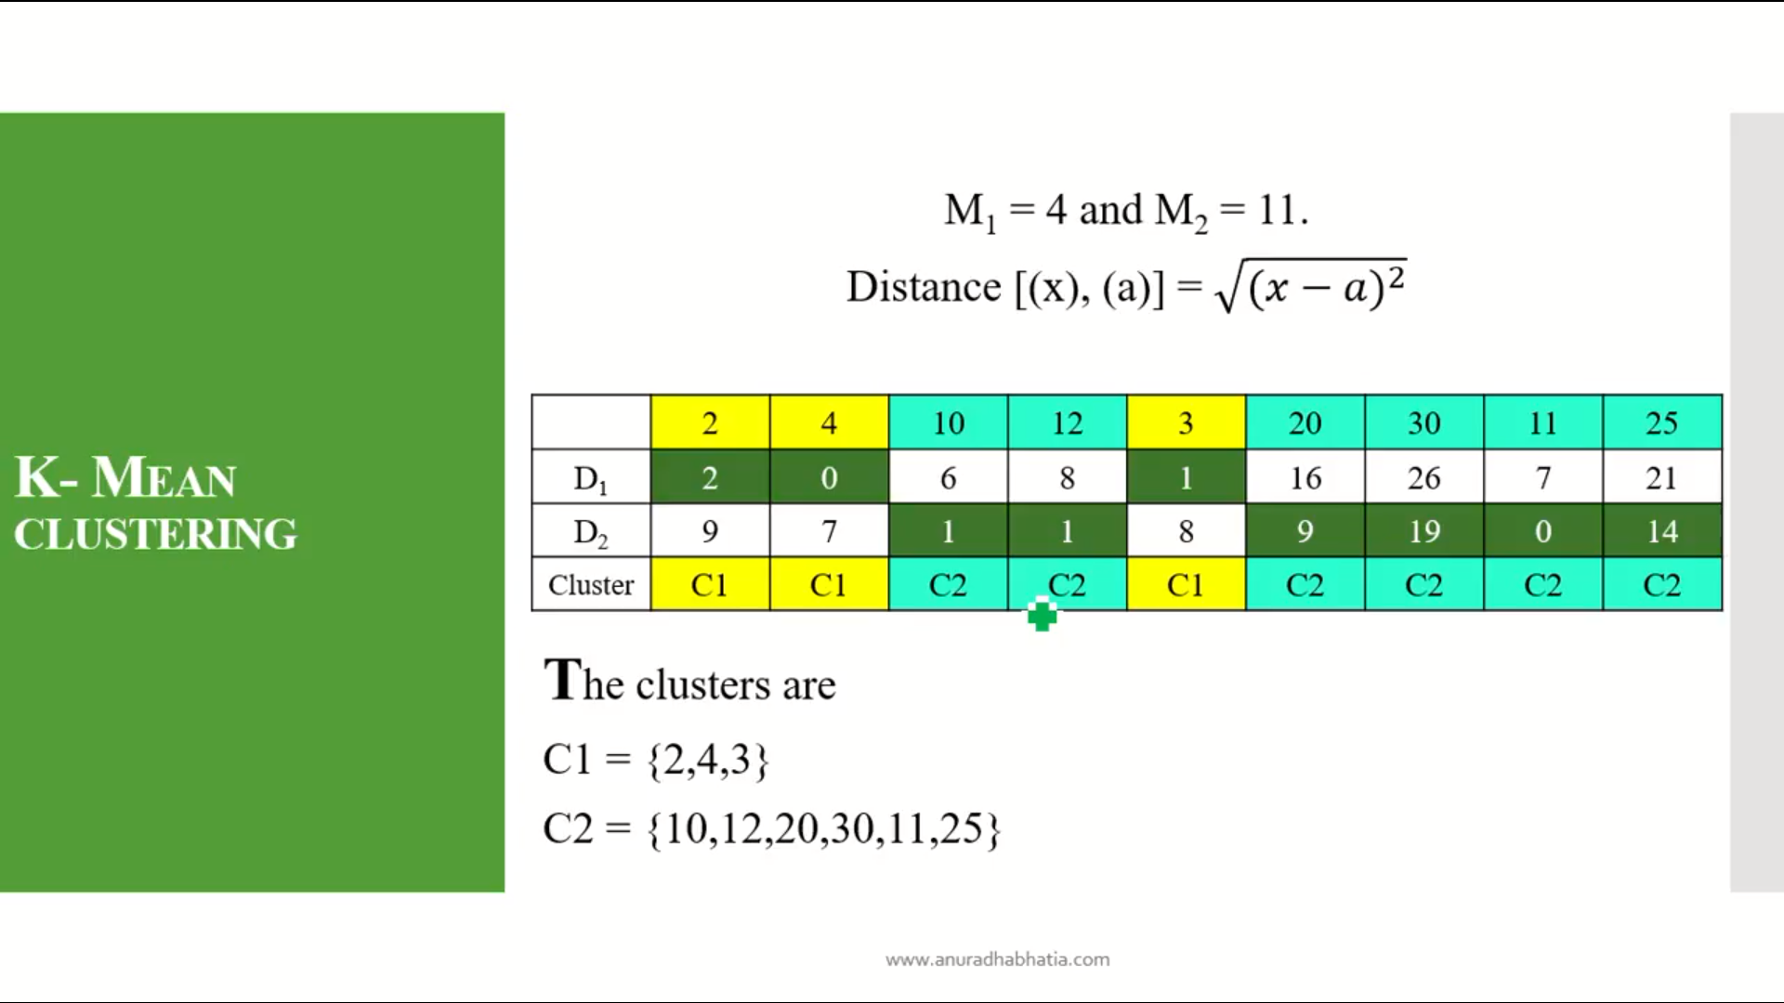

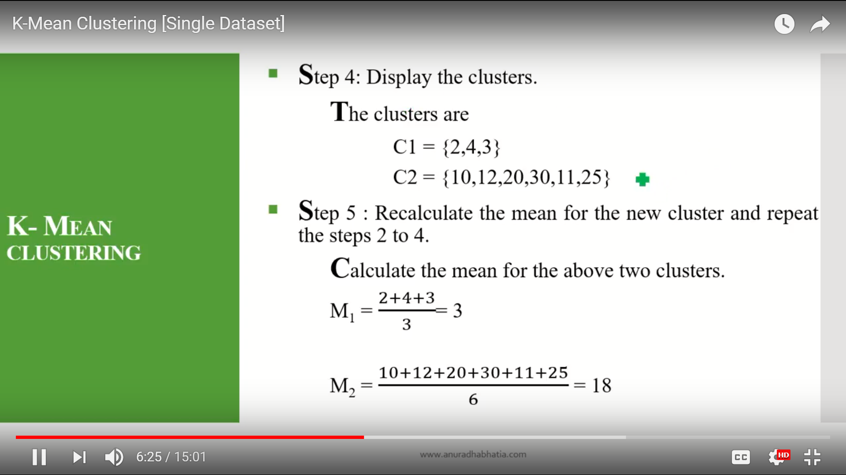

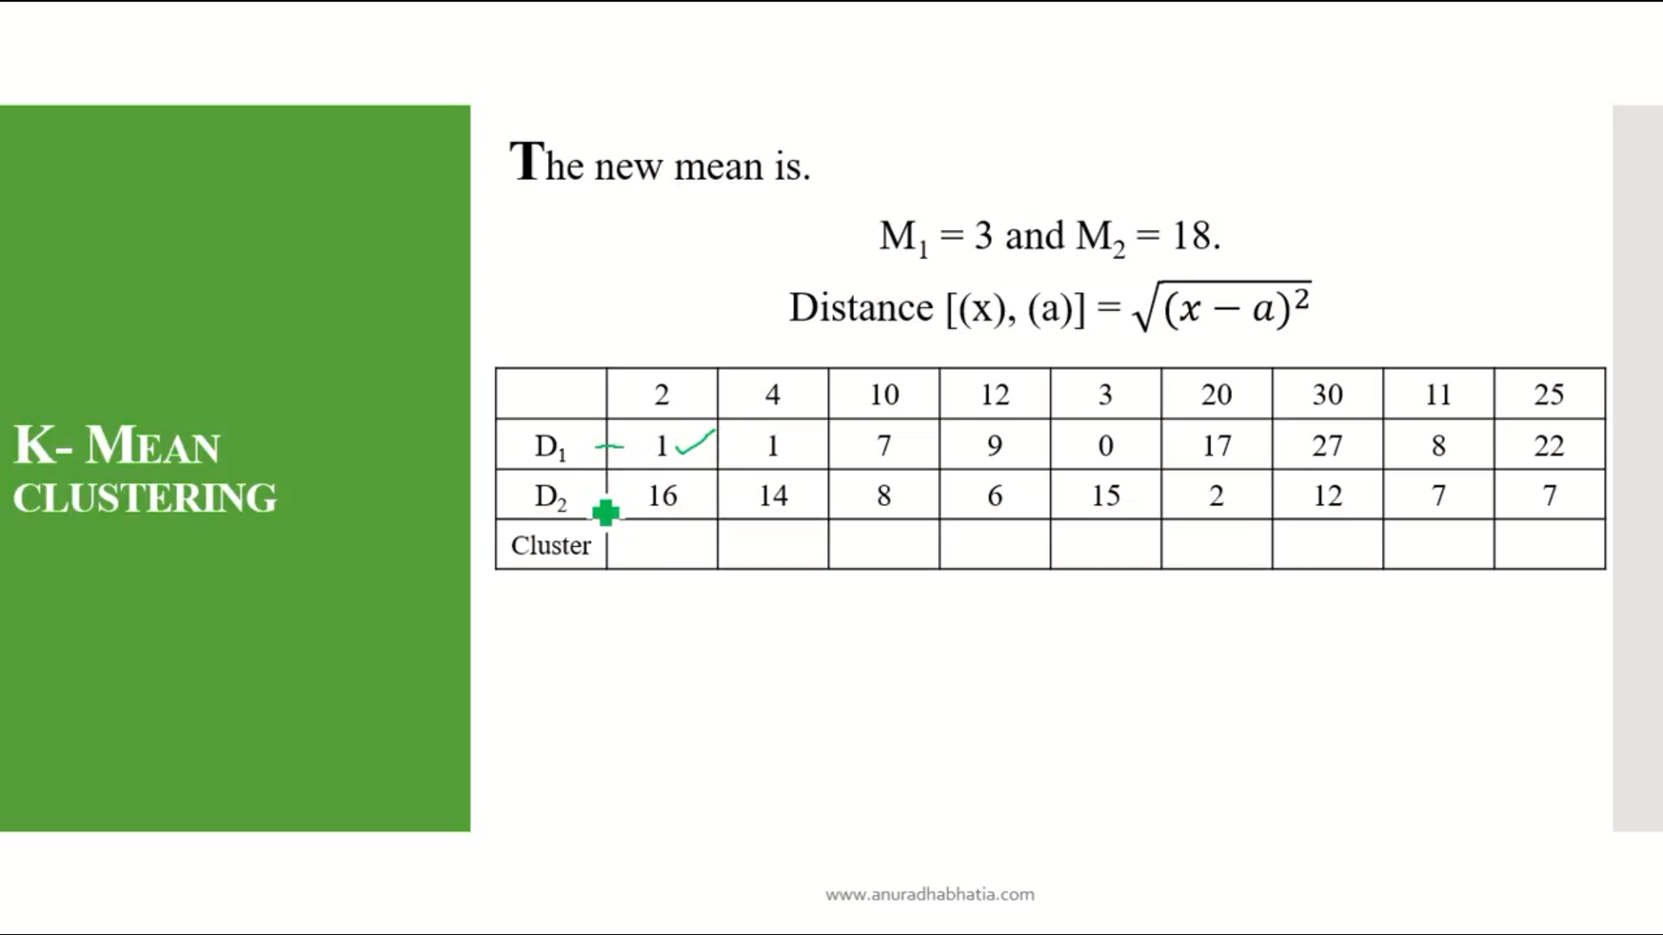

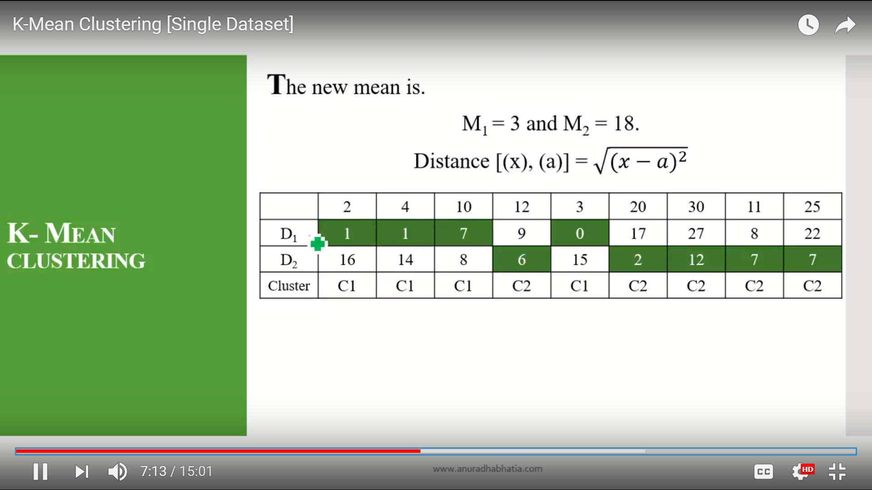

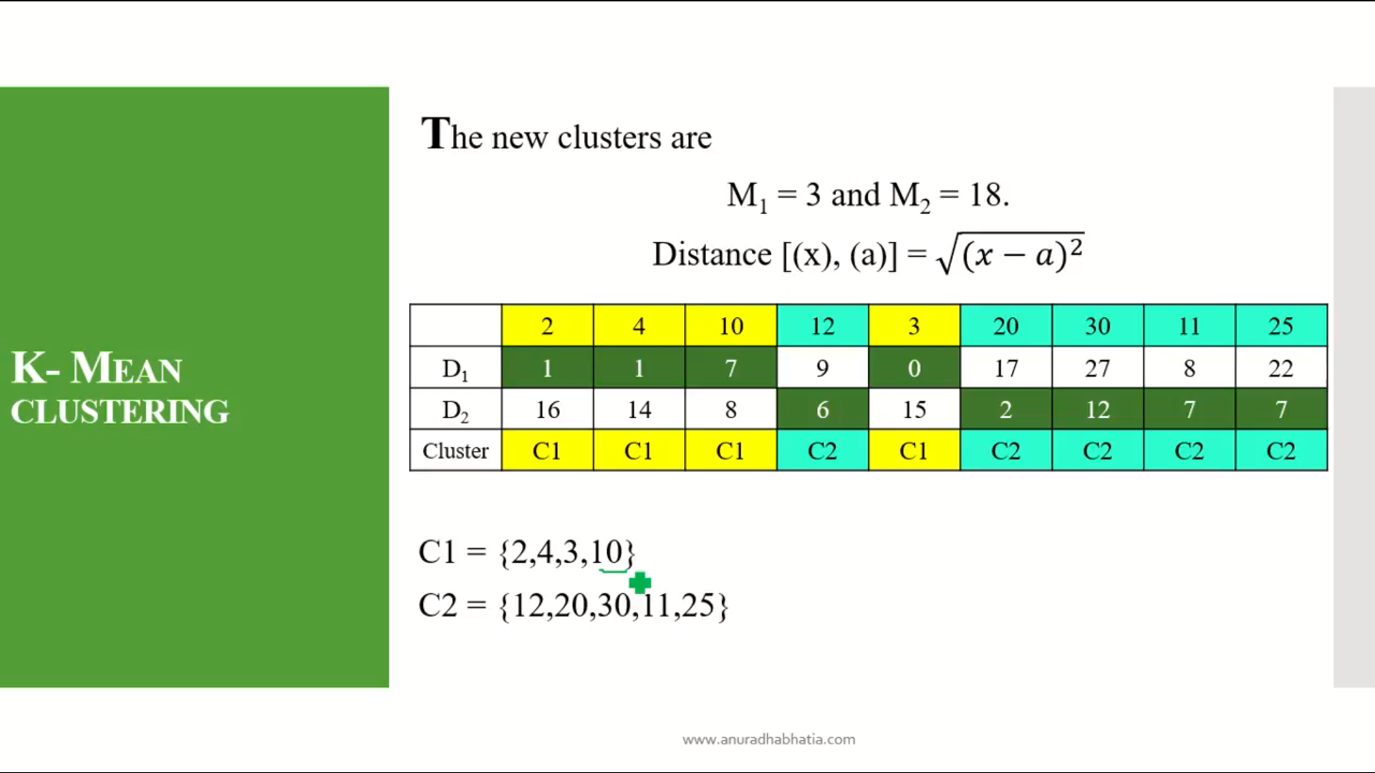

Here the 10 is moved to cluster 2 to cluster 1. So as the moment of item set between the cluster so this can not be final cluster so we start re calculating the mean again with these values of cluster C1 and C2.

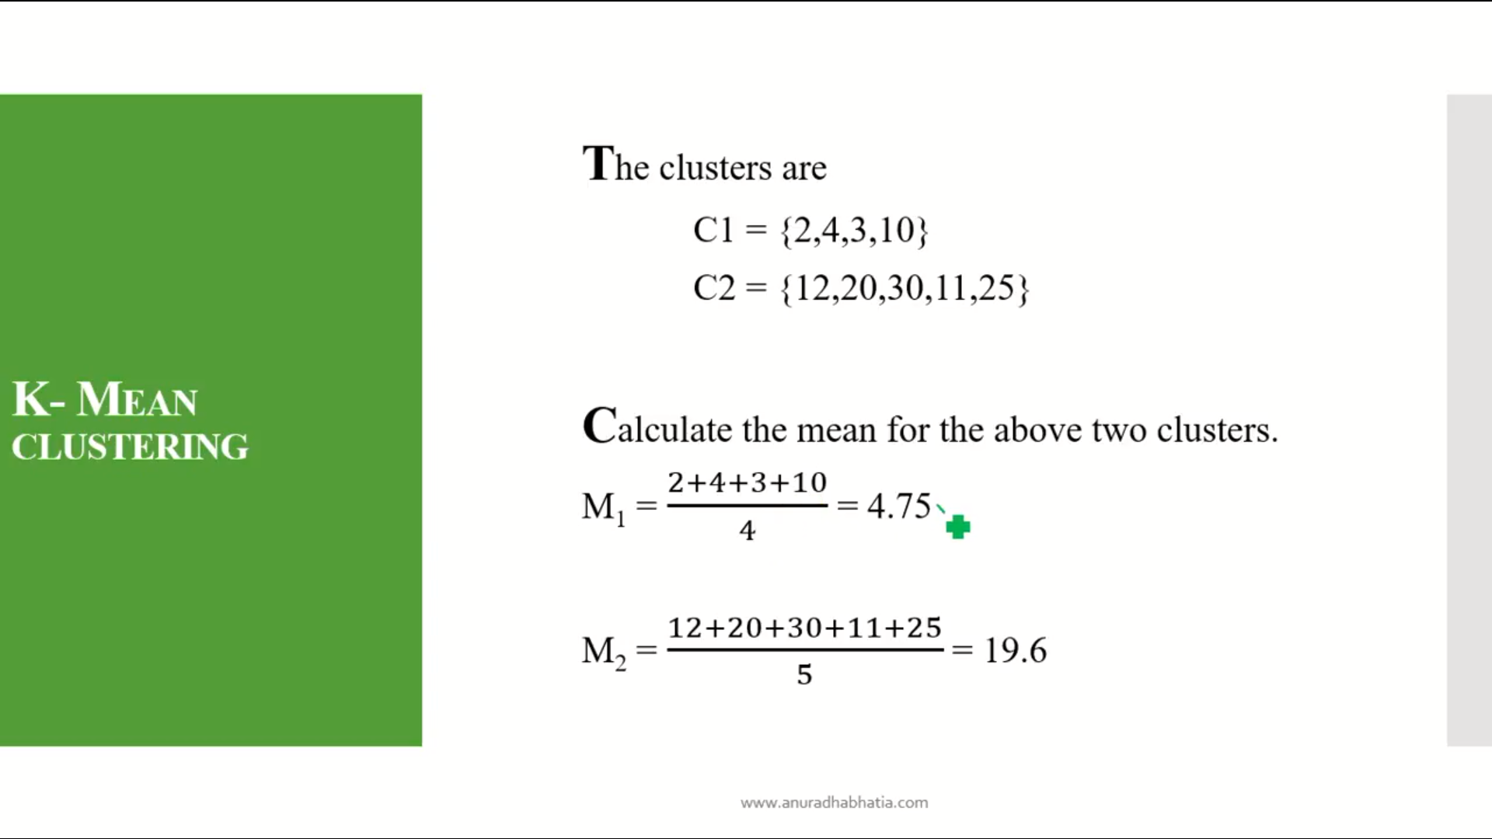

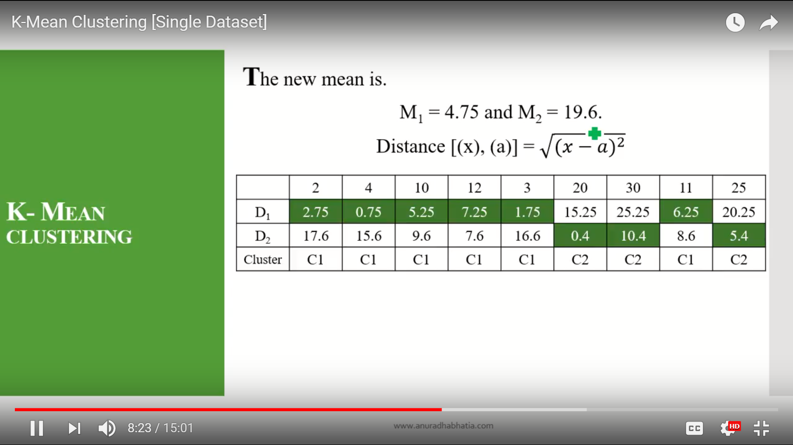

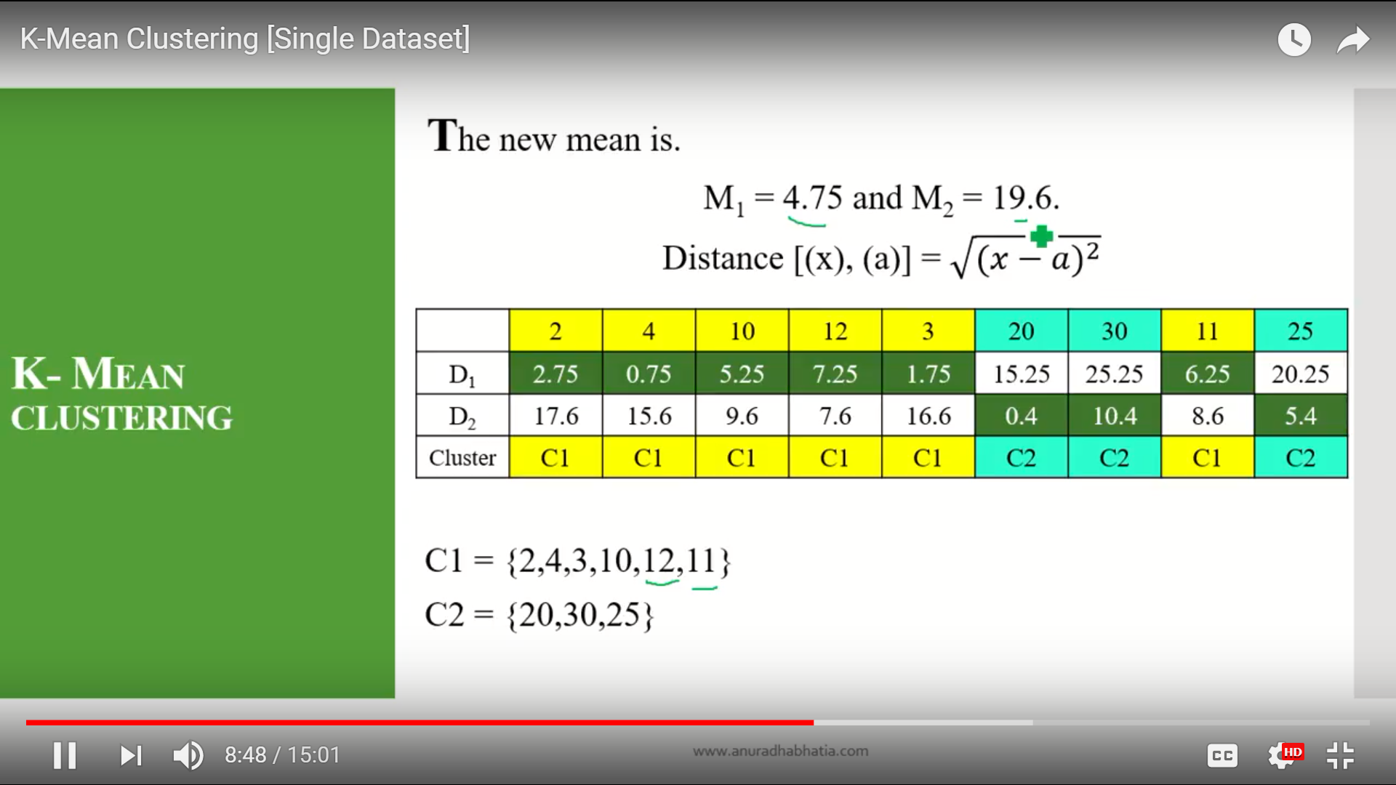

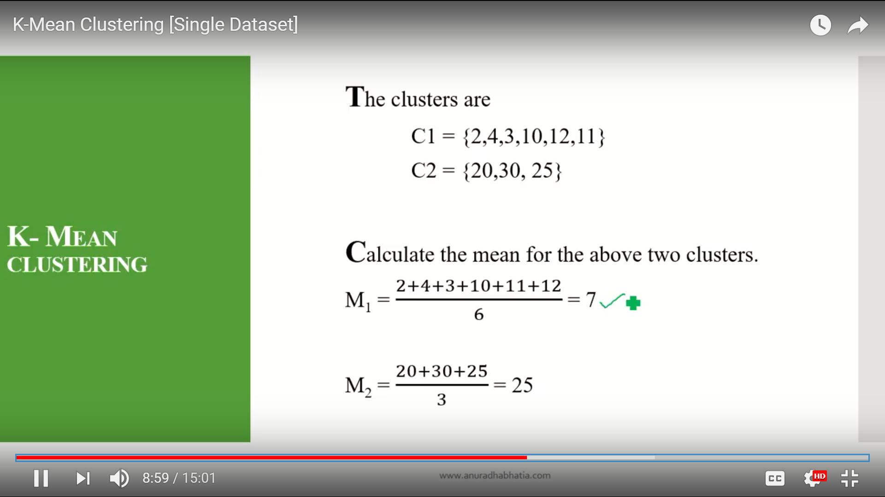

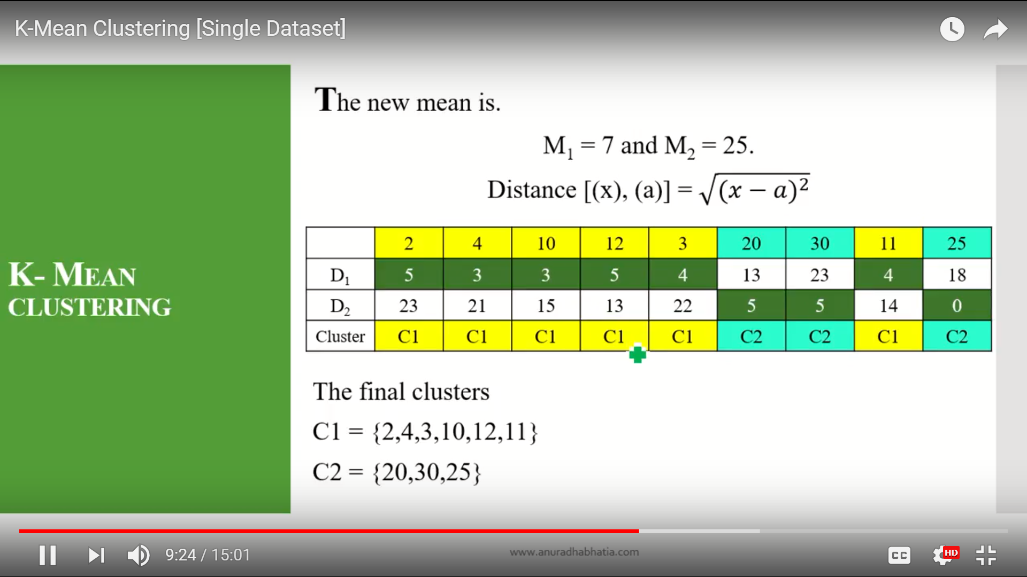

Here the the two clusters are same as previous.

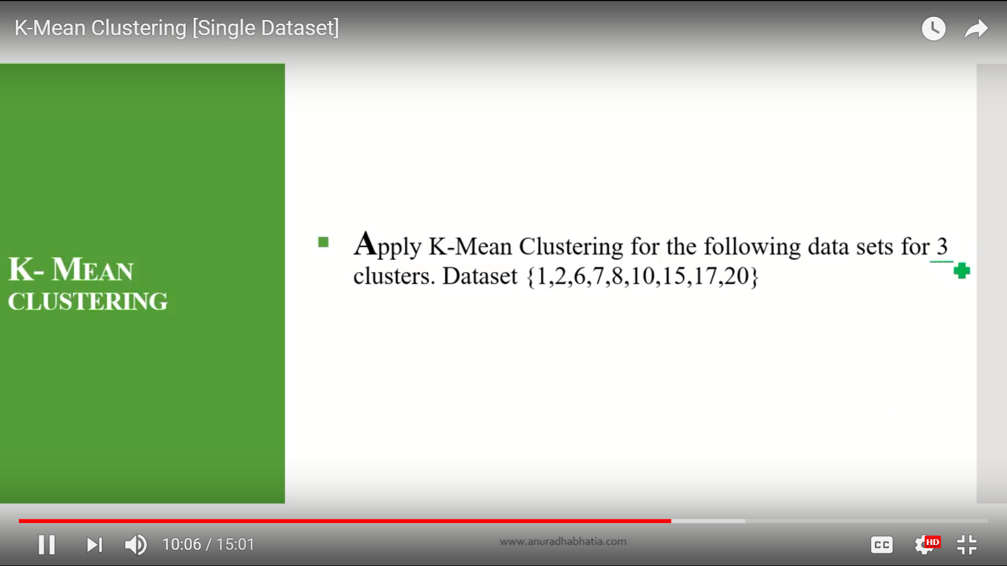

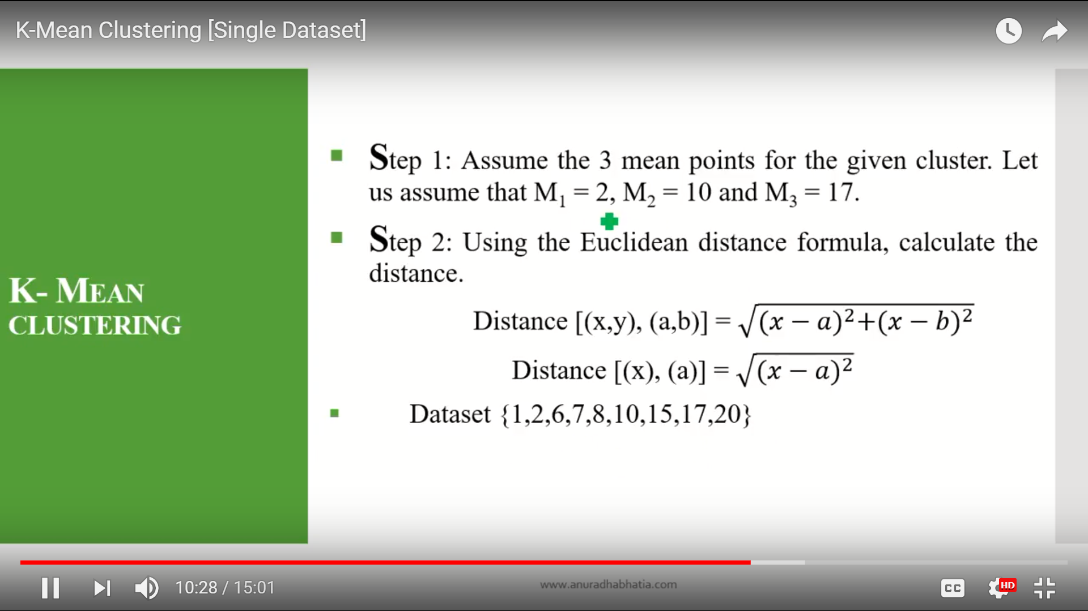

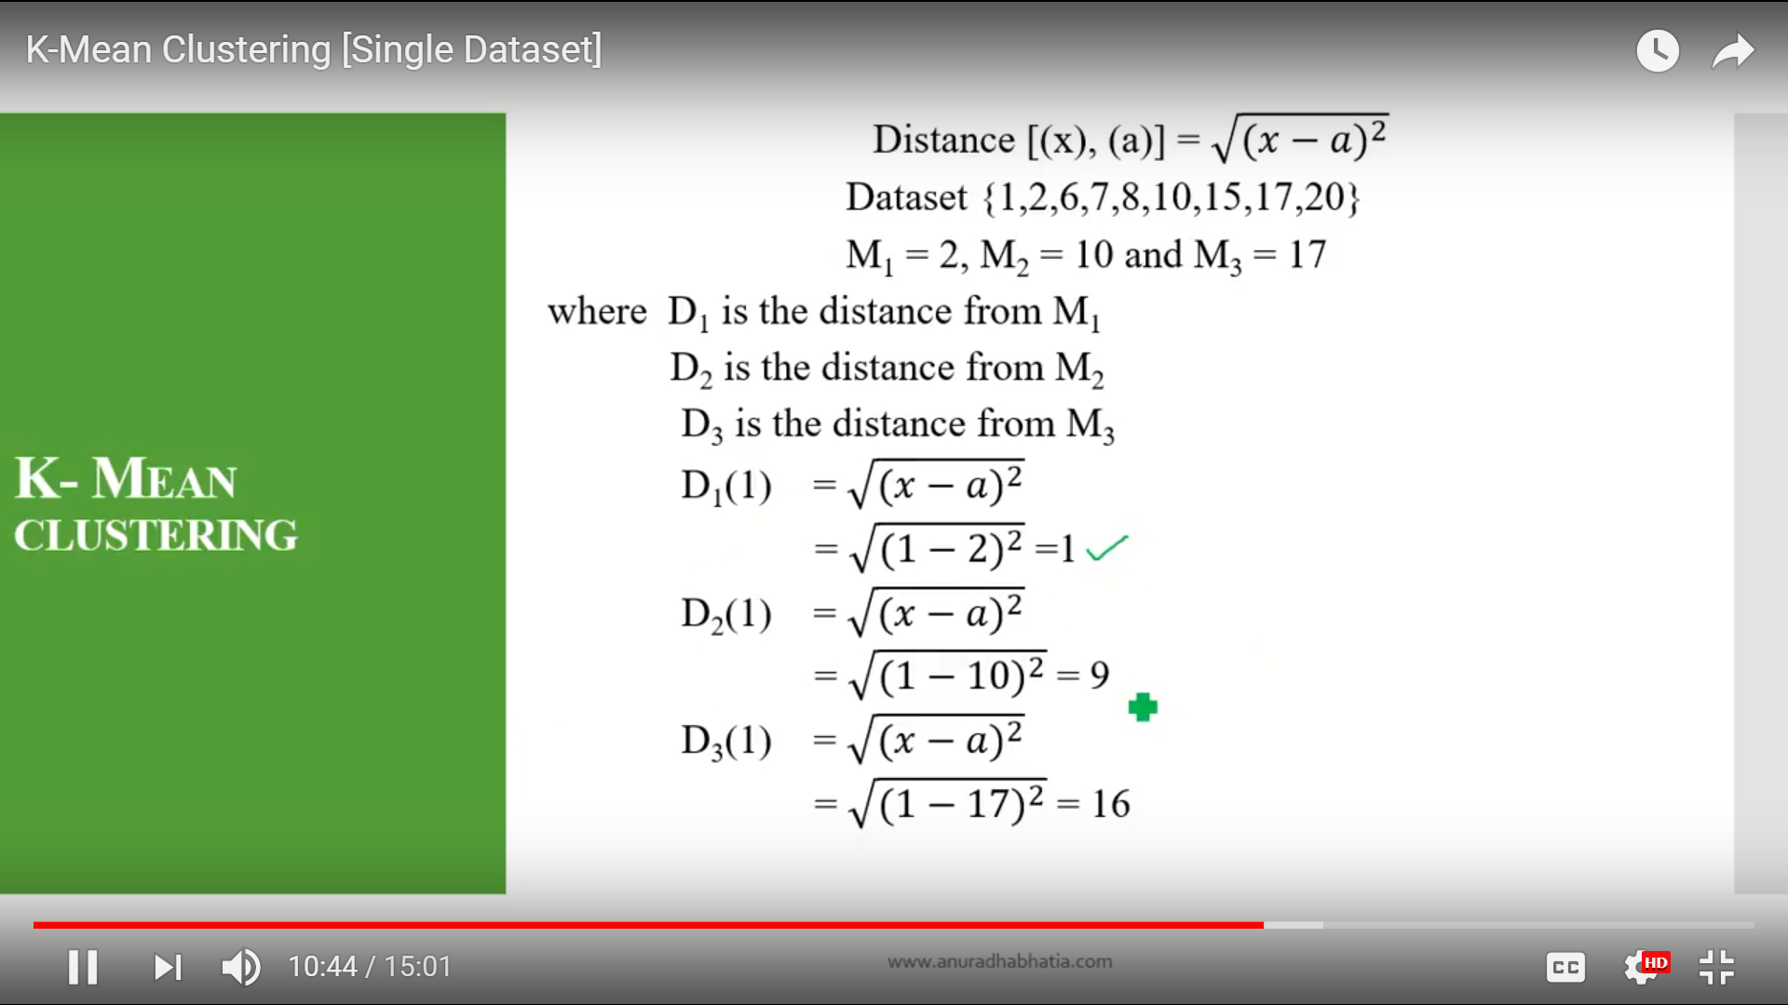

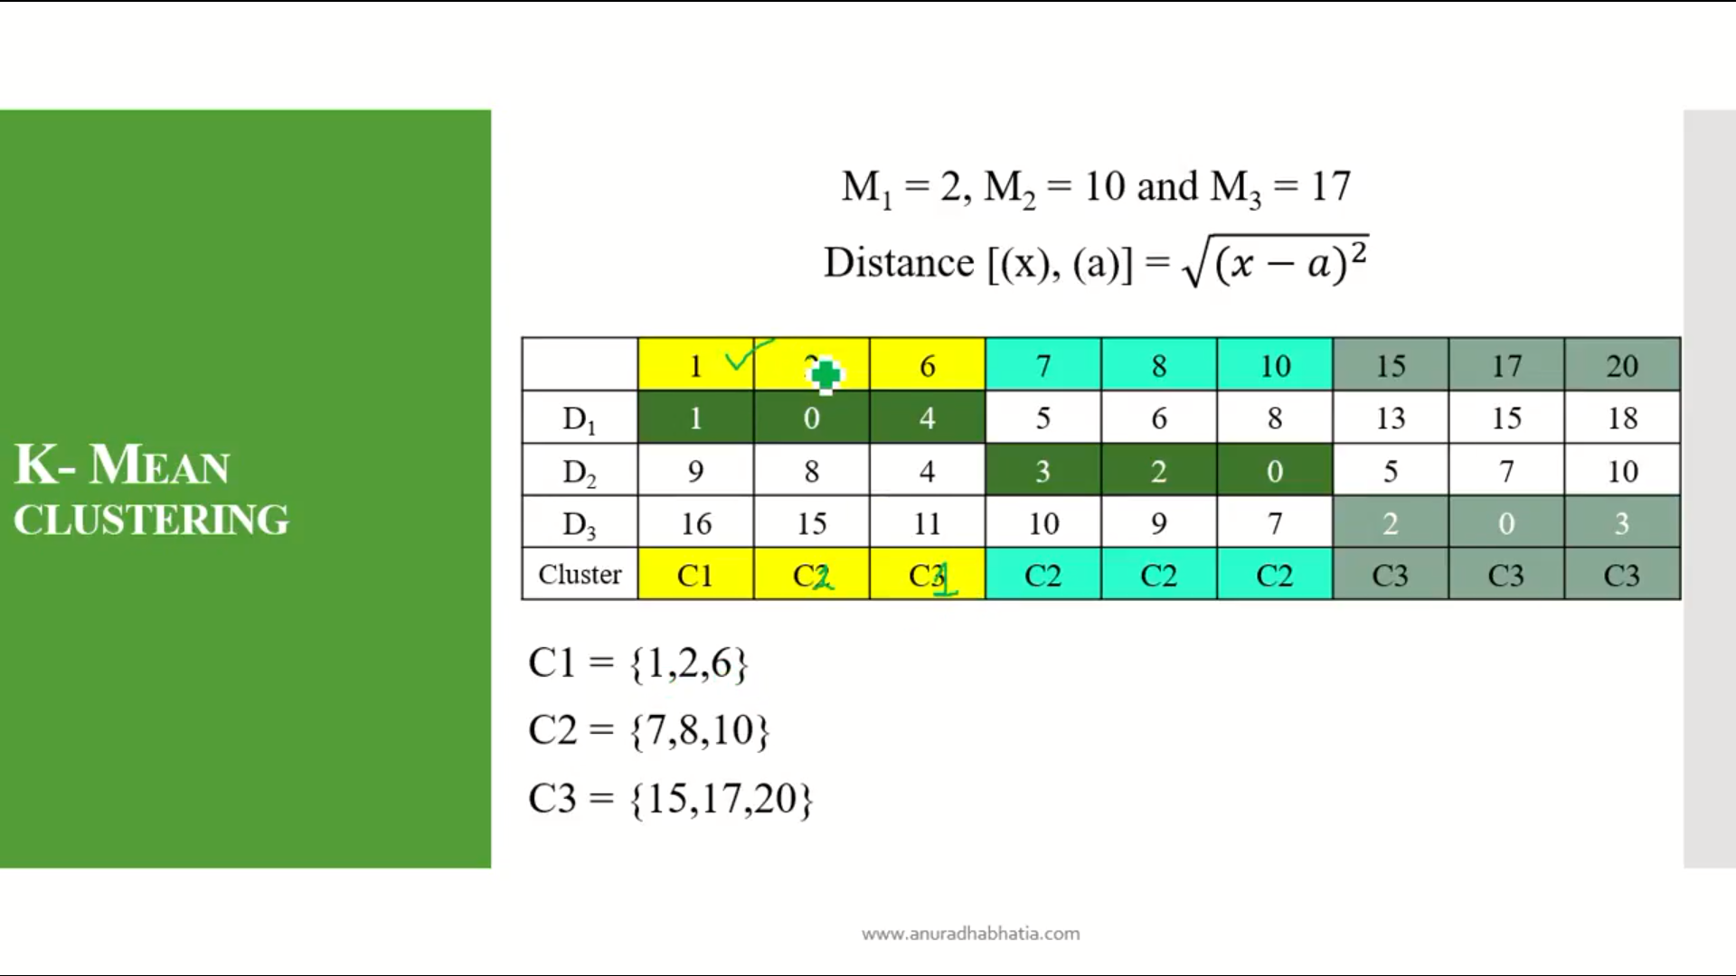

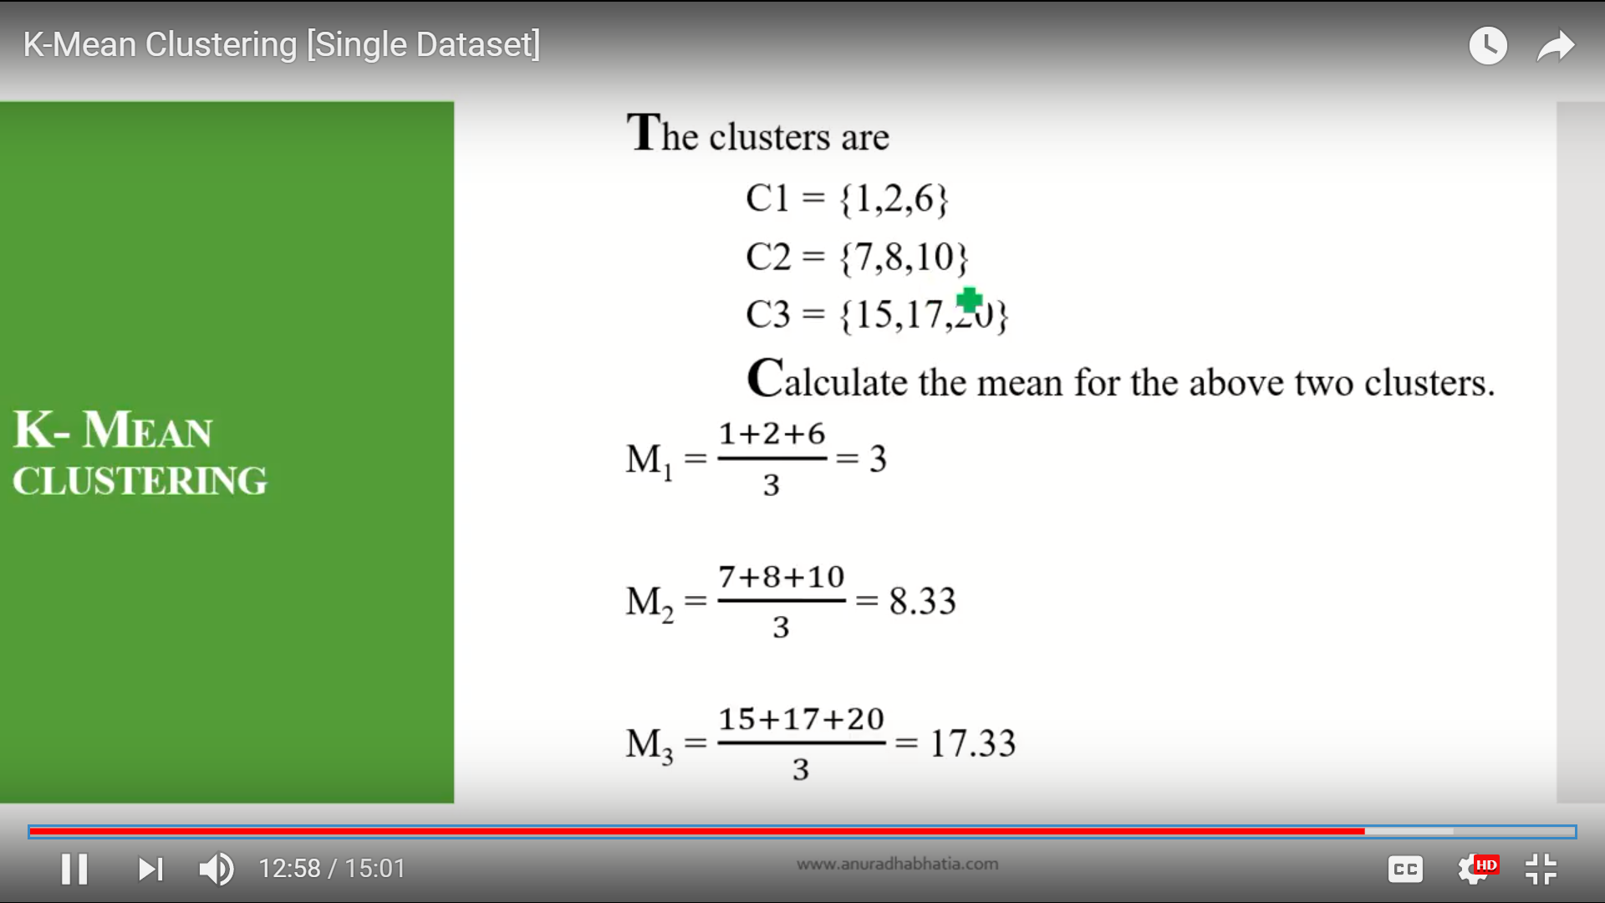

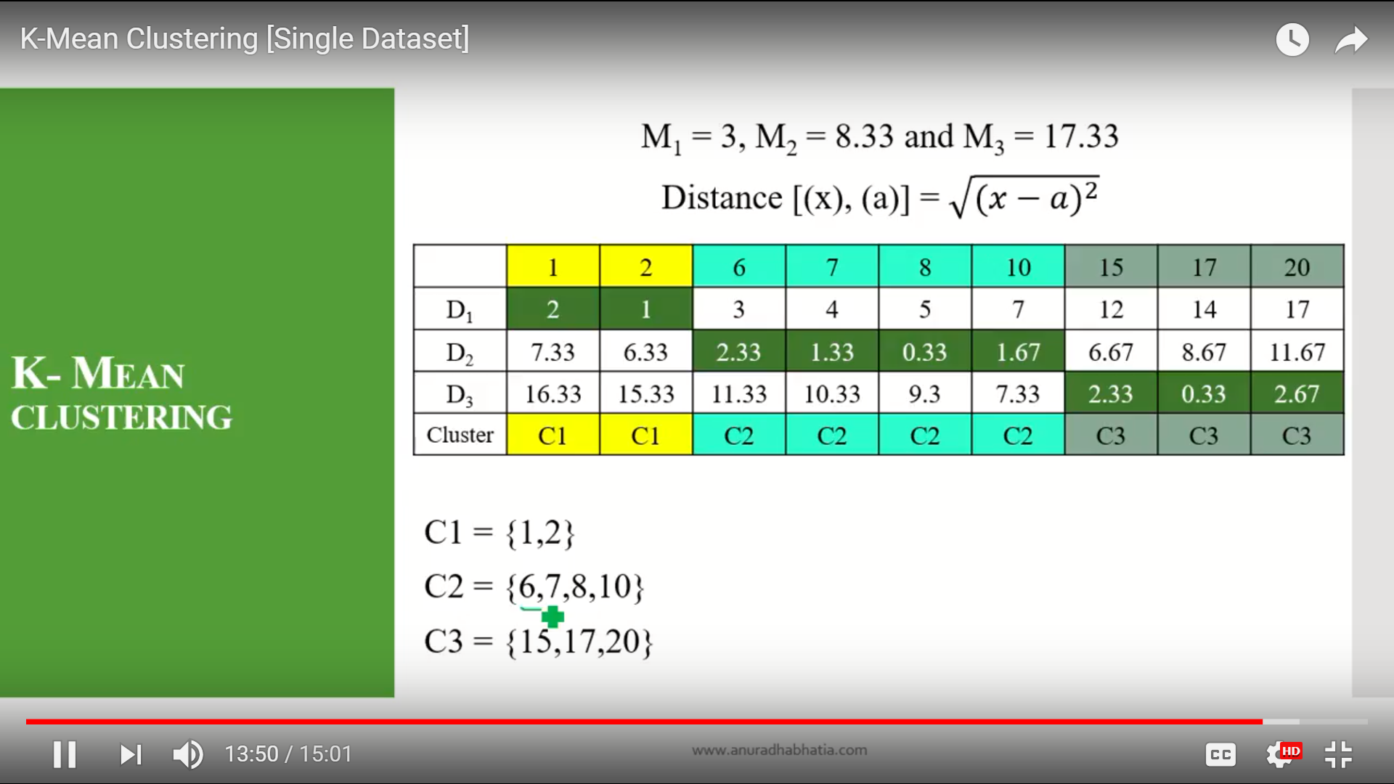

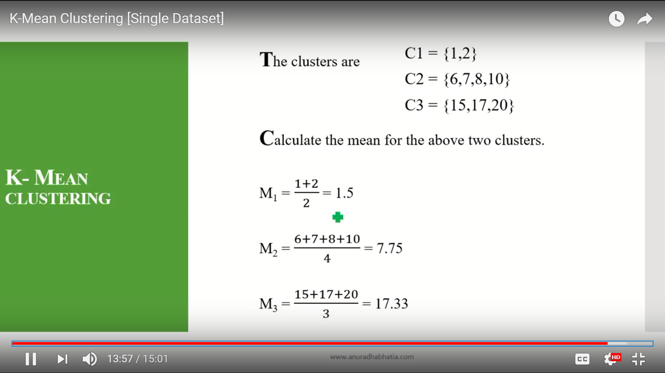

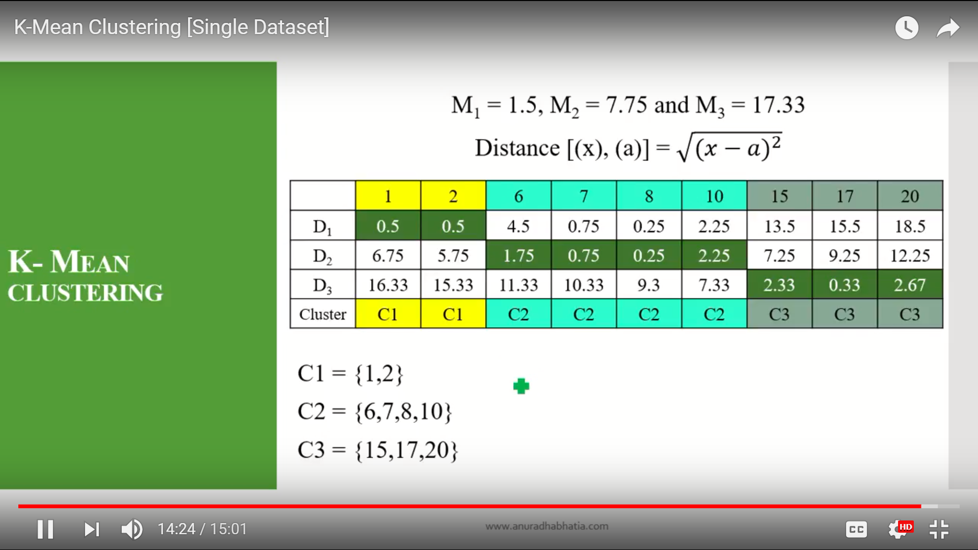

**How Tokenization Can be Used for Securing Payment Card Transactions and Data**

Over the summer, representatives of the merchant community called upon all stakeholders in the payments industry to work together on establishing open and efficient standards to protect consumers and businesses in the United States against security threats.

The Food Marketing Institute, the Merchant Advisory Group, the National Grocers Association, the National Restaurant Association, the National Retail Federation, the National Association of Convenience Stores, and the Retail Industry Leaders Association believe that payment card and other sensitive personal information can be protected across commerce channels by adopting a universal tokenization standard. The organizations believe that this is a step that needs to be taken in order to mitigate identity theft and payment card fraud.

"Regardless of whether a consumer is paying at a brick and mortar checkout, at the pump, on the Internet, or even via a mobile phone, there is a need to ensure the payment data is protected. One way this can be done is through a technology called tokenization," the organizations wrote in a joint [**statement**](http://www.prnewswire.com/news-releases/merchant-community-coalesces-behind-open-process-for-security-standards-to-better-protect-us-consumers-and-businesses-from-cybercriminal-activity-268879481.html) issued July 28.

The U.S. Federal Reserve's Mobile Payments Industry Workgroup (MPIW) has also [**discussed**](http://www.bostonfed.org/news/press/2014/pr092314.htm)the advantages and the challenges of payment tokenization. A report released to the public in late September shows that the MPIW is concerned about the challenges posed by the development of common standards for tokenization, and the lack of consistent terminology. A new tokenization sub-group has been tasked with investigating the challenges.

[**American Express**](http://www.securityweek.com/new-american-express-services-combat-fraud-through-tokenization) has also embraced tokenization. The company just launched a suite of solutions designed to protect online and mobile payments by replacing sensitive card information with tokens.

[**Tokenization**](http://en.wikipedia.org/wiki/Tokenization_%28data_security%29) is the process in which sensitive information is replaced with a randomly generated unique token or symbol. These tokens would ensure that data is not transmitted or stored in an unsecure format. However, for the use of tokenization to be efficient in the payments industry, a universal standard must be created to ensure that merchants can support the technology across multiple providers, and without negatively impacting customer experience.

Furthermore, the groups noted that tokenization can be the answer to securing not just payments, but other aspects of commerce as well, including the transmission and storage of electronic health records and age verification identity checks.

"This call stems from the fact the merchants are required to connect to services provided by the payment industry, and they cannot by themselves perform changes in the way these systems operate," said Irene Abezgauz, VP of product management at Quotium. "The magnetic stripe technology is an old technology, over four decades old. A lot about the way we perform payments has changed, but this technology is still with us, and it’s weighing us back. The merchants need to comply and work with the interfaces they are given."

Experts contacted by *SecurityWeek* agree that tokenization can be an efficient solution for security of credit and debit card data.

"Tokenization is a very useful solution that can protect cardholder data at many points in the transaction lifecycle, especially post-authorization and for recurring transactions once a card has been presented," noted Rob Sadowski, director of Technology Solutions for RSA.

"Tokenization is a great solution that has been utilized for many years to mitigate the risks associated with payment processing for retailers of all types. One downfall to tokenization thus far has been the lack of a standard that everyone followed so this is a great step forward for consumer financial security," said Mark Stanislav, security evangelist for Duo Security.

"Tokenization is the best currently available solution to significantly increase the security around payment card data without having to change anything on the cardholder end," Gregory Nowak, principal research analyst with the Information Security Forum, told *SecurityWeek*.

While tokenization can be an efficient solution, many have pointed out that it's not enough to protect payment card data.

"[There] are no solver bullet solutions and protecting payment card data requires a comprehensive, layered approach. End-to-end encryption during the acceptance and authorization process as well as enhanced card and cardholder authentication technology in addition to tokenization also play an important role in card data protection," Sadowski explained.

"It is best to view the security of payment card data as a series of layers that address different kinds of security threats.  Payment cards can be attacked on several fronts and no solution comprehensively addresses all of them," said David Tushie, standards and technical representative at the International Card Manufacturers Association (ICMA).

The merchant groups that support the use of tokenization noted that criminals can steal payment card data where the card is swiped or a card number is entered, where card information is stored, and where card information is transmitted.

However, of these three vulnerability points, tokenization fully addresses only the second point, storage, and partially addresses the third point, transmission, explained Raymond Côté, president of Auric Systems International, a company that provides payment processing solutions.

"The press release is also unclear as to what is meant by 'supported by all networks, brands and payment types.' Does this imply a tokenized card could be submitted to multiple payment processors? If so, that would turn the token itself into a valuable commodity -- an unfavorable outcome. The value of tokenization is that the token itself is valueless," Côté told SecurityWeek. "One concern in regards to an industry standard for tokenization is that it could result in a monoculture with a single interface into tokenization services. Security exploits propagate quickly within monoculture environments."

**Advantages of tokenization**

The obvious advantage of tokenization is that it preserves the value of cardholder data for merchants and service providers, while making it useless to criminals if it is compromised or stolen, Sadowski said.

"Tokenization dramatically lowers the likelihood of a credit card breach impacting them when a retailer is compromised. By representing their credit card details with a token instead, a breach of one retailer won't require a replacement card to be issued," Stanislav explained.

Rush Taggart, chief security officer at payment processing firm CardConnect, believes that tokenization offers better protection even than high quality encryption because the latter can be broken if the attacker obtains the encryption keys or if they have access to enough computing power.

On the other hand, tokenization doesn't rely on encryption keys so organizations don't have to worry about managing such sensitive data. Tokenization offers a higher level of security as long as the tokenization system is logically isolated and segmented from data processing systems and applications that process or store the sensitive data replaced by tokens.

"Another advantage of tokenization is that it can be applied to all types of sensitive data, not just credit and debit card numbers. Its capabilities include Social Security numbers, drivers’ license numbers, electronic health records, prescriptions, and even addresses – all personal information that should be properly protected," Taggart told *SecurityWeek*.

Another advantage, pointed out by Nowak, is that tokenization can reduce the scope of systems for which PCI DSS compliance needs to be demonstrated. "Correctly implemented, it can both improve security and lessen the compliance burden," he explained.

Taggart has noted that many large and small merchants in the U.S. have already implemented tokenization to radically reduce their PCI scope.

"Maintaining PCI DSS compliance across thousands of machines or more is extremely costly. Maintaining PCI DSS compliance for a small number of systems running the tokenization service is quite manageable. Utilizing a Visa-approved tokenization service provider can reduce PCI DSS compliance to just a few questions," Taggart explained.

**Disadvantages of Tokenization**

As with all technologies, tokenization has some disadvantages. One of them, as pointed out by Sadowski, is that the most secure implementations require that the original card number be presented for tokenization. This means that the tokenization solution must have a way to protect the original cardholder data before it is tokenized. Furthermore, the centralized token vault in which the original payment card data is stored becomes an attractive target for criminals.

Another issue, according to Tushie, is related to infrastructure.

"Tokens must be created for each merchant and card account.  When a transaction flows through the Merchant and Acquirer processing systems, these account tokens must be de-tokenized so that the Issuer can approve the transaction for a known card account.  Transaction settlement messages must be tokenized for Merchant and Acquirer systems," said Tushie. "This requires new infrastructure of trusted third parties in the transaction flow to tokenize and de-tokenize card accounts in these transactions.  While this is not seen as a huge technological hurdle to overcome, it likely will add cost to the transaction fees for these third party services."

Côté believes one of the disadvantages is that using payment processor specific tokenization, for instance, locks organizations into a particular payment processor. That's why the tokenization service should support multiple payment processors or it should be payment processor agnostic. Other issues highlighted by the expert are the potentially negative impact on the speed of transactions, and the fact that data analysis can't be performed on tokenized data since "good" tokens do not allow the initial data to be reconstituted just from the token itself.

"The only disadvantage I currently see is the recent watering down of what qualifies as a token. When we first developed our tokenization solution, about eight years ago, only random number strings with no value could be considered tokens," said Taggart. "Now, there are things known as 'cryptographically reversible' tokens, which just seem to be created with a high-level of encryption – there is the risk the code could be cracked. The question remains how a business can receive an honest answer as to what type of tokenization a payment provider uses."

"One of the concerns is replaying – we need to be sure that our token cannot be replayed or reused, because if it can – attackers will just use this token instead of the actual data and achieve the same criminal goals," said Abezgauz.

**Addressing the challenges**

One of the challenges that must be addressed in implementing tokenization is that existing applications and infrastructure might have to be retrofitted or built from the ground up to accommodate the change, said Stanislav.

Tushie noted that secure financial payment cards, by their nature, must be interoperable in international interchange.  For example, a card issued in the United States must work at point-of-sale terminals in Singapore or Paris, and vice versa. This means that international standards addressing the card technology as well as the processing systems in which they work must be developed and agreed upon. However, the expert has pointed out that technology frameworks for tokenization have already been proposed by international standards organizations and EMVco, which manages, maintains and enhances the EMV integrated circuit card specifications for chip-based payment cards and acceptance devices.

"With strong industry backing, clear guidelines, and well devised reference implementations, tokenization will have the best chance to succeed in a timely manner. With consideration for keeping backwards compatibility with the primary account number (PAN), organizations would be more likely to adopt tokenization more quickly if there were fewer technical hurdles in their way," said Stanislav

On the other hand, Côté highlights that in many cases the barrier to implementation is not technical, but institutional.

"Corporate reluctance to mandate proper security and privacy (whether PCI, HIPAA, or regional security standards) handling of their data is the largest challenge," he noted.

According to Abezgauz, the balance is between the tokens not being replayable, and usability/scalability.

"Do we provide a new token to the user every time? How do we manage these tokens? We need to make sure we can easily connect the real payment information to the token. For smaller organizations this can be doable, but it’s not trivial when looking at massive scale," she noted.

"One solution is providing means to do a challenge/response mechanism that will ensure that the user information never leaves the user possession. One example is the end-to-end encryption solution suggested by Visa. They released recommendations for doing end-to-end encryption to protect user data," Abezgauz added. "When we talk about user payments though, how do we extend this from POS to online purchases where users want to be able to perform purchases using their payment card from different devices – mobile devices, laptops and more. Currently users are not supplied with card readers. It can be one option for a solution though."

**Conclusions**

Some experts estimate that it would take several years to adopt tokenization on a wide scale. Abezgauz argues that tokenization on a wide scale is not trivial. "I do not see it happening in the near future. I am also not sure that eventually tokenization will prevail over end-to-end encryption solutions," she said.

Taggart is more optimistic and points out that the recent data breaches have led to a surge in interest in these technologies.

"There are so many variables here that it is hard to say. If there was a dedicated effort to implement tokenization into all payment channels and tokenize all legacy cardholder information in software systems, I would say a lot could be done within the next six months to one year," he said.

"Tokenization is the pinnacle of data protection technologies. The physical and logical separation of payment and privacy information significantly reduces a company's exposure to information theft. Well-tested, reliable, and flexible tokenization services are available today; there is no technical reason to delay implementation," said Côté.

Rick Ricker, VP of enterprise payment solutions at 3Delta Systems, a provider of payment and data tokenization services that specializes in card-not-present tokenization, says his company is pleased that the merchant community is recognizing tokenization as a valid technique for protecting customer data.

"Tokenization has gotten a fair bit of attention lately with efforts by the Clearing House and EMV (the card brands) touting solutions for transactional tokens.  The proposal to have ANSI x.9 create the standard to make it open is an interesting twist, of course the merchants have an interest in an open system that will have low cost," Ricker said. "Overlooked in these recent announcements about new standard proposals is that currently there are several hundred thousand merchants that have already adopted tokenization offered by 3Delta and other gateways, as well as the processor community.  These solutions have tokenized and protected millions of credit cards.  Any merchant desiring a tokenization solution today can choose and implement today without waiting for a new standard."

Nowak says tokenization is not a magic bullet, and organizations should only implement it after they've properly assessed the risks and benefits.

"Its primary benefit is to reduce the number of merchant systems on which cardholder data resides, thus reducing the PCI DSS compliance burden, and hopefully reducing risk of data loss as well.  Any organization considering implementing tokenization should do so only if their risk assessments have determined that, of all the major security initiatives they could undertake, this was the one that would have the most significant positive impact," he explained.

Stanislav believes that the efforts to standardize tokenization are a great step forward and one that, much like EMV adoption in the United States, is well past due.

"The fight now will be to get a single standard created to reduce fragmentation of usage and also retrofit, as needed, fronted and backend systems to utilize the adopted standard when it's ready," said Stanislav.

*\*Updated to correct the mention of the International Capital Market Association which should have been International Card Manufacturers Association.*

## PostHeaderIcon [MACHINE TRANSLATION – OVERVIEW](http://language.worldofcomputing.net/machine-translation/machine-translation-overview.html)

### WHAT IS MACHINE TRANSLATION?

The term **machine translation** (MT) is used in the sense of translation of one language to another. The ideal aim of machine translation systems is to produce the best possible translation without human assistance. Basically every machine translation system requires programs for translation and automated dictionaries and [grammars](http://language.worldofcomputing.net/grammar/what-is-grammar.html) to support translation.

The translation quality of the machine translation systems can be improved by pre-editing the input. Pre-editing means adjusting the input by marking prefixes, suffixes, clause boundaries, etc. Translation quality can also be improved by controlling the vocabulary. The output of the machine translation should be post-edited to make it perfect. Post-editing is required especially for health related information.

### TYPES OF MACHINE TRANSLATION SYSTEMS

Machine translation systems that produce translations between only two particular languages are called bilingual systems and those that produce translations for any given pair of languages are called multilingual systems. Multilingual systems may be either uni-directional or bi-directional. Multilingual systems are preferred to be bi-directional and bi-lingual as they have ability to translate from any given language to any other given language and vice versa.

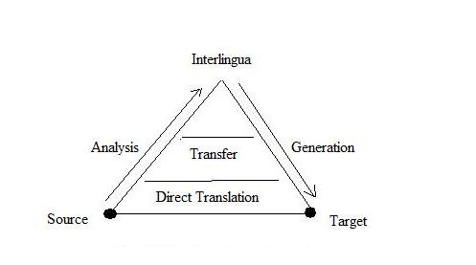

Figure: Machine Translation Pyramid

### DIRECT MACHINE TRANSLATION APPROACH

Direct translation approach is the oldest and less popular approach. Machine translation systems that use this approach are capable of translating a language, called source language (SL) directly to another language, called target language (TL). The analysis of SL texts is oriented to only one TL. Direct translation systems are basically bilingual and uni-directional. Direct translation approach needs only a little syntactic and semantic analysis. SL analysis is oriented specifically to the production of representations appropriate for one particular TL.

### INTERLINGUA APPROACH

[Interlingua approach](http://language.worldofcomputing.net/machine-translation/interlingual-machine-translation.html) intends to translate SL texts to that of more than one language. Translation is from SL to an intermediate form called interlingua (IL) and then from IL to TL. Interlingua may be artificial one or auxiliary language like Esperanto with universal vocabulary. [Interlingua approach](http://language.worldofcomputing.net/machine-translation/interlingual-machine-translation.html) requires complete resolution of all ambiguities in the SL text.

### TRANSFER APPROACH

Unlike interlingua approach, transfer approach has three stages involved. In the first stage, SL texts are converted into abstract SL-oriented representations. In the second stage, SL-oriented representations are converted into equivalent TL-oriented representations. Final texts are generated in the third stage. In transfer approach complete resolution of ambiguities of SL text is not required, but only the ambiguities inherent in the language itself are tackled. Three types of dictionaries are required: SL dictionaries, TL dictionaries and a bilingual transfer dictionary. Transfer systems have separate [grammars](http://language.worldofcomputing.net/grammar/what-is-grammar.html)for SL analysis, TL analysis and for the transformation of SL structures into equivalent TL forms.

### EMPIRICAL MACHINE TRANSLATION APPROACH

Empirical approach is the emerging one that uses large amount of raw data in the form of parallel [corpora](http://language.worldofcomputing.net/linguistics/introduction/what-is-corpus.html). The raw data consists of texts and their translations. [Example-based MT](http://language.worldofcomputing.net/machine-translation/example-based-machine-translation.html), analogy-based MT, memory-based MT, and case-based MT are the techniques that use empirical approach. Basically all these techniques use a [corpus](http://language.worldofcomputing.net/linguistics/introduction/what-is-corpus.html)or database of translated examples. Statistical machine translation is [corpus](http://language.worldofcomputing.net/linguistics/introduction/what-is-corpus.html) based but slightly different in the sense that it depends on statistical modelling of the word order of the target language and of source-target word equivalences. [Statistical machine translation](http://en.wikipedia.org/wiki/Statistical_machine_translation) automatically learns lexical and structural preferences from [corpora](http://language.worldofcomputing.net/linguistics/introduction/what-is-corpus.html). Statistical models offer good solution to ambiguity problem. They are robust and work well even if there are errors and the presence of new data. IBM researchers pioneered the first statistical approach to machine translation in 1980’s. IBM group relies on the source-channel approach, a framework for combining a word-based translation model and a [language model](http://en.wikipedia.org/wiki/Language_model). The translation model ensures that the machine translation system produces target hypothesis corresponding to the source sentence. The language model ensures the grammtically correct output.

6 Easy Steps to Learn Naive Bayes Algorithm (with codes in Python and R)

Table of Contents

1. What is Naive Bayes algorithm?
2. How Naive Bayes Algorithms works?
3. What are the Pros and Cons of using Naive Bayes?
4. 4 Applications of Naive Bayes Algorithm
5. Steps to build a basic Naive Bayes Model in Python
6. Tips to improve the power of Naive Bayes Model

What is Naive Bayes algorithm?

It is a classification technique based on [Bayes’ Theorem](https://en.wikipedia.org/wiki/Bayes%27_theorem) with an assumption of independence among predictors. In simple terms, a Naive Bayes classifier assumes that the presence of a particular feature in a class is unrelated to the presence of any other feature. For example, a fruit may be considered to be an apple if it is red, round, and about 3 inches in diameter. Even if these features depend on each other or upon the existence of the other features, all of these properties independently contribute to the probability that this fruit is an apple and that is why it is known as ‘Naive’.

Naive Bayes model is easy to build and particularly useful for very large data sets. Along with simplicity, Naive Bayes is known to outperform even highly sophisticated classification methods.

Bayes theorem provides a way of calculating posterior probability P(c|x) from P(c), P(x) and P(x|c). Look at the equation below:

[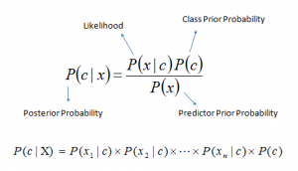](https://www.analyticsvidhya.com/wp-content/uploads/2015/09/Bayes_rule-300x172.png)Above,

* *P*(*c|x*) is the posterior probability of *class* (c, *target*) given *predictor* (x, *attributes*).
* *P*(*c*) is the prior probability of *class*.
* *P*(*x|c*) is the likelihood which is the probability of *predictor* given *class*.
* *P*(*x*) is the prior probability of *predictor*.

How Naive Bayes algorithm works?

Let’s understand it using an example. Below I have a training data set of weather and corresponding target variable ‘Play’ (suggesting possibilities of playing). Now, we need to classify whether players will play or not based on weather condition. Let’s follow the below steps to perform it.

Step 1: Convert the data set into a frequency table

Step 2: Create Likelihood table by finding the probabilities like Overcast probability = 0.29 and probability of playing is 0.64.

[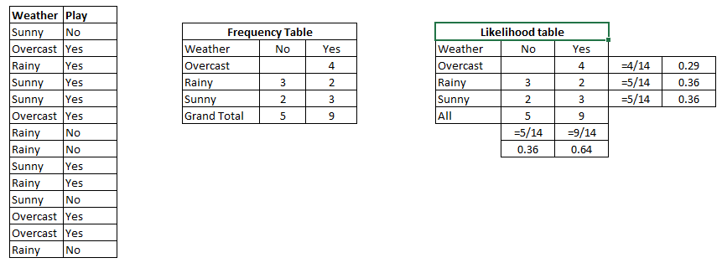](https://www.analyticsvidhya.com/wp-content/uploads/2015/08/Bayes_41.png)

Step 3: Now, use Naive Bayesian equation to calculate the posterior probability for each class. The class with the highest posterior probability is the outcome of prediction.

**Problem:**Players will play if weather is sunny. Is this statement is correct?

We can solve it using above discussed method of posterior probability.

P(Yes | Sunny) = P( Sunny | Yes) * P(Yes) / P (Sunny)

Here we have P (Sunny |Yes) = 3/9 = 0.33, P(Sunny) = 5/14 = 0.36, P( Yes)= 9/14 = 0.64

Now, P (Yes | Sunny) = 0.33 * 0.64 / 0.36 = 0.60, which has higher probability.

Naive Bayes uses a similar method to predict the probability of different class based on various attributes. This algorithm is mostly used in text classification and with problems having multiple classes.

What are the Pros and Cons of Naive Bayes?

***Pros:***

* It is easy and fast to predict class of test data set. It also perform well in multi class prediction
* When assumption of independence holds, a Naive Bayes classifier performs better compare to other models like logistic regression and you need less training data.
* It perform well in case of categorical input variables compared to numerical variable(s). For numerical variable, normal distribution is assumed (bell curve, which is a strong assumption).

***Cons:***

* If categorical variable has a category (in test data set), which was not observed in training data set, then model will assign a 0 (zero) probability and will be unable to make a prediction. This is often known as “Zero Frequency”. To solve this, we can use the smoothing technique. One of the simplest smoothing techniques is called Laplace estimation.
* On the other side naive Bayes is also known as a bad estimator, so the probability outputs from predict_proba are not to be taken too seriously.
* Another limitation of Naive Bayes is the assumption of independent predictors. In real life, it is almost impossible that we get a set of predictors which are completely independent.

4 Applications of Naive Bayes Algorithms

* **Real time Prediction:**Naive Bayes is an eager learning classifier and it is sure fast. Thus, it could be used for making predictions in real time.
* **Multi class Prediction:**This algorithm is also well known for multi class prediction feature. Here we can predict the probability of multiple classes of target variable.
* **Text classification/ Spam Filtering/ Sentiment Analysis:** Naive Bayes classifiers mostly used in text classification (due to better result in multi class problems and independence rule) have higher success rate as compared to other algorithms. As a result, it is widely used in Spam filtering (identify spam e-mail) and Sentiment Analysis (in social media analysis, to identify positive and negative customer sentiments)
* **Recommendation System:**Naive Bayes Classifier and [Collaborative Filtering](https://en.wikipedia.org/wiki/Collaborative_filtering) together builds a Recommendation System that uses machine learning and data mining techniques to filter unseen information and predict whether a user would like a given resource or not

How to build a basic model using Naive Bayes in Python?

Again, scikit learn (python library) will help here to build a Naive Bayes model in Python. There are three types of Naive Bayes model under scikit learn library:

* [**Gaussian:**](http://scikit-learn.org/stable/modules/naive_bayes.html)It is used in classification and it assumes that features follow a normal distribution.
* [**Multinomial**](http://scikit-learn.org/stable/modules/naive_bayes.html)**:**It is used for discrete counts. For example, let’s say,  we have a text classification problem. Here we can consider bernoulli trials which is one step further and instead of “word occurring in the document”, we have “count how often word occurs in the document”, you can think of it as “number of times outcome number x_i is observed over the n trials”.
* [**Bernoulli**](http://scikit-learn.org/stable/modules/naive_bayes.html)**:**The binomial model is useful if your feature vectors are binary (i.e. zeros and ones). One application would be text classification with ‘bag of words’ model where the 1s & 0s are “word occurs in the document” and “word does not occur in the document” respectively.

Based on your data set, you can choose any of above discussed model. Below is the example of Gaussian model.

Python Code

#Import Library of Gaussian Naive Bayes model

from sklearn.naive_bayes import GaussianNB

import numpy as np

#assigning predictor and target variables

x= np.array([[-3,7],[1,5], [1,2], [-2,0], [2,3], [-4,0], [-1,1], [1,1], [-2,2], [2,7], [-4,1], [-2,7]])

Y = np.array([3, 3, 3, 3, 4, 3, 3, 4, 3, 4, 4, 4])

#Create a Gaussian Classifier

model = GaussianNB()

# Train the model using the training sets

model.fit(x, y)

#Predict Output

predicted= model.predict([[1,2],[3,4]])

print predicted

**Output: ([3,4])**

R Code:

require(e1071) #Holds the Naive Bayes Classifier

Train <- read.csv(file.choose())

Test <- read.csv(file.choose())

#Make sure the target variable is of a two-class classification problem only

levels(Train$Item_Fat_Content)

model <- naiveBayes(Item_Fat_Content~., data = Train)

class(model)

pred <- predict(model,Test)

table(pred)

Above, we looked at the basic Naive Bayes model, you can improve the power of this basic model by tuning parameters and handle assumption intelligently. Let’s look at the methods to improve the performance of Naive Bayes Model. I’d recommend you to go through [this document](http://www.inf.ed.ac.uk/teaching/courses/inf2b/learnnotes/inf2b-learn-note07-2up.pdf) for more details on Text classification using Naive Bayes.

 Tips to improve the power of Naive Bayes Model

Here are some tips for improving power of Naive Bayes Model:

* If continuous features do not have normal distribution, we should use transformation or different methods to convert it in normal distribution.
* If test data set has zero frequency issue, apply smoothing techniques “Laplace Correction” to predict the class of test data set.
* Remove correlated features, as the highly correlated features are voted twice in the model and it can lead to over inflating importance.
* Naive Bayes classifiers has limited options for parameter tuning like alpha=1 for smoothing, fit_prior=[True|False] to learn class prior probabilities or not and some other options (look at detail [here](http://scikit-learn.org/stable/modules/generated/sklearn.naive_bayes.MultinomialNB.html#sklearn.naive_bayes.MultinomialNB)). I would recommend to focus on your  pre-processing of data and the feature selection.
* You might think to apply some *classifier combination technique like*ensembling, bagging and boosting but these methods would not help. Actually, “ensembling, boosting, bagging” won’t help since their purpose is to reduce variance. Naive Bayes has no variance to minimize.

The Essential NLP Guide for data scientists (with codes for top 10 common NLP tasks)

Introduction

Organizations today deal with huge amount and wide variety of data – calls from customers, their emails, tweets, data from mobile applications and what not. It takes a lot of effort and time to make this data useful. One of the core skills in extracting information from text data is Natural Language Processing (NLP).

Natural Language Processing (NLP) is the art and science which helps us extract information from text and use it in our computations and algorithms. Given then increase in content on internet and social media, it is one of the must have still for all data scientists out there.

Whether you know NLP or not, this guide should help you as a ready reference for you. Through this guide, I have provided you with resources and codes to run the most common tasks in NLP.

* 1. Stemming

**What is Stemming?:**Stemming is the process of reducing the words(generally modified or derived) to their word stem or root form. The objective of stemming is to reduce related words to the same stem even if the stem is not a dictionary word. For example, in the English language-

1. ***beautiful*** and ***beautifully***are stemmed to ***beauti***
2. ***good, better*** and ***best*** are stemmed to ***good, better*** and ***best*** respectively

**Paper:**The [original paper by Martin Porter](https://tartarus.org/martin/PorterStemmer/def.txt) on Porter Algorithm for stemming.

**Algorithm:**[Here is the Python implementation of Porter2 stemming algorithm.](https://bitbucket.org/mchaput/stemming/src/5c242aa592a6d4f0e9a0b2e1afdca4fd757b8e8a/stemming/porter2.py?at=default&fileviewer=file-view-default)

**Implementation:**Here is how you can stem a word using the Porter2 algorithm from the ***stemming***library.

#!pip install stemming  
from stemming.porter2 import stem  
stem("casually")

 2. Lemmatisation

**What is Lemmatisation?:**Lemmatisation is the process of reducing a group of words into their lemma or dictionary form. It takes into account things like POS(Parts of Speech), the meaning of the word in the sentence, the meaning of the word in the nearby sentences etc. before reducing the word to its lemma. For example, in the English Language-

1. ***beautiful*** and ***beautifully*** are lemmatised to ***beautiful*** and ***beautifully*** respectively.
2. ***good***, ***better*** and ***best*** are lemmatised to ***good***, ***good*** and ***good*** respectively.

**Paper 1:**[This paper](http://www.ijrat.org/downloads/icatest2015/ICATEST-2015127.pdf) discusses different methods for performing lemmatisation in great detail. A must read if you want to know hoe traditional lemmatisers work.

**Paper 2**: [This is an excellent paper](https://academic.oup.com/dsh/article-abstract/doi/10.1093/llc/fqw034/2669790/Lemmatization-for-variation-rich-languages-using) which addresses the problem of lemmatisation for variation rich languages using Deep Learning.

**Dataset:**[This is the link for Treebank-3 dataset](https://catalog.ldc.upenn.edu/ldc99t42) which you can use if you wish to create your own Lemmatiser.

**Implementation:** Below is an implementation of an English Lemmatiser using spacy.

#!pip install spacy  
#python -m spacy download en  
import spacy  
nlp=spacy.load("en")  
doc="good better best"

for token in nlp(doc):  
    print(token,token.lemma_)

 3. Word Embeddings

**What is Word Embeddings?:**Word Embeddings is the name of the techniques which are used to represent Natural Language in vector form of real numbers. They are useful because of computers’ inability to process Natural Language. So these Word Embeddings capture the essence and relationship between words in a Natural Language using real numbers. In Word Embeddings, a word or a phrase is represented in a fixed dimension vector of length say 100.

So for example-

A word “man” might be represented in a 5-dimension vector as



where each of these numbers is the magnitude of the word in a particular direction.

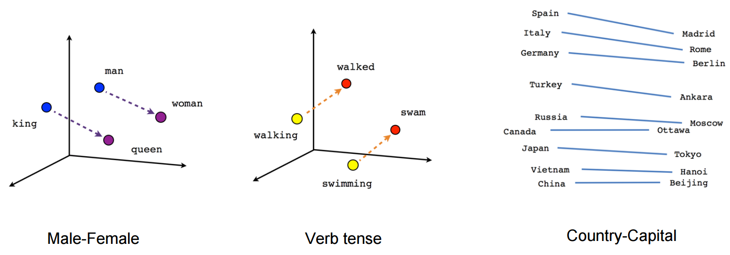

#!pip install gensim  
from gensim.models.keyedvectors import KeyedVectors  
word_vectors=KeyedVectors.load_word2vec_format('GoogleNews-vectors-negative300.bin',binary=True)  
word_vectors['human']

**Implementation:**Here is how you can train your own word vectors using gensim

sentence=[['first','sentence'],['second','sentence']]  
model = gensim.models.Word2Vec(sentence, min_count=1,size=300,workers=4)

 4. Part-Of-Speech Tagging

**What is Part-Of-Speech Tagging?:**In Simplistic terms, Part-Of-Speech Tagging is the process of marking up of words in a sentence as *nouns*, *verbs*, *adjectives*, *adverbs etc*. For example, in the sentence-

“Ashok killed the snake with a stick”

The Parts-Of-Speech are identified as –

Ashok *PROPN*  
killed *VERB*  
the *DET*  
snake *NOUN*  
with *ADP*  
a *DET*  
stick *NOUN*  
. *PUNCT*

**Implementation:**Here is how we can perform POS Tagging using spacy.

#!pip install spacy  
#!python -m spacy download en   
nlp=spacy.load('en')  
sentence="Ashok killed the snake with a stick"  
for token in nlp(sentence):  
   print(token,token.pos_)

 5. Named Entity Disambiguation

**What is Named Entity Disambiguation?:**Named Entity Disambiguation is the process of identifying the mentions of entities in a sentence. For example, in the sentence-

“Apple earned a revenue of 200 Billion USD in 2016”

It is the task of Named Entity Disambiguation to infer that Apple in the sentence is the company Apple and not a fruit.

Named Entity, in general, requires a knowledge base of entities which it can use to link entities in the sentence to the knowledge base.

 6. Named Entity Recognition

**What is Named Entity Recognition?:** Named Entity Recognition is the task of identifying entities in a sentence and classifying them into categories like a person, organisation, date, location, time etc. For example, a NER would take in a sentence like –

“Ram of Apple Inc. travelled to Sydney on 5th October 2017”

and return something like

Ram  
of  
Apple *ORG*  
Inc. *ORG*  
travelled  
to  
Sydney *GPE*  
on  
5th *DATE*  
October *DATE*  
2017 *DATE*

Here, ORG stands for Organisation and GPE stands for location.

The problem with current NERs is that even state-of-the-art NER tend to perform poorly when they are used on a domain of data which is different from the data, the NER was trained on. 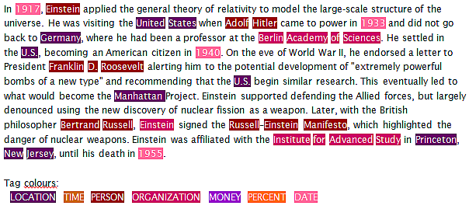

**Implementation:** Here is how you can perform Named Entity Recognition using spacy.

import spacy  
nlp=spacy.load('en')sentence="Ram of Apple Inc. travelled to Sydney on 5th October 2017"  
for token in nlp(sentence):  
   print(token, token.ent_type_)

 7. Sentiment Analysis

**What is Sentiment Analysis?:** Sentiment Analysis is a broad range of subjective analysis which uses Natural Language processing techniques to perform tasks such as identifying the sentiment of a customer review, positive or negative feeling in a sentence, judging mood via voice analysis or written text analysis etc. For example-

“I did not like the chocolate ice-cream” – is a negative experience of ice-cream.

“I did not hate the chocolate ice-cream” – may be considered as a neutral experience

There is a wide range of methods which are used to perform sentiment analysis starting from taking a count of negative and positive words in a sentence to using LSTMs with Word Embeddings.

 8. Semantic Text Similarity

**What is Semantic Text Similarity?:** Semantic Text Similarity is the process of analysing similarity between two pieces of text with respect to the meaning and essence of the text rather than analysing the syntax of the two pieces of text. Also, similarity is different than relatedness.

For example –

Car and Bus are similar but Car and fuel are related.

 9. Language Identification

**What is Language Identification?:**Language identification is the task of identifying the language in which the content is in.  It makes use of statistical as well as syntactical properties of the language to perform this task. It may also be considered as a special case of text classification.

 10.  Text Summarisation

**What is Text Summarisation?:**Text Summarisation is the process of shortening up of a text by identifying the important points of the text and creating a summary using these points. The goal of Text Summarisation is to retain maximum information along with maximum shortening of text without altering the meaning of the text.

Implementation: Here is how you can quickly summarise your text using the gensim package.

from gensim.summarization import summarize  
  
sentence="Automatic summarization is the process of shortening a text document with software, in order to create a summary with the major points of the original document. Technologies that can make a coherent summary take into account variables such as length, writing style and syntax.Automatic data summarization is part of machine learning and data mining. The main idea of summarization is to find a subset of data which contains the information of the entire set. Such techniques are widely used in industry today. Search engines are an example; others include summarization of documents, image collections and videos. Document summarization tries to create a representative summary or abstract of the entire document, by finding the most informative sentences, while in image summarization the system finds the most representative and important (i.e. salient) images. For surveillance videos, one might want to extract the important events from the uneventful context.There are two general approaches to automatic summarization: extraction and abstraction. Extractive methods work by selecting a subset of existing words, phrases, or sentences in the original text to form the summary. In contrast, abstractive methods build an internal semantic representation and then use natural language generation techniques to create a summary that is closer to what a human might express. Such a summary might include verbal innovations. Research to date has focused primarily on extractive methods, which are appropriate for image collection summarization and video summarization."  
  
summarize(sentence)

**Natural Language Processing – Business Applications**

**Last updated on January 23, 2017 by**[**Marco Lagi**](https://www.techemergence.com/author/marco-lagi/)

Executives worry about their businesses.

They often have to navigate, with limited resources, a stormy market made of customers, competitors, and regulators, and the interactions between all these actors make finding answers to business questions a complex process.

But recently, machines have demonstrated their abilities to help shine some light on this chaos and provide, if not direct answers, context clues that help guide executives in using [AI to to handle business problems](https://www.techemergence.com/apply-machine-learning-to-business-problems/).

In this article, we delve into examples of how natural language processing (NLP) business applications can be applied at scale to address 5 pressing business questions.

**Five NLP Business Applications**

**1 – Customer service: *“How can I keep my customers happy?”***

NLP is used by computers to manipulate human language, whether  to extract meaning, generate text, or for any other purpose. The interaction computer-language is categorized according to the task that needs to be accomplished: summarizing a long document, translating between two human languages, or detecting spam email are all examples of tasks that today can be decently accomplished by a machine.

While this wasn’t the case 30 years ago, most of NLP today is based on machine learning i.e. statistical methods that are able to simulate what a human would do in similar circumstances.

[NLP is heavily used in customer service](http://www.nuance.com/for-business/natural-language-understanding/index.htm). The interactions between customers and companies contain a lot of useful breadcrumbs that point towards the reasons for customer dissatisfaction, and the interaction itself can be cause of discontent.

In order to keep a finger on the pulse of consumers’ intent, many companies now transcribe and analyze customer call recordings. They also deploy [chat bots and automated online assistants](https://www.techemergence.com/chatbot-use-cases/) to provide an immediate response to simple needs and decrease the load for customer service reps. Relevant NLP tasks include:

* **Speech recognition**, which converts spoken language into text. Advances in deep learning over the last 10 years have allowed major players to deploy this technology in commercial systems like Siri, Google Now, Skype’s translator etc. with good performances.
* **Question answering**, which involves exactly that—answering questions posed by humans in a natural language. When in 2011 IBM’s Watson outclassed the two best humans at Jeopardy!, Ken Jennings wrote on his video screen: “I, for one, welcome our new computer overlords.” The task was especially hard for the machine, since the game is renowned for its convoluted and often opaque questions about general knowledge. Similar technology is used today by many companies for chatbots, both for internal (HR, operations) and external (customer service, IoT) projects.

**2 – Reputation monitoring: *“What are people saying about me?”***

In the 1980s, companies started using software to find patterns in their own data and make better decisions. Optimization of supply chains, inventories and warehouses, sales processes and many other applications gave rise to what we now call business intelligence. But what’s inside a company’s walls is not nearly as much (or as valuable) as what’s outside of them.

As the cost of computation kept dropping and algorithms kept improving, businesses started adopting tools that allowed them to look beyond their databases. This kind of data is commonly referred to as external data, public data, or [open-source intelligence (OSINT)](http://searchbusinessanalytics.techtarget.com/definition/open-source-business-intelligence-OSBI).

While some of this data is structured and ready to be analyzed (e.g. census data, stock prices), most of its value remains tapped in unstructured, human-generated text such as news; blog posts; forums; patents; job postings; reports; SEC filings; social media; company websites; etc. These sources contain a plethora of precious information about how competitors, customers and the market as a whole are evolving.

An example of how this kind of data can be used is reputation monitoring. It’s no secret that most customers check reviews online before buying a product, whether it’s a phone or a falafel. According to the most recent BrightLocal survey, 92 percent of customers read online reviews and 86 percent won’t buy a product with fewer than 3 out of 5 stars.

And as consumers have started voicing their complaints on Twitter and Facebook, reputation monitoring and management has become a top priority for businesses. Companies can now scan the entire web for mentions of their brand and products and recognize cases when they should take action.

Relevant NLP tasks for this application include:

* **Sentiment analysis**, which determines the attitude, emotional state, judgment or intent of the writer. This is done by either assigning a polarity to the text (positive, neutral or negative) or trying to recognize the underlying mood (happy, sad, calm, angry…). What about the times when multiple attitudes need to be accounted for in the same sentence? For example, “The pizza was amazing, but the waiter was awful!”

In the case above, the text is split into clauses, and polarity and mood are assessed for each. So, the previous text becomes something like:

{“clause”: “The pizza was amazing”,  
“polarity”: 0.92,  
“mood”: “happy”},

{“clause”: “but the waiter was awful!”,  
“polarity”: -0.95,  
“mood”: “angry”}

* **Coreference resolution**, which connects pronouns to the right objects. This is a hard task, but it’s essential to interpret the text correctly. For example, if a customer writes: “A guy from the dealer called to ask if I liked my new car. Well, no man, it sucks?”, it’s important to recognize that “it” refers to the car and not the guy. The customer is complaining about the product, not the service. As Elon Musk says, “Brand is just a perception”. Right now, your customers are talking about you, influencing the way other consumers perceive your brand. NLP can help you stay on top of your in-the-trenches reputation.

**3 – Ad placement: *“Who is interested in my product?”***

Media buying is usually the largest line in a company’s advertising budget, so any targeting that can be done to ensure that ads are presented to the right eyeballs is of paramount importance. While in the past marketers have focused on demographics (race, economic status, sex, age, etc.) and psychographics (values, personality, attitudes, opinions, etc.), they’ve quickly adapted to the new digital area.

Our emails, social media, e-commerce and browsing behaviors contain a lot of information about what we’re really interested in. The huge potential of this kind of unstructured data is confirmed by the fact that 2 of the 10 largest companies today generate most of their revenue selling ads (Google and Facebook). Relevant NLP tasks for this application include:

* **Keyword matching**, which checks whether words of interest are included in some text. This is one of the easiest tasks in NLP, and at the same time one of the most remunerative. While this first approximation is often good enough, its lack of sophistication can produce pretty inappropriate results.
* **Sense disambiguation**, or identification of which sense of a word is used in a sentence. While the human brain is pretty good at this task, a computer won’t necessarily find it easy to recognize that the term pounds in the sentence, “I gained 20 pounds since the wedding!”,  most likely refers to the unit of mass rather than the currency. This is still an open problem in NLP.

**4 – Market intelligence: *“What’s happening with my competitors?”***

Markets are influenced by information exchange – between company/shareholders, government/citizens or simply individuals. Knowing the status of an industry is essential to developing an effective strategy, but the channels of content distribution today (RSS feeds, social media, emails) produce so much information that it’s becoming hard to keep up.

This is especially true in financial markets, which is why [hedge funds routinely use NLP](https://www.bloomberg.com/news/articles/2015-05-20/the-10-hedge-fund-supercomputer-that-s-sweeping-wall-street) to improve their models. Relevant NLP tasks for this application include:

* **Event extraction**, which recognizes what’s happening to an entity. M&As, employment changes, deal closings and everything else that happens to organizations or people can be extracted automatically. For example, “Howard Schultz Stepping Down As Starbucks CEO” can be parsed as:

{“company”: “Starbucks”,  
“position”: “CEO”,  
“person”: “Howard Schultz”,  
“event”: “end of employment”}

A structured database of events about companies, governments and people is an extremely powerful tool for analyzing the business ecosystem.

* **Sentence classification,**or putting a sentence in a predefined set of buckets. This is often used as a first pass to extract relevant content from large repositories, like the SEC’s EDGAR system. For example, “We expect a 15% increase in revenue next year,” can be classified as a forward-looking statement.

**5 – Regulatory compliance: *“Is my product a liability?”***

A crucial example of compliance is pharmacovigilance i.e. the studies done after a drug has been marketed (phase IV of clinical trials) to gather information on its side effects. A lot of information about adverse drug events (ADEs) resides in what’s called unstructured clinical narratives, or patients’ reports about their health.

Pharma companies extract ADEs from 1) electronic health records (EHRs), social media and forums for patients complaining about a problem, and 2) web search trends and patterns for patients looking for a solution. Relevant NLP tasks for this application include:

* **Named entity recognition (NER)**, which extracts the names of drugs, diseases, patients, and pharma companies using rule-based or statistical methods. Applying NER to a sentence will be able to convert it from, “Valium makes me sleepy,” to “{drug} makes me {symptom}.”
* **Relation detection**, used to identify the context in which the ADE is mentioned. This is often done with frames, or patterns of words that correspond to a concept, e.g. “I felt {symptom} after taking {drug}” is a pattern that matches the presence of side effects.

By applying these two tasks consecutively, we’ve identified that the patient is linking the drug Valium to the side effect sleepy. Both these tasks benefit from using ontologies i.e. structured domain knowledge (in this case biomedical) that provides the object dictionary and the relations between objects.

**What’s next in AI for BI**

Over the last 10 years, companies have been able to carve the most promising NLP business applications out of academic research, and use them to improve their business intelligence. The NLP market size, which is about $7.5B today, is estimated to grow to $16B by 2021.

Still, computers are not able to process or understand text like humans do, at least not yet.

As mentioned before, most of the methods employed in NLP are statistical in nature, and statistics can only go so far without context or semantics. The algorithms behind the applications described above simulate human understanding and can do that at scale, but they are still brittle in that they can’t simulate a behavior they haven’t seen before.

For example, every time Siri tries to answer a question that has not been programmed to respond, it fails miserably, and it will keep failing until Apple’s engineers implement the fix.

The future of this field is about moving from NLP to natural language understanding (NLU), where a deeper connection between the concepts communicated and facts about the world is established. In artificial intelligence, this is considered an AI-hard problem: to be solved, computers have to be as intelligent as people.

But while the future is still in the works, present NLP technologies  can still provide businesses with useful answers to bounded questions.

Ultimate Guide to Understand & Implement Natural Language Processing (with codes in Python)

According to industry estimates, only 21% of the available data is present in structured form. Data is being generated as we speak, as we tweet, as we send messages on Whatsapp and in various other activities. Majority of this data exists in the textual form, which is highly unstructured in nature.

Few notorious examples include – tweets / posts on social media, user to user chat conversations, news, blogs and articles, product or services reviews and patient records in the healthcare sector. A few more recent ones includes chatbots and other voice driven bots.

Despite having high dimension data, the information present in it is not directly accessible unless it is processed (read and understood) manually or analyzed by an automated system.

In order to produce significant and actionable insights from text data, it is important to get acquainted with the techniques and principles of Natural Language Processing (NLP).

So, if you plan to create chatbots this year, or you want to use the power of unstructured text, this guide is the right starting point. This guide unearths the concepts of natural language processing, its techniques and implementation. The aim of the article is to teach the concepts of natural language processing and apply it on real data set.

Table of Contents

1. Introduction to NLP
2. Text Preprocessing
   * Noise Removal
   * Lexicon Normalization
     + Lemmatization
     + Stemming
   * Object Standardization
3. Text to Features (Feature Engineering on text data)
   * Syntactical Parsing
     + Dependency Grammar
     + Part of Speech Tagging
   * Entity Parsing
     + Phrase Detection
     + Named Entity Recognition
     + Topic Modelling
     + N-Grams
   * Statistical features
     + TF – IDF
     + Frequency / Density Features
     + Readability Features
   * Word Embeddings
4. Important tasks of NLP
   * Text Classification
   * Text Matching
     + Levenshtein Distance
     + Phonetic Matching
     + Flexible String Matching
   * Coreference Resolution
   * Other Problems
5. Important NLP libraries

1. Introduction to Natural Language Processing

NLP is a branch of data science that consists of systematic processes for analyzing, understanding, and deriving information from the text data in a smart and efficient manner. By utilizing NLP and its components, one can organize the massive chunks of text data, perform numerous automated tasks and solve a wide range of problems such as – automatic summarization, machine translation, named entity recognition, relationship extraction, sentiment analysis, speech recognition, and topic segmentation etc.

Before moving further, I would like to explain some terms that are used in the article:

* Tokenization – process of converting a text into tokens
* Tokens – words or entities present in the text
* Text object – a sentence or a phrase or a word or an article

Steps to install NLTK and its data:

Install Pip: run in terminal:

    sudo easy_install pip

Install NLTK: run in terminal :

    sudo pip install -U nltk

Download NLTK data: run python shell (in terminal) and write the following code:

``` import nltk nltk.download() ```

Follow the instructions on screen and download the desired package or collection. Other libraries can be directly installed using pip.

2. Text Preprocessing

Since, text is the most unstructured form of all the available data, various types of noise are present in it and the data is not readily analyzable without any pre-processing. The entire process of cleaning and standardization of text, making it noise-free and ready for analysis is known as text preprocessing.

It is predominantly comprised of three steps:

* Noise Removal
* Lexicon Normalization
* Object Standardization

The following image shows the architecture of text preprocessing pipeline.

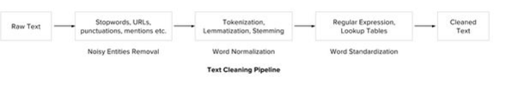

2.1 Noise Removal

Any piece of text which is not relevant to the context of the data and the end-output can be specified as the noise.

For example – language stopwords (commonly used words of a language – is, am, the, of, in etc), URLs or links, social media entities (mentions, hashtags), punctuations and industry specific words. This step deals with removal of all types of noisy entities present in the text.

A general approach for noise removal is to prepare a dictionary of noisy entities, and iterate the text object by tokens (or by words), eliminating those tokens which are present in the noise dictionary.

Following is the python code for the same purpose.

```# Sample code to remove noisy words from a text

noise_list = ["is", "a", "this", "..."]

def _remove_noise(input_text):

words = input_text.split()

noise_free_words = [word for word in words if word not in noise_list]

noise_free_text = " ".join(noise_free_words)

return noise_free_text

_remove_noise("this is a sample text")

>>> "sample text"

```

Another approach is to use the regular expressions while dealing with special patterns of noise. We have explained regular expressions in detail in one of our [previous article](https://www.analyticsvidhya.com/blog/2015/06/regular-expression-python/). Following python code removes a regex pattern from the input text:

# Sample code to remove a regex pattern

import re

def _remove_regex(input_text, regex_pattern):

urls = re.finditer(regex_pattern, input_text)

for i in urls:

input_text = re.sub(i.group().strip(), '', input_text)

return input_text

regex_pattern = "#[\w]*"

_remove_regex("remove this #hashtag from analytics vidhya", regex_pattern)

>>> "remove this from analytics vidhya"

2.2 Lexicon Normalization

Another type of textual noise is about the multiple representations exhibited by single word.

For example – “play”, “player”, “played”, “plays” and “playing” are the different variations of the word – “play”, Though they mean different but contextually all are similar. The step converts all the disparities of a word into their normalized form (also known as lemma). Normalization is a pivotal step for feature engineering with text as it converts the high dimensional features (N different features) to the low dimensional space (1 feature), which is an ideal ask for any ML model.

The most common lexicon normalization practices are :

* **Stemming:** Stemming is a rudimentary rule-based process of stripping the suffixes (“ing”, “ly”, “es”, “s” etc) from a word.
* **Lemmatization:**Lemmatization, on the other hand, is an organized & step by step procedure of obtaining the root form of the word, it makes use of vocabulary (dictionary importance of words) and morphological analysis (word structure and grammar relations).

Below is the sample code that performs lemmatization and stemming using python’s popular library – NLTK.

from nltk.stem.wordnet import WordNetLemmatizer

lem = WordNetLemmatizer()

from nltk.stem.porter import PorterStemmer

stem = PorterStemmer()

word = "multiplying"

lem.lemmatize(word, "v")

>> "multiply"

stem.stem(word)

>> "multipli"

2.3 Object Standardization

Text data often contains words or phrases which are not present in any standard lexical dictionaries. These pieces are not recognized by search engines and models.

Some of the examples are – acronyms, hashtags with attached words, and colloquial slangs. With the help of regular expressions and manually prepared data dictionaries, this type of noise can be fixed, the code below uses a dictionary lookup method to replace social media slangs from a text.

lookup_dict = {'rt':'Retweet', 'dm':'direct message', "awsm" : "awesome", "luv" :"love", "..."}

def _lookup_words(input_text):

words = input_text.split()

new_words = []

for word in words:

if word.lower() in lookup_dict:

word = lookup_dict[word.lower()]

new_words.append(word) new_text = " ".join(new_words)

return new_text

_lookup_words("RT this is a retweeted tweet by Shivam Bansal")

>> "Retweet this is a retweeted tweet by Shivam Bansal"

Apart from three steps discussed so far, other types of text preprocessing includes encoding-decoding noise, grammar checker, and spelling correction etc. The detailed article about preprocessing and its methods is given in one of my previous [article](https://www.analyticsvidhya.com/blog/2014/11/text-data-cleaning-steps-python/)**.**

3.Text to Features (Feature Engineering on text data)

To analyse a preprocessed data, it needs to be converted into features. Depending upon the usage, text features can be constructed using assorted techniques – Syntactical Parsing, Entities / N-grams / word-based features, Statistical features, and word embeddings. Read on to understand these techniques in detail.

3.1 Syntactic Parsing

Syntactical parsing invol ves the analysis of words in the sentence for grammar and their arrangement in a manner that shows the relationships among the words. Dependency Grammar and Part of Speech tags are the important attributes of text syntactics.

**Dependency Trees –**Sentences are composed of some words sewed together. The relationship among the words in a sentence is determined by the basic dependency grammar. Dependency grammar is a class of syntactic text analysis that deals with (labeled) asymmetrical binary relations between two lexical items (words). Every relation can be represented in the form of a triplet (relation, governor, dependent). For example: consider the sentence – “*Bills* *on ports and immigration were submitted by Senator Brownback, Republican of Kansas.”*The relationship among the words can be observed in the form of a tree representation as shown: 

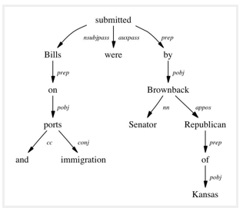The tree shows that “submitted” is the root word of this sentence, and is linked by two sub-trees (subject and object subtrees). Each subtree is a itself a dependency tree with relations such as – (“Bills” <-> “ports” <by> “proposition” relation), (“ports” <-> “immigration” <by> “conjugation” relation).

This type of tree, when parsed recursively in top-down manner gives grammar relation triplets as output which can be used as features for many nlp problems like entity wise sentiment analysis, actor & entity identification, and text classification. The python wrapper [StanfordCoreNLP](http://stanfordnlp.github.io/CoreNLP/) (by Stanford NLP Group, only commercial license) and NLTK dependency grammars can be used to generate dependency trees.

**Part of speech tagging** – Apart from the grammar relations, every word in a sentence is also associated with a part of speech (pos) tag (nouns, verbs, adjectives, adverbs etc). The pos tags defines the usage and function of a word in the sentence. H ere is a list of all possible pos-tags defined by Pennsylvania university. Following code using NLTK performs pos tagging annotation on input text. (it provides several implementations, the default one is perceptron tagger)

from nltk import word_tokenize, pos_tag

text = "I am learning Natural Language Processing on Analytics Vidhya"

tokens = word_tokenize(text)

print pos_tag(tokens)

>>> [('I', 'PRP'), ('am', 'VBP'), ('learning', 'VBG'), ('Natural', 'NNP'),('Language', 'NNP'),

('Processing', 'NNP'), ('on', 'IN'), ('Analytics', 'NNP'),('Vidhya', 'NNP')]

Part of Speech tagging is used for many important purposes in NLP:

**A.Word sense disambiguation:** Some language words have multiple meanings according to their usage. For example, in the two sentences below:

*I. “Please book my flight for Delhi”*

*II. “I am going to read this book in the flight”*

“Book” is used with different context, however the part of speech tag for both of the cases are different. In sentence I, the word “book” is used as ***v*** ***erb***, while in II it is used as ***no*** ***un***. ([Lesk Algorithm](https://en.wikipedia.org/wiki/Lesk_algorithm) is also us ed for similar purposes)

**B.Improving word-based features:** A learning model could learn different contexts of a word when used word as the features, however if the part of speech tag is linked with them, the context is preserved, thus making strong features. For example:

*Sentence -“book my flight, I will read this book”*

*Tokens – (“book”, 2), (“my”, 1), (“flight”, 1), (“I”, 1), (“will”, 1), (“read”, 1), (“this”, 1)*

*Tokens with POS – (“book_VB”, 1), (“my_PRP$”, 1), (“flight_NN”, 1), (“I_PRP”, 1), (“will_MD”, 1), (“read_VB”, 1), (“this_DT”, 1), (“book_NN”, 1)*

**C. Normalization and Lemmatization**: POS tags are the basis of lemmatization process for converting a word to its base form (lemma).

**D.Efficient stopword removal** : P OS tags are also useful in efficient removal of stopwords.

For example, there are some tags which always define the low frequency / less important words of a language. For example: (**IN** – “within”, “upon”, “except”), (**CD** – “one”,”two”, “hundred”), (**MD** – “may”, “mu st” etc)

3.2 Entity Extraction (Entities as features)

Entities are defined as the most important chunks of a sentence – noun phrases, verb phrases or both. Entity Detection algorithms are generally ensemble models of rule based parsing, dictionary lookups, pos tagging and dependency parsing. The applicability of entity detection can be seen in the automated chat bots, content analyzers and consumer insights.

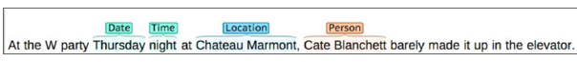

Topic Modelling & Named Entity Recognition are the two key entity detection methods in NLP.

A. Named Entity Recognition (NER)

The process of detecting the named entities such as person names, location names, company names etc from the text is called as NER. For example :

*Sentence – Sergey Brin, the manager of Google Inc. is walking in the streets of New York.*

*Named Entities –  ( “person” : “Sergey Brin” ), (“org” : “Google Inc.”), (“location” : “New York”)*

A typical NER model consists of three blocks:

**Noun phrase identification:** This step deals with extracting all the noun phrases from a text using dependency parsing and part of speech tagging.

**Phrase classification:** This is the classification step in which all the extracted noun phrases are classified into respective categories (locations, names etc). Google Maps API provides a good path to disambiguate locations, Then, the open databases from dbpedia, wikipedia can be used to identify person names or company names. Apart from this, one can curate the lookup tables and dictionaries by combining information from different sources.

**Entity disambiguation:** Sometimes it is possible that entities are misclassified, hence creating a validation layer on top of the results is useful. Use of knowledge graphs can be exploited for this purposes. The popular knowledge graphs are – Google Knowledge Graph, IBM Watson and Wikipedia.

B. Topic Modeling

Topic modeling is a process of automatically identifying the topics present in a text corpus, it derives the hidden patterns among the words in the corpus in an unsupervised manner. Topics are defined as “a repeating pattern of co-occurring terms in a corpus”. A good topic model results in – “health”, “doctor”, “patient”, “hospital” for a topic – Healthcare, and “farm”, “crops”, “wheat” for a topic – “Farming”.

Latent Dirichlet Allocation (LDA) is the most popular topic modelling technique, Following is the code to implement topic modeling using LDA in python. For a detailed explanation about its working and implementation, check the complete article [here.](https://www.analyticsvidhya.com/blog/2016/08/beginners-guide-to-topic-modeling-in-python/)

doc1 = "Sugar is bad to consume. My sister likes to have sugar, but not my father."

doc2 = "My father spends a lot of time driving my sister around to dance practice."

doc3 = "Doctors suggest that driving may cause increased stress and blood pressure."

doc_complete = [doc1, doc2, doc3]

doc_clean = [doc.split() for doc in doc_complete]

import gensim from gensim

import corpora

# Creating the term dictionary of our corpus, where every unique term is assigned an index.

dictionary = corpora.Dictionary(doc_clean)

# Converting list of documents (corpus) into Document Term Matrix using dictionary prepared above.

doc_term_matrix = [dictionary.doc2bow(doc) for doc in doc_clean]

# Creating the object for LDA model using gensim library

Lda = gensim.models.ldamodel.LdaModel

# Running and Training LDA model on the document term matrix

ldamodel = Lda(doc_term_matrix, num_topics=3, id2word = dictionary, passes=50)

# Results

print(ldamodel.print_topics())

C.  N-Grams as Features

A combination of N words together are called N-Grams. N grams (N > 1) are generally more informative as compared to words (Unigrams) as features. Also, bigrams (N = 2) are considered as the most important features of all the others. The following code generates bigram of a text.

def generate_ngrams(text, n):

words = text.split()

output = []

for i in range(len(words)-n+1):

output.append(words[i:i+n])

return output

>>> generate_ngrams('this is a sample text', 2)

# [['this', 'is'], ['is', 'a'], ['a', 'sample'], , ['sample', 'text']]

3.3 Statistical Features

Text data can also be quantified directly into numbers using several techniques described in this section:

A.  Term Frequency – Inverse Document Frequency (TF – IDF)

TF-IDF is a weighted model commonly used for information retrieval problems. It aims to convert the text documents into vector models on the basis of occurrence of words in the documents without taking considering the exact ordering. For Example – let say there is a dataset of N text documents, In any document “D”, TF and IDF will be defined as –

**Term Frequency (TF)** – TF for a term “t” is defined as the count of a term “t” in a document “D”

**Inverse Document Frequency (IDF**) – IDF for a term is defined as logarithm of ratio of total documents available in the corpus and number of documents containing the term T.

**TF . IDF –**TF IDF formula gives the relative importance of a term in a corpus (list of documents), given by the following formula below. Following is the code using python’s scikit learn package to convert a text into tf idf vectors:

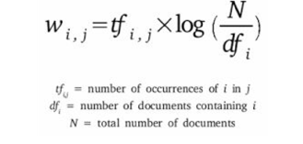

from sklearn.feature_extraction.text import TfidfVectorizer

obj = TfidfVectorizer()

corpus = ['This is sample document.', 'another random document.', 'third sample document text']

X = obj.fit_transform(corpus)

print X

>>>

(0, 1) 0.345205016865

(0, 4) ... 0.444514311537

(2, 1) 0.345205016865

(2, 4) 0.444514311537

The model creates a vocabulary dictionary and assigns an index to each word. Each row in the output contains a tuple (i,j) and a tf-idf value of word at index j in document i.

B. Count / Density / Readability Features

Count or Density based features can also be used in models and analysis. These features might seem trivial but shows a great impact in learning models. Some of the features are: Word Count, Sentence Count, Punctuation Counts and Industry specific word counts. Other types of measures include readability measures such as syllable counts, smog index and flesch reading ease. Refer to [Textstat](https://github.com/shivam5992/textstat) library to create such features.

3.4 Word Embedding (text vectors)

Word embedding is the modern way of representing words as vectors. The aim of word embedding is to redefine the high dimensional word features into low dimensional feature vectors by preserving the contextual similarity in the corpus. They are widely used in deep learning models such as Convolutional Neural Networks and Recurrent Neural Networks.

[Word2Vec](https://code.google.com/archive/p/word2vec/) and [GloVe](http://nlp.stanford.edu/projects/glove/) are the two popular models to create word embedding of a text. These models takes a text corpus as input and produces the word vectors as output.

Word2Vec model is composed of preprocessing module, a shallow neural network model called Continuous Bag of Words and another shallow neural network model called skip-gram. These models are widely used for all other nlp problems. It first constructs a vocabulary from the training corpus and then learns word embedding representations. Following code using gensim package prepares the word embedding as the vectors.

from gensim.models import Word2Vec

sentences = [['data', 'science'], ['vidhya', 'science', 'data', 'analytics'],['machine', 'learning'], ['deep', 'learning']]

# train the model on your corpus

model = Word2Vec(sentences, min_count = 1)

print model.similarity('data', 'science')

>>> 0.11222489293

print model['learning']

>>> array([ 0.00459356  0.00303564 -0.00467622  0.00209638, ...])

They can be used as feature vectors for ML model, used to measure text similarity using cosine similarity techniques, words clustering and text classification techniques.

4. Important tasks of NLP

This section talks about different use cases and problems in the field of natural language processing.

4.1 Text Classification

Text classification is one of the classical problem of NLP. Notorious examples include – Email Spam Identification, topic classification of news, sentiment classification and organization of web pages by search engines.

Text classification, in common words is defined as a technique to systematically classify a text object (document or sentence) in one of the fixed category. It is really helpful when the amount of data is too large, especially for organizing, information filtering, and storage purposes.

A typical natural language classifier consists of two parts: (a) Training (b) Prediction as shown in image below. Firstly the text input is processes and features are created. The machine learning models then learn these features and is used for predicting against the new text.

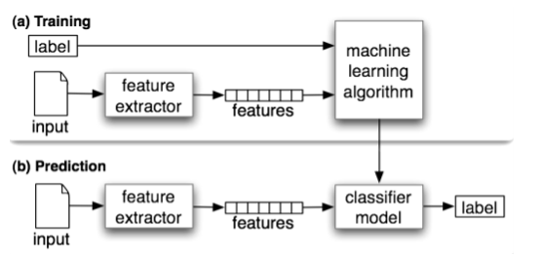

Here is a code that uses naive bayes classifier using text blob library (built on top of nltk).

```

from textblob.classifiers import NaiveBayesClassifier as NBC

from textblob import TextBlob

training_corpus = [

('I am exhausted of this work.', 'Class_B'),

("I can't cooperate with this", 'Class_B'),

('He is my badest enemy!', 'Class_B'),

('My management is poor.', 'Class_B'),

('I love this burger.', 'Class_A'),

('This is an brilliant place!', 'Class_A'),

('I feel very good about these dates.', 'Class_A'),

('This is my best work.', 'Class_A'),

("What an awesome view", 'Class_A'),

('I do not like this dish', 'Class_B')]

test_corpus = [

("I am not feeling well today.", 'Class_B'),

("I feel brilliant!", 'Class_A'),

('Gary is a friend of mine.', 'Class_A'),

("I can't believe I'm doing this.", 'Class_B'),

('The date was good.', 'Class_A'), ('I do not enjoy my job', 'Class_B')]

model = NBC(training_corpus)

print(model.classify("Their codes are amazing."))

>>> "Class_A"

print(model.classify("I don't like their computer."))

>>> "Class_B"

print(model.accuracy(test_corpus))

>>> 0.83

Scikit.Learn also provides a pipeline framework for text classification:

from sklearn.feature_extraction.text

import TfidfVectorizer from sklearn.metrics

import classification_report

from sklearn import svm

# preparing data for SVM model (using the same training_corpus, test_corpus from naive bayes example)

train_data = []

train_labels = []

for row in training_corpus:

train_data.append(row[0])

train_labels.append(row[1])

test_data = []

test_labels = []

for row in test_corpus:

test_data.append(row[0])

test_labels.append(row[1])

# Create feature vectors

vectorizer = TfidfVectorizer(min_df=4, max_df=0.9)

# Train the feature vectors

train_vectors = vectorizer.fit_transform(train_data)

# Apply model on test data

test_vectors = vectorizer.transform(test_data)

# Perform classification with SVM, kernel=linear

model = svm.SVC(kernel='linear')

model.fit(train_vectors, train_labels)

prediction = model.predict(test_vectors)

>>> ['Class_A' 'Class_A' 'Class_B' 'Class_B' 'Class_A' 'Class_A']

print (classification_report(test_labels, prediction))

The text classification model are heavily dependent upon the quality and quantity of features, while applying any machine learning model it is always a good practice to include more and more training data. H ere are some tips that I wrote about improving the text classification accuracy in one of my previous article.

4.2 Text Matching / Similarity

One of the important areas of NLP is the matching of text objects to find similarities. Important applications of text matching includes automatic spelling correction, data de-duplication and genome analysis etc.

A number of text matching techniques are available depending upon the requirement. This section describes the important techniques in detail.

**A. Levenshtein Distance** – The Levenshtein distance between two strings is defined as the minimum number of edits needed to transform one string into the other, with the allowable edit operations being insertion, deletion, or substitution of a single character. Following is the implementation for efficient memory computations.

def levenshtein(s1,s2):

if len(s1) > len(s2):

s1,s2 = s2,s1

distances = range(len(s1) + 1)

for index2,char2 in enumerate(s2):

newDistances = [index2+1]

for index1,char1 in enumerate(s1):

if char1 == char2:

newDistances.append(distances[index1])

else:

newDistances.append(1 + min((distances[index1], distances[index1+1], newDistances[-1])))

distances = newDistances

return distances[-1]

print(levenshtein("analyze","analyse"))

**B. Phonetic Matching** – A Phonetic matching algorithm takes a keyword as input (person’s name, location name etc) and produces a character string that identifies a set of words that are (roughly) phonetically similar. It is very useful for searching large text corpuses, correcting spelling errors and matching relevant names. Soundex and Metaphone are two main phonetic algorithms used for this purpose. Python’s module Fuzzy is used to compute soundex strings for different words, for example –

import fuzzy

soundex = fuzzy.Soundex(4)

print soundex('ankit')

>>> “A523”

print soundex('aunkit')

>>> “A523”

**C. Flexible String Matching** – A complete text matching system includes different algorithms pipelined together to compute variety of text variations. Regular expressions are really helpful for this purposes as well. Another common techniques include – exact string matching, lemmatized matching, and compact matching (takes care of spaces, punctuation’s, slangs etc).

**D. Cosine Similarity** – W hen the text is represented as vector notation, a general cosine similarity can also be applied in order to measure vectorized similarity. Following code converts a text to vectors (using term frequency) and applies cosine similarity to provide closeness among two text.

import math

from collections import Counter

def get_cosine(vec1, vec2):

common = set(vec1.keys()) & set(vec2.keys())

numerator = sum([vec1[x] * vec2[x] for x in common])

sum1 = sum([vec1[x]**2 for x in vec1.keys()])

sum2 = sum([vec2[x]**2 for x in vec2.keys()])

denominator = math.sqrt(sum1) * math.sqrt(sum2)

if not denominator:

return 0.0

else:

return float(numerator) / denominator

def text_to_vector(text):

words = text.split()

return Counter(words)

text1 = 'This is an article on analytics vidhya'

text2 = 'article on analytics vidhya is about natural language processing'

vector1 = text_to_vector(text1)

vector2 = text_to_vector(text2)

cosine = get_cosine(vector1, vector2)

>>> 0.62

4.3 Coreference Resolution

Coreference Resolution is a process of finding relational links among the words (or phrases) within the sentences. Consider an example sentence: ” Donald went to John’s office to see the new table. He looked at it for an hour.“

Humans can quickly figure out that “he” denotes Donald (and not John), and that “it” denotes the table (and not John’s office). Coreference Resolution is the component of NLP that does this job automatically. It is used in document summarization, question answering, and information extraction. Stanford CoreNLP provides a python [wrapper](https://github.com/Wordseer/stanford-corenlp-python) for commercial purposes.

4.4 Other NLP problems / tasks

* **Text Summarization** – Given a text article or paragraph, summarize it automatically to produce most important and relevant sentences in order.
* **Machine Translation** – Automatically translate text from one human language to another by taking care of grammar, semantics and information about the real world, etc.
* **Natural Language Generation and Understanding** – Convert information from computer databases or semantic intents into readable human language is called language generation. Converting chunks of text into more logical structures that are easier for computer programs to manipulate is called language understanding.
* **Optical Character Recognition** – Given an image representing printed text, determine the corresponding text.
* **Document to Information** – This involves parsing of textual data present in documents (websites, files, pdfs and images) to analyzable and clean format.

5. Important Libraries for NLP (python)

* Scikit-learn: Machine learning in Python
* Natural Language Toolkit (NLTK): The complete toolkit for all NLP techniques.
* Pattern – A web mining module for the with tools for NLP and machine learning.
* TextBlob – Easy to use nl p tools API, built on top of NLTK and Pattern.
* spaCy – Industrial strength N LP with Python and Cython.
* Gensim – Topic Modelling for Humans
* Stanford Core NLP – NLP services and packages by Stanford NLP Group.

NLP

**Tokenization with nltk**

The NLTK module is a massive tool kit, aimed at helping you with the entire Natural Language Processing (NLP) methodology. NLTK will aid you with everything from splitting sentences from paragraphs, splitting up words, recognizing the part of speech of those words, highlighting the main subjects, and then even with helping your machine to understand what the text is all about. In this series, we're going to tackle the field of opinion mining, or sentiment analysis.

Now that you have all the things that you need, let's knock out some quick vocabulary:

* Corpus - Body of text, singular. Corpora is the plural of this. Example: A collection of medical journals.
* Lexicon - Words and their meanings. Example: English dictionary. Consider, however, that various fields will have different lexicons. For example: To a financial investor, the first meaning for the word "Bull" is someone who is confident about the market, as compared to the common English lexicon, where the first meaning for the word "Bull" is an animal. As such, there is a special lexicon for financial investors, doctors, children, mechanics, and so on.
* Token - Each "entity" that is a part of whatever was split up based on rules. For examples, each word is a token when a sentence is "tokenized" into words. Each sentence can also be a token, if you tokenized the sentences out of a paragraph.

Ex: from nltk.tokenize import sent_tokenize, word_tokenize

EXAMPLE_TEXT = "Hello Mr. Smith, how are you doing today? The weather is great, and Python is awesome. The sky is pinkish-blue. You shouldn't eat cardboard."

print(sent_tokenize(EXAMPLE_TEXT))

o/p: ['Hello Mr. Smith, how are you doing today?', 'The weather is great, and Python is awesome.', 'The sky is pinkish-blue.', "You shouldn't eat cardboard."]

print(word_tokenize(EXAMPLE_TEXT))

o/p: ['Hello', 'Mr.', 'Smith', ',', 'how', 'are', 'you', 'doing', 'today', '?', 'The', 'weather', 'is', 'great', ',', 'and', 'Python', 'is', 'awesome', '.', 'The', 'sky', 'is', 'pinkish-blue', '.', 'You', 'should', "n't", 'eat', 'cardboard', '.']

Stop words with NLTK

The idea of Natural Language Processing is to do some form of analysis, or processing, where the machine can understand, at least to some level, what the text means, says, or implies.

This is an obviously massive challenge, but there are steps to doing it that anyone can follow. The main idea, however, is that computers simply do not, and will not, ever understand words directly. Humans don't either *shocker*. In humans, memory is broken down into electrical signals in the brain, in the form of neural groups that fire in patterns. There is a lot about the brain that remains unknown, but, the more we break down the human brain to the basic elements, we find out basic the elements really are. Well, it turns out computers store information in a very similar way! We need a way to get as close to that as possible if we're going to mimic how humans read and understand text. Generally, computers use numbers for everything, but we often see directly in programming where we use binary signals (True or False, which directly translate to 1 or 0, which originates directly from either the presence of an electrical signal (True, 1), or not (False, 0)). To do this, we need a way to convert words to values, in numbers, or signal patterns. The process of converting data to something a computer can understand is referred to as "pre-processing." One of the major forms of pre-processing is going to be filtering out useless data. In natural language processing, useless words (data), are referred to as stop words.

Immediately, we can recognize ourselves that some words carry more meaning than other words. We can also see that some words are just plain useless, and are filler words. We use them in the English language, for example, to sort of "fluff" up the sentence so it is not so strange sounding. An example of one of the most common, unofficial, useless words is the phrase "umm." People stuff in "umm" frequently, some more than others. This word means nothing, unless of course we're searching for someone who is maybe lacking confidence, is confused, or hasn't practiced much speaking. We all do it, you can hear me saying "umm" or "uhh" in the videos plenty of ...uh ... times. For most analysis, these words are useless.

We would not want these words taking up space in our database, or taking up valuable processing time. As such, we call these words "stop words" because they are useless, and we wish to do nothing with them. Another version of the term "stop words" can be more literal: Words we stop on.

For example, you may wish to completely cease analysis if you detect words that are commonly used sarcastically, and stop immediately. Sarcastic words, or phrases are going to vary by lexicon and corpus. For now, we'll be considering stop words as words that just contain no meaning, and we want to remove them.

You can do this easily, by storing a list of words that you consider to be stop words. NLTK starts you off with a bunch of words that they consider to be stop words, you can access it via the NLTK corpus with:

from nltk.corpus import stopwords

Here is the list:

>>> set(stopwords.words('english'))  
{'ourselves', 'hers', 'between', 'yourself', 'but', 'again', 'there', 'about', 'once', 'during', 'out', 'very', 'having', 'with', 'they', 'own', 'an', 'be', 'some', 'for', 'do', 'its', 'yours', 'such', 'into', 'of', 'most', 'itself', 'other', 'off', 'is', 's', 'am', 'or', 'who', 'as', 'from', 'him', 'each', 'the', 'themselves', 'until', 'below', 'are', 'we', 'these', 'your', 'his', 'through', 'don', 'nor', 'me', 'were', 'her', 'more', 'himself', 'this', 'down', 'should', 'our', 'their', 'while', 'above', 'both', 'up', 'to', 'ours', 'had', 'she', 'all', 'no', 'when', 'at', 'any', 'before', 'them', 'same', 'and', 'been', 'have', 'in', 'will', 'on', 'does', 'yourselves', 'then', 'that', 'because', 'what', 'over', 'why', 'so', 'can', 'did', 'not', 'now', 'under', 'he', 'you', 'herself', 'has', 'just', 'where', 'too', 'only', 'myself', 'which', 'those', 'i', 'after', 'few', 'whom', 't', 'being', 'if', 'theirs', 'my', 'against', 'a', 'by', 'doing', 'it', 'how', 'further', 'was', 'here', 'than'}

Here is how you might incorporate using the stop_words set to remove the stop words from your text:

from nltk.corpus import stopwords

from nltk.tokenize import word_tokenize

example_sent = "This is a sample sentence, showing off the stop words filtration."

stop_words = set(stopwords.words('english'))

word_tokens = word_tokenize(example_sent)

filtered_sentence = [w for w in word_tokens if not w in stop_words]

filtered_sentence = []

for w in word_tokens:

if w not in stop_words:

filtered_sentence.append(w)

print(word_tokens)

print(filtered_sentence)

Our output here:  
['This', 'is', 'a', 'sample', 'sentence', ',', 'showing', 'off', 'the', 'stop', 'words', 'filtration', '.']  
['This', 'sample', 'sentence', ',', 'showing', 'stop', 'words', 'filtration', '.']

## Stemming words with NLTK

Stemming

Stemming is an attempt to reduce a word to its stem or root form. Search engines usually treat words with the same stem as synonyms. Thus, the key terms of a query or document are represented by stems rather than by the original words. This reduces the dictionary size.

NLTK provides several famous stemmers interfaces, such as

1. [Porter stemmer](http://textanalysisonline.com/nltk-porter-stemmer)
2. [Lancaster Stemmer](http://textanalysisonline.com/nltk-lancaster-stemmer)
3. [Snowball Stemmer](http://textanalysisonline.com/nltk-snowball-stemmer)

Stemming sample

We'll use the following short text for our input for stemming:

cats catlike catty cat

stemmer stemming stemmed stem

fishing fished fisher fish

argue argued argues arguing argus argu

argument arguments argument

Here is a description from [wiki](http://en.wikipedia.org/wiki/Stemming) regarding the behavior of stemmer for the words in the sample above:

A stemmer for English, for example, should identify the string "cats" (and possibly "catlike", "catty" etc.) as based on the root "cat", and "stemmer", "stemming", "stemmed" as based on "stem". A stemming algorithm reduces the words "fishing", "fished", and "fisher" to the root word, "fish". On the other hand, "argue", "argued", "argues", "arguing", and "argus" reduce to the stem "argu" (illustrating the case where the stem is not itself a word or root) but "argument" and "arguments" reduce to the stem "argument".

**Stemming Code:**

The code for NLTK stemming code looks like this:

import nltk

from nltk.stem.porter import PorterStemmer

from nltk.stem.lancaster import LancasterStemmer

from nltk.stem import SnowballStemmer

def get_tokens():

with open('/home/k/TEST/NLTK/stem_sample.txt') as stem:

tokens = nltk.word_tokenize(stem.read())

return tokens

def do_stemming(filtered):

stemmed = []

for f in filtered:

stemmed.append(PorterStemmer().stem(f))

#stemmed.append(LancasterStemmer().stem(f))

#stemmed.append(SnowballStemmer('english').stem(f))

return stemmed

if __name__ == "__main__":

tokens = get_tokens()

print("tokens = %s") %(tokens)

stemmed_tokens = do_stemming(tokens)

print("stemmed_tokens = %s") %stemmed_tokens

result = dict(zip(tokens, stemmed_tokens))

print("{tokens:stemmed} = %s") %(result)

Output:

tokens = ['cats', 'catlike', 'catty', 'cat', 'stemmer', 'stemming', 'stemmed', 'stem', 'fishing', 'fished', 'fisher', 'fish', 'argue', 'argued', 'argues', 'arguing', 'argus', 'argu', 'argument', 'arguments', 'argument']

stemmed_tokens = ['cat', 'catlik', 'catti', 'cat', 'stemmer', 'stem', 'stem', 'stem', 'fish', 'fish', 'fisher', 'fish', 'argu', 'argu', 'argu', 'argu', 'argu', 'argu', 'argument', 'argument', 'argument']

{tokens:stemmed} = {'stemmed': 'stem', 'argu': 'argu', 'argue': 'argu', 'fished': 'fish', 'arguing': 'argu', 'catlike': 'catlik', 'argues': 'argu', 'catty': 'catti', 'argus': 'argu', 'cat': 'cat', 'cats': 'cat', 'stemming': 'stem', 'fishing': 'fish', 'stemmer': 'stemmer', 'argued': 'argu', 'fisher': 'fisher', 'argument': 'argument', 'stem': 'stem', 'fish': 'fish', 'arguments': 'argument'}

Output comparison

Depending on the stemming algorithms, we have a slightly different stemming. Here are the outputs:

PorterStemmer:  
{tokens:stemmed} = {'stemmed': 'stem', 'argu': 'argu', 'argue': 'argu', 'fished': 'fish', 'arguing': 'argu', 'catlike': 'catlik', 'argues': 'argu', 'catty': 'catti', 'argus': 'argu', 'cat': 'cat', 'cats': 'cat', 'stemming': 'stem', 'fishing': 'fish', 'stemmer': 'stemmer', 'argued': 'argu', 'fisher': 'fisher', 'argument': 'argument', 'stem': 'stem', 'fish': 'fish', 'arguments': 'argument'}

LancasterStemmer:  
{tokens:stemmed} = {'stemmed': 'stem', 'argu': 'argu', 'argue': 'argu', 'fished': 'fish', 'arguing': 'argu', 'catlike': 'catlik', 'argues': 'argu', 'catty': 'catty', 'argus': 'arg', 'cat': 'cat', 'cats': 'cat', 'stemming': 'stem', 'fishing': 'fish', 'stemmer': 'stem', 'argued': 'argu', 'fisher': 'fish', 'argument': 'argu', 'stem': 'stem', 'fish': 'fish', 'arguments': 'argu'}

SnowballStemmer:  
{tokens:stemmed} = {'stemmed': u'stem', 'argu': u'argu', 'argue': u'argu', 'fished': u'fish', 'arguing': u'argu', 'catlike': u'catlik', 'argues': u'argu', 'catty': u'catti', 'argus': u'argus', 'cat': u'cat', 'cats': u'cat', 'stemming': u'stem', 'fishing': u'fish', 'stemmer': u'stemmer', 'argued': u'argu', 'fisher': u'fisher', 'argument': u'argument', 'stem': u'stem', 'fish': u'fish', 'arguments': u'argument'}

The idea of stemming is a sort of normalizing method. Many variations of words carry the same meaning, other than when tense is involved.

The reason why we stem is to shorten the lookup, and normalize sentences.

Consider:

I was taking a ride in the car.  
I was riding in the car.

This sentence means the same thing. in the car is the same. I was is the same. the ing denotes a clear past-tense in both cases, so is it truly necessary to differentiate between ride and riding, in the case of just trying to figure out the meaning of what this past-tense activity was?

No, not really.

This is just one minor example, but imagine every word in the English language, every possible tense and affix you can put on a word. Having individual dictionary entries per version would be highly redundant and inefficient, especially since, once we convert to numbers, the "value" is going to be identical.

One of the most popular stemming algorithms is the Porter stemmer, which has been around since 1979.

First, we're going to grab and define our stemmer:

from nltk.stem import PorterStemmer

from nltk.tokenize import sent_tokenize, word_tokenize

ps = PorterStemmer()

Now, let's choose some words with a similar stem, like:

example_words = ["python","pythoner","pythoning","pythoned","pythonly"]

Next, we can easily stem by doing something like:

for w in example_words:

print(ps.stem(w))

Our output:

python

python

python

python

pythonli

Now let's try stemming a typical sentence, rather than some words:

new_text = "It is important to by very pythonly while you are pythoning with python. All pythoners have pythoned poorly at least once."

words = word_tokenize(new_text)

for w in words:

print(ps.stem(w))

Now our result is:

It

is

import

to

by

veri

pythonli

while

you

are

python

with

python

.

All

python

have

python

poorli

at

least

onc

.

## Part of Speech Tagging with NLTK

One of the more powerful aspects of the NLTK module is the Part of Speech tagging that it can do for you. This means labeling words in a sentence as nouns, adjectives, verbs...etc. Even more impressive, it also labels by tense, and more. Here's a list of the tags, what they mean, and some examples:

POS tag list:

CC coordinating conjunction

CD cardinal digit

DT determiner

EX existential there (like: "there is" ... think of it like "there exists")

FW foreign word

IN preposition/subordinating conjunction

JJ adjective 'big'

JJR adjective, comparative 'bigger'

JJS adjective, superlative 'biggest'

LS list marker 1)

MD modal could, will

NN noun, singular 'desk'

NNS noun plural 'desks'

NNP proper noun, singular 'Harrison'

NNPS proper noun, plural 'Americans'

PDT predeterminer 'all the kids'

POS possessive ending parent's

PRP personal pronoun I, he, she

PRP$ possessive pronoun my, his, hers

RB adverb very, silently,

RBR adverb, comparative better

RBS adverb, superlative best

RP particle give up

TO to go 'to' the store.

UH interjection errrrrrrrm

VB verb, base form take

VBD verb, past tense took

VBG verb, gerund/present participle taking

VBN verb, past participle taken

VBP verb, sing. present, non-3d take

VBZ verb, 3rd person sing. present takes

WDT wh-determiner which

WP wh-pronoun who, what

WP$ possessive wh-pronoun whose

WRB wh-abverb where, when

How might we use this? While we're at it, we're going to cover a new sentence tokenizer, called the PunktSentenceTokenizer. This tokenizer is capable of unsupervised machine learning, so you can actually train it on any body of text that you use. First, let's get some imports out of the way that we're going to use:

import nltk

from nltk.corpus import state_union

from nltk.tokenize import PunktSentenceTokenizer

Now, let's create our training and testing data:

train_text = state_union.raw("2005-GWBush.txt")

sample_text = state_union.raw("2006-GWBush.txt")

One is a State of the Union address from 2005, and the other is from 2006 from past President George W. Bush.

Next, we can train the Punkt tokenizer like:

custom_sent_tokenizer = PunktSentenceTokenizer(train_text)

Then we can actually tokenize, using:

tokenized = custom_sent_tokenizer.tokenize(sample_text)

Now we can finish up this part of speech tagging script by creating a function that will run through and tag all of the parts of speech per sentence like so:

def process_content():

try:

for i in tokenized[:5]:

words = nltk.word_tokenize(i)

tagged = nltk.pos_tag(words)

print(tagged)

except Exception as e:

print(str(e))

process_content()

The output should be a list of tuples, where the first element in the tuple is the word, and the second is the part of speech tag. It should look like:

##### **[('PRESIDENT', 'NNP'), ('GEORGE', 'NNP'), ('W.', 'NNP'), ('BUSH', 'NNP'), ("'S", 'POS'), ('ADDRESS', 'NNP'), ('BEFORE', 'NNP'), ('A', 'NNP'), ('JOINT', 'NNP'), ('SESSION', 'NNP'), ('OF', 'NNP'), ('THE', 'NNP'), ('CONGRESS', 'NNP'), ('ON', 'NNP'), ('THE', 'NNP'),**

## Chunking with NLTK:

Now that we know the parts of speech, we can do what is called chunking, and group words into hopefully meaningful chunks. One of the main goals of chunking is to group into what are known as "noun phrases." These are phrases of one or more words that contain a noun, maybe some descriptive words, maybe a verb, and maybe something like an adverb. The idea is to group nouns with the words that are in relation to them.

In order to chunk, we combine the part of speech tags with [regular expressions](https://pythonprogramming.net/regular-expressions-regex-tutorial-python-3/). Mainly from regular expressions, we are going to utilize the following:

+ = match 1 or more

? = match 0 or 1 repetitions.

* = match 0 or MORE repetitions

. = Any character except a new line

See the tutorial linked above if you need help with regular expressions. The last things to note is that the part of speech tags are denoted with the "<" and ">" and we can also place regular expressions within the tags themselves, so account for things like "all nouns" (<N.*>)

import nltk

from nltk.corpus import state_union

from nltk.tokenize import PunktSentenceTokenizer

train_text = state_union.raw("2005-GWBush.txt")

sample_text = state_union.raw("2006-GWBush.txt")

custom_sent_tokenizer = PunktSentenceTokenizer(train_text)

tokenized = custom_sent_tokenizer.tokenize(sample_text)

def process_content():

try:

for i in tokenized:

words = nltk.word_tokenize(i)

tagged = nltk.pos_tag(words)

chunkGram = r"""Chunk: {<RB.?>*<VB.?>*<NNP>+<NN>?}"""

chunkParser = nltk.RegexpParser(chunkGram)

chunked = chunkParser.parse(tagged)

chunked.draw()

except Exception as e:

print(str(e))

process_content()

The result of this is something like:

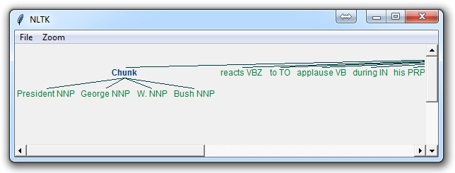

The main line here in question is:

chunkGram = r"""Chunk: {<RB.?>*<VB.?>*<NNP>+<NN>?}"""

This line, broken down:

<RB.?>* = "0 or more of any tense of adverb," followed by:

<VB.?>* = "0 or more of any tense of verb," followed by:

<NNP>+ = "One or more proper nouns," followed by

<NN>? = "zero or one singular noun."

Try playing around with combinations to group various instances until you feel comfortable with chunking.

Not covered in the video, but also a reasonable task is to actually access the chunks specifically. This is something rarely talked about, but can be an essential step depending on what you're doing. Say you print the chunks out, you are going to see output like:

(S

(Chunk PRESIDENT/NNP GEORGE/NNP W./NNP BUSH/NNP)

'S/POS

(Chunk

ADDRESS/NNP

BEFORE/NNP

A/NNP

JOINT/NNP

SESSION/NNP

OF/NNP

THE/NNP

CONGRESS/NNP

ON/NNP

THE/NNP

STATE/NNP

OF/NNP

THE/NNP

UNION/NNP

January/NNP)

31/CD

,/,

2006/CD

THE/DT

(Chunk PRESIDENT/NNP)

:/:

(Chunk Thank/NNP)

you/PRP

all/DT

./.)

Cool, that helps us visually, but what if we want to access this data via our program? Well, what is happening here is our "chunked" variable is an NLTK tree. Each "chunk" and "non chunk" is a "subtree" of the tree. We can reference these by doing something like chunked.subtrees. We can then iterate through these subtrees like so:

for subtree in chunked.subtrees():

print(subtree)

Next, we might be only interested in getting just the chunks, ignoring the rest. We can use the filter parameter in the chunked.subtrees() call.

for subtree in chunked.subtrees(filter=lambda t: t.label() == 'Chunk'):

print(subtree)

Now, we're filtering to only show the subtrees with the label of "Chunk." Keep in mind, this isn't "Chunk" as in the NLTK chunk attribute... this is "Chunk" literally because that's the label we gave it here: chunkGram = r"""Chunk: {<RB.?>*<VB.?>*<NNP>+<NN>?}"""

Had we said instead something like chunkGram = r"""Pythons: {<RB.?>*<VB.?>*<NNP>+<NN>?}""", then we would filter by the label of "Pythons." The result here should be something like:

-

(Chunk PRESIDENT/NNP GEORGE/NNP W./NNP BUSH/NNP)

(Chunk

ADDRESS/NNP

BEFORE/NNP

A/NNP

JOINT/NNP

SESSION/NNP

OF/NNP

THE/NNP

CONGRESS/NNP

ON/NNP

THE/NNP

STATE/NNP

OF/NNP

THE/NNP

UNION/NNP

January/NNP)

(Chunk PRESIDENT/NNP)

(Chunk Thank/NNP)

Full code for this would be:

import nltk

from nltk.corpus import state_union

from nltk.tokenize import PunktSentenceTokenizer

train_text = state_union.raw("2005-GWBush.txt")

sample_text = state_union.raw("2006-GWBush.txt")

custom_sent_tokenizer = PunktSentenceTokenizer(train_text)

tokenized = custom_sent_tokenizer.tokenize(sample_text)

def process_content():

try:

for i in tokenized:

words = nltk.word_tokenize(i)

tagged = nltk.pos_tag(words)

chunkGram = r"""Chunk: {<RB.?>*<VB.?>*<NNP>+<NN>?}"""

chunkParser = nltk.RegexpParser(chunkGram)

chunked = chunkParser.parse(tagged)

print(chunked)

for subtree in chunked.subtrees(filter=lambda t: t.label() == 'Chunk'):

print(subtree)

chunked.draw()

except Exception as e:

print(str(e))

process_content()

If you get particular enough, you may find that you may be better off if there was a way to chunk everything, except some stuff. This process is what is known as chinking, and that's what we're going to be covering next.

You may find that, after a lot of chunking, you have some words in your chunk you still do not want, but you have no idea how to get rid of them by chunking. You may find that chinking is your solution.

Chinking is a lot like chunking, it is basically a way for you to remove a chunk from a chunk. The chunk that you remove from your chunk is your chink.

The code is very similar, you just denote the chink, after the chunk, with }{ instead of the chunk's {}.

import nltk

from nltk.corpus import state_union

from nltk.tokenize import PunktSentenceTokenizer

train_text = state_union.raw("2005-GWBush.txt")

sample_text = state_union.raw("2006-GWBush.txt")

custom_sent_tokenizer = PunktSentenceTokenizer(train_text)

tokenized = custom_sent_tokenizer.tokenize(sample_text)

def process_content():

try:

for i in tokenized[5:]:

words = nltk.word_tokenize(i)

tagged = nltk.pos_tag(words)

chunkGram = r"""Chunk: {<.*>+}

}<VB.?|IN|DT|TO>+{"""

chunkParser = nltk.RegexpParser(chunkGram)

chunked = chunkParser.parse(tagged)

chunked.draw()

except Exception as e:

print(str(e))

process_content()

With this, you are given something like:

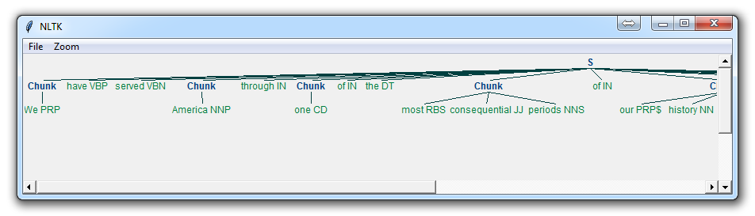

Now, the main difference here is:

}<VB.?|IN|DT|TO>+{

This means we're removing from the chink one or more verbs, prepositions, determiners, or the word 'to'.

## Named Entity Recognition with NLTK:

One of the most major forms of chunking in natural language processing is called "Named Entity Recognition." The idea is to have the machine immediately be able to pull out "entities" like people, places, things, locations, monetary figures, and more.

This can be a bit of a challenge, but NLTK is this built in for us. There are two major options with NLTK's named entity recognition: either recognize all named entities, or recognize named entities as their respective type, like people, places, locations, etc.

Here's an example:

import nltk

from nltk.corpus import state_union

from nltk.tokenize import PunktSentenceTokenizer

train_text = state_union.raw("2005-GWBush.txt")

sample_text = state_union.raw("2006-GWBush.txt")

custom_sent_tokenizer = PunktSentenceTokenizer(train_text)

tokenized = custom_sent_tokenizer.tokenize(sample_text)

def process_content():

try:

for i in tokenized[5:]:

words = nltk.word_tokenize(i)

tagged = nltk.pos_tag(words)

namedEnt = nltk.ne_chunk(tagged, binary=True)

namedEnt.draw()

except Exception as e:

print(str(e))

process_content()

Here, with the option of binary = True, this means either something is a named entity, or not. There will be no further detail. The result is:

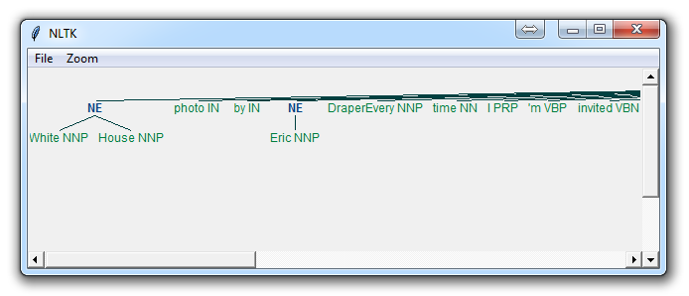

If you set binary = False, then the result is:

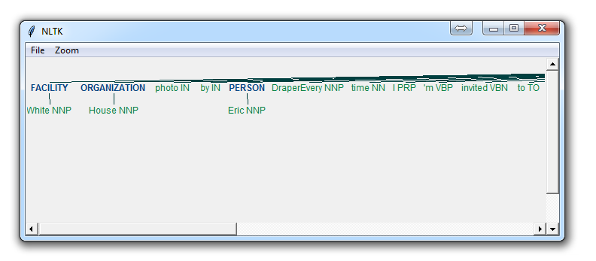

Immediately, you can see a few things. When Binary is False, it picked up the same things, but wound up splitting up terms like White House into "White" and "House" as if they were different, whereas we could see in the binary = True option, the named entity recognition was correct to say White House was part of the same named entity.

Depending on your goals, you may use the binary option how you see fit. Here are the types of Named Entities that you can get if you have binary as false:

NE Type and Examples  
ORGANIZATION - Georgia-Pacific Corp., WHO  
PERSON - Eddy Bonte, President Obama  
LOCATION - Murray River, Mount Everest  
DATE - June, 2008-06-29  
TIME - two fifty a m, 1:30 p.m.  
MONEY - 175 million Canadian Dollars, GBP 10.40  
PERCENT - twenty pct, 18.75 %  
FACILITY - Washington Monument, Stonehenge  
GPE - South East Asia, Midlothian

Either way, you will probably find that you need to do a bit more work to get it just right, but this is pretty powerful right out of the box.

## Lemmatizing with NLTK:

A very similar operation to stemming is called lemmatizing. The major difference between these is, as you saw earlier, stemming can often create non-existent words, whereas lemmas are actual words.

So, your root stem, meaning the word you end up with, is not something you can just look up in a dictionary, but you can look up a lemma.

Some times you will wind up with a very similar word, but sometimes, you will wind up with a completely different word. Let's see some examples.

from nltk.stem import WordNetLemmatizer

lemmatizer = WordNetLemmatizer()

print(lemmatizer.lemmatize("cats"))

print(lemmatizer.lemmatize("cacti"))

print(lemmatizer.lemmatize("geese"))

print(lemmatizer.lemmatize("rocks"))

print(lemmatizer.lemmatize("python"))

print(lemmatizer.lemmatize("better", pos="a"))

print(lemmatizer.lemmatize("best", pos="a"))

print(lemmatizer.lemmatize("run"))

print(lemmatizer.lemmatize("run",'v'))

o/p: cat

cactus

goose

rock

python

good

best

run

run

Here, we've got a bunch of examples of the lemma for the words that we use. The only major thing to note is that lemmatize takes a part of speech parameter, "pos." If not supplied, the default is "noun." This means that an attempt will be made to find the closest noun, which can create trouble for you. Keep this inmind if you use lemmatizing!

## The corpora with NLTK:

In this part of the tutorial, I want us to take a moment to peak into the corpora we all downloaded! The NLTK corpus is a massive dump of all kinds of natural language data sets that are definitely worth taking a look at.

Almost all of the files in the NLTK corpus follow the same rules for accessing them by using the NLTK module, but nothing is magical about them. These files are plain text files for the most part, some are XML and some are other formats, but they are all accessible by you manually, or via the module and Python. Let's talk about viewing them manually.

Depending on your installation, your nltk_data directory might be hiding in a multitude of locations. To figure out where it is, head to your Python directory, where the NLTK module is. If you do not know where that is, use the following code:

import nltk

print(nltk.__file__)

Run that, and the output will be the location of the NLTK module's __init__.py. Head into the NLTK directory, and then look for the data.py file.

The important blurb of code is:

if sys.platform.startswith('win'):

# Common locations on Windows:

path += [

str(r'C:\nltk_data'), str(r'D:\nltk_data'), str(r'E:\nltk_data'),

os.path.join(sys.prefix, str('nltk_data')),

os.path.join(sys.prefix, str('lib'), str('nltk_data')),

os.path.join(os.environ.get(str('APPDATA'), str('C:\\')), str('nltk_data'))

]

else:

# Common locations on UNIX & OS X:

path += [

str('/usr/share/nltk_data'),

str('/usr/local/share/nltk_data'),

str('/usr/lib/nltk_data'),

str('/usr/local/lib/nltk_data')

]

There, you can see the various possible directories for the nltk_data. If you're on Windows, chances are it is in your appdata, in the local directory. To get there, you will want to open your file browser, go to the top, and type in %appdata%

Next click on roaming, and then find the nltk_data directory. In there, you will have your corpora file. The full path is something like:   
C:\Users\yourname\AppData\Roaming\nltk_data\corpora

Within here, you have all of the available corpora, including things like books, chat logs, movie reviews, and a whole lot more.

Now, we're going to talk about accessing these documents via NLTK. As you can see, these are mostly text documents, so you could just use normal Python code to open and read documents. That said, the NLTK module has a few nice methods for handling the corpus, so you may find it useful to use their methology. Here's an example of us opening the Gutenberg Bible, and reading the first few lines:

from nltk.tokenize import sent_tokenize, PunktSentenceTokenizer

from nltk.corpus import gutenberg

# sample text

sample = gutenberg.raw("bible-kjv.txt")

tok = sent_tokenize(sample)

for x in range(5):

print(tok[x])

## Wordnet with NLTK

[WordNet](https://wordnet.princeton.edu/) is a lexical database for the English language, which was created by Princeton, and is part of the NLTK corpus.

You can use WordNet alongside the NLTK module to find the meanings of words, synonyms, antonyms, and more. Let's cover some examples.

First, you're going to need to import wordnet:

from nltk.corpus import wordnet

Then, we're going to use the term "program" to find synsets like so:

syns = wordnet.synsets("program")

An example of a synset:

print(syns[0].name())

plan.n.01

Just the word:

print(syns[0].lemmas()[0].name())

plan

Definition of that first synset:

print(syns[0].definition())

a series of steps to be carried out or goals to be accomplished

Examples of the word in use:

print(syns[0].examples())

['they drew up a six-step plan', 'they discussed plans for a new bond issue']

Next, how might we discern synonyms and antonyms to a word? The lemmas will be synonyms, and then you can use .antonyms to find the antonyms to the lemmas. As such, we can populate some lists like:

synonyms = []

antonyms = []

for syn in wordnet.synsets("good"):

for l in syn.lemmas():

synonyms.append(l.name())

if l.antonyms():

antonyms.append(l.antonyms()[0].name())

print(set(synonyms))

print(set(antonyms))

{'beneficial', 'just', 'upright', 'thoroughly', 'in_force', 'well', 'skilful', 'skillful', 'sound', 'unspoiled', 'expert', 'proficient', 'in_effect', 'honorable', 'adept', 'secure', 'commodity', 'estimable', 'soundly', 'right', 'respectable', 'good', 'serious', 'ripe', 'salutary', 'dear', 'practiced', 'goodness', 'safe', 'effective', 'unspoilt', 'dependable', 'undecomposed', 'honest', 'full', 'near', 'trade_good'} {'evil', 'evilness', 'bad', 'badness', 'ill'}

As you can see, we got many more synonyms than antonyms, since we just looked up the antonym for the first lemma, but you could easily balance this buy also doing the exact same process for the term "bad."

Next, we can also easily use WordNet to compare the similarity of two words and their tenses, by incorporating the [Wu and Palmer method](http://search.cpan.org/~tpederse/WordNet-Similarity-1.03/lib/WordNet/Similarity/wup.pm) for semantic related-ness.

Let's compare the noun of "ship" and "boat:"

w1 = wordnet.synset('ship.n.01')

w2 = wordnet.synset('boat.n.01')

print(w1.wup_similarity(w2))

0.9090909090909091

w1 = wordnet.synset('ship.n.01')

w2 = wordnet.synset('car.n.01')

print(w1.wup_similarity(w2))

0.6956521739130435

w1 = wordnet.synset('ship.n.01')

w2 = wordnet.synset('cat.n.01')

print(w1.wup_similarity(w2))

0.38095238095238093

## Text Classification with NLTK:

Now that we're comfortable with NLTK, let's try to tackle text classification. The goal with text classification can be pretty broad. Maybe we're trying to classify text as about politics or the military. Maybe we're trying to classify it by the gender of the author who wrote it. A fairly popular text classification task is to identify a body of text as either spam or not spam, for things like email filters. In our case, we're going to try to create a sentiment analysis algorithm.

To do this, we're going to start by trying to use the movie reviews database that is part of the NLTK corpus. From there we'll try to use words as "features" which are a part of either a positive or negative movie review. The NLTK corpus movie_reviews data set has the reviews, and they are labeled already as positive or negative. This means we can train and test with this data. First, let's wrangle our data.

import nltk

import random

from nltk.corpus import movie_reviews

documents = [(list(movie_reviews.words(fileid)), category)

for category in movie_reviews.categories()

for fileid in movie_reviews.fileids(category)]

random.shuffle(documents)

print(documents[1])

all_words = []

for w in movie_reviews.words():

all_words.append(w.lower())

all_words = nltk.FreqDist(all_words)

print(all_words.most_common(15))

print(all_words["stupid"])

It may take a moment to run this script, as the movie reviews dataset is somewhat large. Let's cover what is happening here.

After importing the data set we want, you see:

documents = [(list(movie_reviews.words(fileid)), category)

for category in movie_reviews.categories()

for fileid in movie_reviews.fileids(category)]

Basically, in plain English, the above code is translated to: In each category (we have pos or neg), take all of the file IDs (each review has its own ID), then store the word_tokenized version (a list of words) for the file ID, followed by the positive or negative label in one big list.

Next, we use random to shuffle our documents. This is because we're going to be training and testing. If we left them in order, chances are we'd train on all of the negatives, some positives, and then test only against positives. We don't want that, so we shuffle the data.

Then, just so you can see the data you are working with, we print out documents[1], which is a big list, where the first element is a list the words, and the 2nd element is the "pos" or "neg" label.

Next, we want to collect all words that we find, so we can have a massive list of typical words. From here, we can perform a frequency distribution, to then find out the most common words. As you will see, the most popular "words" are actually things like punctuation, "the," "a" and so on, but quickly we get to legitimate words. We intend to store a few thousand of the most popular words, so this shouldn't be a problem.

print(all_words.most_common(15))

The above gives you the 15 most common words. You can also find out how many occurences a word has by doing:

print(all_words["stupid"])

## Converting words to Features with NLTK:

In this tutorial, we're going to be building off the previous video and compiling feature lists of words from positive reviews and words from the negative reviews to hopefully see trends in specific types of words in positive or negative reviews.

To start, our code:

import nltk

import random

from nltk.corpus import movie_reviews

documents = [(list(movie_reviews.words(fileid)), category)

for category in movie_reviews.categories()

for fileid in movie_reviews.fileids(category)]

random.shuffle(documents)

all_words = []

for w in movie_reviews.words():

all_words.append(w.lower())

all_words = nltk.FreqDist(all_words)

word_features = list(all_words.keys())[:3000]

Mostly the same as before, only with now a new variable, word_features, which contains the top 3,000 most common words. Next, we're going to build a quick function that will find these top 3,000 words in our positive and negative documents, marking their presence as either positive or negative:

def find_features(document):

words = set(document)

features = {}

for w in word_features:

features[w] = (w in words)

return features

Next, we can print one feature set like:

print((find_features(movie_reviews.words('neg/cv000_29416.txt'))))

Then we can do this for all of our documents, saving the feature existence booleans and their respective positive or negative categories by doing:

featuresets = [(find_features(rev), category) for (rev, category) in d

## Naive Bayes Classifier with NLTK

Now it is time to choose an algorithm, separate our data into training and testing sets, and press go! The algorithm that we're going to use first is the [Naive Bayes classifier](http://en.wikipedia.org/wiki/Naive_Bayes_classifier). This is a pretty popular algorithm used in text classification, so it is only fitting that we try it out first. Before we can train and test our algorithm, however, we need to go ahead and split up the data into a training set and a testing set.

You could train and test on the same dataset, but this would present you with some serious bias issues, so you should never train and test against the exact same data. To do this, since we've shuffled our data set, we'll assign the first 1,900 shuffled reviews, consisting of both positive and negative reviews, as the training set. Then, we can test against the last 100 to see how accurate we are.

This is called supervised machine learning, because we're showing the machine data, and telling it "hey, this data is positive," or "this data is negative." Then, after that training is done, we show the machine some new data and ask the computer, based on what we taught the computer before, what the computer thinks the category of the new data is.

We can split the data with:

# set that we'll train our classifier with

training_set = featuresets[:1900]

# set that we'll test against.

testing_set = featuresets[1900:]

Next, we can define, and train our classifier like:

classifier = nltk.NaiveBayesClassifier.train(training_set)

First we just simply are invoking the Naive Bayes classifier, then we go ahead and use .train() to train it all in one line.

Easy enough, now it is trained. Next, we can test it:

print("Classifier accuracy percent:",(nltk.classify.accuracy(classifier, testing_set))*100)

Boom, you have your answer. In case you missed it, the reason why we can "test" the data is because we still have the correct answers. So, in testing, we show the computer the data without giving it the correct answer. If it guesses correctly what we know the answer to be, then the computer got it right. Given the shuffling that we've done, you and me might come up with varying accuracy, but you should see something from 60-75% on average.

Next, we can take it a step further to see what the most valuable words are when it comes to positive or negative reviews:

classifier.show_most_informative_features(15)

This is going to vary again for each person, but you should see something like:

Most Informative Features  
insulting = True neg : pos = 10.6 : 1.0  
ludicrous = True neg : pos = 10.1 : 1.0  
winslet = True pos : neg = 9.0 : 1.0  
detract = True pos : neg = 8.4 : 1.0  
breathtaking = True pos : neg = 8.1 : 1.0  
silverstone = True neg : pos = 7.6 : 1.0  
excruciatingly = True neg : pos = 7.6 : 1.0  
warns = True pos : neg = 7.0 : 1.0  
tracy = True pos : neg = 7.0 : 1.0  
insipid = True neg : pos = 7.0 : 1.0  
freddie = True neg : pos = 7.0 : 1.0  
damon = True pos : neg = 5.9 : 1.0  
debate = True pos : neg = 5.9 : 1.0  
ordered = True pos : neg = 5.8 : 1.0  
lang = True pos : neg = 5.7 : 1.0

What this tells you is the ratio of occurences in negative to positive, or visa versa, for every word. So here, we can see that the term "insulting" appears 10.6 more times as often in negative reviews as it does in positive reviews. Ludicrous, 10.1.

Now, let's say you were totally content with your results, and you wanted to move forward, maybe using this classifier to predict things right now. It would be very impractical to train the classifier, and retrain it every time you needed to use it. As such, you can save the classifier using the pickle module. Let's do that next.

## Saving Classifiers with NLTK

Training classifiers and machine learning algorithms can take a very long time, especially if you're training against a larger data set. Ours is actually pretty small. Can you imagine having to train the classifier every time you wanted to fire it up and use it? What horror! Instead, what we can do is use the Pickle module to go ahead and serialize our classifier object, so that all we need to do is load that file in real quick.

So, how do we do this? The first step is to save the object. To do this, first you need to import pickle at the top of your script, then, after you have trained with .train() the classifier, you can then call the following lines:

save_classifier = open("naivebayes.pickle","wb")

pickle.dump(classifier, save_classifier)

save_classifier.close()

This opens up a pickle file, preparing to write in bytes some data. Then, we use pickle.dump() to dump the data. The first parameter to pickle.dump() is what are you dumping, the second parameter is where are you dumping it.

After that, we close the file as we're supposed to, and that is that, we now have a pickled, or serialized, object saved in our script's directory!

Next, how would we go about opening and using this classifier? The .pickle file is a serialized object, all we need to do now is read it into memory, which will be about as quick as reading any other ordinary file. To do this:

classifier_f = open("naivebayes.pickle", "rb")

classifier = pickle.load(classifier_f)

classifier_f.close()

Here, we do a very similar process. We open the file to read as bytes. Then, we use pickle.load() to load the file, and we save the data to the classifier variable. Then we close the file, and that is that. We now have the same classifier object as before!

Now, we can use this object, and we no longer need to train our classifier every time we wanted to use it to classify.

While this is all fine and dandy, we're probably not too content with the 60-75% accuracy we're getting. What about other classifiers? Turns out, there are many classifiers, but we need the scikit-learn (sklearn) module. Luckily for us, the people at NLTK recognized the value of incorporating the sklearn module into NLTK, and they have built us a little API to do it.

## Scikit-Learn Sklearn with NLTK:

We've seen by now how easy it can be to use classifiers out of the box, and now we want to try some more! The best module for Python to do this with is the [Scikit-learn (sklearn) module](http://scikit-learn.org/stable/).

If you would like to learn more about the Scikit-learn Module, I have some tutorials on [machine learning with Scikit-Learn](https://pythonprogramming.net/machine-learning-python-sklearn-intro/).

Luckily for us, the people behind NLTK forsaw the value of incorporating the sklearn module into the NLTK classifier methodology. As such, they created the SklearnClassifier API of sorts. To use that, you just need to import it like:

from nltk.classify.scikitlearn import SklearnClassifier

From here, you can use just about any of the sklearn classifiers. For example, lets bring in a couple more variations of the Naive Bayes algorithm:

from sklearn.naive_bayes import MultinomialNB,BernoulliNB

With this, how might we use them? It turns out, this is very simple:

MNB_classifier = SklearnClassifier(MultinomialNB())

MNB_classifier.train(training_set)

print("MultinomialNB accuracy percent:",nltk.classify.accuracy(MNB_classifier, testing_set))

BNB_classifier = SklearnClassifier(BernoulliNB())

BNB_classifier.train(training_set)

print("BernoulliNB accuracy percent:",nltk.classify.accuracy(BNB_classifier, testing_set))

It is as simple as that. Let's bring in some more:

from sklearn.linear_model import LogisticRegression,SGDClassifier

from sklearn.svm import SVC, LinearSVC, NuSVC

Now, all of our classifiers should look something like:

print("Original Naive Bayes Algo accuracy percent:", (nltk.classify.accuracy(classifier, testing_set))*100)

classifier.show_most_informative_features(15)

MNB_classifier = SklearnClassifier(MultinomialNB())

MNB_classifier.train(training_set)

print("MNB_classifier accuracy percent:", (nltk.classify.accuracy(MNB_classifier, testing_set))*100)

BernoulliNB_classifier = SklearnClassifier(BernoulliNB())

BernoulliNB_classifier.train(training_set)

print("BernoulliNB_classifier accuracy percent:", (nltk.classify.accuracy(BernoulliNB_classifier, testing_set))*100)

LogisticRegression_classifier = SklearnClassifier(LogisticRegression())

LogisticRegression_classifier.train(training_set)

print("LogisticRegression_classifier accuracy percent:", (nltk.classify.accuracy(LogisticRegression_classifier, testing_set))*100)

SGDClassifier_classifier = SklearnClassifier(SGDClassifier())

SGDClassifier_classifier.train(training_set)

print("SGDClassifier_classifier accuracy percent:", (nltk.classify.accuracy(SGDClassifier_classifier, testing_set))*100)

SVC_classifier = SklearnClassifier(SVC())

SVC_classifier.train(training_set)

print("SVC_classifier accuracy percent:", (nltk.classify.accuracy(SVC_classifier, testing_set))*100)

LinearSVC_classifier = SklearnClassifier(LinearSVC())

LinearSVC_classifier.train(training_set)

print("LinearSVC_classifier accuracy percent:", (nltk.classify.accuracy(LinearSVC_classifier, testing_set))*100)

NuSVC_classifier = SklearnClassifier(NuSVC())

NuSVC_classifier.train(training_set)

print("NuSVC_classifier accuracy percent:", (nltk.classify.accuracy(NuSVC_classifier, testing_set))*100)

The result of running this should give you something along the lines of:

Original Naive Bayes Algo accuracy percent: 63.0

Most Informative Features

thematic = True pos : neg = 9.1 : 1.0

secondly = True pos : neg = 8.5 : 1.0

narrates = True pos : neg = 7.8 : 1.0

rounded = True pos : neg = 7.1 : 1.0

supreme = True pos : neg = 7.1 : 1.0

layered = True pos : neg = 7.1 : 1.0

crappy = True neg : pos = 6.9 : 1.0

uplifting = True pos : neg = 6.2 : 1.0

ugh = True neg : pos = 5.3 : 1.0

mamet = True pos : neg = 5.1 : 1.0

gaining = True pos : neg = 5.1 : 1.0

wanda = True neg : pos = 4.9 : 1.0

onset = True neg : pos = 4.9 : 1.0

fantastic = True pos : neg = 4.5 : 1.0

kentucky = True pos : neg = 4.4 : 1.0

MNB_classifier accuracy percent: 66.0

BernoulliNB_classifier accuracy percent: 72.0

LogisticRegression_classifier accuracy percent: 64.0

SGDClassifier_classifier accuracy percent: 61.0

SVC_classifier accuracy percent: 45.0

LinearSVC_classifier accuracy percent: 68.0

NuSVC_classifier accuracy percent: 59.0

So, we can see SVC is wrong more often than it is right right out of the gate, so we should probably dump that one. But then what? The next thing we can try is to use all of these algorithms at once. An algo of algos! To do this, we can create another classifier, and make the result of that classifier based on what the other algorithms said. Sort of like a voting system, so we'll just need an odd number of algorithms.

## Combining Algorithms with NLTK

Now that we know how to use a bunch of algorithmic classifiers, like a child in the candy isle, told they can only pick one, we may find it difficult to choose just one classifier. The good news is, you don't have to! Combining classifier algorithms is is a common technique, done by creating a sort of voting system, where each algorithm gets one vote, and the classification that has the votes votes is the chosen one.

To do this, we want our new classifier to act like a typical NLTK classifier, with all of the methods. Simple enough, using object oriented programming, we can just be sure to inherit from the NLTK classifier class. To do this, we'll import it:

from nltk.classify import ClassifierI

from statistics import mode

We also import mode, as it will be our method for choosing the most popular vote.

Now, let's build our classifier class:

class VoteClassifier(ClassifierI):

def __init__(self, *classifiers):

self._classifiers = classifiers

We're calling our class the VoteClassifier, and we're inheriting from NLTK's ClassifierI. Next, we're assigning the list of classifiers that are passed to our class to self._classifiers.

Next, we want to go ahead and create our own classify method. We want to call it classify, so that we can invoke .classify later on, like a traditional NLTK classifier would allow.

def classify(self, features):

votes = []

for c in self._classifiers:

v = c.classify(features)

votes.append(v)

return mode(votes)

Easy enough, all we're doing here is iterating through our list of classifier objects. Then, for each one, we ask it to classify based on the features. The classification is being treated as a vote. After we are done iterating, we then return the mode(votes), which is just returning the most popular vote.

This is all we really need, but I think it would be useful to have another parameter, confidence. Since we have algorithms voting, we can also tally the votes for and against the winning vote, and call this "confidence." For example, 3/5 votes for positive is weaker than 5/5 votes. As such, we can literally return the ratio of votes as a sort of confidence indicator. Here's our confidence method:

def confidence(self, features):

votes = []

for c in self._classifiers:

v = c.classify(features)

votes.append(v)

choice_votes = votes.count(mode(votes))

conf = choice_votes / len(votes)

return conf

Now, let's put everything together:

import nltk

import random

from nltk.corpus import movie_reviews

from nltk.classify.scikitlearn import SklearnClassifier

import pickle

from sklearn.naive_bayes import MultinomialNB, BernoulliNB

from sklearn.linear_model import LogisticRegression, SGDClassifier

from sklearn.svm import SVC, LinearSVC, NuSVC

from nltk.classify import ClassifierI

from statistics import mode

class VoteClassifier(ClassifierI):

def __init__(self, *classifiers):

self._classifiers = classifiers

def classify(self, features):

votes = []

for c in self._classifiers:

v = c.classify(features)

votes.append(v)

return mode(votes)

def confidence(self, features):

votes = []

for c in self._classifiers:

v = c.classify(features)

votes.append(v)

choice_votes = votes.count(mode(votes))

conf = choice_votes / len(votes)

return conf

documents = [(list(movie_reviews.words(fileid)), category)

for category in movie_reviews.categories()

for fileid in movie_reviews.fileids(category)]

random.shuffle(documents)

all_words = []

for w in movie_reviews.words():

all_words.append(w.lower())

all_words = nltk.FreqDist(all_words)

word_features = list(all_words.keys())[:3000]

def find_features(document):

words = set(document)

features = {}

for w in word_features:

features[w] = (w in words)

return features

#print((find_features(movie_reviews.words('neg/cv000_29416.txt'))))

featuresets = [(find_features(rev), category) for (rev, category) in documents]

training_set = featuresets[:1900]

testing_set = featuresets[1900:]

#classifier = nltk.NaiveBayesClassifier.train(training_set)

classifier_f = open("naivebayes.pickle","rb")

classifier = pickle.load(classifier_f)

classifier_f.close()

print("Original Naive Bayes Algo accuracy percent:", (nltk.classify.accuracy(classifier, testing_set))*100)

classifier.show_most_informative_features(15)

MNB_classifier = SklearnClassifier(MultinomialNB())

MNB_classifier.train(training_set)

print("MNB_classifier accuracy percent:", (nltk.classify.accuracy(MNB_classifier, testing_set))*100)

BernoulliNB_classifier = SklearnClassifier(BernoulliNB())

BernoulliNB_classifier.train(training_set)

print("BernoulliNB_classifier accuracy percent:", (nltk.classify.accuracy(BernoulliNB_classifier, testing_set))*100)

LogisticRegression_classifier = SklearnClassifier(LogisticRegression())

LogisticRegression_classifier.train(training_set)

print("LogisticRegression_classifier accuracy percent:", (nltk.classify.accuracy(LogisticRegression_classifier, testing_set))*100)

SGDClassifier_classifier = SklearnClassifier(SGDClassifier())

SGDClassifier_classifier.train(training_set)

print("SGDClassifier_classifier accuracy percent:", (nltk.classify.accuracy(SGDClassifier_classifier, testing_set))*100)

##SVC_classifier = SklearnClassifier(SVC())

##SVC_classifier.train(training_set)

##print("SVC_classifier accuracy percent:", (nltk.classify.accuracy(SVC_classifier, testing_set))*100)

LinearSVC_classifier = SklearnClassifier(LinearSVC())

LinearSVC_classifier.train(training_set)

print("LinearSVC_classifier accuracy percent:", (nltk.classify.accuracy(LinearSVC_classifier, testing_set))*100)

NuSVC_classifier = SklearnClassifier(NuSVC())

NuSVC_classifier.train(training_set)

print("NuSVC_classifier accuracy percent:", (nltk.classify.accuracy(NuSVC_classifier, testing_set))*100)

voted_classifier = VoteClassifier(classifier,

NuSVC_classifier,

LinearSVC_classifier,

SGDClassifier_classifier,

MNB_classifier,

BernoulliNB_classifier,

LogisticRegression_classifier)

print("voted_classifier accuracy percent:", (nltk.classify.accuracy(voted_classifier, testing_set))*100)

print("Classification:", voted_classifier.classify(testing_set[0][0]), "Confidence %:",voted_classifier.confidence(testing_set[0][0])*100)

print("Classification:", voted_classifier.classify(testing_set[1][0]), "Confidence %:",voted_classifier.confidence(testing_set[1][0])*100)

print("Classification:", voted_classifier.classify(testing_set[2][0]), "Confidence %:",voted_classifier.confidence(testing_set[2][0])*100)

print("Classification:", voted_classifier.classify(testing_set[3][0]), "Confidence %:",voted_classifier.confidence(testing_set[3][0])*100)

print("Classification:", voted_classifier.classify(testing_set[4][0]), "Confidence %:",voted_classifier.confidence(testing_set[4][0])*100)

print("Classification:", voted_classifier.classify(testing_set[5][0]), "Confidence %:",voted_classifier.confidence(testing_set[5][0])*100)

So at the end here, we're running a few classification examples against text. All of our output:

Original Naive Bayes Algo accuracy percent: 66.0

Most Informative Features

thematic = True pos : neg = 9.1 : 1.0

secondly = True pos : neg = 8.5 : 1.0

narrates = True pos : neg = 7.8 : 1.0

layered = True pos : neg = 7.1 : 1.0

rounded = True pos : neg = 7.1 : 1.0

supreme = True pos : neg = 7.1 : 1.0

crappy = True neg : pos = 6.9 : 1.0

uplifting = True pos : neg = 6.2 : 1.0

ugh = True neg : pos = 5.3 : 1.0

gaining = True pos : neg = 5.1 : 1.0

mamet = True pos : neg = 5.1 : 1.0

wanda = True neg : pos = 4.9 : 1.0

onset = True neg : pos = 4.9 : 1.0

fantastic = True pos : neg = 4.5 : 1.0

milos = True pos : neg = 4.4 : 1.0

MNB_classifier accuracy percent: 67.0

BernoulliNB_classifier accuracy percent: 67.0

LogisticRegression_classifier accuracy percent: 68.0

SGDClassifier_classifier accuracy percent: 57.99999999999999

LinearSVC_classifier accuracy percent: 67.0

NuSVC_classifier accuracy percent: 65.0

voted_classifier accuracy percent: 65.0

Classification: neg Confidence %: 100.0

Classification: pos Confidence %: 57.14285714285714

Classification: neg Confidence %: 57.14285714285714

Classification: neg Confidence %: 57.14285714285714

Classification: pos Confidence %: 57.14285714285714

Classification: pos Confidence %: 85.71428571428571

## Investigating bias with NLTK

The most major issue is that we have a fairly biased algorithm. You can test this yourself by commenting-out the shuffling of the documents, then training against the first 1900, and leaving the last 100 (all positive) reviews. Test, and you will find you have very poor accuracy.

Conversely, you can test against the first 100 data sets, all negative, and train against the following 1900. You will find very high accuracy here. This is a bad sign. It could mean a lot of things, and there are many options for us to fix it.

That said, the project I have in mind for us suggests we go ahead and use a different data set anyways, so we will do that. In the end, we will find this new data set still contains some bias, and that is that it picks up negative things more often. The reason for this is that negative reviews tend to be "more negative" than positive reviews are positive. Handling this can be done with some simple weighting, but it can also get complex fast. Maybe a tutorial for another day.

## Improving Training Data for sentiment analysis with NLTK

So now it is time to train on a new data set. Our goal is to do Twitter sentiment, so we're hoping for a data set that is a bit shorter per positive and negative statement. It just so happens that I have a data set of 5300+ positive and 5300+ negative movie reviews, which are much shorter. These should give us a bit more accuracy from the larger training set, as well as be more fitting for tweets from Twitter.

I have hosted both files here, you can find them by going to the [downloads for the short reviews](https://pythonprogramming.net/static/downloads/short_reviews/). Save these files as positive.txt and negative.txt.

Now, we can build our new data set in a very similar way as before. What needs to change?

We need a new methodology for creating our "documents" variable, and then we also need a new way to create the "all_words" variable. No problem, really, here's how I did it:

short_pos = open("short_reviews/positive.txt","r").read()

short_neg = open("short_reviews/negative.txt","r").read()

documents = []

for r in short_pos.split('\n'):

documents.append( (r, "pos") )

for r in short_neg.split('\n'):

documents.append( (r, "neg") )

all_words = []

short_pos_words = word_tokenize(short_pos)

short_neg_words = word_tokenize(short_neg)

for w in short_pos_words:

all_words.append(w.lower())

for w in short_neg_words:

all_words.append(w.lower())

all_words = nltk.FreqDist(all_words)

Next, we also need to adjust our feature finding function, mainly tokenizing by word in the document, since we didn't have a nifty .words() feature for our new sample. I also went ahead and increased the most common words:

word_features = list(all_words.keys())[:5000]

def find_features(document):

words = word_tokenize(document)

features = {}

for w in word_features:

features[w] = (w in words)

return features

featuresets = [(find_features(rev), category) for (rev, category) in documents]

random.shuffle(featuresets)

Other than this, the rest is the same. Here's the full script just in case you or I missed something:

This process will take a while.. You may want to just go run some errands. It took me about 30-40 minutes to run it in full, and I am running an i7 3930k. For the typical processor in the year I am writing this (2015), it may be hours. This is a one and done process, however.

import nltk

import random

from nltk.corpus import movie_reviews

from nltk.classify.scikitlearn import SklearnClassifier

import pickle

from sklearn.naive_bayes import MultinomialNB, BernoulliNB

from sklearn.linear_model import LogisticRegression, SGDClassifier

from sklearn.svm import SVC, LinearSVC, NuSVC

from nltk.classify import ClassifierI

from statistics import mode

from nltk.tokenize import word_tokenize

class VoteClassifier(ClassifierI):

def __init__(self, *classifiers):

self._classifiers = classifiers

def classify(self, features):

votes = []

for c in self._classifiers:

v = c.classify(features)

votes.append(v)

return mode(votes)

def confidence(self, features):

votes = []

for c in self._classifiers:

v = c.classify(features)

votes.append(v)

choice_votes = votes.count(mode(votes))

conf = choice_votes / len(votes)

return conf

short_pos = open("short_reviews/positive.txt","r").read()

short_neg = open("short_reviews/negative.txt","r").read()

documents = []

for r in short_pos.split('\n'):

documents.append( (r, "pos") )

for r in short_neg.split('\n'):

documents.append( (r, "neg") )

all_words = []

short_pos_words = word_tokenize(short_pos)

short_neg_words = word_tokenize(short_neg)

for w in short_pos_words:

all_words.append(w.lower())

for w in short_neg_words:

all_words.append(w.lower())

all_words = nltk.FreqDist(all_words)

word_features = list(all_words.keys())[:5000]

def find_features(document):

words = word_tokenize(document)

features = {}

for w in word_features:

features[w] = (w in words)

return features

#print((find_features(movie_reviews.words('neg/cv000_29416.txt'))))

featuresets = [(find_features(rev), category) for (rev, category) in documents]

random.shuffle(featuresets)

# positive data example:

training_set = featuresets[:10000]

testing_set = featuresets[10000:]

##

### negative data example:

##training_set = featuresets[100:]

##testing_set = featuresets[:100]

classifier = nltk.NaiveBayesClassifier.train(training_set)

print("Original Naive Bayes Algo accuracy percent:", (nltk.classify.accuracy(classifier, testing_set))*100)

classifier.show_most_informative_features(15)

MNB_classifier = SklearnClassifier(MultinomialNB())

MNB_classifier.train(training_set)

print("MNB_classifier accuracy percent:", (nltk.classify.accuracy(MNB_classifier, testing_set))*100)

BernoulliNB_classifier = SklearnClassifier(BernoulliNB())

BernoulliNB_classifier.train(training_set)

print("BernoulliNB_classifier accuracy percent:", (nltk.classify.accuracy(BernoulliNB_classifier, testing_set))*100)

LogisticRegression_classifier = SklearnClassifier(LogisticRegression())

LogisticRegression_classifier.train(training_set)

print("LogisticRegression_classifier accuracy percent:", (nltk.classify.accuracy(LogisticRegression_classifier, testing_set))*100)

SGDClassifier_classifier = SklearnClassifier(SGDClassifier())

SGDClassifier_classifier.train(training_set)

print("SGDClassifier_classifier accuracy percent:", (nltk.classify.accuracy(SGDClassifier_classifier, testing_set))*100)

##SVC_classifier = SklearnClassifier(SVC())

##SVC_classifier.train(training_set)

##print("SVC_classifier accuracy percent:", (nltk.classify.accuracy(SVC_classifier, testing_set))*100)

LinearSVC_classifier = SklearnClassifier(LinearSVC())

LinearSVC_classifier.train(training_set)

print("LinearSVC_classifier accuracy percent:", (nltk.classify.accuracy(LinearSVC_classifier, testing_set))*100)

NuSVC_classifier = SklearnClassifier(NuSVC())

NuSVC_classifier.train(training_set)

print("NuSVC_classifier accuracy percent:", (nltk.classify.accuracy(NuSVC_classifier, testing_set))*100)

voted_classifier = VoteClassifier(

NuSVC_classifier,

LinearSVC_classifier,

MNB_classifier,

BernoulliNB_classifier,

LogisticRegression_classifier)

print("voted_classifier accuracy percent:", (nltk.classify.accuracy(voted_classifier, testing_set))*100)

Output:

Original Naive Bayes Algo accuracy percent: 66.26506024096386

Most Informative Features

refreshing = True pos : neg = 13.6 : 1.0

captures = True pos : neg = 11.3 : 1.0

stupid = True neg : pos = 10.7 : 1.0

tender = True pos : neg = 9.6 : 1.0

meandering = True neg : pos = 9.1 : 1.0

tv = True neg : pos = 8.6 : 1.0

low-key = True pos : neg = 8.3 : 1.0

thoughtful = True pos : neg = 8.1 : 1.0

banal = True neg : pos = 7.7 : 1.0

amateurish = True neg : pos = 7.7 : 1.0

terrific = True pos : neg = 7.6 : 1.0

record = True pos : neg = 7.6 : 1.0

captivating = True pos : neg = 7.6 : 1.0

portrait = True pos : neg = 7.4 : 1.0

culture = True pos : neg = 7.3 : 1.0

MNB_classifier accuracy percent: 65.8132530120482

BernoulliNB_classifier accuracy percent: 66.71686746987952

LogisticRegression_classifier accuracy percent: 67.16867469879519

SGDClassifier_classifier accuracy percent: 65.8132530120482

LinearSVC_classifier accuracy percent: 66.71686746987952

NuSVC_classifier accuracy percent: 60.09036144578314

voted_classifier accuracy percent: 65.66265060240963

## Creating a module for Sentiment Analysis with NLTK

With this new dataset, and new classifier, we're ready to move forward. As you probably noticed, this new data set takes even longer to train against, since it's a larger set. As you've already been shown, we can actually save tons of time by pickling, or serializing, the trained classifiers, which are just objects.

You've already been shown how to use pickle to do this, so I encourage you to attempt to do it on your own. In case you need help, I will paste the full code to do that here...but seriously, do it yourself!

This process will take a while.. You may want to just go run some errands. It took me about 30-40 minutes to run it in full, and I am running an i7 3930k. For the typical processor in the year I am writing this (2015), it may be hours. This is a one and done process, however.

import nltk

import random

#from nltk.corpus import movie_reviews

from nltk.classify.scikitlearn import SklearnClassifier

import pickle

from sklearn.naive_bayes import MultinomialNB, BernoulliNB

from sklearn.linear_model import LogisticRegression, SGDClassifier

from sklearn.svm import SVC, LinearSVC, NuSVC

from nltk.classify import ClassifierI

from statistics import mode

from nltk.tokenize import word_tokenize

class VoteClassifier(ClassifierI):

def __init__(self, *classifiers):

self._classifiers = classifiers

def classify(self, features):

votes = []

for c in self._classifiers:

v = c.classify(features)

votes.append(v)

return mode(votes)

def confidence(self, features):

votes = []

for c in self._classifiers:

v = c.classify(features)

votes.append(v)

choice_votes = votes.count(mode(votes))

conf = choice_votes / len(votes)

return conf

short_pos = open("short_reviews/positive.txt","r").read()

short_neg = open("short_reviews/negative.txt","r").read()

# move this up here

all_words = []

documents = []

# j is adject, r is adverb, and v is verb

#allowed_word_types = ["J","R","V"]

allowed_word_types = ["J"]

for p in short_pos.split('\n'):

documents.append( (p, "pos") )

words = word_tokenize(p)

pos = nltk.pos_tag(words)

for w in pos:

if w[1][0] in allowed_word_types:

all_words.append(w[0].lower())

for p in short_neg.split('\n'):

documents.append( (p, "neg") )

words = word_tokenize(p)

pos = nltk.pos_tag(words)

for w in pos:

if w[1][0] in allowed_word_types:

all_words.append(w[0].lower())

save_documents = open("pickled_algos/documents.pickle","wb")

pickle.dump(documents, save_documents)

save_documents.close()

all_words = nltk.FreqDist(all_words)

word_features = list(all_words.keys())[:5000]

save_word_features = open("pickled_algos/word_features5k.pickle","wb")

pickle.dump(word_features, save_word_features)

save_word_features.close()

def find_features(document):

words = word_tokenize(document)

features = {}

for w in word_features:

features[w] = (w in words)

return features

featuresets = [(find_features(rev), category) for (rev, category) in documents]

random.shuffle(featuresets)

print(len(featuresets))

testing_set = featuresets[10000:]

training_set = featuresets[:10000]

classifier = nltk.NaiveBayesClassifier.train(training_set)

print("Original Naive Bayes Algo accuracy percent:", (nltk.classify.accuracy(classifier, testing_set))*100)

classifier.show_most_informative_features(15)

###############

save_classifier = open("pickled_algos/originalnaivebayes5k.pickle","wb")

pickle.dump(classifier, save_classifier)

save_classifier.close()

MNB_classifier = SklearnClassifier(MultinomialNB())

MNB_classifier.train(training_set)

print("MNB_classifier accuracy percent:", (nltk.classify.accuracy(MNB_classifier, testing_set))*100)

save_classifier = open("pickled_algos/MNB_classifier5k.pickle","wb")

pickle.dump(MNB_classifier, save_classifier)

save_classifier.close()

BernoulliNB_classifier = SklearnClassifier(BernoulliNB())

BernoulliNB_classifier.train(training_set)

print("BernoulliNB_classifier accuracy percent:", (nltk.classify.accuracy(BernoulliNB_classifier, testing_set))*100)

save_classifier = open("pickled_algos/BernoulliNB_classifier5k.pickle","wb")

pickle.dump(BernoulliNB_classifier, save_classifier)

save_classifier.close()

LogisticRegression_classifier = SklearnClassifier(LogisticRegression())

LogisticRegression_classifier.train(training_set)

print("LogisticRegression_classifier accuracy percent:", (nltk.classify.accuracy(LogisticRegression_classifier, testing_set))*100)

save_classifier = open("pickled_algos/LogisticRegression_classifier5k.pickle","wb")

pickle.dump(LogisticRegression_classifier, save_classifier)

save_classifier.close()

LinearSVC_classifier = SklearnClassifier(LinearSVC())

LinearSVC_classifier.train(training_set)

print("LinearSVC_classifier accuracy percent:", (nltk.classify.accuracy(LinearSVC_classifier, testing_set))*100)

save_classifier = open("pickled_algos/LinearSVC_classifier5k.pickle","wb")

pickle.dump(LinearSVC_classifier, save_classifier)

save_classifier.close()

##NuSVC_classifier = SklearnClassifier(NuSVC())

##NuSVC_classifier.train(training_set)

##print("NuSVC_classifier accuracy percent:", (nltk.classify.accuracy(NuSVC_classifier, testing_set))*100)

SGDC_classifier = SklearnClassifier(SGDClassifier())

SGDC_classifier.train(training_set)

print("SGDClassifier accuracy percent:",nltk.classify.accuracy(SGDC_classifier, testing_set)*100)

save_classifier = open("pickled_algos/SGDC_classifier5k.pickle","wb")

pickle.dump(SGDC_classifier, save_classifier)

save_classifier.close()

Now, you just need to run this one time. You can always run it again if you wanted, but now, you are ready to create the sentiment analysis module. Here's the file that we're going to call sentiment_mod.py

#File: sentiment_mod.py

import nltk

import random

#from nltk.corpus import movie_reviews

from nltk.classify.scikitlearn import SklearnClassifier

import pickle

from sklearn.naive_bayes import MultinomialNB, BernoulliNB

from sklearn.linear_model import LogisticRegression, SGDClassifier

from sklearn.svm import SVC, LinearSVC, NuSVC

from nltk.classify import ClassifierI

from statistics import mode

from nltk.tokenize import word_tokenize

class VoteClassifier(ClassifierI):

def __init__(self, *classifiers):

self._classifiers = classifiers

def classify(self, features):

votes = []

for c in self._classifiers:

v = c.classify(features)

votes.append(v)

return mode(votes)

def confidence(self, features):

votes = []

for c in self._classifiers:

v = c.classify(features)

votes.append(v)

choice_votes = votes.count(mode(votes))

conf = choice_votes / len(votes)

return conf

documents_f = open("pickled_algos/documents.pickle", "rb")

documents = pickle.load(documents_f)

documents_f.close()

word_features5k_f = open("pickled_algos/word_features5k.pickle", "rb")

word_features = pickle.load(word_features5k_f)

word_features5k_f.close()

def find_features(document):

words = word_tokenize(document)

features = {}

for w in word_features:

features[w] = (w in words)

return features

featuresets_f = open("pickled_algos/featuresets.pickle", "rb")

featuresets = pickle.load(featuresets_f)

featuresets_f.close()

random.shuffle(featuresets)

print(len(featuresets))

testing_set = featuresets[10000:]

training_set = featuresets[:10000]

open_file = open("pickled_algos/originalnaivebayes5k.pickle", "rb")

classifier = pickle.load(open_file)

open_file.close()

open_file = open("pickled_algos/MNB_classifier5k.pickle", "rb")

MNB_classifier = pickle.load(open_file)

open_file.close()

open_file = open("pickled_algos/BernoulliNB_classifier5k.pickle", "rb")

BernoulliNB_classifier = pickle.load(open_file)

open_file.close()

open_file = open("pickled_algos/LogisticRegression_classifier5k.pickle", "rb")

LogisticRegression_classifier = pickle.load(open_file)

open_file.close()

open_file = open("pickled_algos/LinearSVC_classifier5k.pickle", "rb")

LinearSVC_classifier = pickle.load(open_file)

open_file.close()

open_file = open("pickled_algos/SGDC_classifier5k.pickle", "rb")

SGDC_classifier = pickle.load(open_file)

open_file.close()

voted_classifier = VoteClassifier(

classifier,

LinearSVC_classifier,

MNB_classifier,

BernoulliNB_classifier,

LogisticRegression_classifier)

def sentiment(text):

feats = find_features(text)

return voted_classifier.classify(feats),voted_classifier.confidence(feats)

So here, there's really nothing new, besides the final function, which is quite simple. This function is the crux of what we will be interacting with from here on out. This function, which we're calling "sentiment," takes one parameter, which is text. From there, we break down the features with the find_features function we created long ago. From there, now all we need to do is use our voted_classifier to return not only the classification, but also the confidence in that classification.

With that, we can now use this file, and the sentiment function as a module. Here's an example script that might utilize the module:

import sentiment_mod as s

print(s.sentiment("This movie was awesome! The acting was great, plot was wonderful, and there were pythons...so yea!"))

print(s.sentiment("This movie was utter junk. There were absolutely 0 pythons. I don't see what the point was at all. Horrible movie, 0/10"))

As expected, the movie with pythons obviously did very well with reviewers, and the movie without any pythons was junk. Both of these were with 100% confidence as well.

It took me about 5 seconds to import the module, since we pickled the classifiers, as compared to the 30ish minutes it took without pickling. Yay for pickling. Your time will vary greatly depending on your processor. If you continue down this path, I will just throw out there that you may also want to look into joblib.

## Twitter Sentiment Analysis with NLTK

Now that we have a sentiment analysis module, we can apply it to just about any text, but preferrably short bits of text, like from Twitter! To do this, we're going to combine this tutorial with the [Twitter streaming API tutorial](https://pythonprogramming.net/twitter-api-streaming-tweets-python-tutorial/).

The initial code from that tutorial is:

from tweepy import Stream

from tweepy import OAuthHandler

from tweepy.streaming import StreamListener

#consumer key, consumer secret, access token, access secret.

ckey="fsdfasdfsafsffa"

csecret="asdfsadfsadfsadf"

atoken="asdf-aassdfs"

asecret="asdfsadfsdafsdafs"

class listener(StreamListener):

def on_data(self, data):

print(data)

return(True)

def on_error(self, status):

print status

auth = OAuthHandler(ckey, csecret)

auth.set_access_token(atoken, asecret)

twitterStream = Stream(auth, listener())

twitterStream.filter(track=["car"])

That is enough to print out all of the data for the streaming live tweets that contain the term "car." We can use the json module to load the data var with json.loads(data), and then we can reference the tweet specifically with:

tweet = all_data["text"]

Now that we have a tweet, we can easily pass this through our sentiment_mod module!

from tweepy import Stream

from tweepy import OAuthHandler

from tweepy.streaming import StreamListener

import json

import sentiment_mod as s

#consumer key, consumer secret, access token, access secret.

ckey="asdfsafsafsaf"

csecret="asdfasdfsadfsa"

atoken="asdfsadfsafsaf-asdfsaf"

asecret="asdfsadfsadfsadfsadfsad"

from twitterapistuff import *

class listener(StreamListener):

def on_data(self, data):

all_data = json.loads(data)

tweet = all_data["text"]

sentiment_value, confidence = s.sentiment(tweet)

print(tweet, sentiment_value, confidence)

if confidence*100 >= 80:

output = open("twitter-out.txt","a")

output.write(sentiment_value)

output.write('\n')

output.close()

return True

def on_error(self, status):

print(status)

auth = OAuthHandler(ckey, csecret)

auth.set_access_token(atoken, asecret)

twitterStream = Stream(auth, listener())

twitterStream.filter(track=["happy"])

Along with that, we're also saving the results to an output file, twitter-out.txt.

Next, what data analysis would be complete without graphs? Let's combine yet another tutorial with this one to make a live streaming graph from the sentiment analysis on the Twitter API!

## Graphing Live Twitter Sentiment Analysis with NLTK with NLTK

Now that we have live data coming in from the Twitter streaming API, why not also have a live graph that shows the sentiment trend? To do this, we're going to combine this tutorial with the [live matplotlib graphing tutorial](https://pythonprogramming.net/python-matplotlib-live-updating-graphs/).

If you want to know more about how the code works, see that tutorial. Otherwise:

import matplotlib.pyplot as plt

import matplotlib.animation as animation

from matplotlib import style

import time

style.use("ggplot")

fig = plt.figure()

ax1 = fig.add_subplot(1,1,1)

def animate(i):

pullData = open("twitter-out.txt","r").read()

lines = pullData.split('\n')

xar = []

yar = []

x = 0

y = 0

for l in lines[-200:]:

x += 1

if "pos" in l:

y += 1

elif "neg" in l:

y -= 1

xar.append(x)

yar.append(y)

ax1.clear()

ax1.plot(xar,yar)

ani = animation.FuncAnimation(fig, animate, interval=1000)

plt.show()

## Named Entity Recognition with Stanford NER Tagger

An alternative to NLTK's named entity recognition (NER) classifier is provided by the Stanford NER tagger. This tagger is largely seen as the standard in named entity recognition, but since it uses an advanced statistical learning algorithm it's more computationally expensive than the option provided by NLTK.

A big benefit of the Stanford NER tagger is that is provides us with a few different models for pulling out named entities. We can use any of the following:

* 3 class model for recognizing locations, persons, and organizations
* 4 class model for recognizing locations, persons, organizations, and miscellaneous entities
* 7 class model for recognizing locations, persons, organizations, times, money, percents, and dates

In order to move forward we'll need to download the models and a jar file, since the NER classifier is written in Java. These are available for free from the [Stanford Natural Language Processing Group](http://nlp.stanford.edu/software/CRF-NER.shtml#Download). Conveniently for us, NTLK provides a wrapper to the Stanford tagger so we can use it in the best language ever (ahem, Python)!

The parameters passed to the StanfordNERTagger class include:

1. Classification model path (3 class model used below)
2. Stanford tagger jar file path
3. Training data encoding (default of ASCII)

Here's how we set it up to tag a sentence with the 3 class model:

# -*- coding: utf-8 -*-

from nltk.tag import StanfordNERTagger

from nltk.tokenize import word_tokenize

st = StanfordNERTagger('/usr/share/stanford-ner/classifiers/english.all.3class.distsim.crf.ser.gz',

'/usr/share/stanford-ner/stanford-ner.jar',

encoding='utf-8')

text = 'While in France, Christine Lagarde discussed short-term stimulus efforts in a recent interview with the Wall Street Journal.'

tokenized_text = word_tokenize(text)

classified_text = st.tag(tokenized_text)

print(classified_text)

Once we've tokenized by word and classified the sentence, we see the tagger produces a list of tuples as follows:

[('While', 'O'), ('in', 'O'), ('France', 'LOCATION'), (',', 'O'), ('Christine', 'PERSON'), ('Lagarde', 'PERSON'), ('discussed', 'O'), ('short-term', 'O'), ('stimulus', 'O'), ('efforts', 'O'), ('in', 'O'), ('a', 'O'), ('recent', 'O'), ('interview', 'O'), ('with', 'O'), ('the', 'O'), ('Wall', 'ORGANIZATION'), ('Street', 'ORGANIZATION'), ('Journal', 'ORGANIZATION'), ('.', 'O')]

Nice! Each token is tagged (using our 3 class model) with either 'PERSON', 'LOCATION', 'ORGANIZATION', or 'O'. The 'O' simply stands for other, i.e., non-named entities.

## Testing NLTK and Stanford NER Taggers for Accuracy

We know how to use two different NER classifiers! But which one should we choose, NLTK's or Stanford's? Let's do some testing to find out.

The first thing we'll need is some annotated reference data on which to test our NER classifiers. One way to get this data would be to find lots of articles and label each token as a type of named entity (e.g., person, organization, location) or other non-named entity. Then we could test our separate NER classifiers against the labels we know are correct.

Unfortunately, this would be really time consuming! Good thing there's a [manually annotated dataset](http://schwa.org/projects/resources/wiki/Wikiner) available for free with over 16,000 English sentences. There are also datasets available in German, Spanish, French, Italian, Dutch, Polish, Portuguese, and Russian!

Here's one annotated sentence from the dataset:

Founding O

member O

Kojima I-PER

Minoru I-PER

played O

guitar O

on O

Good I-MISC

Day I-MISC

, O

and O

Wardanceis I-MISC

cover O

of O

a O

song O

by O

UK I-LOC

post O

punk O

industrial O

band O

Killing I-ORG

Joke I-ORG

. O

Let's read, split, and manipulate the data so it's in a better format for testing.

import nltk

from nltk.tag import StanfordNERTagger

from nltk.metrics.scores import accuracy

raw_annotations = open("/usr/share/wikigold.conll.txt").read()

split_annotations = raw_annotations.split()

# Amend class annotations to reflect Stanford's NERTagger

for n,i in enumerate(split_annotations):

if i == "I-PER":

split_annotations[n] = "PERSON"

if i == "I-ORG":

split_annotations[n] = "ORGANIZATION"

if i == "I-LOC":

split_annotations[n] = "LOCATION"

# Group NE data into tuples

def group(lst, n):

for i in range(0, len(lst), n):

val = lst[i:i+n]

if len(val) == n:

yield tuple(val)

reference_annotations = list(group(split_annotations, 2))

Ok, that looks good! But we'll also need the “clean” form of that data to stick into our NER classifiers. Let's make that happen too.

pure_tokens = split_annotations[::2]

This reads in the data, splits it by spacing, then subsets everything in split_annotations by an increment of 2 (starting with the 0th element). This produces a dataset like the following (much smaller) example:

['Founding', 'member', 'Kojima', 'Minoru', 'played', 'guitar', 'on', 'Good', 'Day', ',', 'and', 'Wardanceis', 'cover', 'of', 'a', 'song', 'by', 'UK', 'post', 'punk', 'industrial', 'band', 'Killing', 'Joke', '.']

Let's go ahead and test the NLTK classifier.

tagged_words = nltk.pos_tag(pure_tokens)

nltk_unformatted_prediction = nltk.ne_chunk(tagged_words)

Since the NLTK NER classifier produces trees (including POS tags), we'll need to do some additional data manipulation to get it in a proper form for testing.

#Convert prediction to multiline string and then to list (includes pos tags)

multiline_string = nltk.chunk.tree2conllstr(nltk_unformatted_prediction)

listed_pos_and_ne = multiline_string.split()

# Delete pos tags and rename

del listed_pos_and_ne[1::3]

listed_ne = listed_pos_and_ne

# Amend class annotations for consistency with reference_annotations

for n,i in enumerate(listed_ne):

if i == "B-PERSON":

listed_ne[n] = "PERSON"

if i == "I-PERSON":

listed_ne[n] = "PERSON"

if i == "B-ORGANIZATION":

listed_ne[n] = "ORGANIZATION"

if i == "I-ORGANIZATION":

listed_ne[n] = "ORGANIZATION"

if i == "B-LOCATION":

listed_ne[n] = "LOCATION"

if i == "I-LOCATION":

listed_ne[n] = "LOCATION"

if i == "B-GPE":

listed_ne[n] = "LOCATION"

if i == "I-GPE":

listed_ne[n] = "LOCATION"

# Group prediction into tuples

nltk_formatted_prediction = list(group(listed_ne, 2))

Now we can test the accuracy of NLTK:

nltk_accuracy = accuracy(reference_annotations, nltk_formatted_prediction)

print(nltk_accuracy)

Wow, .8971 accurate!

Now let's test the Stanford classifier. Since this classifier produces output in tuples, testing doesn't require more data manipulation.

st = StanfordNERTagger('/usr/share/stanford-ner/classifiers/english.all.3class.distsim.crf.ser.gz',

'/usr/share/stanford-ner/stanford-ner.jar',

encoding='utf-8')

stanford_prediction = st.tag(pure_tokens)

stanford_accuracy = accuracy(reference_annotations, stanford_prediction)

print(stanford_accuracy)

Sheesh, .9223 accuracy! Even better!

If you'd like to visualize this, here's some extra code. Check out the [matplotlib](https://www.youtube.com/playlist?list=PLQVvvaa0QuDfefDfXb9Yf0la1fPDKluPF) series if you'd like to figure out more about how this works:

import numpy as np

import matplotlib.pyplot as plt

from matplotlib import style

style.use('fivethirtyeight')

N = 1

ind = np.arange(N) # the x locations for the groups

width = 0.35 # the width of the bars

fig, ax = plt.subplots()

stanford_percentage = stanford_accuracy * 100

rects1 = ax.bar(ind, stanford_percentage, width, color='r')

nltk_percentage = nltk_accuracy * 100

rects2 = ax.bar(ind+width, nltk_percentage, width, color='y')

# add some text for labels, title and axes ticks

ax.set_xlabel('Classifier')

ax.set_ylabel('Accuracy (by percentage)')

ax.set_title('Accuracy by NER Classifier')

ax.set_xticks(ind+width)

ax.set_xticklabels( ('') )

ax.legend( (rects1[0], rects2[0]), ('Stanford', 'NLTK'), bbox_to_anchor=(1.05, 1), loc=2, borderaxespad=0. )

def autolabel(rects):

# attach some text labels

for rect in rects:

height = rect.get_height()

ax.text(rect.get_x()+rect.get_width()/2., 1.02*height, '%10.2f' % float(height),

ha='center', va='bottom')

autolabel(rects1)

autolabel(rects2)

plt.show()

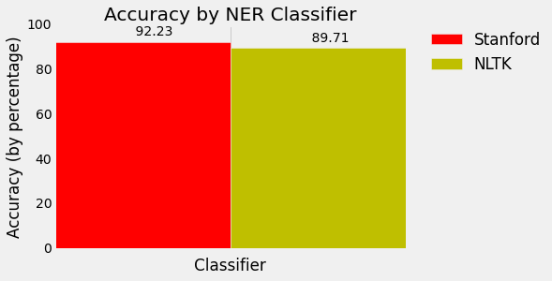

## Testing NLTK and Stanford NER Taggers for Speed

We've tested our NER classifiers for accuracy, but there's more we should consider in deciding which classifier to implement. Let's test for speed next!

Just so we know we're comparing apples to apples, we'll conduct our test on the same article. Let's go with this short piece from NBC news:

House Speaker John Boehner became animated Tuesday over the proposed Keystone Pipeline, castigating the Obama administration for not having approved the project yet.

Republican House Speaker John Boehner says there's "nothing complex about the Keystone Pipeline," and that it's time to build it.

"Complex? You think the Keystone Pipeline is complex?!" Boehner responded to a questioner. "It's been under study for five years! We build pipelines in America every day. Do you realize there are 200,000 miles of pipelines in the United States?"

The speaker went on: "And the only reason the president's involved in the Keystone Pipeline is because it crosses an international boundary. Listen, we can build it. There's nothing complex about the Keystone Pipeline -- it's time to build it."

Boehner said the president had no excuse at this point to not give the pipeline the go-ahead after the State Department released a report on Friday indicating the project would have a minimal impact on the environment.

Republicans have long pushed for construction of the project, which enjoys some measure of Democratic support as well. The GOP is considering conditioning an extension of the debt limit on approval of the project by Obama.

The White House, though, has said that it has no timetable for a final decision on the project.

First we'll make our imports and process the article by reading and tokenizing.

# -*- coding: utf-8 -*-

import nltk

import os

import numpy as np

import matplotlib.pyplot as plt

from matplotlib import style

from nltk import pos_tag

from nltk.tag import StanfordNERTagger

from nltk.tokenize import word_tokenize

style.use('fivethirtyeight')

# Process text

def process_text(txt_file):

raw_text = open("/usr/share/news_article.txt").read()

token_text = word_tokenize(raw_text)

return token_text

Perfect! Now let's write some functions to separate out our classification tasks. We'll include POS tagging in our NLTK function since it's required for the NLTK NE classifier.

# Stanford NER tagger

def stanford_tagger(token_text):

st = StanfordNERTagger('/usr/share/stanford-ner/classifiers/english.all.3class.distsim.crf.ser.gz',

'/usr/share/stanford-ner/stanford-ner.jar',

encoding='utf-8')

ne_tagged = st.tag(token_text)

return(ne_tagged)

# NLTK POS and NER taggers

def nltk_tagger(token_text):

tagged_words = nltk.pos_tag(token_text)

ne_tagged = nltk.ne_chunk(tagged_words)

return(ne_tagged)

Each classifier needs to read the article and classify the named entities, so we'll wrap these functions in a larger function to make timing easy.

def stanford_main():

print(stanford_tagger(process_text(txt_file)))

def nltk_main():

print(nltk_tagger(process_text(txt_file)))

Let's call the functions when we call our program. We'll wrap our stanford_main() and nltk_main() functions in os.times() functions, taking the 4th index, elapsed time. Then we'll graph our results.

if __name__ == '__main__':

stanford_t0 = os.times()[4]

stanford_main()

stanford_t1 = os.times()[4]

stanford_total_time = stanford_t1 - stanford_t0

nltk_t0 = os.times()[4]

nltk_main()

nltk_t1 = os.times()[4]

nltk_total_time = nltk_t1 - nltk_t0

time_plot(stanford_total_time, nltk_total_time)

For our graph, we'll be using the folloing time_plot() function:

def time_plot(stanford_total_time, nltk_total_time):

N = 1

ind = np.arange(N) # the x locations for the groups

width = 0.35 # the width of the bars

stanford_total_time = stanford_total_time

nltk_total_time = nltk_total_time

fig, ax = plt.subplots()

rects1 = ax.bar(ind, stanford_total_time, width, color='r')

rects2 = ax.bar(ind+width, nltk_total_time, width, color='y')

# Add text for labels, title and axes ticks

ax.set_xlabel('Classifier')

ax.set_ylabel('Time (in seconds)')

ax.set_title('Speed by NER Classifier')

ax.set_xticks(ind+width)

ax.set_xticklabels( ('') )

ax.legend( (rects1[0], rects2[0]), ('Stanford', 'NLTK'), bbox_to_anchor=(1.05, 1), loc=2, borderaxespad=0. )

def autolabel(rects):

# attach some text labels

for rect in rects:

height = rect.get_height()

ax.text(rect.get_x()+rect.get_width()/2., 1.02*height, '%10.2f' % float(height),

ha='center', va='bottom')

autolabel(rects1)

autolabel(rects2)

plt.show()

Whoa, NLTK is lightning fast! It seems Stanford is more accurate, but NLTK is faster. This is great information to know when weighing our preferred level of precision alongside required computing resources.

But wait, there's still a problem. Our output is ugly! Here's a small sample from Stanford:

[('House', 'ORGANIZATION'), ('Speaker', 'O'), ('John', 'PERSON'), ('Boehner', 'PERSON'), ('became', 'O'), ('animated', 'O'), ('Tuesday', 'O'), ('over', 'O'), ('the', 'O'), ('proposed', 'O'), ('Keystone', 'ORGANIZATION'), ('Pipeline', 'ORGANIZATION'), (',', 'O'), ('castigating', 'O'), ('the', 'O'), ('Obama', 'PERSON'), ('administration', 'O'), ('for', 'O'), ('not', 'O'), ('having', 'O'), ('approved', 'O'), ('the', 'O'), ('project', 'O'), ('yet', 'O'), ('.', 'O')

And from NLTK:

(S

(ORGANIZATION House/NNP)

Speaker/NNP

(PERSON John/NNP Boehner/NNP)

became/VBD

animated/VBN

Tuesday/NNP

over/IN

the/DT

proposed/VBN

(PERSON Keystone/NNP Pipeline/NNP)

,/,

castigating/VBG

the/DT

(ORGANIZATION Obama/NNP)

administration/NN

for/IN

not/RB

having/VBG

approved/VBN

the/DT

project/NN

yet/RB

./.

Let's get these into nice readable forms in the next tutorial!

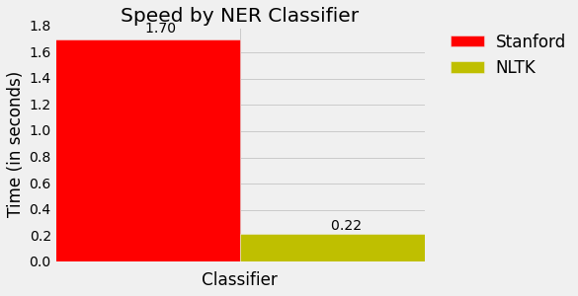

## Using BIO Tags to Create Readable Named Entity Lists

Now that we're done our testing, let's get our named entities in a nice readable format.

Again, we'll use the same short article from NBC news:

House Speaker John Boehner became animated Tuesday over the proposed Keystone Pipeline, castigating the Obama administration for not having approved the project yet.

Republican House Speaker John Boehner says there's "nothing complex about the Keystone Pipeline," and that it's time to build it.

"Complex? You think the Keystone Pipeline is complex?!" Boehner responded to a questioner. "It's been under study for five years! We build pipelines in America every day. Do you realize there are 200,000 miles of pipelines in the United States?"

The speaker went on: "And the only reason the president's involved in the Keystone Pipeline is because it crosses an international boundary. Listen, we can build it. There's nothing complex about the Keystone Pipeline -- it's time to build it."

Boehner said the president had no excuse at this point to not give the pipeline the go-ahead after the State Department released a report on Friday indicating the project would have a minimal impact on the environment.

Republicans have long pushed for construction of the project, which enjoys some measure of Democratic support as well. The GOP is considering conditioning an extension of the debt limit on approval of the project by Obama.

The White House, though, has said that it has no timetable for a final decision on the project.

Our NTLK output is already in a tree (only requiring one last step), so let's get our Stanford output there as well. We'll start by BIO tagging the tokens, with B assigned to the beginning of named entities, I assigned to inside, and O assigned to other. For instance, if we have the sentence "Barack Obama went to Greece today", we should BIO tag it as "Barack-B Obama-I went-O to-O Greece-B today-O." In order to do this we'll write a series of conditionals to examine 'O' tags for current and previous tokens.

# -*- coding: utf-8 -*-

import nltk

import os

import numpy as np

import matplotlib.pyplot as plt

from matplotlib import style

from nltk import pos_tag

from nltk.tag import StanfordNERTagger

from nltk.tokenize import word_tokenize

from nltk.chunk import conlltags2tree

from nltk.tree import Tree

style.use('fivethirtyeight')

# Process text

def process_text(txt_file):

raw_text = open("/usr/share/news_article.txt").read()

token_text = word_tokenize(raw_text)

return token_text

# Stanford NER tagger

def stanford_tagger(token_text):

st = StanfordNERTagger('/usr/share/stanford-ner/classifiers/english.all.3class.distsim.crf.ser.gz',

'/usr/share/stanford-ner/stanford-ner.jar',

encoding='utf-8')

ne_tagged = st.tag(token_text)

return(ne_tagged)

# NLTK POS and NER taggers

def nltk_tagger(token_text):

tagged_words = nltk.pos_tag(token_text)

ne_tagged = nltk.ne_chunk(tagged_words)

return(ne_tagged)

# Tag tokens with standard NLP BIO tags

def bio_tagger(ne_tagged):

bio_tagged = []

prev_tag = "O"

for token, tag in ne_tagged:

if tag == "O": #O

bio_tagged.append((token, tag))

prev_tag = tag

continue

if tag != "O" and prev_tag == "O": # Begin NE

bio_tagged.append((token, "B-"+tag))

prev_tag = tag

elif prev_tag != "O" and prev_tag == tag: # Inside NE

bio_tagged.append((token, "I-"+tag))

prev_tag = tag

elif prev_tag != "O" and prev_tag != tag: # Adjacent NE

bio_tagged.append((token, "B-"+tag))

prev_tag = tag

return bio_tagged

Now we'll write the BIO tagged tokens into trees, so they're in the same formate as the NLTK output.

# Create tree

def stanford_tree(bio_tagged):

tokens, ne_tags = zip(*bio_tagged)

pos_tags = [pos for token, pos in pos_tag(tokens)]

conlltags = [(token, pos, ne) for token, pos, ne in zip(tokens, pos_tags, ne_tags)]

ne_tree = conlltags2tree(conlltags)

return ne_tree

Iterate through and parse out all the named entities.

# Parse named entities from tree

def structure_ne(ne_tree):

ne = []

for subtree in ne_tree:

if type(subtree) == Tree: # If subtree is a noun chunk, i.e. NE != "O"

ne_label = subtree.label()

ne_string = " ".join([token for token, pos in subtree.leaves()])

ne.append((ne_string, ne_label))

return ne

We'll group all our additional functions together in our call:

def stanford_main():

print(structure_ne(stanford_tree(bio_tagger(stanford_tagger(process_text(txt_file))))))

def nltk_main():

print(structure_ne(nltk_tagger(process_text(txt_file))))

And then call the functions:

if __name__ == '__main__':

stanford_main()

nltk_main()

Here's the nice looking output from Stanford:

[('House', 'ORGANIZATION'), ('John Boehner', 'PERSON'), ('Keystone Pipeline', 'ORGANIZATION'), ('Obama', 'PERSON'), ('Republican House', 'ORGANIZATION'), ('John Boehner', 'PERSON'), ('Keystone Pipeline', 'ORGANIZATION'), ('Keystone Pipeline', 'ORGANIZATION'), ('Boehner', 'PERSON'), ('America', 'LOCATION'), ('United States', 'LOCATION'), ('Keystone Pipeline', 'ORGANIZATION'), ('Keystone Pipeline', 'ORGANIZATION'), ('Boehner', 'PERSON'), ('State Department', 'ORGANIZATION'), ('Republicans', 'MISC'), ('Democratic', 'MISC'), ('GOP', 'MISC'), ('Obama', 'PERSON'), ('White House', 'LOCATION')]

And from NLTK:

[('House', 'ORGANIZATION'), ('John Boehner', 'PERSON'), ('Keystone Pipeline', 'PERSON'), ('Obama', 'ORGANIZATION'), ('Republican', 'ORGANIZATION'), ('House', 'ORGANIZATION'), ('John Boehner', 'PERSON'), ('Keystone Pipeline', 'ORGANIZATION'), ('Keystone Pipeline', 'ORGANIZATION'), ('Boehner', 'PERSON'), ('America', 'GPE'), ('United States', 'GPE'), ('Keystone Pipeline', 'ORGANIZATION'), ('Listen', 'PERSON'), ('Keystone', 'ORGANIZATION'), ('Boehner', 'PERSON'), ('State Department', 'ORGANIZATION'), ('Democratic', 'ORGANIZATION'), ('GOP', 'ORGANIZATION'), ('Obama', 'PERSON'), ('White House', 'FACILITY')]

Nicely chunked together and readable. Sweet!

[**A Beginner’s Guide to Recurrent Networks and LSTMs**](https://deeplearning4j.org/lstm.html#a-beginners-guide-to-recurrent-networks-and-lstms)

The purpose of this post is to give students of neural networks an intuition about the functioning of recurrent neural networks and purpose and structure of a prominent RNN variation, LSTMs.

Recurrent nets are a type of artificial neural network designed to recognize patterns in sequences of data, such as text, genomes, handwriting, the spoken word, or numerical times series data emanating from sensors, stock markets and government agencies.

They are arguably the most powerful and useful type of neural network, applicable even to images, which can be decomposed into a series of patches and treated as a sequence.

Since recurrent networks possess a certain type of memory, and memory is also part of the human condition, we’ll make repeated analogies to memory in the brain.[1](https://deeplearning4j.org/lstm.html#one)

Review of Feedforward Networks

To understand recurrent nets, first you have to understand the basics of [feedforward nets](https://deeplearning4j.org/restrictedboltzmannmachine.html). Both of these networks are named after the way they channel information through a series of mathematical operations performed at the nodes of the network. One feeds information straight straight through (never touching a given node twice), while the other cycles it through a loop, and the latter are called recurrent.

In the case of feedforward networks, input examples are fed to the network and transformed into an output; with supervised learning, the output would be a label, a name applied to the input. That is, they map raw data to categories, recognizing patterns that signal, for example, that an input image should be labeled “cat” or “elephant.”

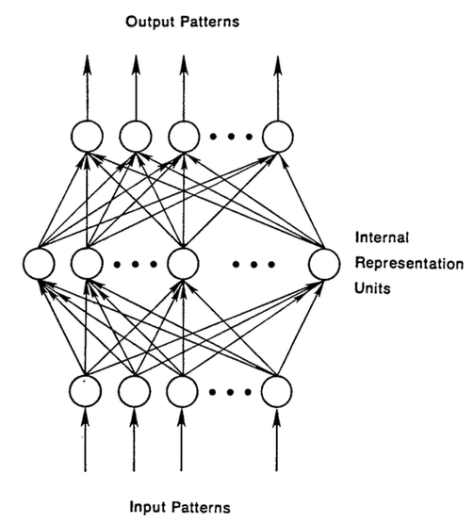

A feedforward network is trained on labeled images until it minimizes the error it makes when guessing their categories. With the trained set of parameters (or weights, collectively known as a model), the network sallies forth to categorize data it has never seen. A trained feedforward network can be exposed to any random collection of photographs, and the first photograph it is exposed to will not necessarily alter how it classifies the second. Seeing photograph of a cat will not lead the net to perceive an elephant next.

That is, a feedforward network has no notion of order in time, and the only input it considers is the current example it has been exposed to. Feedforward networks are amnesiacs regarding their recent past; they remember nostalgically only the formative moments of training.

Recurrent Networks

Recurrent networks, on the other hand, take as their input not just the current input example they see, but also what they have perceived previously in time. Here’s a diagram of an early, [simple recurrent net proposed by Elman](https://web.stanford.edu/group/pdplab/pdphandbook/handbookch8.html), where the *BTSXPE* at the bottom of the drawing represents the input example in the current moment, and *CONTEXT UNIT* represents the output of the previous moment.

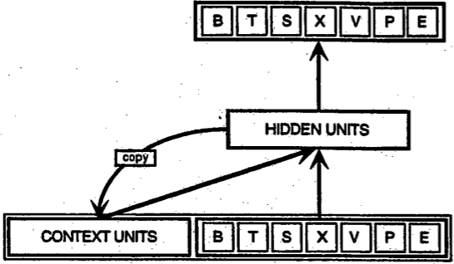

The decision a recurrent net reached at time step t-1 affects the decision it will reach one moment later at time step t. So recurrent networks have two sources of input, the present and the recent past, which combine to determine how they respond to new data, much as we do in life.

Recurrent networks are distinguished from feedforward networks by that feedback loop connected to their past decisions, ingesting their own outputs moment after moment as input. It is often said that recurrent networks have memory.[2](https://deeplearning4j.org/lstm.html#two) Adding memory to neural networks has a purpose: There is information in the sequence itself, and recurrent nets use it to perform tasks that feedforward networks can’t.

That sequential information is preserved in the recurrent network’s hidden state, which manages to span many time steps as it cascades forward to affect the processing of each new example. It is finding correlations between events separated by many moments, and these correlations are called “long-term dependencies”, because an event downstream in time depends upon, and is a function of, one or more events that came before.

Just as human memory circulates invisibly within a body, affecting our behavior without revealing its full shape, information circulates in the hidden states of recurrent nets. The English language is full of words that describe the feedback loops of memory. When we say a person is haunted by their deeds, for example, we are simply talking about the consequences that past outputs wreak on present time. The French call this “*Le passé qui ne passe pas*,” or “The past that does not pass away.”

We’ll describe the process of carrying memory forward mathematically:



The hidden state at time step t is h_t. It is a function of the input at the same time step x_t, modified by a weight matrix W (like the one we used for feedforward nets) added to the hidden state of the previous time step h_t-1 multiplied by its own hidden-state-to-hidden-state matrix U, otherwise known as a transition matrix and similar to a Markov chain. The weight matrices are filters that determine how much importance to accord to both the present input and the past hidden state. The error they generate will return via backpropagation and be used to adjust their weights until error can’t go any lower.

The sum of the weight input and hidden state is squashed by the function φ – either a logistic sigmoid function or tanh, depending – which is a standard tool for condensing very large or very small values into a logistic space, as well as making [gradients](https://deeplearning4j.org/glossary.html#gradient) workable for backpropagation.

Because this feedback loop occurs at every time step in the series, each hidden state contains traces not only of the previous hidden state, but also of all those that preceded h_t-1 for as long as memory can persist.

Given a series of letters, a recurrent *will* use the first character to help determine its perception of the second character, such that an initial q might lead it to infer that the next letter will be u, while an initial t might lead it to infer that the next letter will be h.

Since recurrent nets span time, they are probably best illustrated with animation (the first vertical line of nodes to appear can be thought of as a feedforward network, which becomes recurrent as it unfurls over time).

In the [diagram above](https://imgur.com/kpZBDfV), each x is an input example, w is the weights that filter inputs, a is the activation of the hidden layer (a combination of weighted input and the previous hidden state), and b is the output of the hidden layer after it has been transformed, or squashed, using a rectified linear or sigmoid unit.

Backpropagation Through Time (BPTT)

Remember, the purpose of recurrent nets is to accurately classify sequential input. We rely on the backpropagation of error and gradient descent to do so.

Backpropagation in feedforward networks moves backward from the final error through the outputs, weights and inputs of each hidden layer, assigning those weights responsibility for a portion of the error by calculating their partial derivatives – *∂E/∂w*, or the relationship between their rates of change. Those derivatives are then used by our learning rule, gradient descent, to adjust the weights up or down, whichever direction decreases error.

Recurrent networks rely on an extension of backpropagation called [backpropagation through time](https://www.cs.cmu.edu/~bhiksha/courses/deeplearning/Fall.2015/pdfs/Werbos.backprop.pdf), or BPTT. Time, in this case, is simply expressed by a well-defined, ordered series of calculations linking one time step to the next, which is all backpropagation needs to work.

Neural networks, whether they are recurrent or not, are simply nested composite functions like f(g(h(x))). Adding a time element only extends the series of functions for which we calculate derivatives with the chain rule.

[Truncated BPTT](https://deeplearning4j.org/lstm.html#truncated-bptt)

[Truncated BPTT](https://www.cs.utoronto.ca/~ilya/pubs/ilya_sutskever_phd_thesis.pdf) is an approximation of full BPTT that is preferred for long sequences, since full BPTT’s forward/backward cost per parameter update becomes very high over many time steps. The downside is that the gradient can only flow back so far due to that truncation, so the network can’t learn dependencies that are as long as in full BPTT.

Vanishing (and Exploding) Gradients

Like most neural networks, recurrent nets are old. By the early 1990s, the *vanishing gradient problem*emerged as a major obstacle to recurrent net performance.

Just as a straight line expresses a change in x alongside a change in y, the *gradient* expresses the change in all weights with regard to the change in error. If we can’t know the gradient, we can’t adjust the weights in a direction that will decrease error, and our network ceases to learn.

Recurrent nets seeking to establish connections between a final output and events many time steps before were hobbled, because it is very difficult to know how much importance to accord to remote inputs. (Like great-great-*-grandparents, they multiply quickly in number and their legacy is often obscure.)

This is partially because the information flowing through neural nets passes through many stages of multiplication.

Everyone who has studied compound interest knows that any quantity multiplied frequently by an amount slightly greater than one can become immeasurably large (indeed, that simple mathematical truth underpins network effects and inevitable social inequalities). But its inverse, multiplying by a quantity less than one, is also true. Gamblers go bankrupt fast when they win just 97 cents on every dollar they put in the slots.

Because the layers and time steps of deep neural networks relate to each other through multiplication, derivatives are susceptible to vanishing or exploding.

Exploding gradients treat every weight as though it were the proverbial butterfly whose flapping wings cause a distant hurricane. Those weights’ gradients become saturated on the high end; i.e. they are presumed to be too powerful. But exploding gradients can be solved relatively easily, because they can be truncated or squashed. Vanishing gradients can become too small for computers to work with or for networks to learn – a harder problem to solve.

Below you see the effects of applying a sigmoid function over and over again. The data is flattened until, for large stretches, it has no detectable slope. This is analogous to a gradient vanishing as it passes through many layers.

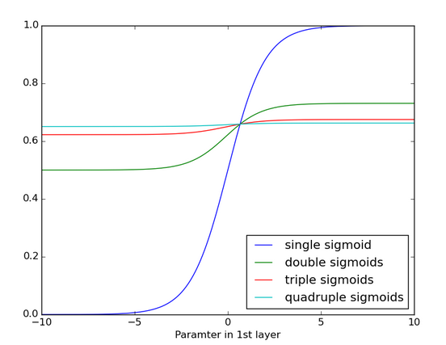

Long Short-Term Memory Units (LSTMs)

In the mid-90s, a variation of recurrent net with so-called Long Short-Term Memory units, or LSTMs, was proposed by the German researchers Sepp Hochreiter and Juergen Schmidhuber as a solution to the vanishing gradient problem.

LSTMs help preserve the error that can be backpropagated through time and layers. By maintaining a more constant error, they allow recurrent nets to continue to learn over many time steps (over 1000), thereby opening a channel to link causes and effects remotely. This is one of the central challenges to machine learning and AI, since algorithms are frequently confronted by environments where reward signals are sparse and delayed, such as life itself. (Religious thinkers have tackled this same problem with ideas of karma or divine reward, theorizing invisible and distant consequences to our actions.)

LSTMs contain information outside the normal flow of the recurrent network in a gated cell. Information can be stored in, written to, or read from a cell, much like data in a computer’s memory. The cell makes decisions about what to store, and when to allow reads, writes and erasures, via gates that open and close. Unlike the digital storage on computers, however, these gates are analog, implemented with element-wise multiplication by sigmoids, which are all in the range of 0-1. Analog has the advantage over digital of being differentiable, and therefore suitable for backpropagation.

Those gates act on the signals they receive, and similar to the neural network’s nodes, they block or pass on information based on its strength and import, which they filter with their own sets of weights. Those weights, like the weights that modulate input and hidden states, are adjusted via the recurrent networks learning process. That is, the cells learn when to allow data to enter, leave or be deleted through the iterative process of making guesses, backpropagating error, and adjusting weights via gradient descent.

The diagram below illustrates how data flows through a memory cell and is controlled by its gates.

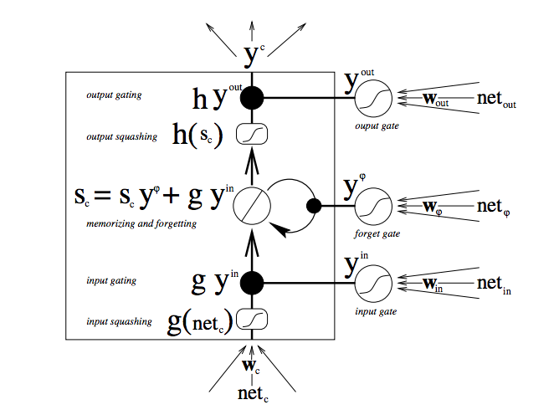

There are a lot of moving parts here, so if you are new to LSTMs, don’t rush this diagram – contemplate it. After a few minutes, it will begin to reveal its secrets.

Starting from the bottom, the triple arrows show where information flows into the cell at multiple points. That combination of present input and past cell state is fed not only to the cell itself, but also to each of its three gates, which will decide how the input will be handled.

The black dots are the gates themselves, which determine respectively whether to let new input in, erase the present cell state, and/or let that state impact the network’s output at the present time step. S_c is the current state of the memory cell, and g_y_in is the current input to it. Remember that each gate can be open or shut, and they will recombine their open and shut states at each step. The cell can forget its state, or not; be written to, or not; and be read from, or not, at each time step, and those flows are represented here.

The large bold letters give us the result of each operation.

Here’s another diagram for good measure, comparing a simple recurrent network (left) to an LSTM cell (right). The blue lines can be ignored; the legend is helpful.

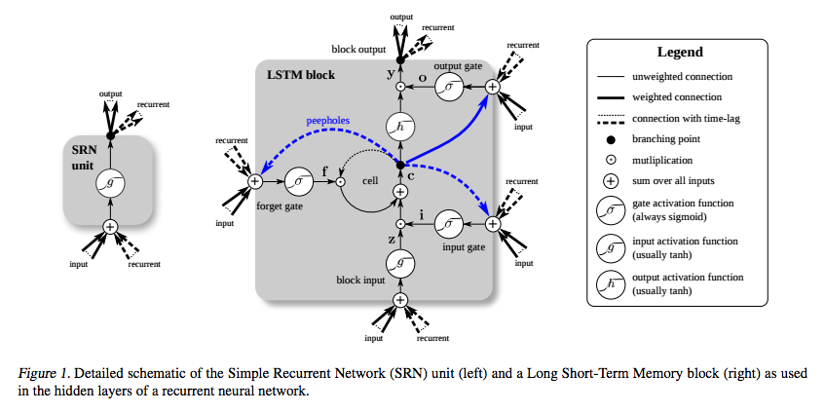

It’s important to note that LSTMs’ memory cells give different roles to addition and multiplication in the transformation of input. The central **plus sign** in both diagrams is essentially the secret of LSTMs. Stupidly simple as it may seem, this basic change helps them preserve a constant error when it must be backpropagated at depth. Instead of determining the subsequent cell state by multiplying its current state with new input, they add the two, and that quite literally makes the difference. (The forget gate still relies on multiplication, of course.)

Different sets of weights filter the input for input, output and forgetting. The forget gate is represented as a linear identity function, because if the gate is open, the current state of the memory cell is simply multiplied by one, to propagate forward one more time step.

Furthermore, while we’re on the topic of simple hacks, [including a bias of 1](http://jmlr.org/proceedings/papers/v37/jozefowicz15.pdf) to the forget gate of every LSTM cell is also shown to [improve performance](http://www.felixgers.de/papers/phd.pdf). (*Sutskever, on the other hand, recommends a bias of 5.*)

You may wonder why LSTMs have a forget gate when their purpose is to link distant occurrences to a final output. Well, sometimes it’s good to forget. If you’re analyzing a text corpus and come to the end of a document, for example, you may have no reason to believe that the next document has any relationship to it whatsoever, and therefore the memory cell should be set to zero before the net ingests the first element of the next document.

In the diagram below, you can see the gates at work, with straight lines representing closed gates, and blank circles representing open ones. The lines and circles running horizontal down the hidden layer are the forget gates.

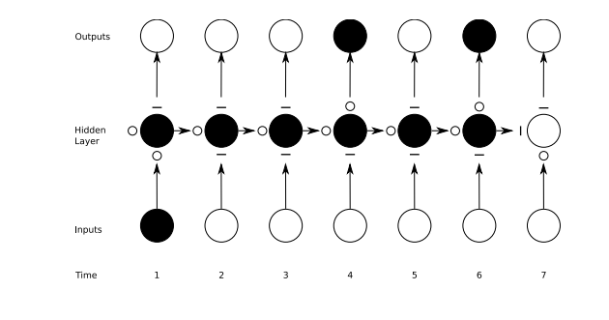

It should be noted that while feedforward networks map one input to one output, recurrent nets can map one to many, as above (one image to many words in a caption), many to many (translation), or many to one (classifying a voice).

Capturing Diverse Time Scales and Remote Dependencies

You may also wonder what the precise value is of input gates that protect a memory cell from new data coming in, and output gates that prevent it from affecting certain outputs of the RNN. You can think of LSTMs as allowing a neural network to operate on different scales of time at once.

Let’s take a human life, and imagine that we are receiving various streams of data about that life in a time series. Geolocation at each time step is pretty important for the next time step, so that scale of time is always open to the latest information.

Perhaps this human is a diligent citizen who votes every couple years. On democratic time, we would want to pay special attention to what they do around elections, before they return to making a living, and away from larger issues. We would not want to let the constant noise of geolocation affect our political analysis.

If this human is also a diligent daughter, then maybe we can construct a familial time that learns patterns in phone calls which take place regularly every Sunday and spike annually around the holidays. Little to do with political cycles or geolocation.

Other data is like that. Music is polyrhythmic. Text contains recurrent themes at varying intervals. Stock markets and economies experience jitters within longer waves. They operate simultaneously on different time scales that LSTMs can capture.

[Gated Recurrent Units (GRUs)](https://deeplearning4j.org/lstm.html#gated-recurrent-units-grus)

A gated recurrent unit (GRU) is basically an LSTM without an output gate, which therefore fully writes the contents from its memory cell to the larger net at each time step.

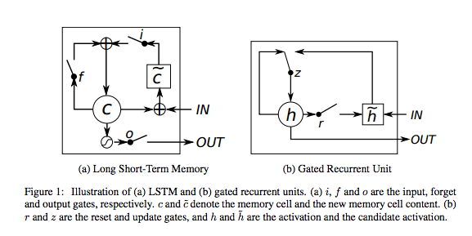

Code Sample

A [commented example of a Graves LSTM](https://github.com/deeplearning4j/dl4j-examples/blob/master/dl4j-examples/src/main/java/org/deeplearning4j/examples/recurrent/character/GravesLSTMCharModellingExample.java) learning how to replicate Shakespearian drama, and implemented with Deeplearning4j, can be found here. The API is commented where it’s not self-explanatory. If you have questions, please join us on [Gitter](https://gitter.im/deeplearning4j/deeplearning4j).

Here’s what the LSTM configuration looks like:

                //Set up network configuration:  
                MultiLayerConfiguration conf = new NeuralNetConfiguration.Builder()  
                        .optimizationAlgo(OptimizationAlgorithm.STOCHASTIC_GRADIENT_DESCENT).iterations(1)  
                        .learningRate(0.1)  
                        .seed(12345)  
                        .regularization(true)  
                        .l2(0.001)  
            .weightInit(WeightInit.XAVIER)  
            .updater(Updater.RMSPROP)  
                        .list()  
                        .layer(0, new GravesLSTM.Builder().nIn(iter.inputColumns()).nOut(lstmLayerSize)  
                                        .activation(Activation.TANH).build())  
                        .layer(1, new GravesLSTM.Builder().nIn(lstmLayerSize).nOut(lstmLayerSize)  
                                        .activation(Activation.TANH).build())  
                        .layer(2, new RnnOutputLayer.Builder(LossFunction.MCXENT).activation(Activation.SOFTMAX)        //MCXENT + softmax for classification  
                                        .nIn(lstmLayerSize).nOut(nOut).build())  
            .backpropType(BackpropType.TruncatedBPTT).tBPTTForwardLength(tbpttLength).tBPTTBackwardLength(tbpttLength)  
                        .pretrain(false).backprop(true)  
                        .build();

[This Gist](https://github.com/deeplearning4j/dl4j-examples/blob/master/dl4j-examples/src/main/java/org/deeplearning4j/examples/recurrent/character/GravesLSTMCharModellingExample.java) brought to you by [gist-it](https://gist-it.appspot.com/).[view raw](https://github.com/deeplearning4j/dl4j-examples/raw/master/dl4j-examples/src/main/java/org/deeplearning4j/examples/recurrent/character/GravesLSTMCharModellingExample.java)[dl4j-examples/src/main/java/org/deeplearning4j/examples/recurrent/character/GravesLSTMCharModellingExample.java](https://github.com/deeplearning4j/dl4j-examples/blob/master/dl4j-examples/src/main/java/org/deeplearning4j/examples/recurrent/character/GravesLSTMCharModellingExample.java)

[GET STARTED WITH DEEP LEARNING](https://skymind.ai/quickstart)

LSTM Hyperparameter Tuning

Here are a few ideas to keep in mind when manually optimizing hyperparameters for RNNs:

* Watch out for *overfitting*, which happens when a neural network essentially “memorizes” the training data. Overfitting means you get great performance on training data, but the network’s model is useless for out-of-sample prediction.
* Regularization helps: regularization methods include l1, l2, and dropout among others.
* So have a separate test set on which the network doesn’t train.
* The larger the network, the more powerful, but it’s also easier to overfit. Don’t want to try to learn a million parameters from 10,000 examples – parameters > examples = trouble.
* More data is almost always better, because it helps fight overfitting.
* Train over multiple epochs (complete passes through the dataset).
* Evaluate test set performance at each epoch to know when to stop (early stopping).
* The learning rate is the single most important hyperparameter. Tune this using [deeplearning4j-ui](https://deeplearning4j.org/visualization); see [this graph](https://cs231n.github.io/neural-networks-3/#baby)
* In general, stacking layers can help.
* For LSTMs, use the softsign (not softmax) activation function over tanh (it’s faster and less prone to saturation (~0 gradients)).
* Updaters: RMSProp, AdaGrad or momentum (Nesterovs) are usually good choices. AdaGrad also decays the learning rate, which can help sometimes.
* Finally, remember data normalization, MSE loss function + identity activation function for regression, [Xavier weight initialization](https://deeplearning4j.org/glossary.html#xavier)

[**Sentence iterator**](https://deeplearning4j.org/sentenceiterator#sentence-iterator)

A [sentence iterator](https://deeplearning4j.org/doc/org/deeplearning4j/word2vec/sentenceiterator/SentenceIterator.html) is used in both [Word2vec](https://deeplearning4j.org/word2vec.html) and [Bag of Words](https://deeplearning4j.org/bagofwords-tf-idf.html).

It feeds bits of text into a neural network in the form of vectors, and also covers the concept of documents in text processing.

In natural-language processing, a document or sentence is typically used to encapsulate a context which an algorithm should learn.

A few examples include analyzing Tweets and full-blown news articles. The purpose of the [sentence iterator](https://deeplearning4j.org/doc/org/deeplearning4j/word2vec/sentenceiterator/SentenceIterator.html) is to divide text into processable bits. Note the sentence iterator is input agnostic. So bits of text (a document) can come from a file system, the Twitter API or Hadoop.

Depending on how input is processed, the output of a sentence iterator will then be passed to a [tokenizer](https://deeplearning4j.org/org/deeplearning4j/word2vec/tokenizer/Tokenizer.html)for the processing of individual tokens, which are usually words, but could also be ngrams, skipgrams or other units. The tokenizer is created on a per-sentence basis by a [tokenizer factory](https://deeplearning4j.org/doc/org/deeplearning4j/word2vec/tokenizer/TokenizerFactory.html). The tokenizer factory is what is passed into a text-processing vectorizer.

Some typical examples are below:

SentenceIterator iter = new LineSentenceIterator(new File("your file"));

This assumes that each line in a file is a sentence.

You can also do list of strings as sentence as follows:

Collection<String> sentences = ...;

SentenceIterator iter = new CollectionSentenceIterator(sentences);

This will assume that each string is a sentence (document). Remember this could be a list of Tweets or articles – both are applicable.

You can iterate over files as follows:

SentenceIterator iter = new FileSentenceIterator(new File("your dir or file"));

This will parse the files line by line and return individual sentences on each one.

For anything complex, we recommend an actual machine-learning level pipeline, represented by the [UimaSentenceIterator](https://deeplearning4j.org/doc/org/deeplearning4j/text/sentenceiterator/UimaSentenceIterator.html).

The UimaSentenceIterator is capable of tokenization, part-of-speech tagging and lemmatization, among other things. The UimaSentenceIterator iterates over a set of files and can segment sentences. You can customize its behavior based on the AnalysisEngine passed into it.

The AnalysisEngine is the [UIMA](https://uima.apache.org/) concept of a text-processing pipeline. DeepLearning4j comes with standard analysis engines for all of these common tasks, allowing you to customize which text is being passed in and how you define sentences. The AnalysisEngines are thread-safe versions of the [opennlp](https://opennlp.apache.org/)pipelines. We also include [cleartk](https://cleartk.googlecode.com/)-based pipelines for handling common tasks.

For those using UIMA or curious about it, this employs the cleartk type system for tokens, sentences, and other annotations within the type system.

Here’s how to create a UimaSentenceItrator.

SentenceIterator iter = UimaSentenceIterator.create("path/to/your/text/documents");

You can also instantiate directly:

SentenceIterator iter = new UimaSentenceIterator(path,AnalysisEngineFactory.createEngine(AnalysisEngineFactory.createEngineDescription(TokenizerAnnotator.getDescription(), SentenceAnnotator.getDescription())));

For those familiar with Uima, this uses Uimafit extensively to create analysis engines. You can also create custom sentence iterators by extending SentenceIterator.

**Tutorial: Finding Important Words in Text Using TF-IDF**

|  |  |
| --- | --- |
| **TF_IDF**  **What does tf-idf mean?** | |
| Tf-idf stands for*term frequency-inverse document frequency*, and the tf-idf weight is a weight often used in information retrieval and text mining. This weight is a statistical measure used to evaluate how important a word is to a document in a collection or corpus. The importance increases proportionally to the number of times a word appears in the document but is offset by the frequency of the word in the corpus. Variations of the tf-idf weighting scheme are often used by search engines as a central tool in scoring and ranking a document's relevance given a user query.  One of the simplest ranking functions is computed by summing the tf-idf for each query term; many more sophisticated ranking functions are variants of this simple model.  Tf-idf can be successfully used for stop-words filtering in various subject fields including text summarization and classification.  To learn more about tf-idf or the topics of information retrieval and text mining, we highly recommend Bruce Croft's practical tutorial [*Search Engines: Information Retrieval in Practice*](http://www.amazon.com/gp/product/0136072240/ref=as_li_tf_tl?ie=UTF8&camp=1789&creative=9325&creativeASIN=0136072240&linkCode=as2&tag=tfidf-20)*http://ir-na.amazon-adsystem.com/e/ir?t=tfidf-20&l=as2&o=1&a=0136072240*, and the classic [*Introduction to Information Retrieval*](http://www.amazon.com/gp/product/0521865719/ref=as_li_tf_tl?ie=UTF8&camp=1789&creative=9325&creativeASIN=0521865719&linkCode=as2&tag=tfidf-20)http://ir-na.amazon-adsystem.com/e/ir?t=tfidf-20&l=as2&o=1&a=0521865719 by Christ Manning.  **How to Compute:**  Typically, the tf-idf weight is composed by two terms: the first computes the normalized Term Frequency (TF), aka. the number of times a word appears in a document, divided by the total number of words in that document; the second term is the Inverse Document Frequency (IDF), computed as the logarithm of the number of the documents in the corpus divided by the number of documents where the specific term appears.   * **TF: Term Frequency**, which measures how frequently a term occurs in a document. Since every document is different in length, it is possible that a term would appear much more times in long documents than shorter ones. Thus, the term frequency is often divided by the document length (aka. the total number of terms in the document) as a way of normalization:   TF(t) = (Number of times term t appears in a document) / (Total number of terms in the document). * **IDF: Inverse Document Frequency**, which measures how important a term is. While computing TF, all terms are considered equally important. However it is known that certain terms, such as "is", "of", and "that", may appear a lot of times but have little importance. Thus we need to weigh down the frequent terms while scale up the rare ones, by computing the following:   IDF(t) = log_e(Total number of documents / Number of documents with term t in it).   See below for a simple example.  **Example:**  Consider a document containing 100 words wherein the word *cat* appears 3 times. The term frequency (i.e., tf) for *cat* is then (3 / 100) = 0.03. Now, assume we have 10 million documents and the word *cat* appears in one thousand of these. Then, the inverse document frequency (i.e., idf) is calculated as log(10,000,000 / 1,000) = 4. Thus, the Tf-idf weight is the product of these quantities: 0.03 * 4 = 0.12. |  |

What is TF-IDF?

TF-IDF stands for "Term Frequency, Inverse Document Frequency". It is a way to score the importance of words (or "terms") in a document based on how frequently they appear across multiple documents.

Intuitively...

* If a word appears frequently in a document, it's important. Give the word a high score.
* But if a word appears in many documents, it's not a unique identifier. Give the word a low score.

Therefore, common words like "the" and "for", which appear in many documents, will be scaled down. Words that appear frequently in a *single* document will be scaled up.

In code

The code here is tested on Python 3 with [TextBlob 0.6.1](https://textblob.readthedocs.org/en/latest/). If you're using Python 2, you'll probably need to add from __future__ import division, unicode_literals at the top.

**import** **math**

**from** **textblob** **import** TextBlob **as** tb

**def** tf(word, blob):

**return** blob.words.count(word) / len(blob.words)

**def** n_containing(word, bloblist):

**return** sum(1 **for** blob **in** bloblist **if** word **in** blob.words)

**def** idf(word, bloblist):

**return** math.log(len(bloblist) / (1 + n_containing(word, bloblist)))

**def** tfidf(word, blob, bloblist):

**return** tf(word, blob) * idf(word, bloblist)

14 lines and we're already [flying](http://xkcd.com/353/).

* tf(word, blob) computes "term frequency" which is the number of times a word appears in a document blob, normalized by dividing by the total number of words in blob. We use TextBlob for breaking up the text into words and getting the word counts.
* n_containing(word, bloblist) returns the number of documents containing word. A [generator expression](http://www.python.org/dev/peps/pep-0289/) is passed to the sum() function.
* idf(word, bloblist) computes "inverse document frequency" which measures how common a word is among all documents in bloblist. The more common a word is, the lower its idf. We take the ratio of the total number of documents to the number of documents containing word, then take the log of that. Add 1 to the divisor to prevent division by zero.
* tfidf(word, blob, bloblist) computes the TF-IDF score. It is simply the product of tf and idf.

Now to test it out on some real documents taken from Wikipedia.

document1 = tb("""Python is a 2000 made-for-TV horror movie directed by Richard

Clabaugh. The film features several cult favorite actors, including William

Zabka of The Karate Kid fame, Wil Wheaton, Casper Van Dien, Jenny McCarthy,

Keith Coogan, Robert Englund (best known for his role as Freddy Krueger in the

A Nightmare on Elm Street series of films), Dana Barron, David Bowe, and Sean

Whalen. The film concerns a genetically engineered snake, a python, that

escapes and unleashes itself on a small town. It includes the classic final

girl scenario evident in films like Friday the 13th. It was filmed in Los Angeles,

California and Malibu, California. Python was followed by two sequels: Python

II (2002) and Boa vs. Python (2004), both also made-for-TV films.""")

document2 = tb("""Python, from the Greek word (πύθων/πύθωνας), is a genus of

nonvenomous pythons[2] found in Africa and Asia. Currently, 7 species are

recognised.[2] A member of this genus, P. reticulatus, is among the longest

snakes known.""")

document3 = tb("""The Colt Python is a .357 Magnum caliber revolver formerly

manufactured by Colt's Manufacturing Company of Hartford, Connecticut.

It is sometimes referred to as a "Combat Magnum".[1] It was first introduced

in 1955, the same year as Smith &amp; Wesson's M29 .44 Magnum. The now discontinued

Colt Python targeted the premium revolver market segment. Some firearm

collectors and writers such as Jeff Cooper, Ian V. Hogg, Chuck Hawks, Leroy

Thompson, Renee Smeets and Martin Dougherty have described the Python as the

finest production revolver ever made.""")

bloblist = [document1, document2, document3]

**for** i, blob **in** enumerate(bloblist):

**print**("Top words in document {}".format(i + 1))

scores = {word: tfidf(word, blob, bloblist) **for** word **in** blob.words}

sorted_words = sorted(scores.items(), key=**lambda** x: x[1], reverse=True)

**for** word, score **in** sorted_words[:3]:

**print**("**\t**Word: {}, TF-IDF: {}".format(word, round(score, 5)))

For each document, we store the TF-IDF scores in a dictionary scores mapping word => score using a [dict comprehension](http://www.python.org/dev/peps/pep-0274/). We then sort the words by their scores and output the top 3 words.

The full script is [here](https://gist.github.com/6407257). The output of the program is:

Top words in document 1

Word: films, TF-IDF: 0.00997

Word: film, TF-IDF: 0.00665

Word: California, TF-IDF: 0.00665

Top words in document 2

Word: genus, TF-IDF: 0.02192

Word: among, TF-IDF: 0.01096

Word: Currently, TF-IDF: 0.01096

Top words in document 3

Word: Magnum, TF-IDF: 0.01382

Word: revolver, TF-IDF: 0.01382

Word: Colt, TF-IDF: 0.01382

There may be ways to improve the our TF-IDF algorithm, such as by ignoring stopwords or using a different tf scheme. I'll leave it up to the reader to experiment.

**Text Mining: Term vs. Document Frequency**

So far we have focused on identifying the [frequency of individual terms](http://uc-r.github.io/tidy_text) within a document along with the [sentiments](http://uc-r.github.io/sentiment_analysis) that these words provide. It is also important to understand the importance that words provide within and across documents. As we saw in the [tidy text tutorial](http://uc-r.github.io/tidy_text) *term frequency* (tf) identifies how frequently a word occurs in a document. We found that many common words such as “the”, “is”, “for”, etc. typically top the term frequency lists. One approach to correct for these common, yet low context words, is to remove these words by using a list of stop words.

Another approach is to use what is called a term’s *inverse document frequency*(idf), which decreases the weight for commonly used words and increases the weight for words that are not used very much in a collection of documents. The idf is defined as:

idf(t,D)=log(Nnt)idf(t,D)=log(Nnt)

where the idf of a given term (*t*) in a set of documents (*D*) is a function of the total number of documents being assessed (*N*) and the number of documents where the term *t* appears (ntnt). In addition, we can combine tf and idf statistics into a single tf-idf statistic, which computes the frequency of a term adjusted for how rarely it is used. Since the ratio inside the idf’s log function is always greater than or equal to 1, the value of idf (and tf-idf) is greater than or equal to 0. As a term appears in more documents, the ratio inside the logarithm approaches 1, bringing the idf and tf-idf closer to 0. tf-idf is defined as

tf-idf(t,d,D)=tf(t,d)⋅idf(t,D)tf-idf(t,d,D)=tf(t,d)⋅idf(t,D)

where tf-idf for a particular term (*t*) in docuement (*d*) for a set of documents (*D*) is simply the product of that term’s *tf* and *idf* statistics. This tutorial will walk you through the process of computing these values so that you can identify high frequency words that provide particularly important context to a single document within a group of documents.

tl;dr

This tutorial builds on the [tidy text](http://uc-r.github.io/tidy_text) and [sentiment analysis](http://uc-r.github.io/sentiment_analysis) tutorials so if you have not read through those tutorials I suggest you start there before proceeding. In this tutorial I cover the following:

1. [Replication requirements](http://uc-r.github.io/tf-idf_analysis#replication): What you’ll need to reproduce the analysis in this tutorial
2. [Term frequencies](http://uc-r.github.io/tf-idf_analysis#tf): Computing term frequencies
3. [Zipf’s law](http://uc-r.github.io/tf-idf_analysis#zip): The frequency of any word is inversely proportional to its rank in the frequency table
4. [Inverse document frequency](http://uc-r.github.io/tf-idf_analysis#idf): Computing idf for terms and combining with tf to get tf-idf

Replication Requirements

This tutorial leverages the data provided in the [harrypotter package](https://github.com/bradleyboehmke/harrypotter). I constructed this package to supply the first seven novels in the Harry Potter series to illustrate text mining and analysis capabilities. You can load the harrypotter package with the following:

if (packageVersion("devtools") < 1.6) {

install.packages("devtools")

}

devtools::install_github("bradleyboehmke/harrypotter")

library(tidyverse) # data manipulation & plotting

library(stringr) # text cleaning and regular expressions

library(tidytext) # provides additional text mining functions

library(harrypotter) # provides the first seven novels of the Harry Potter series

Term Frequencies

To compute term frequencies we need to have our data in a tidy format. The following converts all seven Harry Potter novels into a tibble that has each word by chapter by book. See the [tidy text tutorial](http://uc-r.github.io/tidy_text) for more details.

titles <- c("Philosopher's Stone", "Chamber of Secrets", "Prisoner of Azkaban",

"Goblet of Fire", "Order of the Phoenix", "Half-Blood Prince",

"Deathly Hallows")

books <- list(philosophers_stone, chamber_of_secrets, prisoner_of_azkaban,

goblet_of_fire, order_of_the_phoenix, half_blood_prince,

deathly_hallows)

series <- tibble()

for(i in seq_along(titles)) {

clean <- tibble(chapter = seq_along(books[[i]]),

text = books[[i]]) %>%

unnest_tokens(word, text) %>%

mutate(book = titles[i]) %>%

select(book, everything())

series <- rbind(series, clean)

}

# set factor to keep books in order of publication

series$book <- factor(series$book, levels = rev(titles))

series

## # A tibble: 1,089,386 × 3

## book chapter word

## * <fctr> <int> <chr>

## 1 Philosopher's Stone 1 the

## 2 Philosopher's Stone 1 boy

## 3 Philosopher's Stone 1 who

## 4 Philosopher's Stone 1 lived

## 5 Philosopher's Stone 1 mr

## 6 Philosopher's Stone 1 and

## 7 Philosopher's Stone 1 mrs

## 8 Philosopher's Stone 1 dursley

## 9 Philosopher's Stone 1 of

## 10 Philosopher's Stone 1 number

## # ... with 1,089,376 more rows

From this cleaned up text we can compute the term frequency for each word. Lets do this for computing term frequencies by book and across the entire Harry Potter series:

book_words <- series %>%

count(book, word, sort = TRUE) %>%

ungroup()

series_words <- book_words %>%

group_by(book) %>%

summarise(total = sum(n))

book_words <- left_join(book_words, series_words)

book_words

## # A tibble: 67,881 × 4

## book word n total

## <fctr> <chr> <int> <int>

## 1 Order of the Phoenix the 11740 258763

## 2 Deathly Hallows the 10335 198906

## 3 Goblet of Fire the 9305 191882

## 4 Half-Blood Prince the 7508 171284

## 5 Order of the Phoenix to 6518 258763

## 6 Order of the Phoenix and 6189 258763

## 7 Deathly Hallows and 5510 198906

## 8 Order of the Phoenix of 5332 258763

## 9 Prisoner of Azkaban the 4990 105275

## 10 Goblet of Fire and 4959 191882

## # ... with 67,871 more rows

Here, we can see that common and noncontextual words (“the”, “to”, “and”, “of”, etc.) rule the term frequency list. We can visualize the distribution of term frequency for each novel. Here we’ll look at the distribution of n/total. Since the distribution is so clustered around 0 I add scale_x_log10() to spread it out. Even so we see the long right tails for thos extremely common words.

book_words %>%

mutate(ratio = n / total) %>%

ggplot(aes(ratio, fill = book)) +

geom_histogram(show.legend = FALSE) +

scale_x_log10() +

facet_wrap(~ book, ncol = 2)

**Zipf’s Law**

Zipf’s law states that within a group or corpus of documents, the frequency of any word is inversely proportional to its rank in a frequency table. Thus the most frequent word will occur approximately twice as often as the second most frequent word, three times as often as the third most frequent word, etc. Zipf’s law is most easily observed by plotting the data on a log-log graph, with the axes being log(rank order) and log(term frequency).

freq_by_rank <- book_words %>%

group_by(book) %>%

mutate(rank = row_number(),

`term freq` = n / total)

ggplot(freq_by_rank, aes(rank, `term freq`, color = book)) +

geom_line() +

scale_x_log10() +

scale_y_log10()

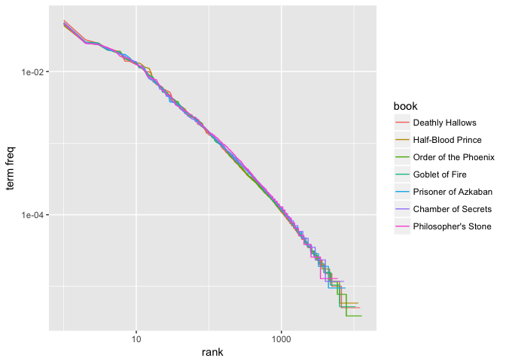

Our plot illustrates that the distribution is similar across the seven books. Furthermore, we can compare the distribution to a simple regression line. We see that the tails of the distribution deviate suggesting our distribution doesn’t follow Zipf’s law perfectly; however, it is close enough to generally state that the law approximately holds within our corpus of text.

lower_rank <- freq_by_rank %>%

filter(rank < 500)

lm(log10(`term freq`) ~ log10(rank), data = lower_rank)

##

## Call:

## lm(formula = log10(`term freq`) ~ log10(rank), data = lower_rank)

##

## Coefficients:

## (Intercept) log10(rank)

## -0.9414 -0.9694

freq_by_rank %>%

ggplot(aes(rank, `term freq`, color = book)) +

geom_abline(intercept = -0.9414, slope = -0.9694, color = "gray50", linetype = 2) +

geom_line(size = 1.2, alpha = 0.8) +

scale_x_log10() +

scale_y_log10()

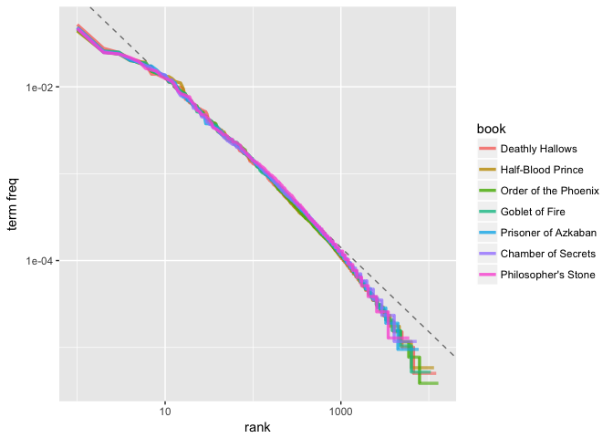

**Inverse Document Frequency and tf-idf**

The idea of tf-idf is to find the important words for the content of each document by decreasing the weight for commonly used words and increasing the weight for words that are not used very much in a collection or corpus of documents, in this case, the Harry Potter series. Calculating tf-idf attempts to find the words that are important (i.e., common) in a text, but not too common. Or put another way, tf-idf helps to find the important words that can provide specific document context. We can easily compute the idf and tf-idf using the bind_tf_idf function provided by the tidytext package.

book_words <- book_words %>%

bind_tf_idf(word, book, n)

book_words

## # A tibble: 67,881 × 7

## book word n total tf idf tf_idf

## <fctr> <chr> <int> <int> <dbl> <dbl> <dbl>

## 1 Order of the Phoenix the 11740 258763 0.04536970 0 0

## 2 Deathly Hallows the 10335 198906 0.05195922 0 0

## 3 Goblet of Fire the 9305 191882 0.04849334 0 0

## 4 Half-Blood Prince the 7508 171284 0.04383363 0 0

## 5 Order of the Phoenix to 6518 258763 0.02518907 0 0

## 6 Order of the Phoenix and 6189 258763 0.02391764 0 0

## 7 Deathly Hallows and 5510 198906 0.02770153 0 0

## 8 Order of the Phoenix of 5332 258763 0.02060573 0 0

## 9 Prisoner of Azkaban the 4990 105275 0.04739967 0 0

## 10 Goblet of Fire and 4959 191882 0.02584401 0 0

## # ... with 67,871 more rows

Notice how the common *non-contextual* words (“the”, “to”, “and”, etc.) have high tf values but their idf and tf-idf values are 0. Remember that idf(t,D)=log(Nnt)idf(t,D)=log(Nnt) so these common terms that occur in every document will have an idf=log(77)=0idf=log(77)=0 And since tf-idf is simply tf⋅idftf⋅idf this will also be zero.

We can look at the words that have the highest tf-idf values. Here we see mainly names for characters in each book that are unique to that book, and therefore used often, but are absent or nearly absent in the other books.

book_words %>%

arrange(desc(tf_idf))

## # A tibble: 67,881 × 7

## book word n total tf idf

## <fctr> <chr> <int> <int> <dbl> <dbl>

## 1 Half-Blood Prince slughorn 335 171284 0.0019558161 1.2527630

## 2 Deathly Hallows c 1300 198906 0.0065357506 0.3364722

## 3 Order of the Phoenix umbridge 496 258763 0.0019168119 0.8472979

## 4 Goblet of Fire bagman 208 191882 0.0010839995 1.2527630

## 5 Chamber of Secrets lockhart 197 85401 0.0023067646 0.5596158

## 6 Prisoner of Azkaban lupin 369 105275 0.0035051057 0.3364722

## 7 Goblet of Fire winky 145 191882 0.0007556728 1.2527630

## 8 Goblet of Fire champions 84 191882 0.0004377690 1.9459101

## 9 Deathly Hallows xenophilius 79 198906 0.0003971725 1.9459101

## 10 Half-Blood Prince mclaggen 65 171284 0.0003794867 1.9459101

## # ... with 67,871 more rows, and 1 more variables: tf_idf <dbl>

To understand the most common *contextual* words in each book we can take a look at the top 15 terms with the highest tf-idf.

book_words %>%

arrange(desc(tf_idf)) %>%

mutate(word = factor(word, levels = rev(unique(word))),

book = factor(book, levels = titles)) %>%

group_by(book) %>%

top_n(15, wt = tf_idf) %>%

ungroup() %>%

ggplot(aes(word, tf_idf, fill = book)) +

geom_bar(stat = "identity", alpha = .8, show.legend = FALSE) +

labs(title = "Highest tf-idf words in the Harry Potter series",

x = NULL, y = "tf-idf") +

facet_wrap(~book, ncol = 2, scales = "free") +

coord_flip()

As you can see most of these high ranking tf-idf words are nouns that provide specific context around the the most common characters in each individual book.

**Tf-Idf and Cosine similarity**

[**Jana Vembunarayanan**](https://janav.wordpress.com/author/jvembuna/) / [October 27, 2013](https://janav.wordpress.com/2013/10/27/tf-idf-and-cosine-similarity/)

In the year 1998 [Google](http://www.statisticbrain.com/google-searches/) handled 9800 average search queries every day. In 2012 this number shot up to 5.13 billion average searches per day. The graph given below shows this astronomical growth.

|  |  |
| --- | --- |
| **Year** | **Average Search per day** |
| 1998 | 9800 |
| 2000 | 60000000 |
| 2007 | 1200000000 |
| 2008 | 1745000000 |
| 2009 | 2610000000 |
| 2010 | 3627000000 |
| 2011 | 4717000000 |
| 2012 | 5134000000 |

[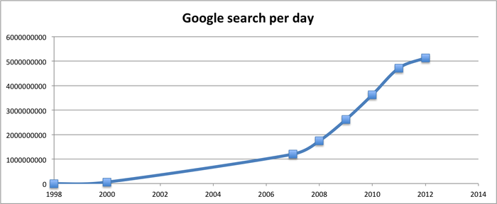](https://janav.files.wordpress.com/2013/10/googlesearchperday.png)

The major reason for google’s success is because of its pageRank algorithm. PageRank determines how trustworthy and reputable a given website is. But there is also another part. The input query entered by the user should be used to match the relevant documents and score them. In this post I will focus on the second part. I have created 3 documents to show how this works. Take some time to go through them.

**Document 1**: The game of life is a game of everlasting learning

**Document 2**: The unexamined life is not worth living

**Document 3**: Never stop learning

Let us imagine that you are doing a search on these documents with the following query: **life learning**

The query is a free text query. It means a query in which the terms of the query are typed freeform into the search interface, without any connecting search operators.

Let us go over each step in detail to see how it all works.

**Step 1: Term Frequency (TF)**

Term Frequency also known as TF measures the number of times a term (word) occurs in a document. Given below are the terms and their frequency on each of the document.

**TF for Document 1**

|  |  |  |  |  |  |  |  |  |
| --- | --- | --- | --- | --- | --- | --- | --- | --- |
| **Document1** | **the** | **game** | **of** | **life** | **is** | **a** | **everlasting** | **learning** |
| **Term Frequency** | 1 | 2 | 2 | 1 | 1 | 1 | 1 | 1 |

**TF for Document 2**

|  |  |  |  |  |  |  |  |
| --- | --- | --- | --- | --- | --- | --- | --- |
| **Document2** | **the** | **unexamined** | **life** | **is** | **not** | **worth** | **living** |
| **Term Frequency** | 1 | 1 | 1 | 1 | 1 | 1 | 1 |

**TF for Document 3**

|  |  |  |  |
| --- | --- | --- | --- |
| **Document3** | **never** | **stop** | **learning** |
| **Term Frequency** | 1 | 1 | 1 |

In reality each document will be of different size. On a large document the frequency of the terms will be much higher than the smaller ones. Hence we need to **normalize** the document based on its size. A simple trick is to divide the term frequency by the total number of terms. For example in Document 1 the term **game** occurs **two** times. The total number of terms in the document is **10**. Hence the normalized term frequency is **2 / 10 = 0.2**. Given below are the normalized term frequency for all the documents.

**Normalized TF for Document 1**

|  |  |  |  |  |  |  |  |  |
| --- | --- | --- | --- | --- | --- | --- | --- | --- |
| **Document1** | **the** | **game** | **of** | **life** | **is** | **a** | **everlasting** | **learning** |
| **Normalized TF** | 0.1 | 0.2 | 0.2 | 0.1 | 0.1 | 0.1 | 0.1 | 0.1 |

**Normalized TF for Document 2**

|  |  |  |  |  |  |  |  |
| --- | --- | --- | --- | --- | --- | --- | --- |
| **Document2** | **the** | **unexamined** | **life** | **is** | **not** | **worth** | **living** |
| **Normalized TF** | 0.142857 | 0.142857 | 0.142857 | 0.142857 | 0.142857 | 0.142857 | 0.142857 |

**Normalized TF for Document 3**

|  |  |  |  |
| --- | --- | --- | --- |
| **Document3** | **never** | **stop** | **learning** |
| **Normalized TF** | 0.333333 | 0.333333 | 0.333333 |

Given below is the code in python which will do the normalized TF calculation.

|  |  |
| --- | --- |
| 1  2  3 | def termFrequency(term, document):      normalizeDocument = document.lower().split()      return normalizeDocument.count(term.lower()) / float(len(normalizeDocument)) |

**Step 2: Inverse Document Frequency (IDF)**

The main purpose of doing a search is to find out **relevant** **documents** matching the query. In the first step all terms are considered equally important. In fact certain terms that occur too frequently have little power in determining the relevance. We need a way to **weigh down** the effects of too frequently occurring terms. Also the terms that occur less in the document can be more relevant. We need a way to **weigh up** the effects of less frequently occurring terms. [Logarithms](https://janav.wordpress.com/2013/09/29/logarithms-in-real-life/)helps us to solve this problem.

Let us compute IDF for the term **game**

IDF(**game**) = 1 + loge(Total Number Of Documents / Number Of Documents with term **game** in it)

There are 3 documents in all = Document1, Document2, Document3

The term game appears in Document1

IDF(**game**) = 1 + loge(3 / 1)

= 1 + 1.098726209

= 2.098726209

Given below is the IDF for terms occurring in all the documents. Since the terms: **the, life, is, learning** occurs in 2 out of 3 documents they have a lower score compared to the other terms that appear in only one document.

|  |  |
| --- | --- |
| **Terms** | **IDF** |
| the | 1.405507153 |
| game | 2.098726209 |
| of | 2.098726209 |
| life | 1.405507153 |
| is | 1.405507153 |
| a | 2.098726209 |
| everlasting | 2.098726209 |
| learning | 1.405507153 |
| unexamined | 2.098726209 |
| not | 2.098726209 |
| worth | 2.098726209 |
| living | 2.098726209 |
| never | 2.098726209 |
| stop | 2.098726209 |

Given below is the python code to calculate IDF

|  |  |
| --- | --- |
| 1  2  3  4  5  6  7  8  9  10 | def inverseDocumentFrequency(term, allDocuments):      numDocumentsWithThisTerm = 0      for doc in allDocuments:          if term.lower() in allDocuments[doc].lower().split():              numDocumentsWithThisTerm = numDocumentsWithThisTerm + 1        if numDocumentsWithThisTerm > 0:          return 1.0 + log(float(len(allDocuments)) / numDocumentsWithThisTerm)      else:          return 1.0 |

**Step 3: TF * IDF**

Remember we are trying to find out relevant documents for the query: **life learning**

For each term in the query multiply its normalized term frequency with its IDF on each document. In Document1 for the term **life** the normalized term frequency is 0.1 and its IDF is 1.405507153. Multiplying them together we get **0.140550715**(0.1 * 1.405507153). Given below is TF * IDF calculations for **life and learning** in all the documents.

|  |  |  |  |
| --- | --- | --- | --- |
|  | **Document1** | **Document2** | **Document3** |
| **life** | 0.140550715 | 0.200786736 | 0 |
| **learning** | 0.140550715 | 0 | 0.468502384 |

**Step 4: Vector Space Model – Cosine Similarity**

From each document we derive a vector. If you need some refresher on vector refer [here](http://www.mathsisfun.com/algebra/vectors-dot-product.html). The set of documents in a collection then is viewed as a set of vectors in a vector space. Each term will have its own axis. Using the formula given below we can find out the similarity between any two documents.

Cosine Similarity (d1, d2) = Dot product(d1, d2) **/** ||d1|| * ||d2||

Dot product (d1,d2) = d1[0] * d2[0] + d1[1] * d2[1] * … * d1[n] * d2[n]

||d1|| = square root(d1[0]2 + d1[1]2 + ... + d1[n]2)

||d2|| = square root(d2[0]2 + d2[1]2 + ... + d2[n]2)

[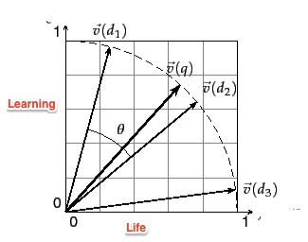](https://janav.files.wordpress.com/2013/10/cosinesimilarity.jpg)

Vectors deals only with numbers. In this example we are dealing with text documents. This was the reason why we used TF and IDF to convert text into numbers so that it can be represented by a vector.

Refer to the [link](http://nlp.stanford.edu/IR-book/html/htmledition/dot-products-1.html) for detailed explanation of cosine similarity and vector space model. I found the following explanation in the book [Mahout in Action](http://www.amazon.com/Mahout-Action-Sean-Owen/dp/1935182684) very useful.

The **cosine measure similarity** is another similarity metric that depends on envisioning user preferences as points in space.  Hold in mind the image of user preferences as points in an **n-dimensional space**. Now imagine two lines from the origin, or  point (0,0,…,0), to each of these two points. When two users are similar, they’ll have similar ratings, and so will be  relatively close in space—at least, they’ll be in roughly the same direction from the origin. The angle formed between these two lines will be relatively small. In contrast, when the two users are dissimilar, their points will be distant, and likely in different directions from the origin, forming a wide angle. This angle can be used as the basis for a similarity metric in the same way that the Euclidean distance was used to form a similarity metric. In this case, the cosine of the angle leads to a similarity value. **If you’re rusty on trigonometry, all you need to remember to understand this is that the cosine value is always between –1 and 1: the cosine of a small angle is near 1, and the cosine of a large angle near 180 degrees is close to –1. This is good, because small angles should map to high similarity, near 1, and large angles should map to near –1**.

The query entered by the user can also be represented as a vector. We will calculate the TF*IDF for the query

|  |  |  |  |
| --- | --- | --- | --- |
|  | **TF** | **IDF** | **TF*IDF** |
| **life** | 0.5 | 1.405507153 | 0.702753576 |
| **learning** | 0.5 | 1.405507153 | 0.702753576 |

Let us now calculate the cosine similarity of the query and Document1. You can do the calculation using this [tool](http://www.appliedsoftwaredesign.com/archives/cosine-similarity-calculator).

Cosine Similarity(Query,Document1) = Dot product(Query, Document1) **/** ||Query|| * ||Document1||

**Dot product(Query, Document1)**

= ((0.702753576) * (0.140550715) + (0.702753576)*(0.140550715))

= 0.197545035151

**||Query||** = sqrt((0.702753576)2 + (0.702753576)2) = 0.993843638185

**||Document1||** = sqrt((0.140550715)2 + (0.140550715)2) = 0.198768727354

**Cosine Similarity(Query, Document)** = 0.197545035151 / (0.993843638185) * (0.198768727354)

= 0.197545035151 / 0.197545035151

= 1

Given below is the similarity scores for all the documents and the query

|  |  |  |  |
| --- | --- | --- | --- |
|  | **Document1** | **Document2** | **Document3** |
| **Cosine Similarity** | 1 | 0.707106781 | 0.707106781 |

I plotted vector values for the query and documents in 2-dimensional space of life and learning. Document1 has the highest score of 1. This is not surprising as it has both the terms life and learning.

[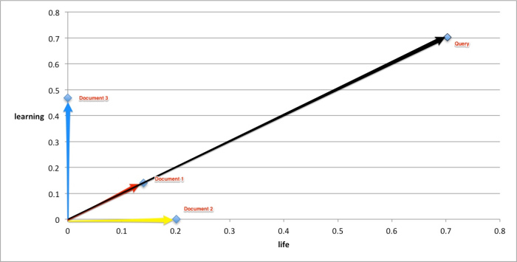](https://janav.files.wordpress.com/2013/10/cosinesimiarlity.jpeg)

Advertisements

# Cosine Similarity

## Cosine Similarity

Cosine similarity is a [Similarity Function](http://mlwiki.org/index.php?title=Similarity_Function&action=edit&redlink=1) that is often used in [Information Retrieval](http://mlwiki.org/index.php/Information_Retrieval)

* it measures the angle between two vectors, and in case of IR - the angle between two documents

### Derivation

* recall the definition of the [Dot Product](http://mlwiki.org/index.php/Dot_Product): v⋅w=∥v∥⋅∥w∥⋅cosθv⋅w=‖v‖⋅‖w‖⋅cos⁡θ
* or, by rearranging get cosθ=v⋅w∥v∥⋅∥w∥cos⁡θ=v⋅w‖v‖⋅‖w‖
* so, let's define the cosine similarity function as cosine(d1,d2)=dT1d2∥d1∥⋅∥d2∥cosine(d1,d2)=d1Td2‖d1‖⋅‖d2‖
* cosine is usually [−1,1][−1,1], but document vectors (see [Vector Space Model](http://mlwiki.org/index.php/Vector_Space_Model)) are usually non-negative, so the angle between two documents can never be greater than 90 degrees, and for document vectors cosine(d1,d2)∈[0,1]cosine(d1,d2)∈[0,1]
  + min cosine is 0 (max angle: the documents are orthogonal)
  + max cosine is 1 (min angle: the documents are the same)

### Cosine Normalization

If documents have unit length, then cosine similarity is the same as [Dot Product](http://mlwiki.org/index.php/Dot_Product)

* cosine(d1,d2)=dT1d2∥d1∥⋅∥d2∥=dT1d2cosine(d1,d2)=d1Td2‖d1‖⋅‖d2‖=d1Td2
* thus we can "unit-normalize" document vectors d′=d∥d∥d′=d‖d‖ and then compute dot product on them and get cosine
* this "unit-length normalization" is often called "cosine normalization" in IR

## Cosine Distance

* for documents cosine(d1,d2)∈[0,1]cosine(d1,d2)∈[0,1]
* it is max when two documents are the same
* how to define a distance? distance function should become larger as elements become less similar
* since maximal value of cosine is 1, we can define **cosine distance** as
* dc(d1,d2)=1−cosine(d1,d2)=1−dT1d2∥d1∥⋅∥d2∥dc(d1,d2)=1−cosine(d1,d2)=1−d1Td2‖d1‖⋅‖d2‖

### [Metricity](http://mlwiki.org/index.php/Distance_Functions)

Let's check if cosine distance is a proper metric, i.e. it satisfies all the requirements

* Let DD be the document space and d1,d2∈Dd1,d2∈D
* dc(d1,d2)⩾0dc(d1,d2)⩾0: checks - 0 is minimum
* dc(d1,d1)=0dc(d1,d1)=0 checks - 1−cos0=01−cos⁡0=0
* dc(d1,d2)=dc(d2,d1)dc(d1,d2)=dc(d2,d1): checks - angle is the same

What about the triangle inequality?

* under certain conditions is doesn't hold (Korenius2007) - so it's not a proper metric

## Cosine and [Euclidean Distance](http://mlwiki.org/index.php/Euclidean_Distance)

Euclidean distance ∥d1−d2∥=(d1−d2)T(d1−d2)−−−−−−−−−−−−−−−−√‖d1−d2‖=(d1−d2)T(d1−d2)

* ED is a proper metric

There's a connection between Cosine Distance end Euclidean Distance

* consider two unit-normalized vectors x1=d1/∥d1∥x1=d1/‖d1‖ and x2=d1/∥d1∥x2=d1/‖d1‖
* ∥x1−x2∥2=(x1−x2)T(x1−x2)=xT1x1−2xT1x2+xT2x2=∥x1∥2−2xT1x2+∥x2∥2=2−2xT1x2‖x1−x2‖2=(x1−x2)T(x1−x2)=x1Tx1−2x1Tx2+x2Tx2=‖x1‖2−2x1Tx2+‖x2‖2=2−2x1Tx2
* if vectors are unit-normalized, cosine = dot product, so we have
* ∥x1−x2∥2=2(1−xT1x2)=2(1−cosine(x1,x2))=2dc(x1,x2)‖x1−x2‖2=2(1−x1Tx2)=2(1−cosine(x1,x2))=2dc(x1,x2)

It can also make some sense visually:

* 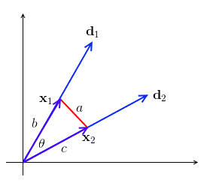
* recall the [Cosine Theorem](http://mlwiki.org/index.php?title=Cosine_Theorem&action=edit&redlink=1): a2=b2+c2−2bccosθa2=b2+c2−2bccos⁡θ
* b=c=1b=c=1, so we have a2=2(1−cosθ)a2=2(1−cos⁡θ)

Thus we can use Euclidean distance and interpret it as Cosine distance

## Other Properties

### Translation Non-Invariant

For [PCA](http://mlwiki.org/index.php/PCA) we usually do mean-correction

* but mean-correction affects the angle between documents
* can show that visually: the angle between two vectors are not translation-resistant
* 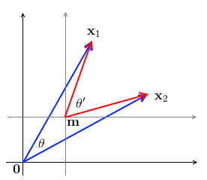
* i.e. if we have two vectors x1x1 and x2x2 and with θθ being the angle between them, when we translate the space by mm, we get a new angle θ′θ′ s.t. θ≠θ′θ≠θ′
* also note that when we translate, some elements may become negative!

**Conversion of Unstructured Data to Structured Data**

These days, Big Data is described with 3 words volume, velocity and variety. The idea or concept to build the developing processes in order to manage the increasing ‘volumes’ and ‘velocity’ of knowledge nearly looks feasible. But from a method excellence purpose we are specifically curious about the ‘variety’, as this relates to two knowledge category; structured data knowledge and unstructured data knowledge. The [web data extraction services](http://datacrops.com/web-data-extraction-software/) are used to extract both of this data types to be applied for business and technology purposes.

Unstructured data is a generic term to describe knowledge that does not sit in knowledgebase’s and may be a mixture of textual and non-textual data. It is difficult to convert **unstructured data to structured data** as it usually resides in media like emails, documents, presentations, spreadsheets, pictures, video or audio files.

As the volumes of this sort of knowledge have increased through the employment of good technology the necessity to analyse this data and its awareness has also grown. This unstructured data file is processed and converted into structured data as the output by using **unstructured data to structured data conversion tools**. [**Automated** **unstructured data mining software**](http://datacrops.com/blogs/why-use-automated-web-data-extraction-software/) will surely help in such scenarios.

**Transforming Unstructured Data to Structured Data**

**How to convert unstructured data to structured data in Hadoop with an example**

One of the immense things about [Hadoop](https://en.wikipedia.org/wiki/Apache_Hadoop) is that it provides a consistent, easy on the pocket and comparatively a simpler framework for gathering, confining and storing multiple data streams that was some years ago not feasible.

Taking an example, consider unstructured data in **Hadoop** as being a crude oil. Though it is one of the most valuable raw materials, however before you can extract or fetch needed gasoline from crude we require to put it across a filtering or more precise a distillation procedure in a refinery to remove its impurity, and extract the valuable hydrocarbons which can be categorised as structured data.

**Structured data is relatively uncomplicated and easy to utilize**

Using structured data is easy with its methodological enhancements and as they reside in databases within the category of rows and columns. It’s classified into relations or categories based mostly upon shared characteristics. The information is usually allotted attributes (data descriptions) associated with the categories inside every cluster to assist in ordering and logically grouping. Finally it is often delineated by predefined formats (string or value) with predefined lengths of characters.

This makes structured data a decent place to begin for anyone longing for sturdy knowledge to form data upon that to create significant insights. Structured data are often queried and analysed to type, group, filter, count and total so as to answer business queries or live method capability. It is used in [product data intelligence](http://datacrops.com/product-data-extraction/) as well as [price monitoring software](http://datacrops.com/price-monitoring-software/) solutions.

With the account for the validity of the information it does modify comparatively with the process to verify and observe the information. Structured data forms an out-sized part of the information utilized by several in method enhancements, but this trend is quickly dynamical because the dominance of unstructured data will increase.

**Unstructured data extraction involve complexities while processing the data initially**

As unstructured data resides on company networks, inside collaboration tools and within the cloud these are often very troublesome to interrogate. So as to look the information, processes ought to be in place to assist tag and sort it. This step is essential to permit for linguistics looking against key words or contexts.

Unstructured knowledge is being used in an exceedingly huge approach for social media corporations needing to perceive their markets and customers in additional depth. This presents identical opportunities to several of our businesses to assist perceive not solely its customers higher, however operations inside.

A recent IDC report foretold the amount of digital content in 2012 can increase from 2011 figures by forty eighth percent to over 2.7 zettabytes (ZB) continued to associate 7.9 zettabytes (ZB) by 2015. Over 90% of this data is calculable to be unstructured data that highlights the necessity to develop sturdy strategies to know and analyse the embedded data.

**Challenges with Business Processes in relation to unstructured data extraction**

The challenge for businesses is to develop processes to use structure to the unstructured nature of the information for instance crucial the amount of satisfaction of consumers by analysing emails and social media could involve sorting out words or phrases. Words and phrases could also be classified into positive, negative or neutral classifications.

At this stage the unstructured data is remodelled to structured knowledge by using [unstructured data mining software](http://datacrops.com/web-data-extraction-software/) wherever the teams of words found based mostly upon their classification are assigned a value. A positive word could equal one, a negative -1 and a neutral zero. This unstructured data will currently be kept and analysed as you’d with structured knowledge. Rather more work is required during this space to analyse the unstructured data and plenty of the large vendors are functioning on solutions.

I believe the companies that may get the foremost of their unstructured knowledge sources are those who notice ways and unstructured data mining software tools to remodel the unstructured to structured data.

**Conclusion**

The actual value can be derived when **structured and unstructured data analysis** is combined for an end-to-end solution.

To know how you can grow your business results using DataCrops [web data extraction software](http://datacrops.com/web-data-extraction-software/) and solutions, connect for a [free consultation](http://datacrops.com/contact-us/) with one of our experts today.

**What is text analytics?**

*Text analysis* is about deriving high-quality structured data from unstructured text. Another name for text analytics is *text mining*. A good reason for using text analytics might be to extract additional data about customers from unstructured data sources to enrich customer master data, to produce new customer insight or to determine sentiment about products and services. Several text analytics use cases exist:

* Case management—for example, insurance claims assessment, healthcare patient records and crime-related interviews and reports
* Competitor analysis
* Fault management and field-service optimization
* Legal ediscovery in litigation cases
* Media coverage analysis
* Pharmaceutical drug trial improvement
* Sentiment analytics
* Voice of the customer

*Entity extraction,*the parsing and extracting of entities from raw text, is a key part of text analytics. Several examples of entity extraction exist:

* Company names
* Dates and times
* Domain-specific names such as names of diseases in pharmaceutical data
* Monetary amounts
* People’s names and social network handles
* Phrases, negative or positive
* Product names

In many cases, entity extraction can be turned into automated entity recognition, in which text is parsed and well-understood entities are automatically selected from the text by the software. This requirement is common. In the previous list of use cases, recognizing dates, times, monetary amounts and so on may be something that text analytics software can do out of the box, without you having to help it figure out what these extractions are. The benefit of this approach should be obvious. The time necessary to do entity extraction is drastically reduced, it can be done at scale across large volumes of text and it produces structured data that can be merged with enterprise data for further analysis.

**Proving its mettle**

Widely used data sources for text analytics include social networks—Facebook, LinkedIn and Twitter—along with internal email, inbound customer email, news articles, online discussion forums and customer relationship management (CRM) customer service notes. Other widely used sources include review websites such as TripAdvisor, documents such as PDF files and online forms such as applications containing text or forms containing structured data stored as text.

Text analytics has been around for many years, and with as much as 80 percent of data in enterprises now in unstructured form, it is proving its worth very quickly. A well-understood process for text analytics includes the following steps:

1. Extracting raw text
2. Tokenizing the text—that is, breaking it down into words and phrases
3. Detecting term boundaries
4. Detecting sentence boundaries
5. Tagging parts of speech—words such as nouns and verbs
6. Tagging named entities so that they are identified—for example, a person, a company, a place, a gene, a disease, a product and so on
7. Parsing—for example, extracting facts and entities from the tagged text
8. Extracting knowledge to understand concepts such as a personal injury within an accident claim

Text analytics can also be combined with other advanced analytics. For example, it can be combined with other data and with machine learning to predict the sentiment trend—such as negative sentiment predicted to increase or people who are likely to tweet negative sentiment based on their profile. Text analytics can also be combined with graph analysis, whereby people, places, activities and things are extracted from text using entity extraction and fed into a graph and graph analysis to discover completely new relationships you weren’t previously aware of.

Probably one of the most widely used forms of text analytics is sentiment analysis. Inbound customer email and social network data such as tweets may help determine positive, negative or neutral sentiment about your products and brands. *Sentiment analysis* is the process of determining a sentiment score from text. Companies want to determine these scores to be able to respond quickly to negative sentiment to minimize its impact and to make sure customer satisfaction and loyalty are constantly being improved. They also want to protect brands. Product managers want to use sentiment analysis to understand any problems with newly released products and services, so they can fix them quickly. In addition, finance departments want to take sentiment into account when doing financial planning—something that may be surprising to many.

**Negotiating hurdles**

All kinds of challenges are evident when using text analysis to analyze sentiment. For example, people tweet in multiple languages. Data quality can be poor. Many people also use emoticons, and different generations seem to speak their own language, even if it is all in one actual language of the world. Slang can also be an obvious challenge. And ambiguities can also exist—for example, a young person may tweet, “This new phone is sick!”

The good news is that text analytics is now mature enough to handle many of these characteristics. Ultimately, sentiment analysis is about opinions that may be transient and therefore have short-lived impact. Of course, an *opinion*consists of a number of elements including the name of a product or brand, perhaps a part of a product, the sentiment itself and even intent or desire—as in, “I really want to get that new *Star Wars* DVD.” Other elements include the opinion holder and when the opinion—the time of the tweet—was expressed.

New visualizations exist for text analytics to easily understand sentiment in a huge amount of text. Examples include word clouds that enable you to see how frequently words appear in a given corpus of text. Also, word trees and phrase nets offer other examples. The former allow you to choose a word or phrase and show you all the different contexts in which it appears; the latter show the relationships between different words used in a text.

Text analysis can be a computationally intensive process involving complex character-level operations such as pattern matching. Therefore, for large volumes scalability matters and is a major reason why people use platforms such as Apache Hadoop to do batch text analysis. However, you can also do the analysis in real time using streaming text analytics to react to sentiment or even to detect fraud as people are filling out online application forms, for example.

**Capitalizing on many flavors**

Today, you can find text analytics available on the cloud, on-premises in stand-alone text analytics offerings and at scale on Hadoop. IBM offers text analytics as part of the [IBM BigInsights Data Science module](http://www.ibm.com/analytics/us/en/technology/cloud-data-services/biginsights-on-cloud/?S_TACT=M1610MLW&iio=panalytics&cmp=m1610&ct=m1610mlw&cr=newsroom&cm=h&csot=-&ccy=-&cpb=-&cd=-). This solution includes web-based tooling to extract information that generates a language called Annotation Query Language (AQL) to do the analysis. IBM also includes application templates in BigInsights to get you up and running quickly with sentiment analysis.

Text analysis can also be done using search, which allows for indexing raw text and launching exploratory queries on that data to find content of interest. Connecting self-service business intelligence (BI) tools to search engines enables using search-based text analytics from within BI tools and to visualize the results in dashboards. Text analytics represents an exciting area that can generate significant business value.

**What Are Word Embeddings for Text?**

Word embeddings are a type of word representation that allows words with similar meaning to have a similar representation.

They are a distributed representation for text that is perhaps one of the key breakthroughs for the impressive performance of deep learning methods on challenging natural language processing problems.

In this post, you will discover the word embedding approach for representing text data.

After completing this post, you will know:

* What the word embedding approach for representing text is and how it differs from other feature extraction methods.
* That there are 3 main algorithms for learning a word embedding from text data.
* That you can either train a new embedding or use a pre-trained embedding on your natural language processing task.

Let’s get started.

**Overview**

This post is divided into 3 parts; they are:

1. What Are Word Embeddings?
2. Word Embedding Algorithms
3. Using Word Embeddings

**What Are Word Embeddings?**

A word embedding is a learned representation for text where words that have the same meaning have a similar representation.

It is this approach to representing words and documents that may be considered one of the key breakthroughs of deep learning on challenging natural language processing problems.

*One of the benefits of using dense and low-dimensional vectors is computational: the majority of neural network toolkits do not play well with very high-dimensional, sparse vectors. … The main benefit of the dense representations is generalization power: if we believe some features may provide similar clues, it is worthwhile to provide a representation that is able to capture these similarities.*Word embeddings are in fact a class of techniques where individual words are represented as real-valued vectors in a predefined vector space. Each word is mapped to one vector and the vector values are learned in a way that resembles a neural network, and hence the technique is often lumped into the field of deep learning.

Key to the approach is the idea of using a dense distributed representation for each word.

Each word is represented by a real-valued vector, often tens or hundreds of dimensions. This is contrasted to the thousands or millions of dimensions required for sparse word representations, such as a one-hot encoding.

*associate with each word in the vocabulary a distributed word feature vector … The feature vector represents different aspects of the word: each word is associated with a point in a vector space. The number of features … is much smaller than the size of the vocabulary*

The distributed representation is learned based on the usage of words. This allows words that are used in similar ways to result in having similar representations, naturally capturing their meaning. This can be contrasted with the crisp but fragile representation in a bag of words model where, unless explicitly managed, different words have different representations, regardless of how they are used.

There is deeper linguistic theory behind the approach, namely the “*distributional hypothesis*” by Zellig Harris that could be summarized as: words that have similar context will have similar meanings. For more depth see Harris’ 1956 paper “[Distributional structure](http://www.tandfonline.com/doi/pdf/10.1080/00437956.1954.11659520)“.

This notion of letting the usage of the word define its meaning can be summarized by an oft repeated quip by John Firth:

*You shall know a word by the company it keeps!*

**Word Embedding Algorithms**

Word embedding methods learn a real-valued vector representation for a predefined fixed sized vocabulary from a corpus of text.

The learning process is either joint with the neural network model on some task, such as document classification, or is an unsupervised process, using document statistics.

This section reviews three techniques that can be used to learn a word embedding from text data.

**1. Embedding Layer**

An embedding layer, for lack of a better name, is a word embedding that is learned jointly with a neural network model on a specific natural language processing task, such as language modeling or document classification.

It requires that document text be cleaned and prepared such that each word is one-hot encoded. The size of the vector space is specified as part of the model, such as 50, 100, or 300 dimensions. The vectors are initialized with small random numbers. The embedding layer is used on the front end of a neural network and is fit in a supervised way using the Backpropagation algorithm.

*… when the input to a neural network contains symbolic categorical features (e.g. features that take one of k distinct symbols, such as words from a closed vocabulary), it is common to associate each possible feature value (i.e., each word in the vocabulary) with a d-dimensional vector for some d. These vectors are then considered parameters of the model, and are trained jointly with the other parameters.*

The one-hot encoded words are mapped to the word vectors. If a multilayer Perceptron model is used, then the word vectors are concatenated before being fed as input to the model. If a recurrent neural network is used, then each word may be taken as one input in a sequence.

This approach of learning an embedding layer requires a lot of training data and can be slow, but will learn an embedding both targeted to the specific text data and the NLP task.

**2. Word2Vec**

Word2Vec is a statistical method for efficiently learning a standalone word embedding from a text corpus.

It was developed by Tomas Mikolov, et al. at Google in 2013 as a response to make the neural-network-based training of the embedding more efficient and since then has become the de facto standard for developing pre-trained word embedding.

Additionally, the work involved analysis of the learned vectors and the exploration of vector math on the representations of words. For example, that subtracting the “*man-ness*” from “*King*” and adding “*women-ness*” results in the word “*Queen*“, capturing the analogy “*king is to queen as man is to woman*“.

*We find that these representations are surprisingly good at capturing syntactic and semantic regularities in language, and that each relationship is characterized by a relation-specific vector offset. This allows vector-oriented reasoning based on the offsets between words. For example, the male/female relationship is automatically learned, and with the induced vector representations, “King – Man + Woman” results in a vector very close to “Queen.”*

Two different learning models were introduced that can be used as part of the word2vec approach to learn the word embedding; they are:

* Continuous Bag-of-Words, or CBOW model.
* Continuous Skip-Gram Model.

The CBOW model learns the embedding by predicting the current word based on its context. The continuous skip-gram model learns by predicting the surrounding words given a current word.

The continuous skip-gram model learns by predicting the surrounding words given a current word.

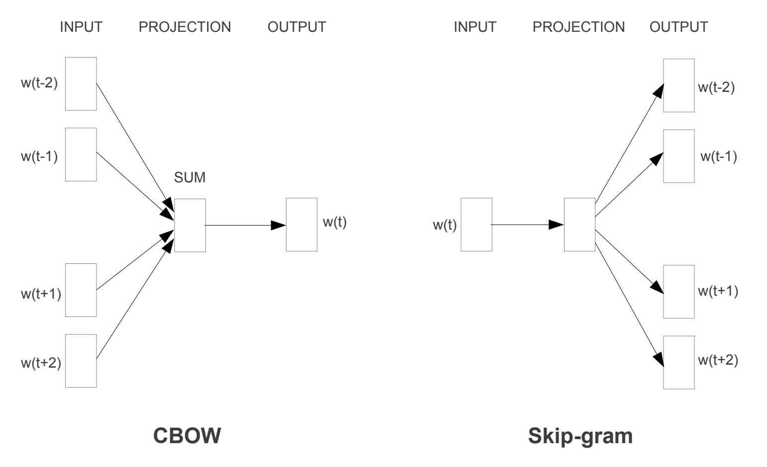

Word2Vec Training Models

Both models are focused on learning about words given their local usage context, where the context is defined by a window of neighboring words. This window is a configurable parameter of the model.

*The size of the sliding window has a strong effect on the resulting vector similarities. Large windows tend to produce more topical similarities […], while smaller windows tend to produce more functional and syntactic similarities.*

The key benefit of the approach is that high-quality word embeddings can be learned efficiently (low space and time complexity), allowing larger embeddings to be learned (more dimensions) from much larger corpora of text (billions of words).

**3. GloVe**

The Global Vectors for Word Representation, or GloVe, algorithm is an extension to the word2vec method for efficiently learning word vectors, developed by Pennington, et al. at Stanford.

Classical vector space model representations of words were developed using matrix factorization techniques such as Latent Semantic Analysis (LSA) that do a good job of using global text statistics but are not as good as the learned methods like word2vec at capturing meaning and demonstrating it on tasks like calculating analogies (e.g. the King and Queen example above).

GloVe is an approach to marry both the global statistics of matrix factorization techniques like LSA with the local context-based learning in word2vec.

Rather than using a window to define local context, GloVe constructs an explicit word-context or word co-occurrence matrix using statistics across the whole text corpus. The result is a learning model that may result in generally better word embeddings.

*GloVe, is a new global log-bilinear regression model for the unsupervised learning of word representations that outperforms other models on word analogy, word similarity, and named entity recognition tasks.*

**Using Word Embeddings**

You have some options when it comes time to using word embeddings on your natural language processing project.

This section outlines those options.

**1. Learn an Embedding**

You may choose to learn a word embedding for your problem.

This will require a large amount of text data to ensure that useful embeddings are learned, such as millions or billions of words.

You have two main options when training your word embedding:

1. **Learn it Standalone**, where a model is trained to learn the embedding, which is saved and used as a part of another model for your task later. This is a good approach if you would like to use the same embedding in multiple models.
2. **Learn Jointly**, where the embedding is learned as part of a large task-specific model. This is a good approach if you only intend to use the embedding on one task.

**2. Reuse an Embedding**

It is common for researchers to make pre-trained word embeddings available for free, often under a permissive license so that you can use them on your own academic or commercial projects.

For example, both word2vec and GloVe word embeddings are available for free download.

These can be used on your project instead of training your own embeddings from scratch.

You have two main options when it comes to using pre-trained embeddings:

1. **Static**, where the embedding is kept static and is used as a component of your model. This is a suitable approach if the embedding is a good fit for your problem and gives good results.
2. **Updated**, where the pre-trained embedding is used to seed the model, but the embedding is updated jointly during the training of the model. This may be a good option if you are looking to get the most out of the model and embedding on your task.

An Intuitive Understanding of Word Embeddings: From Count Vectors to Word2Vec

Introduction

Before we start, have a look at the below examples.

1. You open Google and search for a news article on the ongoing Champions trophy and get hundreds of search results in return about it.
2. Nate silver analysed millions of tweets and correctly predicted the results of 49 out of 50 states in 2008 U.S Presidential Elections.
3. You type a sentence in google translate in English and get an Equivalent Chinese conversion.

So what do the above examples have in common?

You possible guessed it right – **TEXT processing**. All the above three scenarios deal with humongous amount of text to perform different range of tasks like clustering in the google search example, classification in the second and Machine Translation in the third.

Humans can deal with text format quite intuitively but provided we have millions of documents being generated in a single day, we cannot have humans performing the above the three tasks. It is neither scalable nor effective.

So, how do we make computers of today perform clustering, classification etc on a text data since we know that they are generally inefficient at handling and processing strings or texts for any fruitful outputs?

Sure, a computer can match two strings and tell you whether they are same or not. But how do we make computers tell you about football or Ronaldo when you search for Messi? How do you make a computer understand that “Apple” in “Apple is a tasty fruit” is a fruit that can be eaten and not a company?

The answer to the above questions lie in creating a representation for words that capture their *meanings*, *semantic relationships* and the different types of contexts they are used in.

And all of these are implemented by using Word Embeddings or numerical representations of texts so that computers may handle them.

Below, we will see formally what are Word Embeddings and their different types and how we can actually implement them to perform the tasks like returning efficient Google search results.

1. What are Word Embeddings?

In very simplistic terms, Word Embeddings are the texts converted into numbers and there may be different numerical representations of the same text. But before we dive into the details of Word Embeddings, the following question should be asked – Why do we need Word Embeddings?

As it turns out, many Machine Learning algorithms and almost all Deep Learning Architectures are incapable of processing *strings*or *plain text*in their raw form. They require numbers as inputs to perform any sort of job, be it classification, regression etc. in broad terms. And with the huge amount of data that is present in the text format, it is imperative to extract knowledge out of it and build applications. Some real world applications of text applications are – sentiment analysis of reviews by Amazon etc., document or news classification or clustering by Google etc.

Let us now define Word Embeddings formally. A Word Embedding format generally tries to map a word using a dictionary to a vector. Let us break this sentence down into finer details to have a clear view.

Take a look at this example – **sentence**=” Word Embeddings are Word converted into numbers ”

A *word*in this **sentence** may be “Embeddings” or “numbers ” etc.

A *dictionary*may be the list of all unique words in the **sentence.**So, a dictionary may look like – [‘Word’,’Embeddings’,’are’,’Converted’,’into’,’numbers’]

A ve*ctor*representation of a word may be a one-hot encoded vector where 1 stands for the position where the word exists and 0 everywhere else. The vector representation of “numbers”in this format according to the above dictionary is [0,0,0,0,0,1] and of converted is[0,0,0,1,0,0].

This is just a very simple method to represent a word in the vector form. Let us look at different types of Word Embeddings or Word Vectors and their advantages and disadvantages over the rest.

2. Different types of Word Embeddings

The different types of word embeddings can be broadly classified into two categories-

1. Frequency based Embedding
2. Prediction based Embedding

Let us try to understand each of these methods in detail.

2.1 Frequency based Embedding

There are generally three types of vectors that we encounter under this category.

1. Count Vector
2. TF-IDF Vector
3. Co-Occurrence Vector

Let us look into each of these vectorization methods in detail.

2.1.1 Count Vector

Consider a Corpus C of D documents {d1,d2…..dD} and N unique tokens extracted out of the corpus C. The N tokens will form our dictionary and the size of the Count Vector matrix M will be given by D X N. Each row in the matrix M contains the frequency of tokens in document D(i).

Let us understand this using a simple example.

D1: He is a lazy boy. She is also lazy.

D2: Neeraj is a lazy person.

The dictionary created may be a list of unique tokens(words) in the corpus =[‘He’,’She’,’lazy’,’boy’,’Neeraj’,’person’]

Here, D=2, N=6

The count matrix M of size 2 X 6 will be represented as –

|  |  |  |  |  |  |  |
| --- | --- | --- | --- | --- | --- | --- |
|  | He | She | lazy | boy | Neeraj | person |
| D1 | 1 | 1 | 2 | 1 | 0 | 0 |
| D2 | 0 | 0 | 1 | 0 | 1 | 1 |

Now, a column can also be understood as word vector for the corresponding word in the matrix M. For example, the word vector for ‘lazy’ in the above matrix is [2,1] and so on.Here, the *rows* correspond to the *documents* in the corpus and the *columns* correspond to the *tokens* in the dictionary. The second row in the above matrix may be read as – D2 contains ‘lazy’: once, ‘Neeraj’: once and ‘person’ once.

Now there may be quite a few variations while preparing the above matrix M. The variations will be generally in-

1. The way dictionary is prepared.  
   Why? Because in real world applications we might have a corpus which contains millions of documents. And with millions of document, we can extract hundreds of millions of unique words. So basically, the matrix that will be prepared like above will be a very sparse one and inefficient for any computation. So an alternative to using every unique word as a dictionary element would be to pick say top 10,000 words based on frequency and then prepare a dictionary.
2. The way count is taken for each word.  
   We may either take the frequency (number of times a word has appeared in the document) or the presence(has the word appeared in the document?) to be the entry in the count matrix M. But generally, frequency method is preferred over the latter.

Below is a representational image of the matrix M for easy understanding.

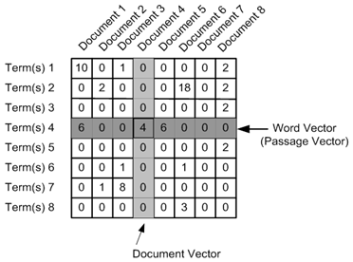

2.1.2 TF-IDF vectorization

This is another method which is based on the frequency method but it is different to the count vectorization in the sense that it takes into account not just the occurrence of a word in a single document but in the entire corpus. So, what is the rationale behind this? Let us try to understand.

Common words like ‘is’, ‘the’, ‘a’ etc. tend to appear quite frequently in comparison to the words which are important to a document. For example, a document **A** on Lionel Messi is going to contain more occurences of the word “Messi” in comparison to other documents. But common words like “the” etc. are also going to be present in higher frequency in almost every document.

Ideally, what we would want is to down weight the common words occurring in almost all documents and give more importance to words that appear in a subset of documents.

TF-IDF works by penalising these common words by assigning them lower weights while giving importance to words like Messi in a particular document.

So, how exactly does TF-IDF work?

Consider the below sample table which gives the count of terms(tokens/words) in two documents.

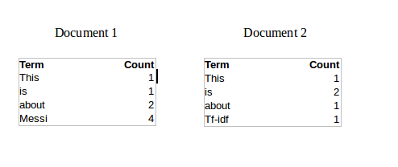

Now, let us define a few terms related to TF-IDF.

TF = (Number of times term t appears in a document)/(Number of terms in the document)

So, TF(This,Document1) = 1/8

TF(This, Document2)=1/5

It denotes the contribution of the word to the document i.e words relevant to the document should be frequent. eg: A document about Messi should contain the word ‘Messi’ in large number.

IDF = log(N/n), where, N is the number of documents and n is the number of documents a term t has appeared in.

where N is the number of documents and n is the number of documents a term t has appeared in.

So, IDF(This) = log(2/2) = 0.

So, how do we explain the reasoning behind IDF? Ideally, if a word has appeared in all the document, then probably that word is not relevant to a particular document. But if it has appeared in a subset of documents then probably the word is of some relevance to the documents it is present in.

Let us compute IDF for the word ‘Messi’.

IDF(Messi) = log(2/1) = 0.301.

Now, let us compare the TF-IDF for a common word ‘This’ and a word ‘Messi’ which seems to be of relevance to Document 1.

TF-IDF(This,Document1) = (1/8) * (0) = 0

TF-IDF(This, Document2) = (1/5) * (0) = 0

TF-IDF(Messi, Document1) = (4/8)*0.301 = 0.15

As, you can see for Document1 , TF-IDF method heavily penalises the word ‘This’ but assigns greater weight to ‘Messi’. So, this may be understood as ‘Messi’ is an important word for Document1 from the context of the entire corpus.

2.1.3 Co-Occurrence Matrix with a fixed context window

**The big idea** – Similar words tend to occur together and will have similar context for example – Apple is a fruit. Mango is a fruit.  
Apple and mango tend to have a similar context i.e fruit.

Before I dive into the details of how a co-occurrence matrix is constructed, there are two concepts that need to be clarified – Co-Occurrence and Context Window.

Co-occurrence – For a given corpus, the co-occurrence of a pair of words say w1 and w2 is the number of times they have appeared together in a Context Window.

Context Window – Context window is specified by a number and the direction. So what does a context window of 2 (around) means? Let us see an example below,

|  |  |  |  |  |  |  |  |
| --- | --- | --- | --- | --- | --- | --- | --- |
| Quick | Brown | Fox | Jump | Over | The | Lazy | Dog |

The green words are a 2 (around) context window for the word ‘Fox’ and for calculating the co-occurrence only these words will be counted. Let us see context window for the word ‘Over’.

|  |  |  |  |  |  |  |  |
| --- | --- | --- | --- | --- | --- | --- | --- |
| Quick | Brown | Fox | Jump | Over | The | Lazy | Dog |

Now, let us take an example corpus to calculate a co-occurrence matrix.

Corpus = He is not lazy. He is intelligent. He is smart.

|  |  |  |  |  |  |  |
| --- | --- | --- | --- | --- | --- | --- |
|  | **He** | **is** | **not** | **lazy** | **intelligent** | **smart** |
| **He** | 0 | 4 | 2 | 1 | 2 | 1 |
| **is** | 4 | 0 | 1 | 2 | 2 | 1 |
| **not** | 2 | 1 | 0 | 1 | 0 | 0 |
| **lazy** | 1 | 2 | 1 | 0 | 0 | 0 |
| **intelligent** | 2 | 2 | 0 | 0 | 0 | 0 |
| **smart** | 1 | 1 | 0 | 0 | 0 | 0 |

Let us understand this co-occurrence matrix by seeing two examples in the table above. Red and the blue box.

Red box- It is the number of times ‘He’ and ‘is’ have appeared in the context window 2 and it can be seen that the count turns out to be 4. The below table will help you visualise the count.

|  |  |  |  |  |  |  |  |  |  |
| --- | --- | --- | --- | --- | --- | --- | --- | --- | --- |
| He | is | not | lazy | He | is | intelligent | He | is | smart |
|  |  |  |  |  |  |  |  |  |  |
| He | is | not | lazy | He | is | intelligent | He | is | smart |
|  |  |  |  |  |  |  |  |  |  |
| He | is | not | lazy | He | is | intelligent | He | is | smart |
|  |  |  |  |  |  |  |  |  |  |
| He | is | not | lazy | He | is | intelligent | He | is | smart |

while the word ‘lazy’ has never appeared with ‘intelligent’ in the context window and therefore has been assigned 0 in the blue box.

**Variations of Co-occurrence Matrix**

Let’s say there are V unique words in the corpus. So Vocabulary size = V. The columns of the Co-occurrence matrix form the *context word*s. The different variations of Co-Occurrence Matrix are-

1. A co-occurrence matrix of size V X V. Now, for even a decent corpus V gets very large and difficult to handle. So generally, this architecture is never preferred in practice.
2. A co-occurrence matrix of size V X N where N is a subset of V and can be obtained by removing irrelevant words like stopwords etc. for example. This is still very large and presents computational difficulties.

But, remember this co-occurrence matrix is not the word vector representation that is generally used. Instead, this Co-occurrence matrix is decomposed using techniques like PCA, SVD etc. into factors and combination of these factors forms the word vector representation.

Let me illustrate this more clearly. For example, you perform PCA on the above matrix of size VXV. You will obtain V principal components. You can choose k components out of these V components. So, the new matrix will be of the form V X k.

And, a single word, instead of being represented in V dimensions will be represented in k dimensions while still capturing almost the same semantic meaning. k is generally of the order of hundreds.

So, what PCA does at the back is decompose Co-Occurrence matrix into three matrices, U,S and V where U and V are both orthogonal matrices. What is of importance is that dot product of U and S gives the word vector representation and V gives the word context representation.

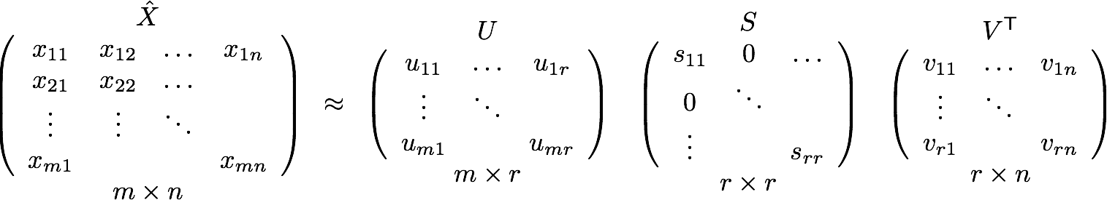

**Advantages of Co-occurrence Matrix**

1. It preserves the semantic relationship between words. i.e man and woman tend to be closer than man and apple.
2. It uses SVD at its core, which produces more accurate word vector representations than existing methods.
3. It uses factorization which is a well-defined problem and can be efficiently solved.
4. It has to be computed once and can be used anytime once computed. In this sense, it is faster in comparison to others.

**Disadvantages of Co-Occurrence Matrix**

1. It requires huge memory to store the co-occurrence matrix.  
   But, this problem can be circumvented by factorizing the matrix out of the system for example in Hadoop clusters etc. and can be saved.

2.2 Prediction based Vector

**Pre-requisite**: This section assumes that you have a working knowledge of how a neural network works and the mechanisms by which weights in an NN are updated. If you are new to Neural Network, I would suggest you go through [this awesome article](https://www.analyticsvidhya.com/blog/2017/05/neural-network-from-scratch-in-python-and-r/) by Sunil to gain a very good understanding of how NN works.

So far, we have seen deterministic methods to determine word vectors. But these methods proved to be limited in their word representations until Mitolov etc. el introduced word2vec to the NLP community. These methods were prediction based in the sense that they provided probabilities to the words and proved to be state of the art for tasks like word analogies and word similarities. They were also able to achieve tasks like King -man +woman = Queen, which was considered a result almost magical. So let us look at the word2vec model used as of today to generate word vectors.

Word2vec is not a single algorithm but a combination of two techniques – CBOW(Continuous bag of words) and Skip-gram model. Both of these are shallow neural networks which map word(s) to the target variable which is also a word(s). Both of these techniques learn weights which act as word vector representations. Let us discuss both these methods separately and gain intuition into their working.

2.2.1 CBOW (Continuous Bag of words)

The way CBOW work is that it tends to predict the probability of a word given a context. A context may be a single word or a group of words. But for simplicity, I will take a single context word and try to predict a single target word.

Suppose, we have a corpus C = “Hey, this is sample corpus using only one context word.” and we have defined a context window of 1. This corpus may be converted into a training set for a CBOW model as follow. The input is shown below. The matrix on the right in the below image contains the one-hot encoded from of the input on the left.

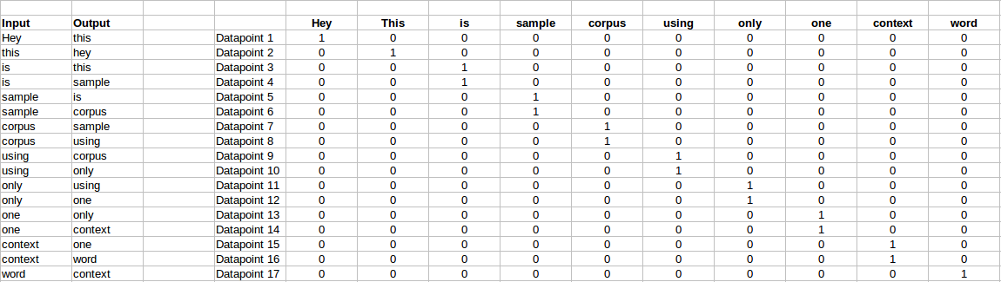

The target for a single datapoint say Datapoint 4 is shown as below

|  |  |  |  |  |  |  |  |  |  |
| --- | --- | --- | --- | --- | --- | --- | --- | --- | --- |
| Hey | this | is | sample | corpus | using | only | one | context | word |
| 0 | 0 | 0 | 1 | 0 | 0 | 0 | 0 | 0 | 0 |

This matrix shown in the above image is sent into a shallow neural network with three layers: an input layer, a hidden layer and an output layer. The output layer is a softmax layer which is used to sum the probabilities obtained in the output layer to 1. Now let us see how the forward propagation will work to calculate the hidden layer activation.

Let us first see a diagrammatic representation of the CBOW model.

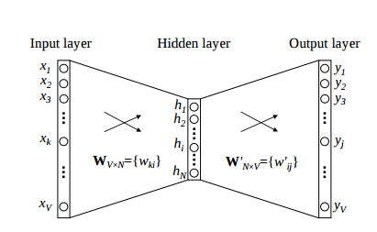

The matrix representation of the above image for a single data point is below.

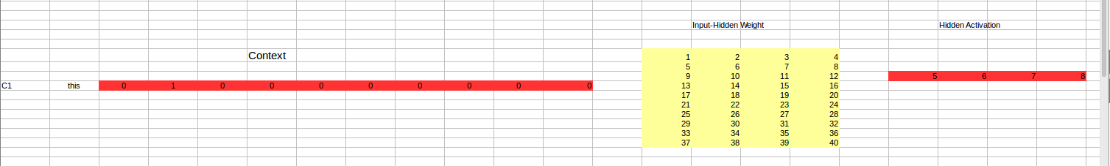

The flow is as follows:

1. The input layer and the target, both are one- hot encoded of size [1 X V]. Here V=10 in the above example.
2. There are two sets of weights. one is between the input and the hidden layer and second between hidden and output layer.  
   Input-Hidden layer matrix size =[V X N] , hidden-Output layer matrix  size =[N X V] : Where N is the number of dimensions we choose to represent our word in. It is arbitary and a hyper-parameter for a Neural Network. Also, N is the number of neurons in the hidden layer. Here, N=4.
3. There is a no activation function between any layers.( and by no, i mean linear activation)
4. The input is multiplied by the input-hidden weights and called hidden activation. It is simply the corresponding row in the input-hidden matrix copied.
5. The hidden input gets multiplied by hidden- output weights and output is calculated.
6. Error between output and target is calculated and propagated back to re-adjust the weights.
7. The weight  between the hidden layer and the output layer is taken as the word vector representation of the word.

We saw the above steps for a single context word. Now, what about if we have multiple context words? The image below describes the architecture for multiple context words.

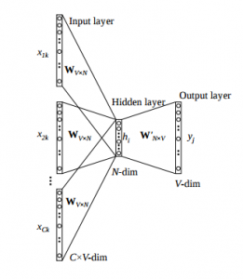

Below is a matrix representation of the above architecture for an easy understanding.

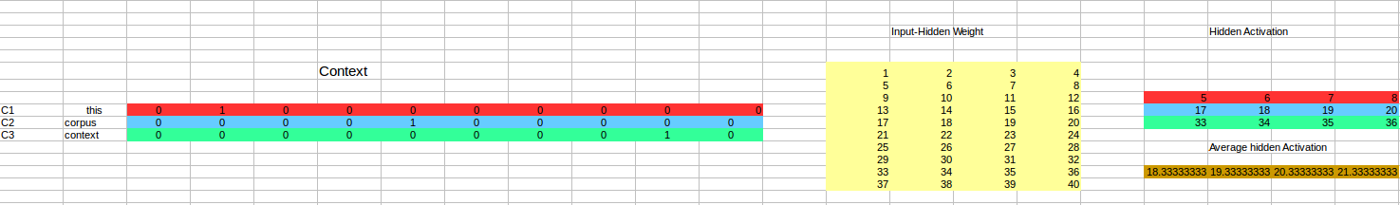

The image above takes 3 context words and predicts the probability of a target word. The input can be assumed as taking three one-hot encoded vectors in the input layer as shown above in red, blue and green.

So, the input layer will have 3 [1 X V] Vectors in the input as shown above and 1 [1 X V] in the output layer. Rest of the architecture is same as for a 1-context CBOW.

The steps remain the same, only the calculation of hidden activation changes. Instead of just copying the corresponding rows of the input-hidden weight matrix to the hidden layer, an average is taken over all the corresponding rows of the matrix. We can understand this with the above figure. The average vector calculated becomes the hidden activation. So, if we have three context words for a single target word, we will have three initial hidden activations which are then averaged element-wise to obtain the final activation.

In both a single context word and multiple context word, I have shown the images till the calculation of the hidden activations since this is the part where CBOW differs from a simple MLP network. The steps after the calculation of hidden layer are same as that of the MLP as mentioned in this article – [Understanding and Coding Neural Networks from scratch](https://www.analyticsvidhya.com/blog/2017/05/neural-network-from-scratch-in-python-and-r/).

The differences between MLP and CBOW are  mentioned below for clarification:

1. The objective function in MLP is a MSE(mean square error) whereas in CBOW it is negative log likelihood of a word given a set of context i.e -log(p(wo/wi)), where p(wo/wi) is given as

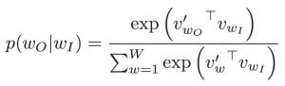

wo : output word  
wi: context words

2. The gradient of error with respect to hidden-output weights and input-hidden weights are different since MLP has  sigmoid activations(generally) but CBOW has linear activations. The method however to calculate the gradient is same as an MLP.

**Advantages of CBOW:**

1. Being probabilistic is nature, it is supposed to perform superior to deterministic methods(generally).
2. It is low on memory. It does not need to have huge RAM requirements like that of co-occurrence matrix where it needs to store three huge matrices.

**Disadvantages of CBOW:**

1. CBOW takes the average of the context of a word (as seen above in calculation of hidden activation). For example, Apple can be both a fruit and a company but CBOW takes an average of both the contexts and places it in between a cluster for fruits and companies.
2. Training a CBOW from scratch can take forever if not properly optimized.

2.2.2 Skip – Gram model

Skip – gram follows the same topology as of CBOW. It just flips CBOW’s architecture on its head. The aim of skip-gram is to predict the context given a word. Let us take the same corpus that we built our CBOW model on. C=”Hey, this is sample corpus using only one context word.” Let us construct the training data.

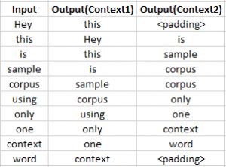

The input vector for skip-gram is going to be similar to a 1-context CBOW model. Also, the calculations up to hidden layer activations are going to be the same. The difference will be in the target variable. Since we have defined a context window of 1 on both the sides, there will be “**two” one hot encoded target variables** and “**two” corresponding outputs** as can be seen by the blue section in the image.

Two separate errors are calculated with respect to the two target variables and the two error vectors obtained are added element-wise to obtain a final error vector which is propagated back to update the weights.

The weights between the input and the hidden layer are taken as the word vector representation after training. The loss function or the objective is of the same type as of the CBOW model.

 Advantages of Skip-Gram Model

1. Skip-gram model can capture two semantics for a single word. i.e it will have two vector representations of Apple. One for the company and other for the fruit.
2. Skip-gram with negative sub-sampling outperforms every other method generally.

[This](http://bit.ly/wevi-online) is an excellent interactive tool to visualise CBOW and skip gram in action. I would suggest you to really go through this link for a better understanding.

3. Word Embeddings use case scenarios

Since word embeddings or word Vectors are numerical representations of contextual similarities between words, they can be manipulated and made to perform amazing tasks like-

1. Finding the degree of similarity between two words.  
   model.similarity('woman','man')  
   0.73723527
2. Finding odd one out.  
   model.doesnt_match('breakfast cereal dinner lunch';.split())  
   'cereal'
3. Amazing things like woman+king-man =queen  
   model.most_similar(positive=['woman','king'],negative=['man'],topn=1)  
   queen: 0.508
4. Probability of a text under the model  
   model.score(['The fox jumped over the lazy dog'.split()])  
   0.21

Below is one interesting visualisation of word2vec.

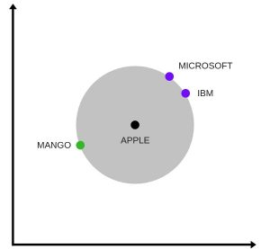

The above image is a t-SNE representation of word vectors in 2 dimension and you can see that two contexts of apple have been captured. One is a fruit and the other company.

5.  It can be used to perform Machine Translation.

The above graph is a bilingual embedding with chinese in green and english in yellow. If we know the words having similar meanings in chinese and english, the above bilingual embedding can be used to translate one language into the other.

4. Using pre-trained word vectors

We are going to use google’s pre-trained model. It contains word vectors for a vocabulary of 3 million words trained on around 100 billion words from the google news dataset. The downlaod link for the model is [this](https://drive.google.com/file/d/0B7XkCwpI5KDYNlNUTTlSS21pQmM/edit). Beware it is a 1.5 GB download.

from gensim.models import Word2Vec

#loading the downloaded model  
model = Word2Vec.load_word2vec_format('GoogleNews-vectors-negative300.bin', binary=True,norm_only=True)

#the model is loaded. It can be used to perform all of the tasks mentioned above.

# getting word vectors of a word  
dog = model['dog']

#performing king queen magic  
print(model.most_similar(positive=['woman', 'king'], negative=['man']))

#picking odd one out  
print(model.doesnt_match("breakfast cereal dinner lunch".split()))

#printing similarity index  
print(model.similarity('woman', 'man'))

5. Training your own word vectors

We will be training our own word2vec on a custom corpus. For training the model we will be using gensim and the steps are illustrated as below.

word2Vec requires that a format of list of list for training where every document is contained in a list and every list contains list of tokens of that documents. I won’t be covering the pre-preprocessing part here. So let’s take an example list of list to train our word2vec model.

sentence=[[‘Neeraj’,’Boy’],[‘Sarwan’,’is’],[‘good’,’boy’]]

#training word2vec on 3 sentences  
model = gensim.models.Word2Vec(sentence, min_count=1,size=300,workers=4)

Let us try to understand the parameters of this model.

sentence – list of list of our corpus  
min_count=1 -the threshold value for the words. Word with frequency greater than this only are going to be included into the model.  
size=300 – the number of dimensions in which we wish to represent our word. This is the size of the word vector.  
workers=4 – used for parallelization

#using the model  
#The new trained model can be used similar to the pre-trained ones.

#printing similarity index  
print(model.similarity('woman', 'man'))

6. End Notes

Word Embeddings is an active research area trying to figure out better word representations than the existing ones. But, with time they have grown large in number and more complex. This article was aimed at simplying some of the workings of these embedding models without carrying the mathematical overhead. If you feel think that I was able to clear some of your confusion, comment below. Any changes or suggestions would be welcomed.

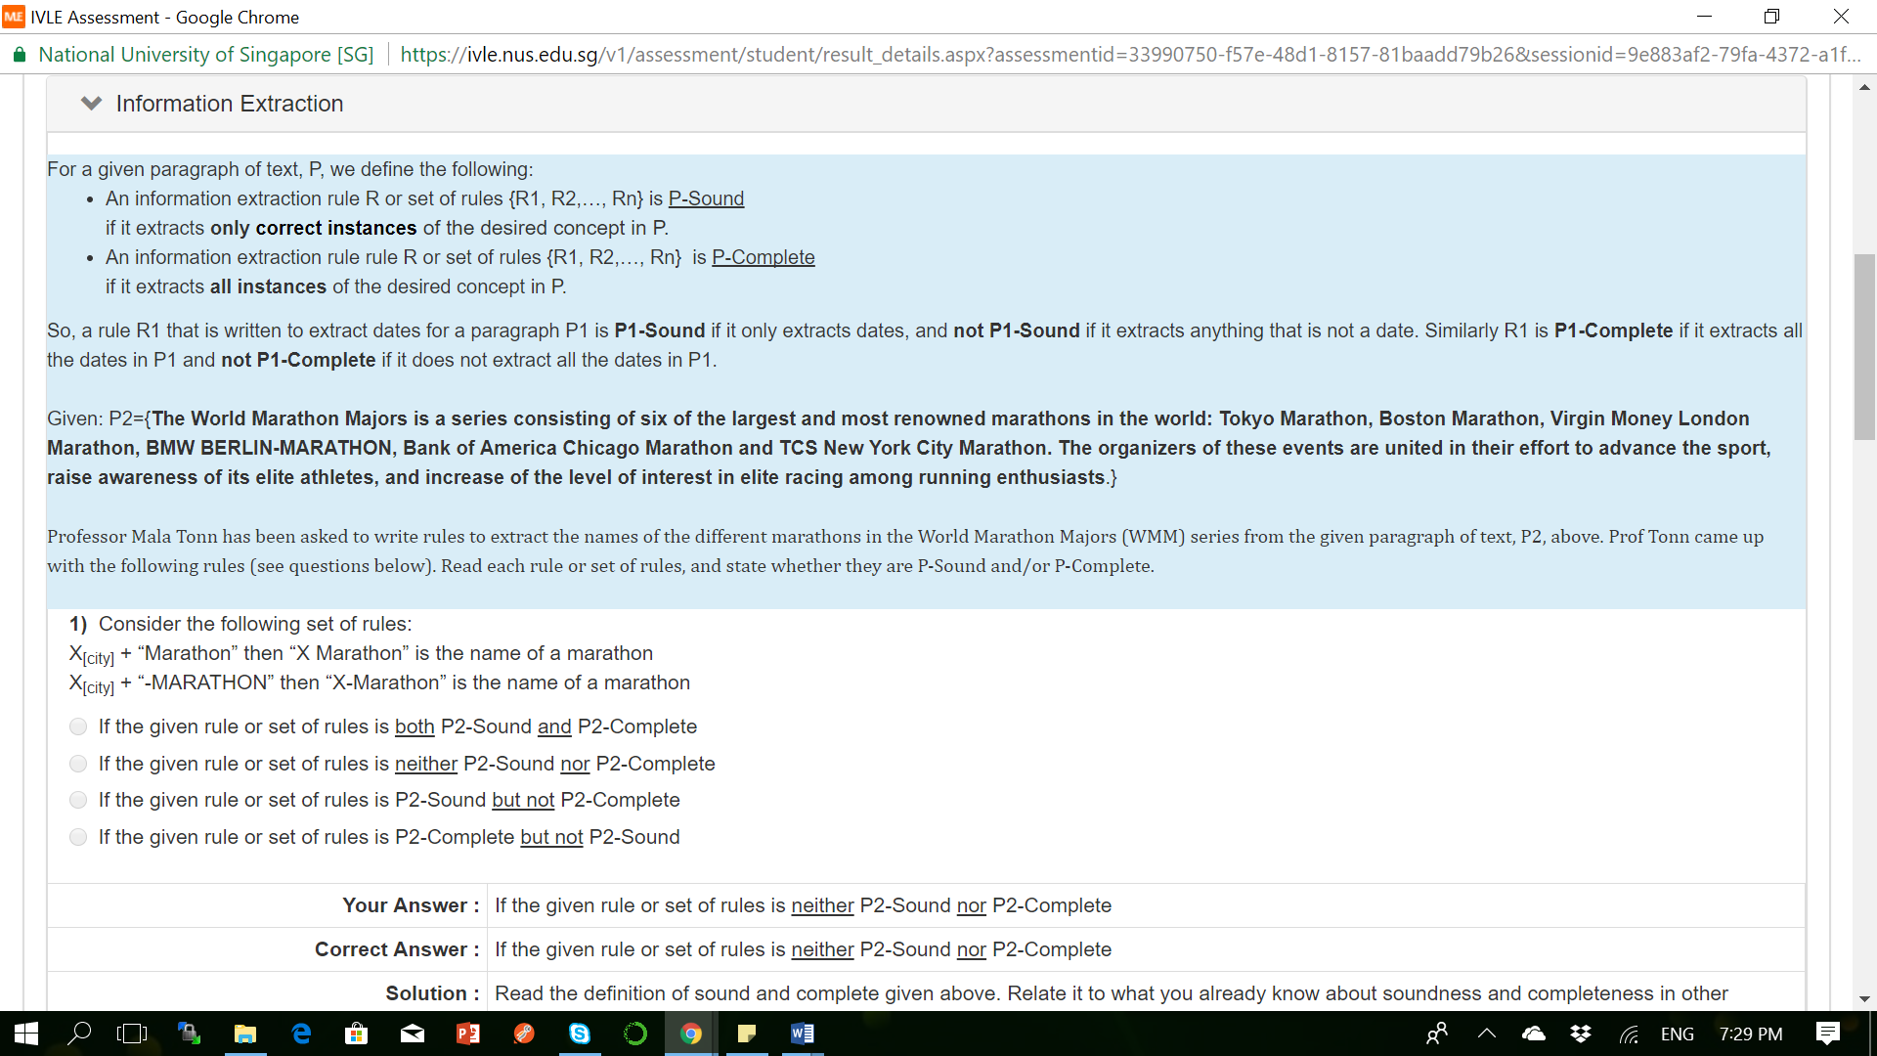

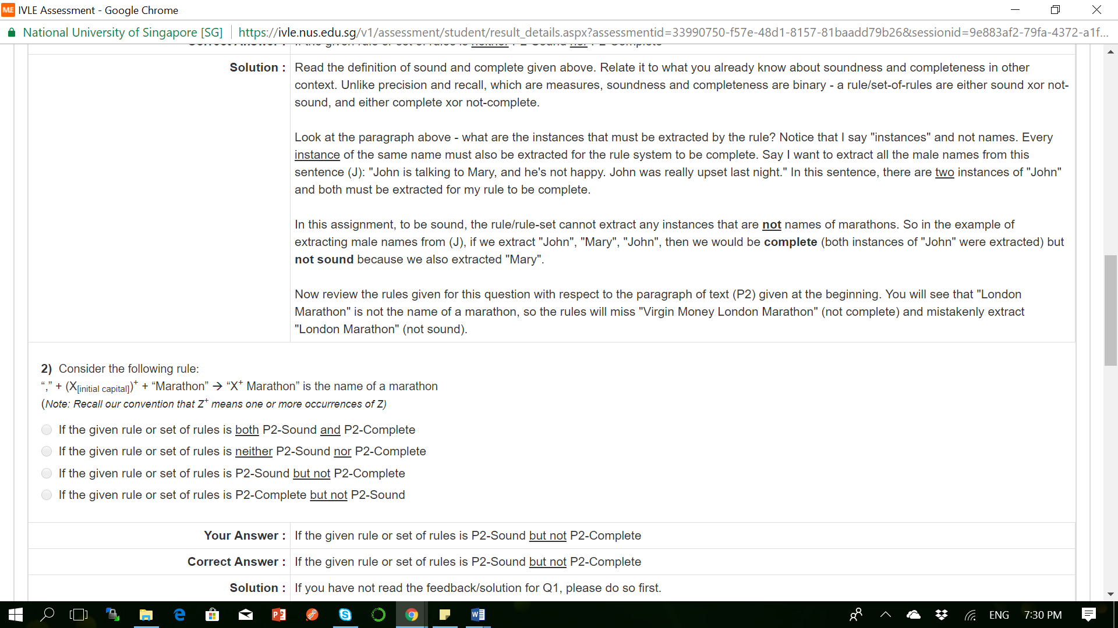

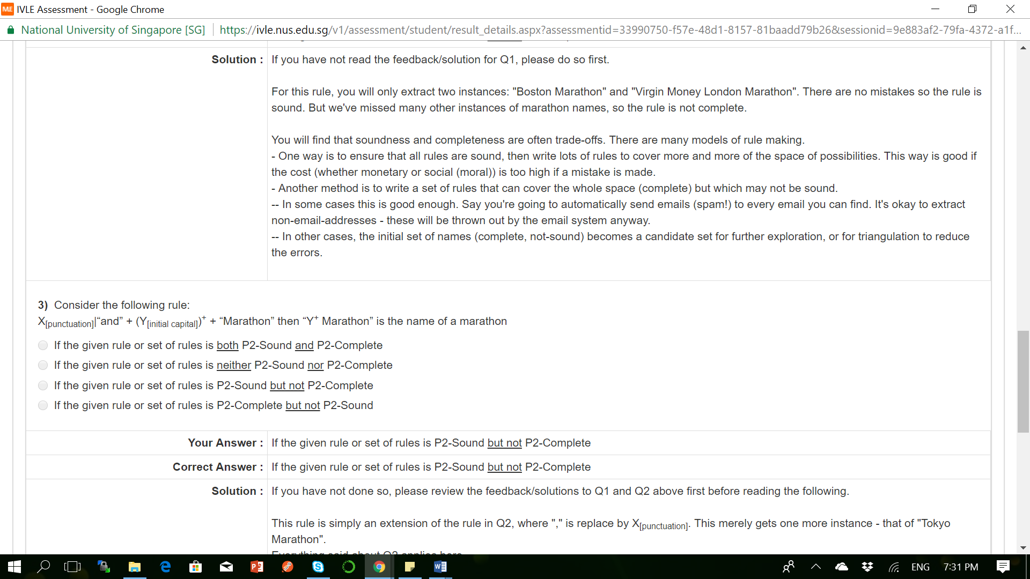

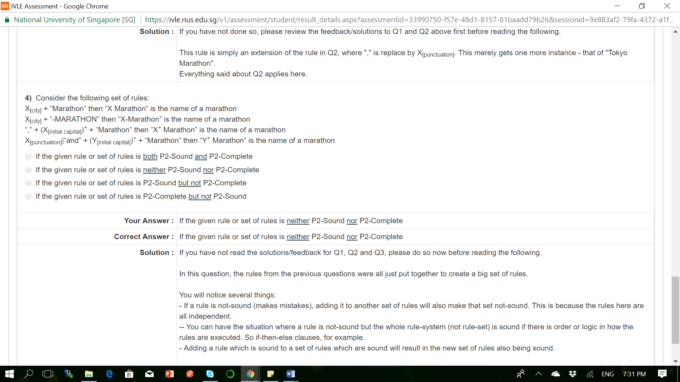

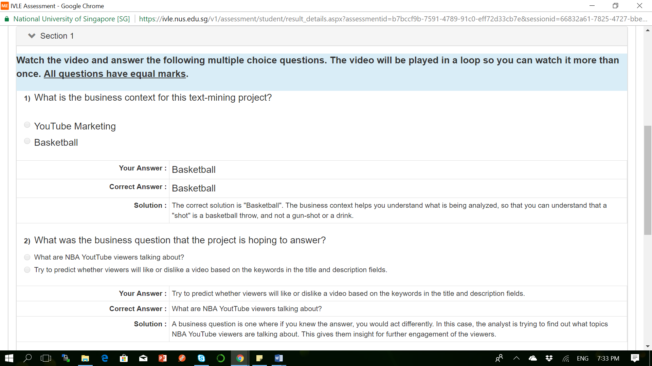

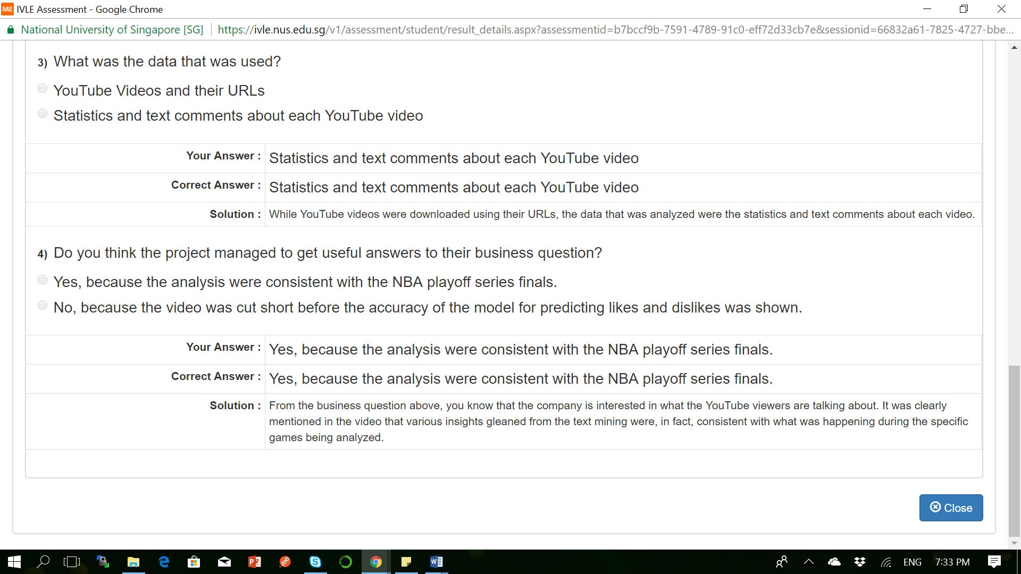

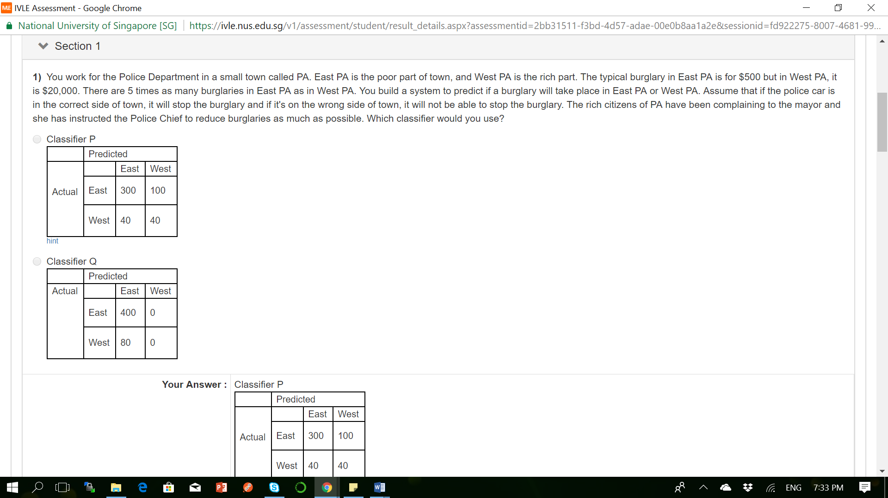

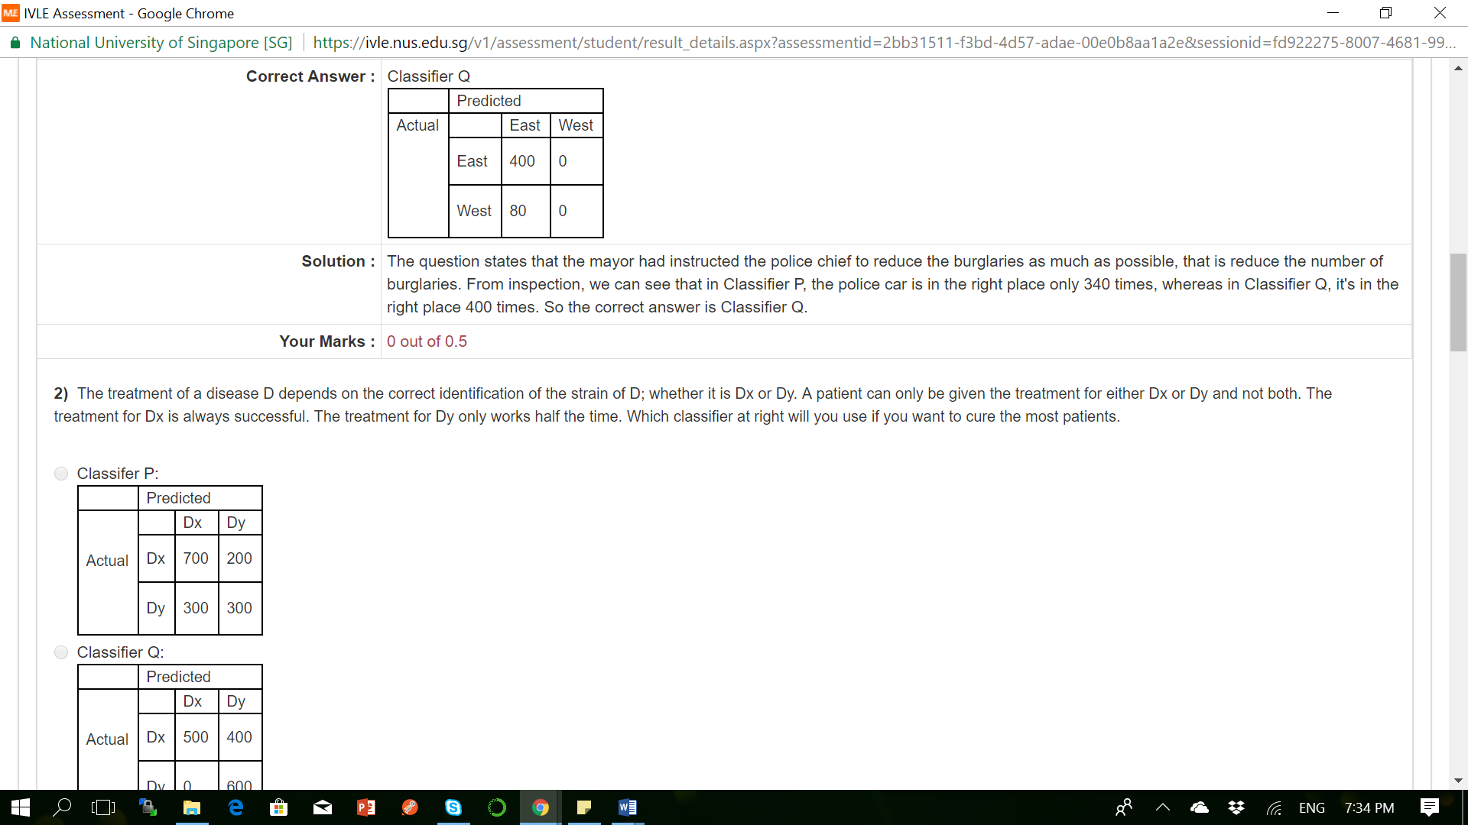

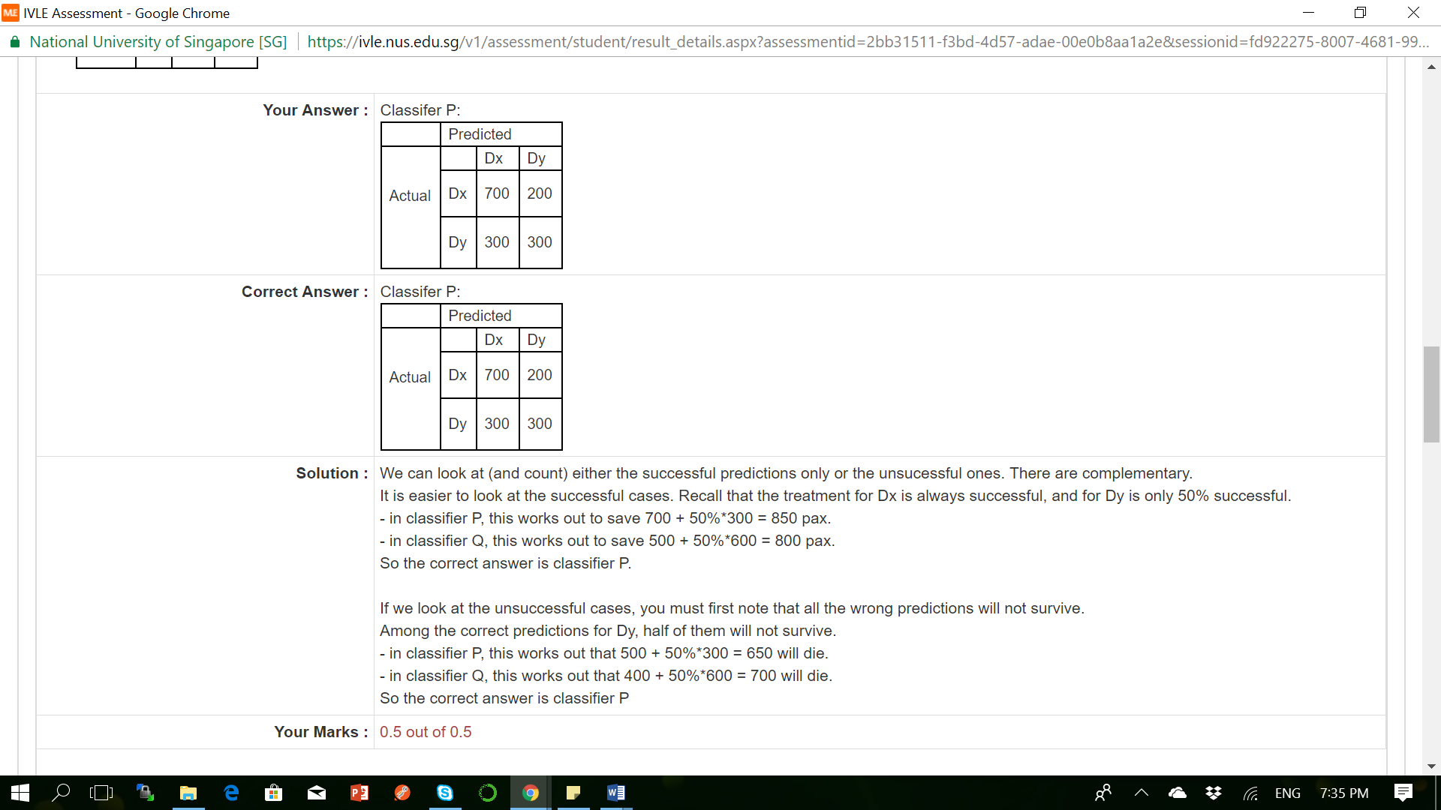

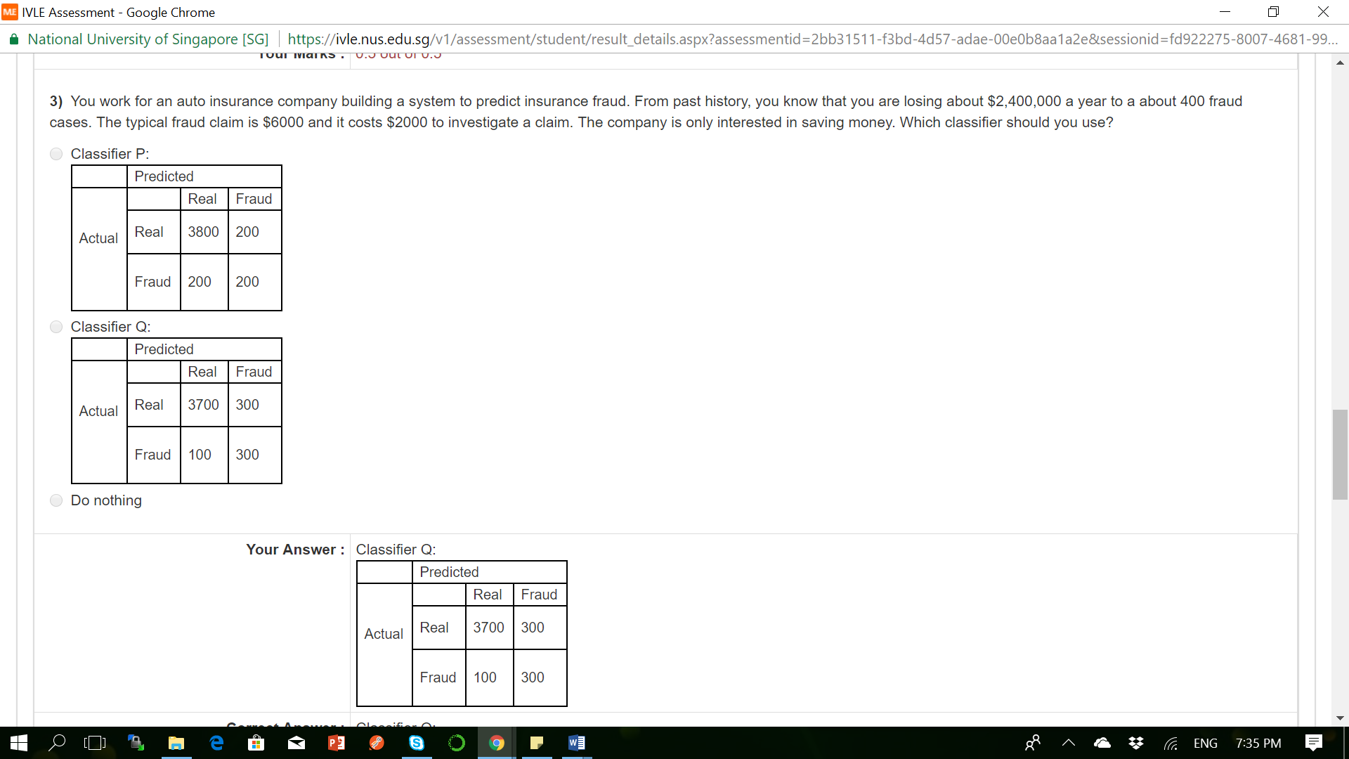

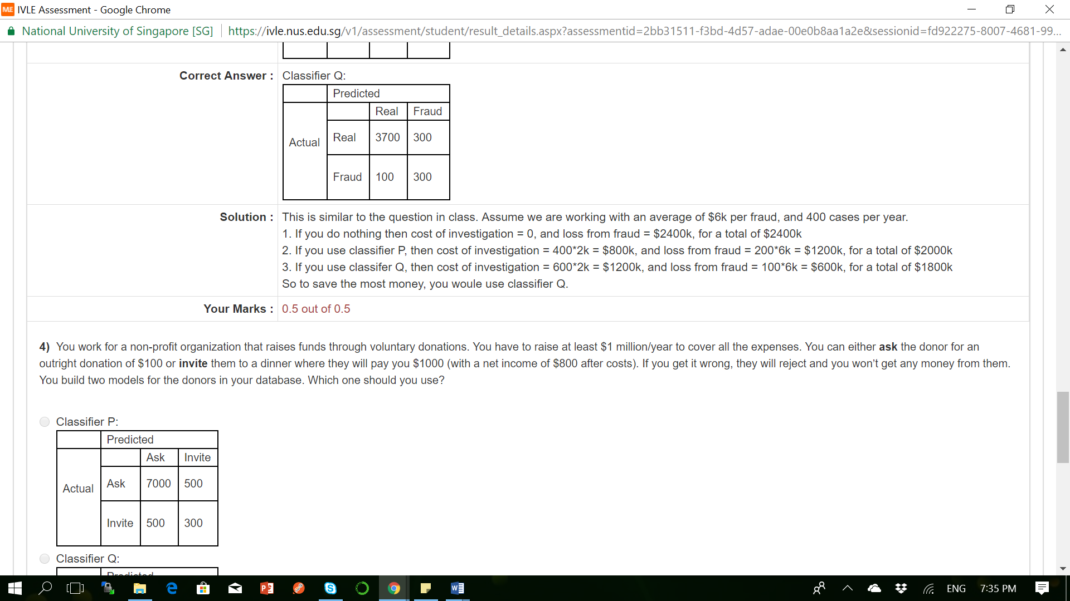

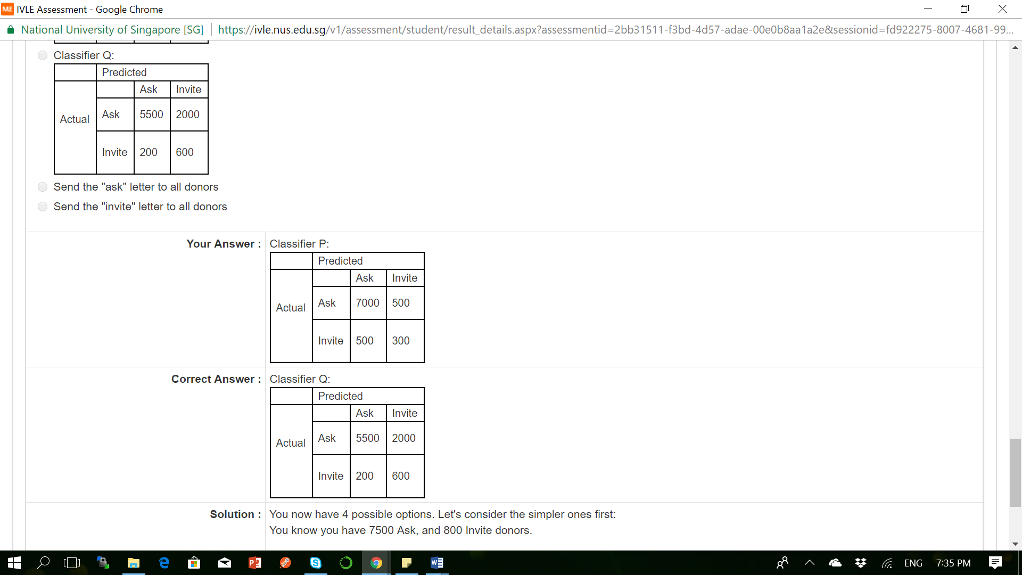

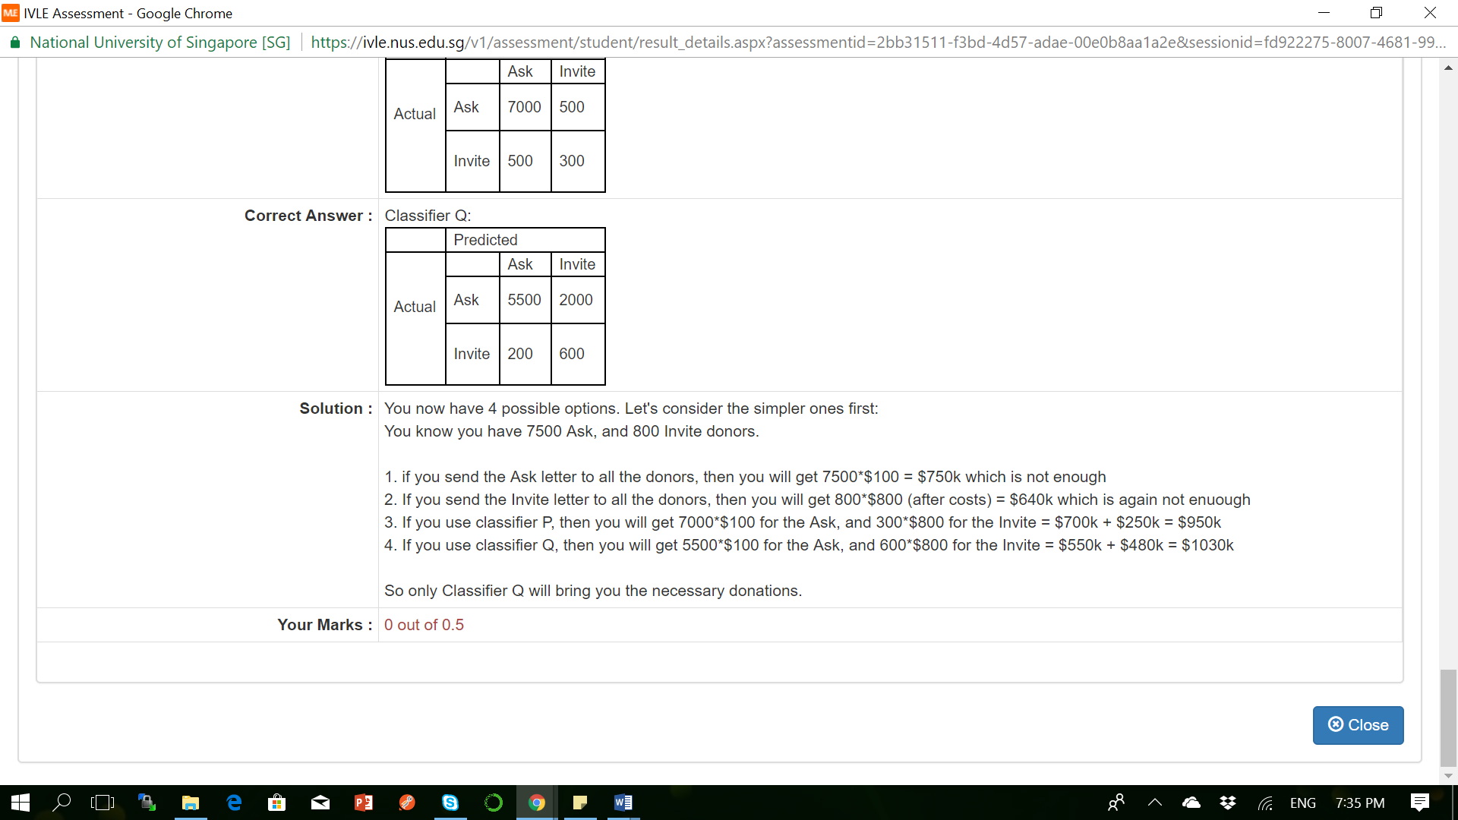

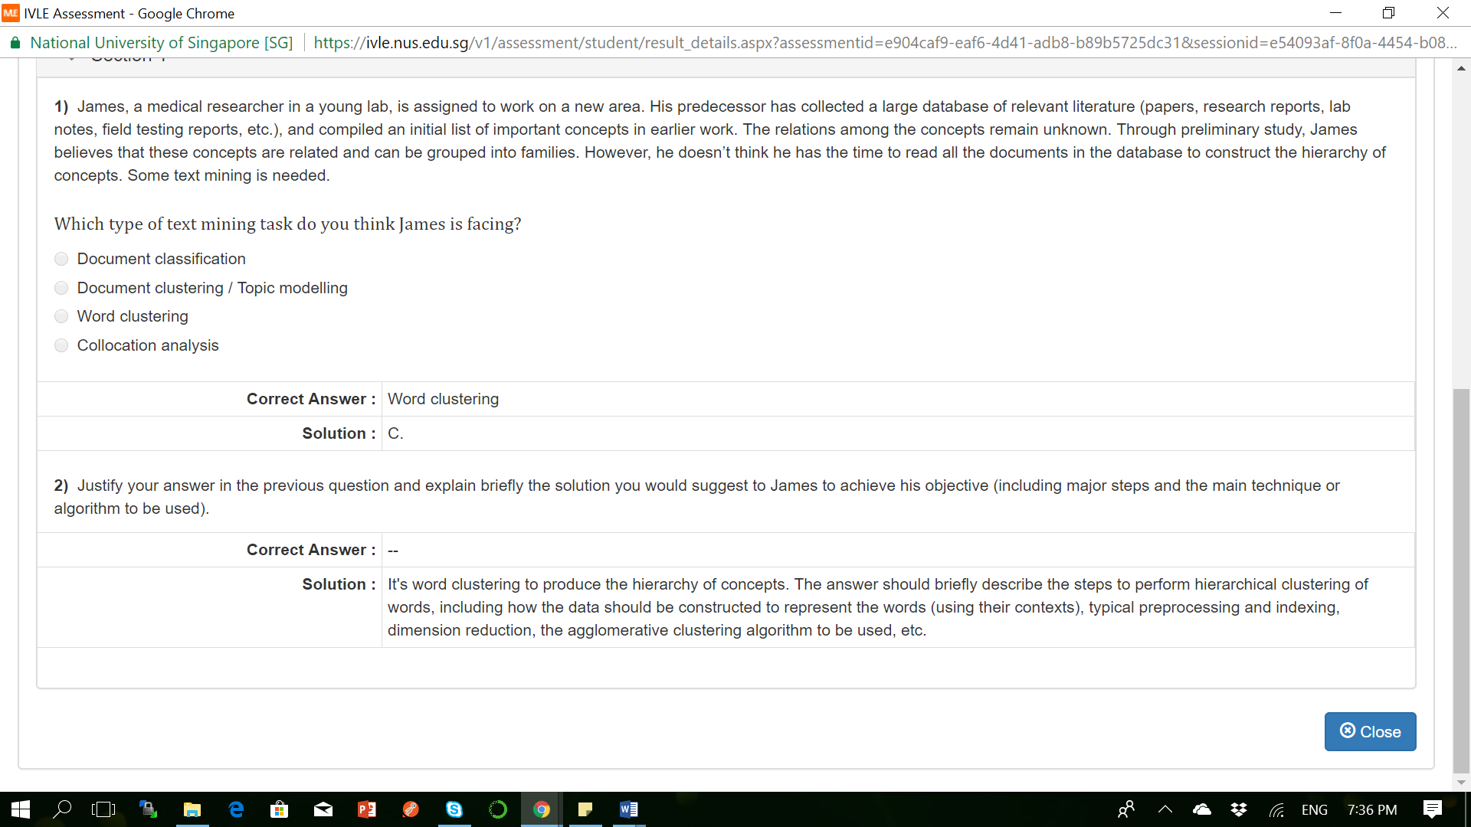

Skill Test Questions and Answers

**Q1 Which of the following techniques can be used for the purpose of keyword normalization, the process of converting a keyword into its base form?**

1. Lemmatization
2. Levenshtein
3. Stemming
4. Soundex

**Solution:** C) 1 and 3

Lemmatization and stemming are the techniques of keyword normalization, while Levenshtein and Soundex are techniques of string matching.  
**2) N-grams are defined as the combination of N keywords together. How many bi-grams can be generated from given sentence:**

“Analytics Vidhya is a great source to learn data science”

**Solution: (C) 9**

Bigrams: Analytics Vidhya, Vidhya is, is a, a great, great source, source to, To learn, learn data, data science

**3) How many trigrams phrases can be generated from the following sentence, after performing following text cleaning steps:**

* Stopword Removal
* Replacing punctuations by a single space

**“#Analytics-vidhya is a great source to learn @data_science.”**

**Solution: (C) 5**

After performing stopword removal and punctuation replacement the text becomes: “Analytics vidhya great source learn data science”

Trigrams – Analytics vidhya great, vidhya great source, great source learn, source learn data, learn data science

**4) Which of the following regular expression can be used to identify date(s) present in the text object:**

***“The next meetup on data science will be held on 2017-09-21, previously it happened on 31/03, 2016”***

A) \d{4}-\d{2}-\d{2}  
B) (19|20)\d{2}-(0[1-9]|1[0-2])-[0-2][1-9] C) (19|20)\d{2}-(0[1-9]|1[0-2])-([0-2][1-9]|3[0-1])  
D) None of the above

**Solution: (D)**

None if these expressions would be able to identify the dates in this text object.

**Question Context 5-6:**

You have collected a data of about 10,000 rows of tweet text and no other information. You want to create a tweet classification model that categorizes each of the tweets in three buckets – positive, negative and neutral.

**5) Which of the following models can perform tweet classification with regards to context mentioned above?**

A) Naive Bayes  
B) SVM  
C) None of the above

**Solution: (C)**

Since, you are given only the data of tweets and no other information, which means there is no target variable present. One cannot train a supervised learning model, both svm and naive bayes are supervised learning techniques.

**6) You have created a document term matrix of the data, treating every tweet as one document. Which of the following is correct, in regards to document term matrix?**

1. Removal of stopwords from the data will affect the dimensionality of data
2. Normalization of words in the data will reduce the dimensionality of data
3. Converting all the words in lowercase will not affect the dimensionality of the data

**Solution: 1 and 2**

Choices A and B are correct because stopword removal will decrease the number of features in the matrix, normalization of words will also reduce redundant features, and, converting all words to lowercase will also decrease the dimensionality.

**7) Which of the following features can be used for accuracy improvement of a classification model**?

A) Frequency count of terms  
B) Vector Notation of sentence  
C) Part of Speech Tag  
D) Dependency Grammar  
E) All of these

**Solution: (E)**

All of the techniques can be used for the purpose of engineering features in a model.

**8) What percentage of the total statements are correct with regards to Topic Modeling?**

1. It is a supervised learning technique
2. LDA (Linear Discriminant Analysis) can be used to perform topic modeling
3. Selection of number of topics in a model does not depend on the size of data
4. Number of topic terms are directly proportional to size of the data

**Solution: 0**

LDA is unsupervised learning model, LDA is latent Dirichlet allocation, not Linear discriminant analysis. Selection of the number of topics is directly proportional to the size of the data, while number of topic terms is not directly proportional to the size of the data. Hence none of the statements are correct.

**9) In Latent Dirichlet Allocation model for text classification purposes, what does alpha and beta hyperparameter represent-**

**Solution:**  Alpha: density of topics generated within documents, beta: density of terms generated within topics True

**10) Solve the equation according to the sentence “I am planning to visit New Delhi to attend Analytics Vidhya Delhi Hackathon”.**

A = (# of words with Noun as the part of speech tag)  
B = (# of words with Verb as the part of speech tag)  
C = (# of words with frequency count greater than one)

**What are the correct values of A, B, and C?**

**Solution:** D) 7, 4, 2

Nouns: I, New, Delhi, Analytics, Vidhya, Delhi, Hackathon (7)

Verbs: am, planning, visit, attend (4)

Words with frequency counts > 1: to, Delhi (2)

**11) In a corpus of N documents, one document is randomly picked. The document contains a total of T terms and the term “data” appears K times.**

**What is the correct value for the product of TF (term frequency) and IDF (inverse-document-frequency), if the term “data” appears in approximately one-third of the total documents?**

**Solution:**   K * Log(3) / T

formula for TF is K/T

formula for IDF is log(total docs / no of docs containing “data”)

= log(1 / (⅓))

= log (3)

**Question Context 12 to 14:**

Refer the following document term matrix  
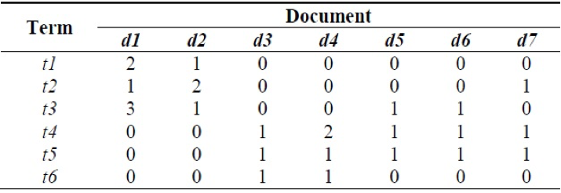

**12) Which of the following documents contains the same number of terms and the number of terms in the one of the document is not equal to least number of terms in any document in the entire corpus.**

**Solution: (C)** d2 and d4

Both of the documents d2 and d4 contains 4 terms and does not contain the least number of terms which is 3.

**13) Which are the most common and the rarest term of the corpus?**

**Solution: (A)** t4, t6

T5 is most common terms across 5 out of 7 documents, T6 is rare term only appears in d3 and d4

**14) What is the term frequency of a term which is used a maximum number of times in that document?**

**Solution:** t3 – 3/6

t3 is used max times in entire corpus = 3, tf for t3 is 3/6

**15) Which of the following technique is not a part of flexible text matching?**

**Solution:** Keyword Hashing

Except Keyword Hashing all other are the techniques used in flexible string matching

**16) True or False: Word2Vec model is a machine learning model used to create vector notations of text objects. Word2vec contains multiple deep neural networks**

A) TRUE  
B) FALSE

**Solution: (B)**

Word2vec also contains preprocessing model which is not a deep neural network

**17) Which of the following statement is(are) true for Word2Vec model?**

A) The architecture of word2vec consists of only two layers – continuous bag of words and skip-gram

**Solution: (C)** Skip-gram is a deep neural network model  
Word2vec contains the Continuous bag of words and skip-gram models, which are deep neural nets.

**18) With respect to this context-free dependency graphs, how many sub-trees exists in the sentence?**

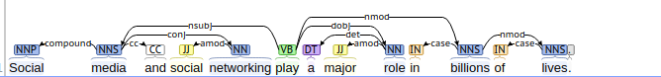  
A) 3  
B) 4  
C) 5  
D) 6

**Solution: (D)**

Subtrees in the dependency graph can be viewed as nodes having an outward link, for example:

Media, networking, play, role, billions, and lives are the roots of subtrees

**19) What is the right order for a text classification model components**

1. Text cleaning
2. Text annotation
3. Gradient descent
4. Model tuning
5. Text to predictors

**Solution:**  12534

A right text classification model contains – cleaning of text to remove noise, annotation to create more features, converting text-based features into predictors, learning a model using gradient descent and finally tuning a model.

**20) Polysemy is defined as the coexistence of multiple meanings for a word or phrase in a text object. Which of the following models is likely the best choice to correct this problem?**

**Solution:** Convolutional Neural Networks

CNNs are popular choice for text classification problems because they take into consideration left and right contexts of the words as features which can solve the problem of polysemy

**21) Which of the following models can be used for the purpose of document similarity?**

A) Training a word 2 vector model on the corpus that learns context present in the document  
B) Training a bag of words model that learns occurrence of words in the document  
C) Creating a document-term matrix and using cosine similarity for each document  
D) All of the above

**Solution: (D)**

word2vec model can be used for measuring document similarity based on context. Bag Of Words and document term matrix can be used for measuring similarity based on terms.

**22) What are the possible features of a text corpus**

1. Count of word in a document
2. Boolean feature – presence of word in a document
3. Vector notation of word
4. Part of Speech Tag
5. Basic Dependency Grammar
6. Entire document as a feature

**Solution:** 12345

Except for entire document as the feature, rest all can be used as features of text classification learning model.

**23) While creating a machine learning model on text data, you created a document term matrix of the input data of 100K documents. Which of the following remedies can be used to reduce the dimensions of data –**

1. Latent Dirichlet Allocation
2. Latent Semantic Indexing
3. Keyword Normalization

**Solution:** 1, 2, 3

All of the techniques can be used to reduce the dimensions of the data.

**24) Google Search’s feature – “Did you mean”, is a mixture of different techniques. Which of the following techniques are likely to be ingredients?**

1. Collaborative Filtering model to detect similar user behaviors (queries)
2. Model that checks for Levenshtein distance among the dictionary terms
3. Translation of sentences into multiple languages

**Solution:** C) 1, 2

Collaborative filtering can be used to check what are the patterns used by people, Levenshtein is used to measure the distance among dictionary terms.

**25) While working with text data obtained from news sentences, which are structured in nature, which of the grammar-based text parsing techniques can be used for noun phrase detection, verb phrase detection, subject detection and object detection.**

**Solution:** Dependency Parsing and Constituency Parsing

Dependency and constituent parsing extract these relations from the text

**26) Social Media platforms are the most intuitive form of text data. You are given a corpus of complete social media data of tweets. How can you create a model that suggests the hashtags?**

A) Perform Topic Models to obtain most significant words of the corpus  
B) Train a Bag of Ngrams model to capture top n-grams – words and their combinations  
C) Train a word2vector model to learn repeating contexts in the sentences  
D) All of these

**Solution: (D)**

All of the techniques can be used to extract most significant terms of a corpus.

**27) While working with context extraction from a text data, you encountered two different sentences: The tank is full of soldiers. The tank is full of nitrogen. Which of the following measures can be used to remove the problem of word sense disambiguation in the sentences?**

**Solution:** Compare the dictionary definition of an ambiguous word with the terms contained in its neighborhood

Option 1 is called Lesk algorithm, used for word sense disambiguation, rest others cannot be used.

**28) Collaborative Filtering and Content Based Models are the two popular recommendation engines, what role does NLP play in building such algorithms.**

A) Feature Extraction from text  
B) Measuring Feature Similarity  
C) Engineering Features for vector space learning model  
D) All of these

**Solution: (D)**

NLP can be used anywhere where text data is involved – feature extraction, measuring feature similarity, create vector features of the text.

**29) Retrieval based models and Generative models are the two popular techniques used for building chatbots. Which of the following is an example of retrieval model and generative model respectively.**

**Solution:**  Rule-based learning and Sequence to Sequence model

choice 2 best explains examples of retrieval based models and generative models

**30) What is the major difference between CRF (Conditional Random Field) and HMM (Hidden Markov Model)?**

**Solution:** CRF is Discriminative whereas HMM is Generative model

Questions and Answers

**Q1. A neural network model is said to be inspired from the human brain.**

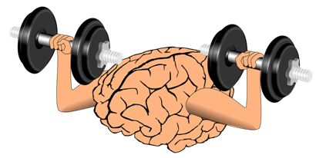

**The neural network consists of many neurons, each neuron takes an input, processes it and gives an output. Here’s a diagrammatic representation of a real neuron.**

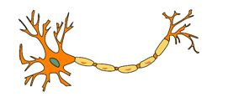

**Which of the following statement(s) correctly represents a real neuron?**

A. A neuron has a single input and a single output only

B. A neuron has multiple inputs but a single output only

C. A neuron has a single input but multiple outputs

D. A neuron has multiple inputs and multiple outputs

E. All of the above statements are valid

**Solution: (E)**

A neuron can have a single Input / Output or multiple Inputs / Outputs.

**Q2. Below is a mathematical representation of a neuron.**

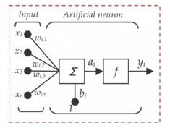**The different components of the neuron are denoted as:**

* **x1, x2,…, xN: These are inputs to the neuron. These can either be the actual observations from input layer or an intermediate value from one of the hidden layers.**
* **w1, w2,…,wN: The Weight of each input.**
* **bi: Is termed as Bias units. These are constant values added to the input of the activation function corresponding to each weight. It works similar to an intercept term.**
* **a:  Is termed as the activation of the neuron which can be represented as**
* **and y: is the output of the neuron**

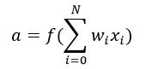

**Considering the above notations, will a line equation (y = mx + c) fall into the category of a neuron?**

A. Yes

B. No

**Solution: (A)**

A single neuron with no non-linearity can be considered as a linear regression function.

**Q3. Let us assume we implement an AND function to a single neuron. Below is a tabular representation of an AND function:**

|  |  |  |
| --- | --- | --- |
| **X1** | **X2** | **X1 AND X2** |
| **0** | **0** | **0** |
| **0** | **1** | **0** |
| **1** | **0** | **0** |
| **1** | **1** | **1** |

**The activation function of our neuron is denoted as:**

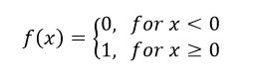

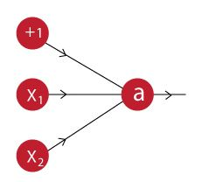

**What would be the weights and bias?**

**(Hint: For which values of w1, w2 and b does our neuron implement an AND function?)**

**Solution:** Bias = -1.5, w1 = 1, w2 = 1

A.

1. f(-1.5*1 + 1*0 + 1*0) = f(-1.5) = 0
2. f(-1.5*1 + 1*0 + 1*1) = f(-0.5) = 0
3. f(-1.5*1 + 1*1 + 1*0) = f(-0.5) = 0
4. f(-1.5*1 + 1*1+ 1*1) = f(0.5) = 1

**Q4. A network is created when we multiple neurons stack together. Let us take an example of a neural network simulating an XNOR function.**

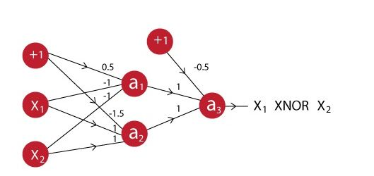

**You can see that the last neuron takes input from two neurons before it. The activation function for all the neurons is given by:**



**Suppose X1 is 0 and X2 is 1, what will be the output for the above neural network?**

A. 0

B. 1

**Solution: (A)**

Output of a1: f(0.5*1 + -1*0 + -1*1) = f(-0.5) = 0

Output of a2: f(-1.5*1 + 1*0 + 1*1) = f(-0.5) = 0

Output of a3: f(-0.5*1 + 1*0 + 1*0) = f(-0.5) = 0

So the correct answer is A

**Q5. In a neural network, knowing the weight and bias of each neuron is the most important step. If you can somehow get the correct value of weight and bias for each neuron, you can approximate any function. What would be the best way to approach this?**

A. Assign random values and pray to God they are correct

B. Search every possible combination of weights and biases till you get the best value

C. Iteratively check that after assigning a value how far you are from the best values, and slightly change the assigned values values to make them better

D. None of these

**Solution: (C)**

Option C is the description of gradient descent.

**Q6. What are the steps for using a gradient descent algorithm?**

1. **Calculate error between the actual value and the predicted value**
2. **Reiterate until you find the best weights of network**
3. **Pass an input through the network and get values from output layer**
4. **Initialize random weight and bias**
5. **Go to each neurons which contributes to the error and change its respective values to reduce the error**

**Solution:** 4, 3, 1, 5, 2

**Q7. Suppose you have inputs as x, y, and z with values -2, 5, and -4 respectively. You have a neuron ‘q’ and neuron ‘f’ with functions:**

**q = x + y**

**f = q * z**

**Graphical representation of the functions is as follows:**

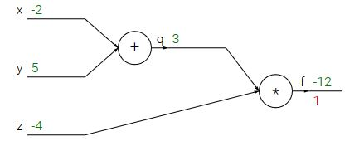

**What is the gradient of F with respect to x, y, and z?**

**(HINT: To calculate gradient, you must find (df/dx), (df/dy) and (df/dz))**

A. (-3,4,4)

B. (4,4,3)

C. (-4,-4,3)

D. (3,-4,-4)

**Solution: (C)**

Option C is correct.

**Q8. Now let’s revise the previous slides. We have learned that:**

* **A neural network is a (crude) mathematical representation of a brain, which consists of smaller components called neurons.**
* **Each neuron has an input, a processing function, and an output.**
* **These neurons are stacked together to form a network, which can be used to approximate any function.**
* **To get the best possible neural network, we can use techniques like gradient descent to update our neural network model.**

**Given above is a description of a neural network. When does a neural network model become a deep learning model?**

**Solution:**When you add more hidden layers and increase depth of neural network

More depth means the network is deeper. There is no strict rule of how many layers are necessary to make a model deep, but still if there are more than 2 hidden layers, the model is said to be deep.

**Q9. A neural network can be considered as multiple simple equations stacked together. Suppose we want to replicate the function for the below mentioned decision boundary.  
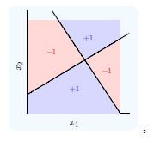**

**Using two simple inputs h1 and h2**

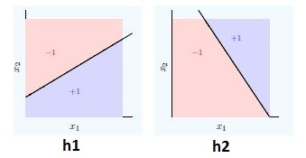

**What will be the final equation?**

**Solution:**  (h1 AND NOT h2) OR (NOT h1 AND h2)

**Q10. “Convolutional Neural Networks can perform various types of transformation (rotations or scaling) in an input”. Is the statement correct True or False?**

A. True

B. False

**Solution: (B)**

Data Preprocessing steps (viz rotation, scaling) is necessary before you give the data to neural network because neural network cannot do it itself.

**Q11. Which of the following techniques perform similar operations as dropout in a neural network?**

**Solution:** Bagging

Dropout can be seen as an extreme form of bagging in which each model is trained on a single case and each parameter of the model is very strongly regularized by sharing it with the corresponding parameter in all the other models.

**Q 12. Which of the following gives non-linearity to a neural network?**

**Solution:**Rectified Linear Unit

Rectified Linear unit is a non-linear activation function.

**Q13. In training a neural network, you notice that the loss does not decrease in the few starting epochs.**

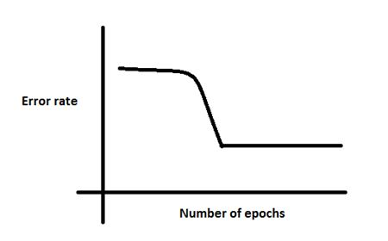

**The reasons for this could be:**

1. **The learning is rate is low**
2. **Regularization parameter is high**
3. **Stuck at local minima**

**What according to you are the probable reasons?**

A. 1 and 2

B. 2 and 3

C. 1 and 3

D. Any of these

**Solution: (D)**

The problem can occur due to any of the reasons mentioned.

**Q14. Which of the following is true about model capacity (where model capacity means the ability of neural network to approximate complex functions) ?**

**Solution:** As number of hidden layers increase, model capacity increases

**Q15. If you increase the number of hidden layers in a Multi Layer Perceptron, the classification error of test data always decreases. True or False?**

A. True

B. False

**Solution: (B)**

This is not always true. Overfitting may cause the error to increase.

**Q16.** **You are building a neural network where it gets input from the previous layer as well as from itself.**

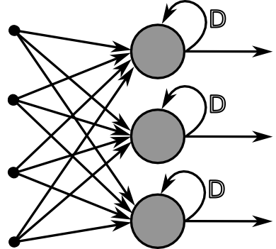

**Which of the following architecture has feedback connections?**

**Solution:**  Recurrent Neural network

**Q17. What is the sequence of the following tasks in a perceptron?**

1. **Initialize weights of perceptron randomly**
2. **Go to the next batch of dataset**
3. **If the prediction does not match the output, change the weights**
4. **For a sample input, compute an output**

**Solution:** 1, 4, 3, 2

**Q18. Suppose that you have to minimize the cost function by changing the parameters. Which of the following technique could be used for this?**

A. Exhaustive Search

B. Random Search

C. Bayesian Optimization

D. Any of these

**Solution: (D)**

Any of the above mentioned technique can be used to change parameters.

**Q19. First Order Gradient descent would not work correctly (i.e. may get stuck) in which of the following graphs?**

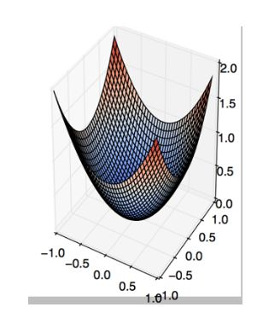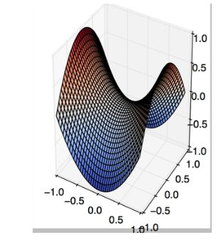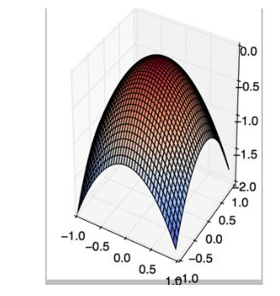

A B C

D. None of these

**Solution: (B)**

This is a classic example of saddle point problem of gradient descent.

**Q20. The below graph shows the accuracy of a trained 3-layer convolutional neural network vs the number of parameters (i.e. number of feature kernels).**

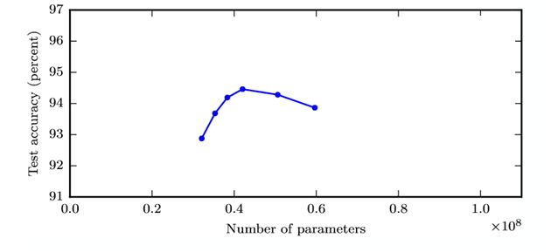  
**The trend suggests that as you increase the width of a neural network, the accuracy increases till a certain threshold value, and then starts decreasing.**

**What could be the possible reason for this decrease?**

**Solution:** As the number of kernels increase, they start to correlate with each other which in turn helps overfitting

As mentioned in option C, the possible reason could be kernel correlation.

**Q21. Suppose we have one hidden layer neural network as shown above. The hidden layer in this network works as a dimensionality reductor. Now instead of using this hidden layer, we replace it with a dimensionality reduction technique such as PCA.**

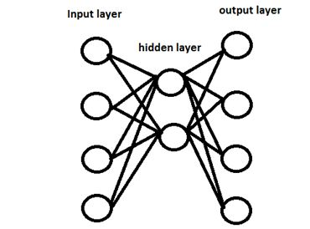

**Would the network that uses a dimensionality reduction technique always give same output as network with hidden layer?**

A. Yes

B. No

**Solution: (B)**

Because PCA works on correlated features, whereas hidden layers work on predictive capacity of features.

**Q22. Can a neural network model the function (y=1/x)?**

A. Yes

B. No

**Solution: (A)**

Option A is true, because activation function can be reciprocal function.

**Q23. In which neural net architecture, does weight sharing occur?**

A. Convolutional neural Network

B. Recurrent Neural Network

C. Fully Connected Neural Network

D. Both A and B

**Solution: (D)**

Option D is correct.

**Q24. Batch Normalization is helpful because**

**Solution:** It normalizes (changes) all the input before sending it to the next layer

**Q25. Instead of trying to achieve absolute zero error, we set a metric called bayes error which is the error we hope to achieve. What could be the reason for using bayes error?**

A. Input variables may not contain complete information about the output variable

B. System (that creates input-output mapping) may be stochastic

C. Limited training data

D. All the above

**Solution: (D)**

In reality achieving accurate prediction is a myth. So we should hope to achieve an “achievable result”.

**Q26. The number of neurons in the output layer should match the number of classes (Where the number of classes is greater than 2) in a supervised learning task. True or False?**

A. True

B. False

**Solution: (B)**

It depends on output encoding. If it is one-hot encoding, then its true. But you can have two outputs for four classes, and take the binary values as four classes(00,01,10,11).

**Q27. In a neural network, which of the following techniques is used to deal with overfitting?**

A. Dropout

B. Regularization

C. Batch Normalization

D. All of these

**Solution: (D)**

All of the techniques can be used to deal with overfitting.

**Q28. Y = ax^2 + bx + c (polynomial equation of degree 2)**

**Can this equation be represented by a neural network of single hidden layer with linear threshold?**

A. Yes

B. No

**Solution: (B)**

The answer is no because having a linear threshold restricts your neural network and in simple terms, makes it a consequential linear transformation function.

**Q29. What is a dead unit in a neural network?**

**Solution:** A unit which doesn’t update during training by any of its neighbour

**Q30. Which of the following statement is the best description of early stopping?**

**Solution:**Simulate the network on a test dataset after every epoch of training. Stop training when the generalization error starts to increase

**Q31. What if we use a learning rate that’s too large?**

Solution: Network will not converge

Option B is correct because the error rate would become erratic and explode.

**Q32. The network shown in Figure 1 is trained to recognize the characters H and T as shown below:**

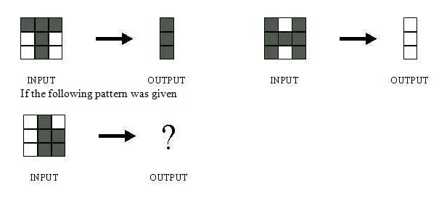

**What would be the output of the network?**

1. 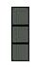
2. 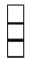
3. 
4. Could be A or B depending on the weights of neural network

**Solution: (D)**

Without knowing what are the weights and biases of a neural network, we cannot comment on what output it would give.

**Q33. Suppose a convolutional neural network is trained on ImageNet dataset (Object recognition dataset). This trained model is then given a completely white image as an input.The output probabilities for this input would be equal for all classes. True or False?**

A. True

B. False

**Solution: (B)**

There would be some neurons which are do not activate for white pixels as input. So the classes wont be equal.

**Q34. When pooling layer is added in a convolutional neural network, translation in-variance is preserved. True or False?**

A. True

B. False

**Solution: (A)**

Translation invariance is induced when you use pooling.

**Q35. Which gradient technique is more advantageous when the data is too big to handle in RAM simultaneously?**

A. Full Batch Gradient Descent

B. Stochastic Gradient Descent

**Solution: (B)**

Option B is correct.

**Q36. The graph represents gradient flow of a four-hidden layer neural network which is trained using sigmoid activation function per epoch of training. The neural network suffers with the vanishing gradient problem.**

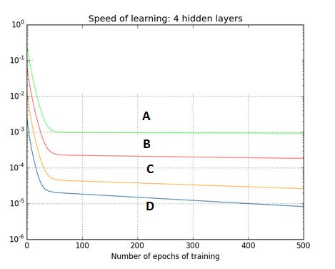

**Which of the following statements is true?**

**Solution:**Hidden layer 1 corresponds to D, Hidden layer 2 corresponds to C, Hidden layer 3 corresponds to B and Hidden layer 4 corresponds to A

This is a description of a vanishing gradient problem. As the backprop algorithm goes to starting layers, learning decreases.

**Q37. For a classification task, instead of random weight initializations in a neural network, we set all the weights to zero. Which of the following statements is true?**

**Solution:** The neural network will train but all the neurons will end up recognizing the same thing

**Q38. There is a plateau at the start. This is happening because the neural network gets stuck at local minima before going on to global minima.**



**To avoid this, which of the following strategy should work?**

**Solution:**Jitter the learning rate, i.e. change the learning rate for a few epochs

Option C can be used to take a neural network out of local minima in which it is stuck.

**Q39. For an image recognition problem (recognizing a cat in a photo), which architecture of neural network would be better suited to solve the problem?**

**Solution:** Convolutional Neural Network

Convolutional Neural Network would be better suited for image related problems because of its inherent nature for taking into account changes in nearby locations of an image

**Q40.** **Suppose while training, you encounter this issue. The error suddenly increases after a couple of iterations.**

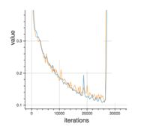

**You determine that there must a problem with the data. You plot the data and find the insight that, original data is somewhat skewed and that may be causing the problem.**

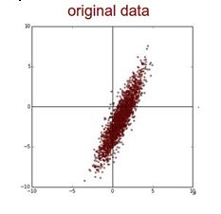

**What will you do to deal with this challenge?**

**Solution:**Apply PCA and then Normalize

First you would remove the correlations of the data and then zero center it.

**Q41. Which of the following is a decision boundary of Neural Network?**

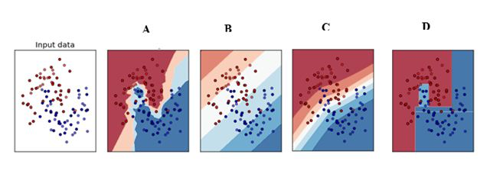

A) B

B) A

C) D

D) C

E) All of these

**Solution: (E)**

A neural network is said to be a universal function approximator, so it can theoretically represent any decision boundary.

**Q42. In the graph below, we observe that the error has many “ups and downs”**

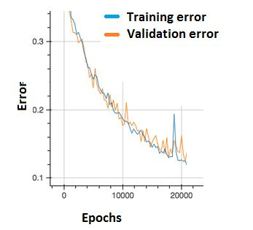

**Should we be worried?**

A. Yes, because this means there is a problem with the learning rate of neural network.

B. No, as long as there is a cumulative decrease in both training and validation error, we don’t need to worry.

**Solution: (B)**

Option B is correct. In order to decrease these “ups and downs” try to increase the batch size.

**Q43. What are the factors to select the depth of neural network?**

1. Type of neural network (eg. MLP, CNN etc)
2. Input data
3. Computation power, i.e. Hardware capabilities and software capabilities
4. Learning Rate
5. The output function to map

A. 1, 2, 4, 5

B. 2, 3, 4, 5

C. 1, 3, 4, 5

D. All of these

**Solution: (D)**

All of the above factors are important to select the depth of neural network

**Q44. Consider the scenario. The problem you are trying to solve has a small amount of data. Fortunately, you have a pre-trained neural network that was trained on a similar problem. Which of the following methodologies would you choose to make use of this pre-trained network?**

**Solution:** Freeze all the layers except the last, re-train the last layer

If the dataset is mostly similar, the best method would be to train only the last layer, as previous all layers work as feature extractors.

**Q45. Increase in size of a convolutional kernel would necessarily increase the performance of a convolutional network.**

A. True

B. False

**Solution: (B)**

Increasing kernel size would not necessarily increase performance. This depends heavily on the dataset.